Read the entire instructions before you try to follow them. Knowing where you are going will help.
When making new folders or files, always make sure you are following METS File Naming Conventions. Refer to the following documentation:
- METS File Naming Conventions
- METS File Naming Dictionary

Preparing Word documents for a Glossary file or Index of Proper Names file for Import

There are two parts to Glossary files and to Index of Proper Names files: the part containing any Abbreviations and/or Headnotes provided by the editor, and the part containing the entries themselves. These two parts need to be separated into individual Word documents so that we can place them correctly into InDesign.
- First, check to see if there is a folder specifically for Word documents for the edition. This is where you will be saving all new Word documents.
  - If there isn’t a folder named Editor-Volume-Word, make one now.
  - If there are a lot of production-related files already in the folder, you may find it helpful to create a subfolder (ex. “Import to InDesign”) to group all your Word files together.
- Open the final Production Word document that contains the Glossary or the Index of Proper Names file that you will be formatting.
  - Copy and Paste the Abbreviations, along with any headnote information, into its own Word document.
    - N.B.: You never want to Cut / Paste these chapters into new files. We want to preserve the original Production file as one complete document.
  - Given the lengthy nature of these backmatter files, it may be easier to save a new version of the Production Word document specifically for the entries, then delete the abbreviations / headnote information.
    - Do this carefully – we want to preserve the original Production file as one complete document.
    - If you see that the entries are in 2+ columns in Word, reformat the new Word document so all entries are in one column.
- Make sure you name each Word document to identify which section of the Glossary it contains. This will help a lot when importing text.
  - Ex. Campbell-Apocalypse-10-Glossary-Abbreviations
  - Ex. Campbell-Apocalypse-10-Glossary-Entries
  - Best practices are to follow our File Naming Conventions

How to Make a New Document for a Glossary or Index in InDesign

All InDesign documents are created using the same initial steps:
- In the InDesign launch screen, select New→ Document. OR, if you are already in an InDesign document, select File→ New → Document.
- This will open a new window where you can set options for the layout. Select METS Book Preset option, which contains the proper layout for all our documents.
  - If you don’t see this preset as an option, go to 03a. Making New InDesign Documents to see instructions on how to recreate it.
- Then click Create.
- When the document opens, File → Save As. Check that you are saving into the Editor-Volume-Print folder. Name the document, following the naming conventions outlined in METS File Naming Conventions Documentation.

Adjusting Initial Pagination

All of our files (except for Facing Page) begin on a recto page.
- The METS Book saved preset should create an InDesign file that automatically begins on a recto page, so you should be good.
  - If for some reason your document is not starting on a recto page, we suggest closing the document and starting again from the top of this workflow. Make sure you are using the correct METS Book saved preset settings.

Loading in Paragraph Styles, Character Styles, and Parent Pages

We use Paragraph Styles, Character Styles, and Parent Pages so that our editions will all be formatted consistently. In order to use these settings, we will need to load them into our shiny, brand-new InDesign file we have just created. You will need to complete the following two steps for every single InDesign document you create for an edition.

Loading Paragraph Styles and Character Styles
Find the Paragraph Styles Panel. Right now, it will only include the style [Basic Paragraph].
- Click the Hamburger menu > Load All Text Styles
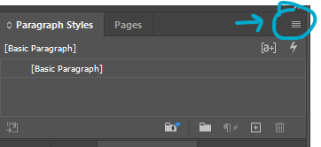
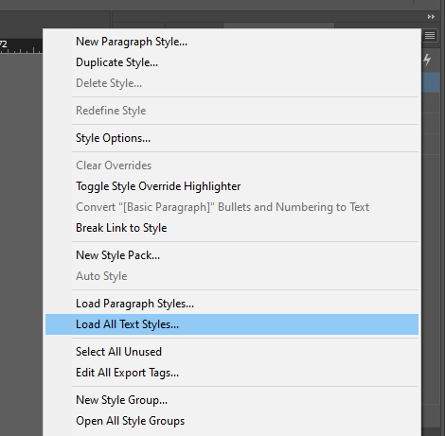
- This will open a File Explorer window where you can select a document to load in the Paragraph Styles and Character Styles from.
  - You always want to load in settings from the Front Matter InDesign Template because it will be the most up-to-date.
  - Select Example-00-Front-Matter
  - Click Open.
- This will open the Load Styles menu. All paragraph and character styles should automatically be checked, with any conflicts with existing styles set to “Use incoming definition”
- Click Ok. This should load in all our current Paragraph Styles and Character Styles.
- Save.

Loading Parent Pages
Find the Parent Pages Panel. It will only have the Parent Pages [None] and A-Parent.
- Click the Hamburger menu > Parent Pages > Load Parent Pages
- 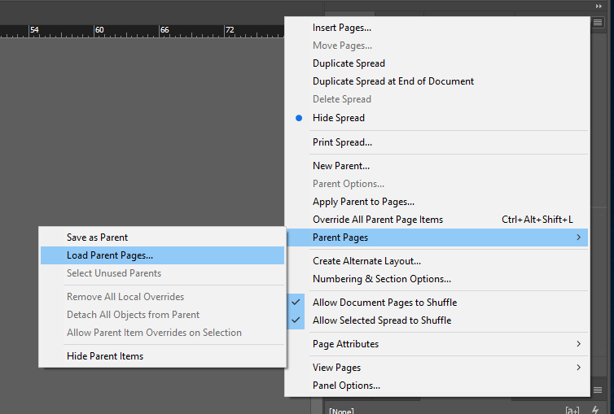
- This will open a File Explorer window where you can select a document to load in the Paragraph Styles and Character Styles from.
  - You always want to load in settings from the Front Matter InDesign Template because it will be the most up-to-date.
  - Select Example-00-Front-Matter
  - Click Open.
- This should have loaded in all our Parent Pages; double check that they all seem present in the new file, just in case.
  - Refer to the section Parent Pages at the end of the Style Reference documentation for a full list.
- Save.

How to Apply Parent Pages

First, in your new InDesign Document, set the Parent Page.
- Open the Pages tab in the vertical menu on the right side of your screen.
- You will see a list of Parent Pages next to icons that look like the pages of a book. Beneath the list you will see a separate section with one white page. This is your document. The Parent Pages are probably set to the default, which is A.
- Which Parent Pages you apply is determined by the type of InDesign document you are creating.

Glossary Parent Pages
- Click on GF- Glossary First Parent Page and drag it down to the page icon.
  - You can click on the actual words, or the image to the right of it.
  - If you click the image, you will need to make sure you are clicking the side of the spread that matches up with the page you want to apply the Parent Page to (i.e., click the recto side to apply to a recto page)
- GF will appear in the upper left corner.
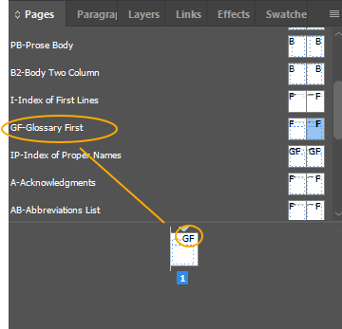
- If the glossary goes onto a second page, add a new page with the B2-Body Two Column Parent Page.

Index of Proper Names Pages
- Click on IP- Index of Proper Names Parent Page and drag it down to the page icon.
  - You can click on the actual words, or the image to the right of it.
  - If you click the image, you will need to make sure you are clicking the side of the spread that matches up with the page you want to apply the Parent Page to (i.e., click the recto side to apply to a recto page)
- IP will appear in the upper left corner.
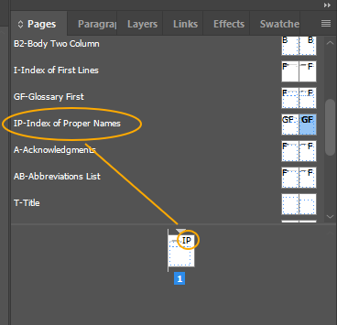
- If the Index of Proper Names goes onto a second page, add a new page with the B2-Body Two Column Parent Page.

Index of First Lines Parent Pages
- Click on I- Index of First Lines Parent Page and drag it down to the page icon.
  - You can click on the actual words, or the image to the right of it.
  - If you click the image, you will need to make sure you are clicking the side of the spread that matches up with the page you want to apply the Parent Page to (i.e., click the recto side to apply to a recto page)
- I will appear in the upper left corner.
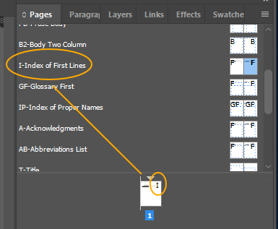
- If the Index of First Lines goes onto a second page, add a new page with the B-Body Parent Page.

How to Import Text from Word into InDesign

N.B.: You need to have applied a Parent Page first before this step, otherwise there will not be a text box to click into on your page.

Glossary and Index of Proper Names
The first page of Glossary and Index of Proper Name files has two text frames: one for any abbreviations or headnotes the editor provides, and one with two columns for the entries. Each text frame will need its respective Word Document imported into it individually.
- In the InDesign Document, ctrl-shift-click inside the text box on the page. This will make a new text box appear. You can tell because little squares appear in the lines at the edge of the text box.
- In InDesign, ctrl+D [place]. A file menu will pop up. Select the relevant Word Document and check the box that is marked Show Import Options (it is above the File Name box). Click ok.
- The Microsoft Word Import Options box will pop up. About ⅔ down the box, look for Manual Page Breaks and make sure that No Breaks is selected in the dropdown menu next to it.
- At the bottom of the box, click Customize Style Import and then click the round button that appears next to it called Style Mapping.
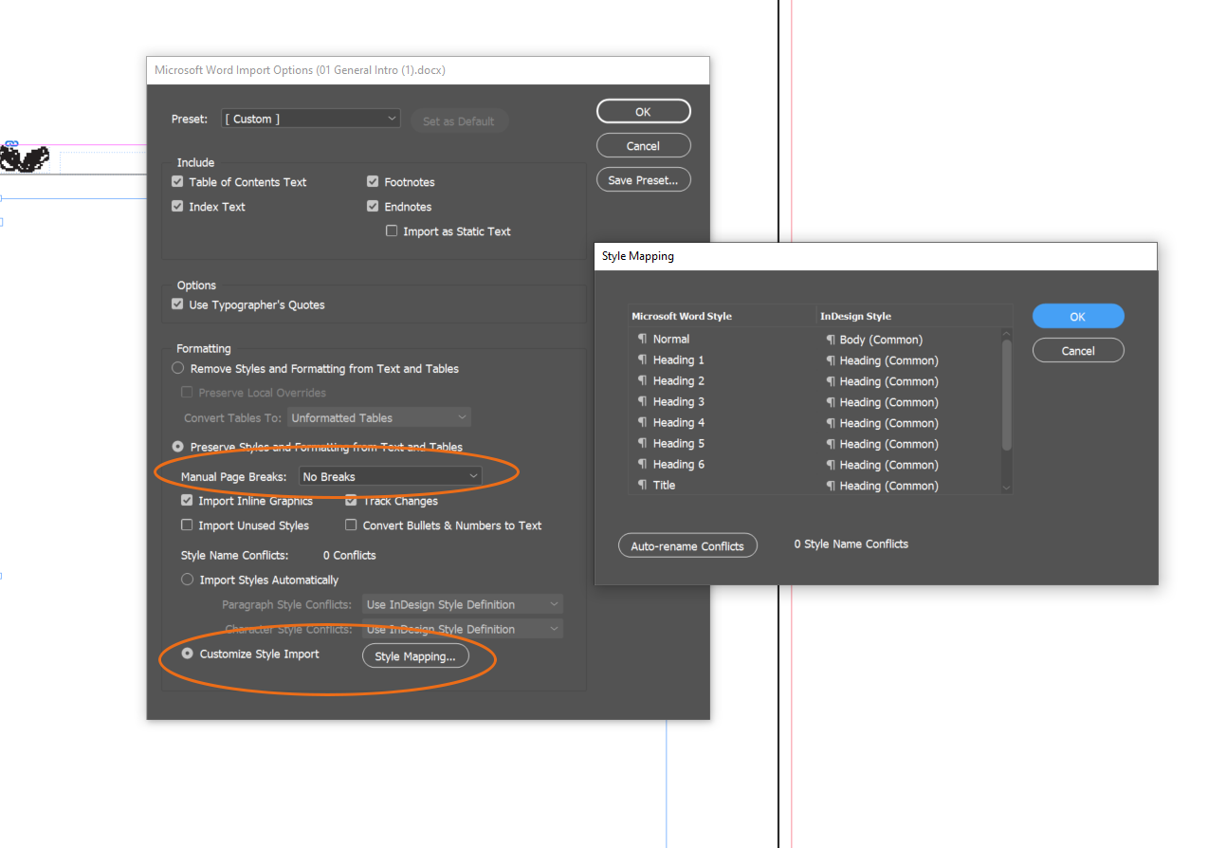
- The Style Mapping box will pop up with a list of styles that will import from the Word Document. Re-map the drop-down menu to conform to our styles:
  - Abbreviations
    - Normal > Body First
  - Entries
    - Glossaries: Normal > Glossary Entry (Glossary and Index Template)
    - Index of Proper Names > Index of Proper Names Entry (Glossary and Index Template)
- If you encounter paragraph or character styles that are connected to revision – such as balloon text/balloon text char, revision, various annotations, or comments, make sure to map these on to [No Paragraph Style] or [None] in order to prevent strange formatting. See screenshot below.
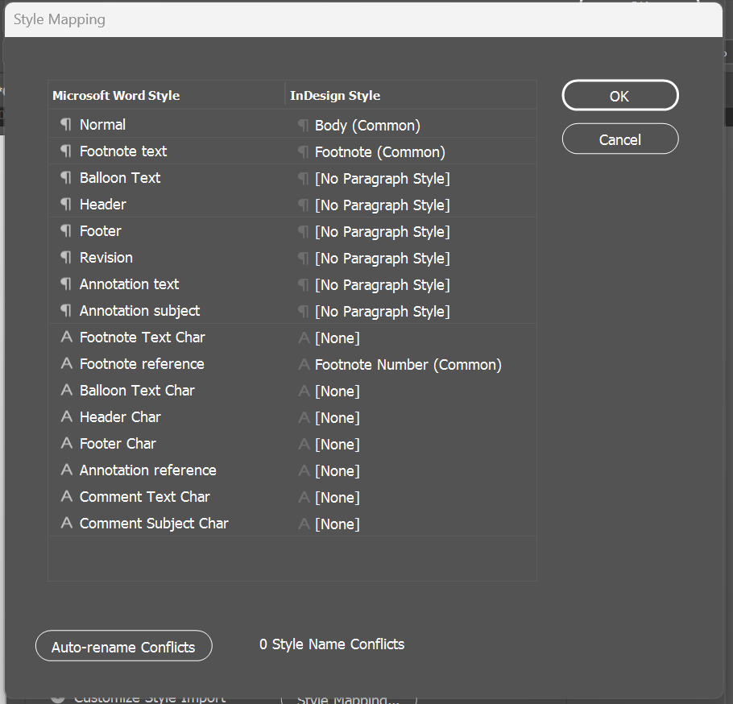
- There may be other choices, and you can use your best guess about how to remap these, but most of this will be fixed in your initial format anyway.
  - It can help to map any unknown / unnecessary styles to either [No Paragraph Style] or [None], but this can be a tedious process. You can skip this step, but you will need to double check whether any of those styles have imported into our styles menu. See below for more.
- Click OK.
- This brings you back to the Microsoft Word Import Options box. Click OK.
- This should make the text appear in the text box on your InDesign document. It will also look horrible. Don’t panic. We will fix it.

Index of First Lines
The first page of the Index of First Lines has one text frame; this text frame has some standard text already loaded into it. (See image below.)
- First, there will be one line of standard text describing the contents of this index: “This index lists first lines, titles, and incipits, styled with Appendix Headnote Paragraph Style.
- In the next line: “Page” right aligned, styled with Heading 3 Paragraph Style.
- One blank line underneath it.
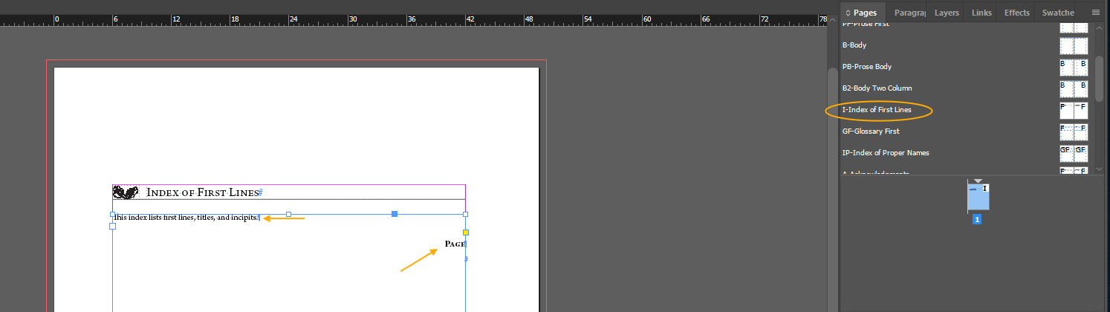
You want to preserve this standard text when you import the relevant Word document into this text frame.
- In the InDesign Document, ctrl-shift-click inside the text frame on the page. This will make a new text frame appear. You can tell because little squares appear in the lines at the edge of the text frame.
- Click into the text frame, either by double-clicking the text frame, or by selecting the Type tool and clicking the text frame. Make sure that the cursor is placed beneath ‘Page’ and before the final hashtag of the text frame.
- In InDesign, ctrl+D [place]. A file menu will pop up. Select the relevant Word Document and check the box that is marked Show Import Options (it is above the File Name box). Click ok.
- The Microsoft Word Import Options box will pop up. About ⅔ down the box, look for Manual Page Breaks and make sure that No Breaks is selected in the dropdown menu next to it.
- At the bottom of the box, click Customize Style Import and then click the round button that appears next to it called Style Mapping.
- The Style Mapping box will pop up with a list of styles that will import from the Word Document. Re-map the drop-down menu to conform to our styles:
  - Normal > Index of First Lines Entry
- If you encounter paragraph or character styles that are connected to revision – such as balloon text/balloon text char, revision, various annotations, or comments, make sure to map these on to [No Paragraph Style] or [None] in order to prevent strange formatting. See screenshot below.
- There may be other choices, and you can use your best guess about how to remap these, but most of this will be fixed in your initial format anyway.
  - It can help to map any unknown / unnecessary styles to either [No Paragraph Style] or [None], but this can be a tedious process. You can skip this step, but you will need to double check whether any of those styles have imported into our styles menu. See below for more.
- Click OK.
- This brings you back to the Microsoft Word Import Options box. Click OK.
- This should make the text appear in the text box on your InDesign document. It will also look horrible. Don’t panic. We will fix it.

Missing Fonts
- You may get a message saying that there are missing fonts in the document because InDesign doesn’t have New Baskerville. Our Styles will apply Arno Pro almost all of the time, but it does help to go ahead and update the fonts here.
  - In the Font Information, select the first font that isn’t Arno Pro.
  - Set the Font Family to be Arno Pro. Match the Font style to whatever is listed in the Font Information (Italic, Regular, etc.).
  - Click ‘Change All’
  - You’ll need to repeat this process for each font that isn’t Arno Pro in the Font Information.
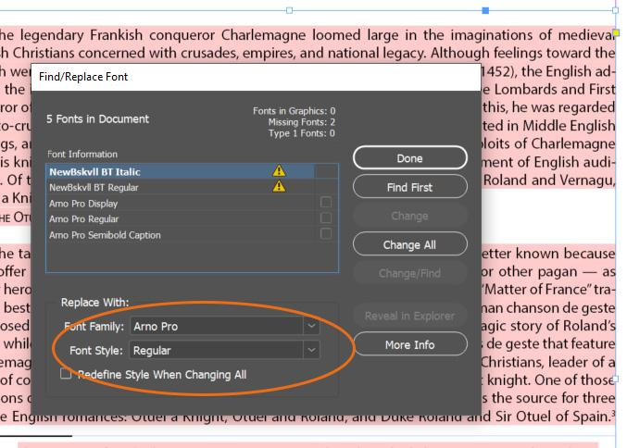

Insert the Second Page and Apply Parent Page
- At this point, check whether there is a red (+) at the bottom of the text frame. If there is, you will need to manually insert the next page (only one).
- Make sure you have the Selection Tool selected (the black arrow) and click into the textbox on your InDesign document.
- In the Pages menu on the right, there are a series of icons at the very bottom of the menu. Click on the one that says Create New Page when you hover over it. It looks like a page with a plus sign (+) inside.
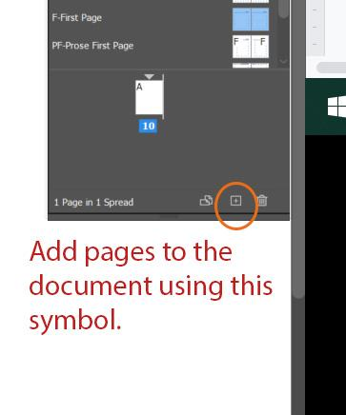

- This should insert a new page after your first one. This is a little finicky. If it doesn’t work, do Ctrl+Z to undo and try it again.
- For the new page, set the Parent Page
  - Use B2 – Body Two Column Parent Page if you are formatting a Glossary file or an Index of Proper Names file.
  - Use B – Body Parent Page if you are formatting an Index of First Lines file.
- Make sure you are using the selection tool (black arrow on left toolbar). Pick up the overset text by clicking on the red (+) on the bottom right of the first page. Hover your mouse over the new page. Notice that it seems to be holding the faint outline of text on it. Click into the box. This will insert the rest of the text into the new page and will cause the text to roll onto as many pages as your text requires.

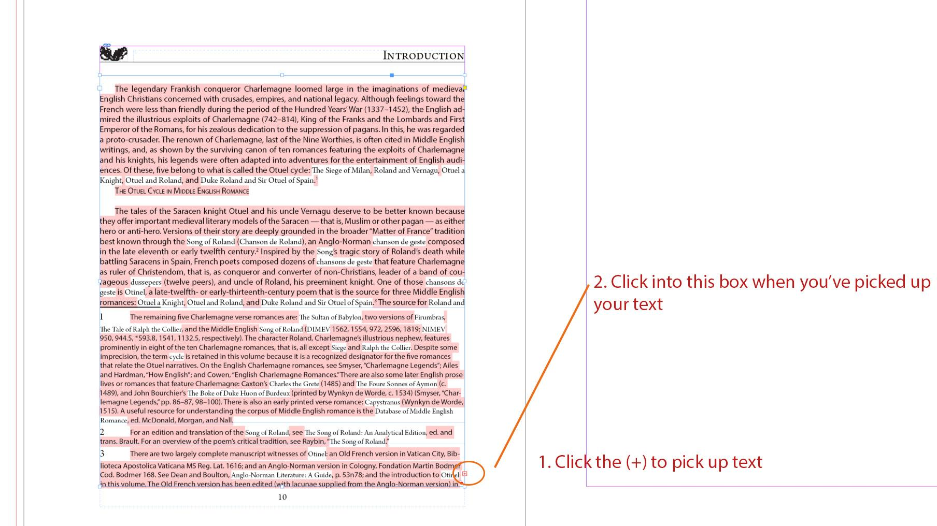

Deleting Extra Styles Imported from Word
- We want to delete any extra Styles from Word that have imported in through the Style Mapping process.
  - Styles from Word typically appear at the end of our list of pre-set styles and have a save icon on their right:
  - 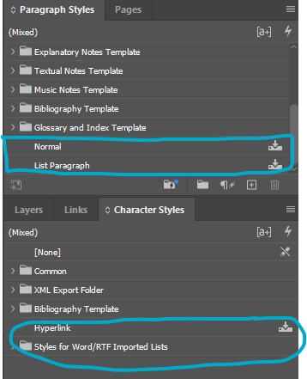
  - If these appear, you’ll need to delete them at the end of formatting.
    - Right click > Delete Style
  - If the style is still applied somewhere in the document, you’ll get a warning:
  - 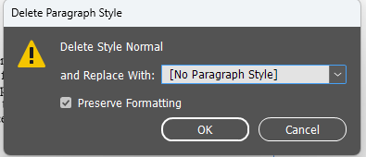
  - Set to replace with either [No Paragraph Style] or [None] if it’s a Character Style, with the Preserve Formatting function set, then click Ok.
  - You’ll need to take another look through your file to look for any blue highlighted overrides and correct/clear them as needed.

Next Steps

Before you move onto the file-specific workflow, review the Initial Steps for All InDesign Documents. Then, go to the file-specific workflow.
- 12. Glossary Instructions
- 13a. Index of Proper Names Instructions
- 13b. Index of First Lines Instructions

