Read the entire instructions before you try to follow them. Knowing where you are going will help.

Notes for the Formatter

Before you begin work on an edition, check for any notes the Managing Editor has left about this particular edition for the formatter. These will either be in descriptions of tasks in the edition’s Asana project, or in a Notes for Formatter Word document. The Managing Editor will review these notes with you before InDesign formatting begins.

How to Turn on “Show Hidden Characters” and “Highlight Override”

Whenever you work in InDesign, no matter what you are doing, if you are changing documents in any way, you must turn on Show Hidden Characters (Ctrl+Alt+I, or Type > Show Hidden Characters) and the Highlight Override (see below). InDesign is not a word processor, so if you treat it like you’re just typing into Word, you will create errors, such as overrides, throughout the text. So while editing, you need to be able to see the hidden characters (such as spaces or tabs) and any overrides – which are errors that will take hours to correct later – that you might be introducing into the text.
- For a complete list of Hidden Characters with examples, see the Hidden Characters section of the Formatting Reference
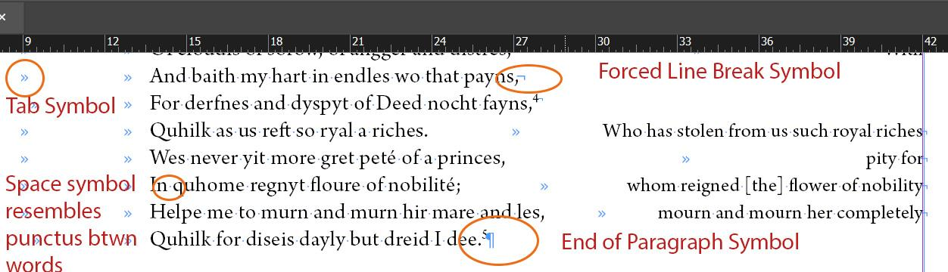

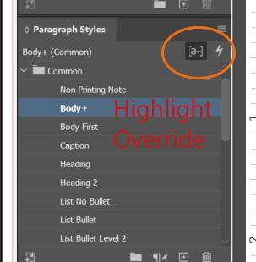

Document Footnote Options: The First Formatting Step for All Documents with Footnotes

This includes the Introduction and Texts.
You will need to change the spacing between the end of the text and beginning of footnotes so that our volumes look consistent. Change this setting in your text before you do any other formatting. You will need to change this setting every time you make a new InDesign document.
You can make global changes to Footnote formatting through the Document Footnote Options, accessed one of two ways:
- Type > Document Footnote Options
- Right Click > Document Footnote Options
The window automatically opens to the Numbering and Formatting tab
- Under Footnote Reference Number in Text, select Footnote Number in the Character Style dropdown
- Under Footnote Formatting, select Footnote in the Paragraph Style dropdown
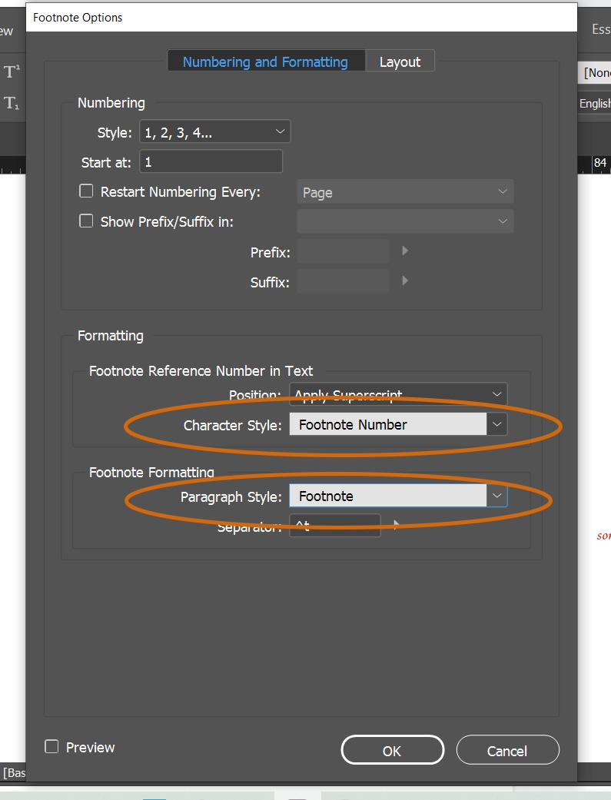
- Then, click into the second tab: Layout
  - The third item down is Minimum Space Before First Footnote with a value of 0p0. Re-set this value to 2p0 and click ok.
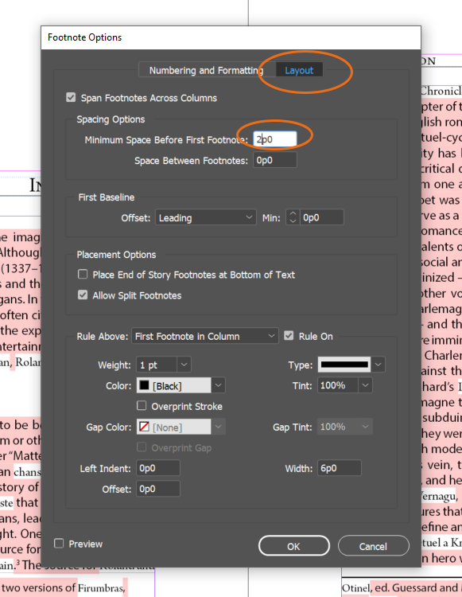
- Click ok. This will automatically apply these styles to all footnote numbers and footnotes within this document, as well as the spacing between the Footnotes and the bottom of the text to all the pages within this document. This saves you from having to manually adjust all the styles and spacing on a case-by-case basis.

Remove Imported Title

The Microsoft Word print production documents can include titles at the top of the file, so they end up importing into the text frame before the text. We do not include titles in the text frames, so if these import in, please delete them and any extra spacing before the content of the file. The content of the file (Introduction, Text, etc.) should start at the top of the text frame.

How to Apply Styles or “Tag,” Basics

There are two ways to “tag,” aka apply Paragraph and Character Styles:
- For Paragraph Styles, just click anywhere in the paragraph or section of text and then click the correct paragraph style in the right drop-down menu. Note that Paragraph Styles will apply to all lines that follow unless the sections are separated by a hard return. In other words, if you have forced line breaks between two separate lines (as you will with verse stanzas), the program automatically applies the Paragraph Style for all lines.
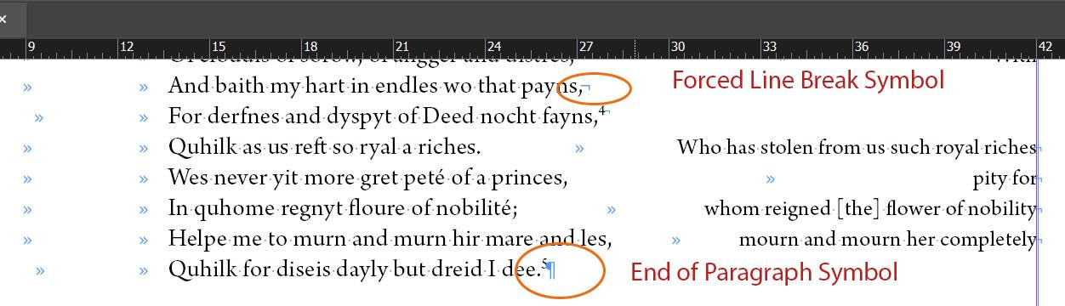
- For Character Styles, highlight the section of text you want to apply the style to and click the style in the right menu
- Do not apply formatting or styling using anything other than designated Paragraph and Character Styles. Also do not correct formatting, as this has already been done in the Word Document. If the formatting seems incorrect or that we lack a Style for it, contact the Managing Editor.

How to Create Keyboard Shortcuts

With any round of tagging, you are going to want to create keyboard shortcuts for the tags you use. You’ll probably change them as you work through different parts of tagging, so the shortcuts are up to your discretion. To assign shortcuts:
- Right-click the Character or Paragraph Style. A box will pop-up. Select Edit [Style name]
- In the Shortcut box assign the shortcut as a combination of keys. We recommend the following:
  - For workstations with wired/wireless keyboards:
    - Ctrl+number from the number pad
    - Shift+number from the number pad
  - For laptops with keyboards that do not have a number pad:
    - Ctrl+shift+number
  - Beneath the “shortcut” box you can see if this number is already assigned. If it has been already assigned, this current shortcut will override the old shortcut assignment. We recommend removing any shortcuts that you aren’t currently using as you continue to format the InDesign document.
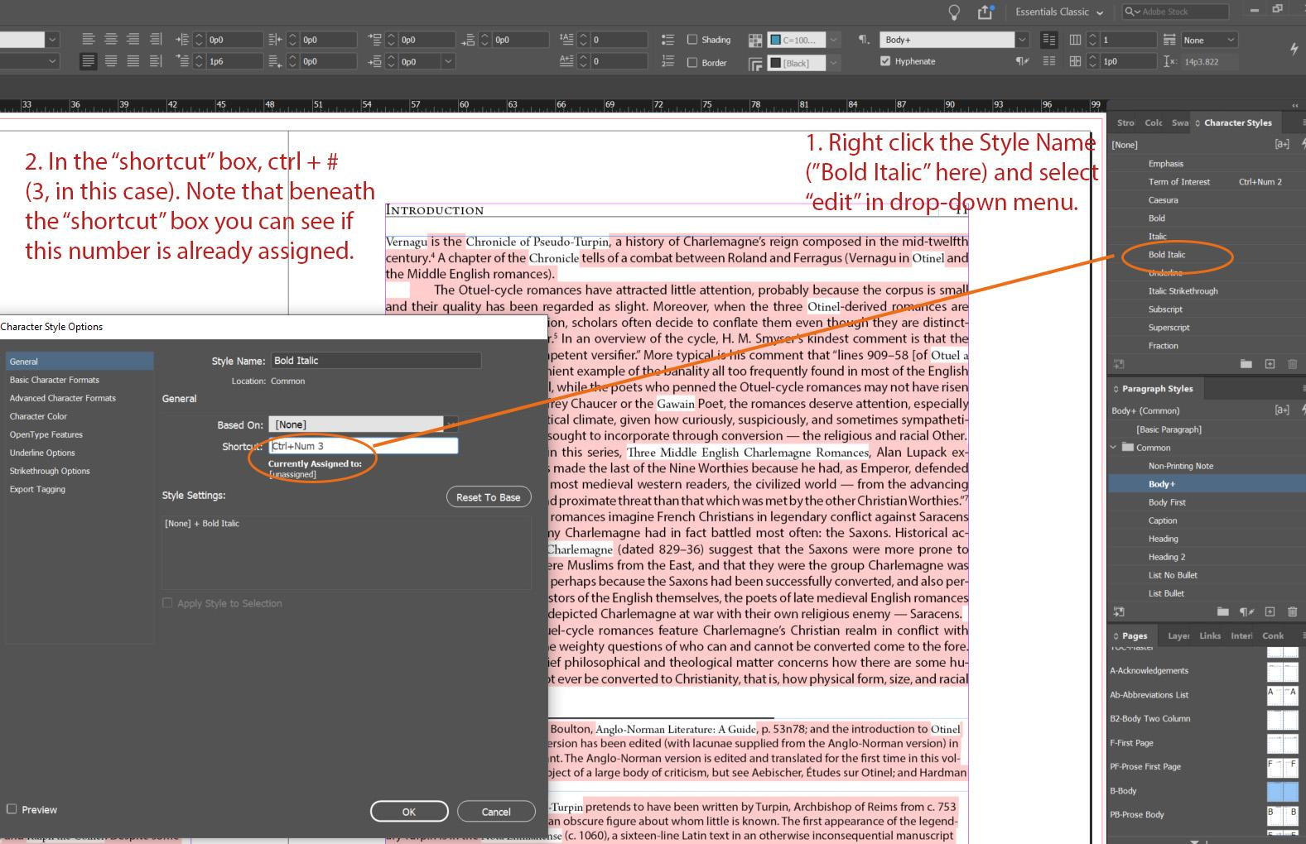

Next Steps

Go to the instructions for the specific document you are working on.

