Read the entire instructions before you try to follow them. Knowing where you are going will help.
It helps to have the Formatting Reference and the Style Reference documentation as you move through this workflow.
First, Show Hidden Characters (ctrl+alt+i) and the Highlight Override feature ([a+] at the top of the Paragraph Style menu). Don’t do anything before turning these on.

Headnote

You will use predominantly one Paragraph Style for Headnotes:
- The Appendix Headnote Paragraph Style should be applied to the first paragraph. This should already be applied to the standard text loaded into the Parent Page.
Loaded into the Parent Page will be a heading that reads Page. This should already have Heading 3 Paragraph Style applied, which applies Bold and Small Caps, and also right aligns the text.
- In some cases you will need to adjust what this heading reads as. Consult with the Managing Editor as needed to make sure that the information recorded in the Index is appropriate for the edition at hand.

Index of First Lines Entries

You will use one Paragraph Style in this section:
- Each individual entry should have the Index of First Lines Entry Paragraph Style applied.
- Make sure page numbers are flush with the right margin. You will only need one tab between the end of the title and the page number to set the page number flush with the right margin; delete any extra spaces present.
With the paragraph styles applied, there should be no extra spaces between entries.
If you imported the document with most paragraph styles as Index of First Lines Entry, then most should be tagged already; you just have to undo the overrides and reformat the text:
- Titles are italicized – use Italic Character Style
- Any words in a foreign language (i.e., Latin) are italicized – use Italic Character Style
- If there is additional location information that is not page numbers:
  - Use a colon after the headphrase for the first line / incipit / title, with no Character Style applied.
  - Additional location information should follow the colon, have no Character Styles applied, and not have ending punctuation.
See below an example of a correctly formatted first page for an Index of First Lines
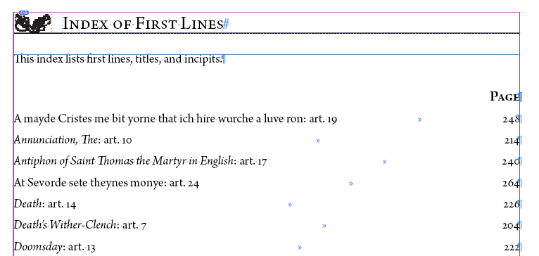

Long Incipits
Some incipits may be too long to fit on one line and still include a page number. If this is the case, we want to shorten the incipit / line / title so it fits on one line and can include location information.
- Preserve the first three words and the last three words of the incipit / line / title
- Replace the middle phrase with an ellipses that has been formatted according to METS Style.
  - See Formatting Reference, section Ellipses, for more information on how we format ellipses.
- Consult with Managing Editor if needed.

Final Pagination Adjustment before Moving on to the next Document

First, make sure that the hashtag that indicates the end of the text appears after the final punctuation on the page. Pagination should be more or less set before you move onto a new document. See the Completing a Text Frame section and the Document Pagination section of the Formatting Reference for more details.

