Once any corrections have been entered from the InDesign Audit, the Managing Editor will make the final changes to all InDesign files.

Print Production InDesign Book

In order to package the edition to prepare for MIP, we will want to put all the print production InDesign files into a Print Book.

Create InDesign Book
InDesign > File > New > Book
- Save the book in the Editor-Volume-Print folder and name the book according to our File Naming Conventions
  - Ex. McShane-Jerusalem-Print.indb
- The Book will list all documents that are added in the order you have added them. The first document you add will automatically become the source document, where the book will pull any Styles or Pages when you sync the book together. You can click and drag documents to reorder them, which will automatically update pagination.

Add Front Matter to the Book
- Open the Book in InDesign. There should be a small, dark gray square that appears in the middle of the screen. The name of the book will appear at the top of the square.
- There is a taskbar at the bottom of the Book. Click the + sign. This will open an Add Documents window.
- Select the appropriate folder, then click the Front Matter document that has already been made for the edition, then click Open.
- This will add the template to the book.
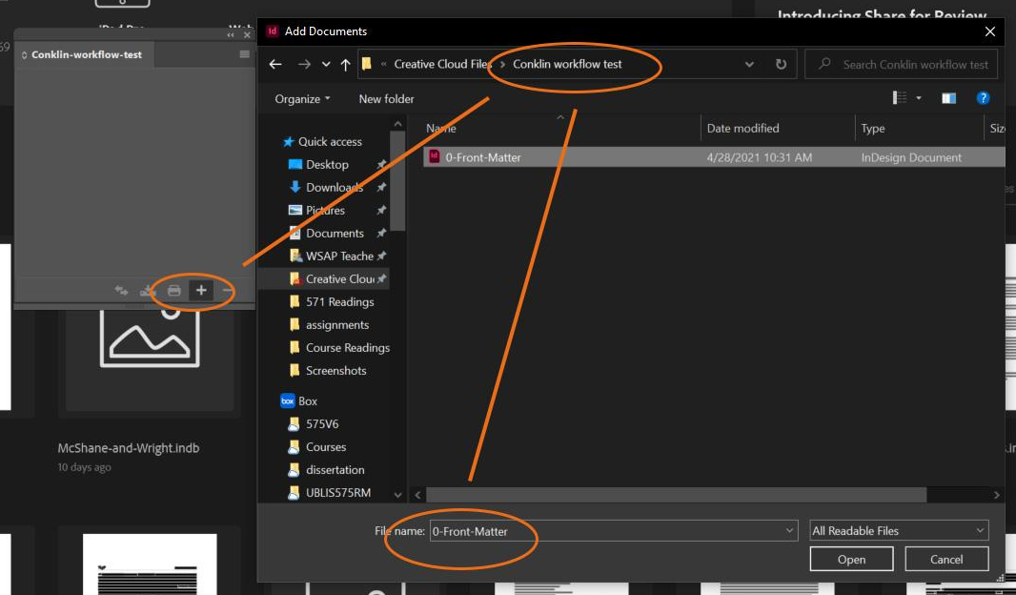

Update Front Matter
Before you add more documents to the Book, you will want to make a few changes to the Front Matter. When you add all the rest of the documents to the Book, you will Synchronize all the documents with this Front Matter file to make global changes throughout all files.

Add File Info
- File > File Info
- 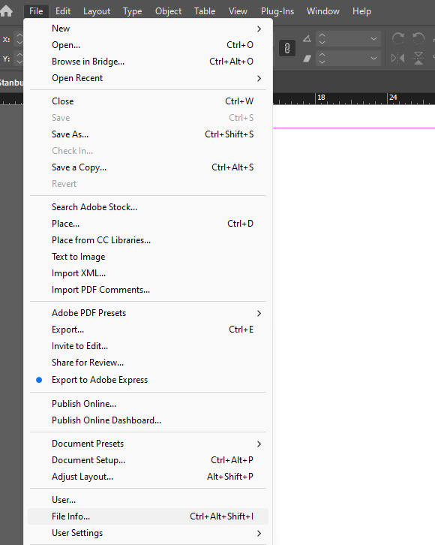
- This will open a menu where you can add in metadata information about the InDesign file. It will look like this:
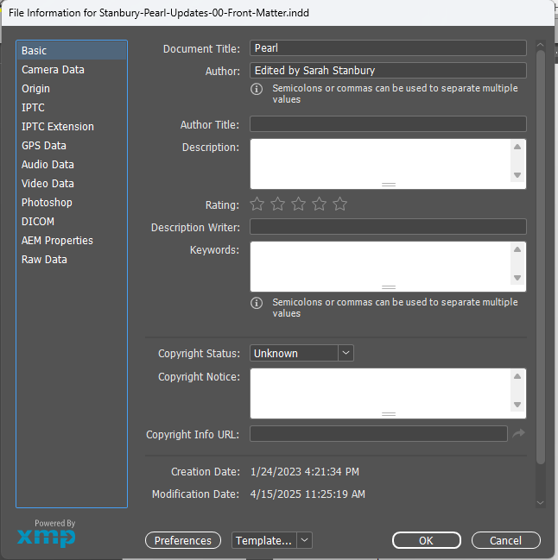
- Document Title: add the title of the edition here
- Author: Add “Edited by [the name(s) of the Volume Editor(s, in the order presented in the title page)]”
- Click OK.

Remove Colors from Character Styles
- Right-click on the Character Style name > Edit Character Style. This will open a menu with full details on the style setting.
  - Person Name, Place Name, Date, Line Number, and Foliation are the styles that typically have colors associated with them.
- Select Character Color, from the left menu.
- In the color menu, scroll all the way to the top and select “Black.”
- Select “ok”
- Save the Front Matter
- Save the Book.
If the text color has been manually changed in the past, this should show up as an override. Make sure the Highlight Override feature ([a] at the top of the Paragraph Style menu) has been turned on. If this is the case, then you will want to remove these colors by clearing the override.

Link Images used in Parent Pages
Because we use Box for most of our initial InDesign formatting, links for images aren’t always preserved properly when opened using different Box accounts. The Managing Editor will want to go back through and update these links on their machine before packaging the files to send off to MIP.
- If a document contains a missing link, an error window will appear when you open the document in InDesign stating that there is a missing link, with the number of missing links present in that particular document. Click OK to continue opening the document.
  - 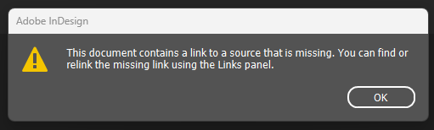
- Open the Preflight Panel.
  - There’s a quick view of the Preflight Panel found along the bottom status bar of InDesign. Click the down arrow, then click Preflight Panel.
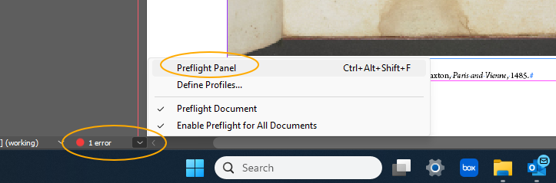
- The Preflight Panel will look like this:
- 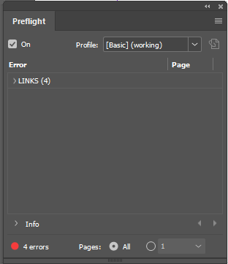
- Expand all the drop-down arrows to show where the missing links are
- 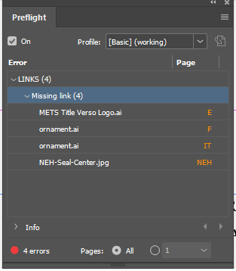
- Each missing link will contain the file name of the image which has a missing link. The Page column on the right will tell you either the Parent Page (an orange letter) or the page number (orange number) in the document where the missing links are. Clicking on one of the missing link entries will open the page / Parent Page of the document where the image is located.
- Double-click on METS Title Verso Logo.ai; this will open the E-Editorial Parent Page and automatically select the image in question.
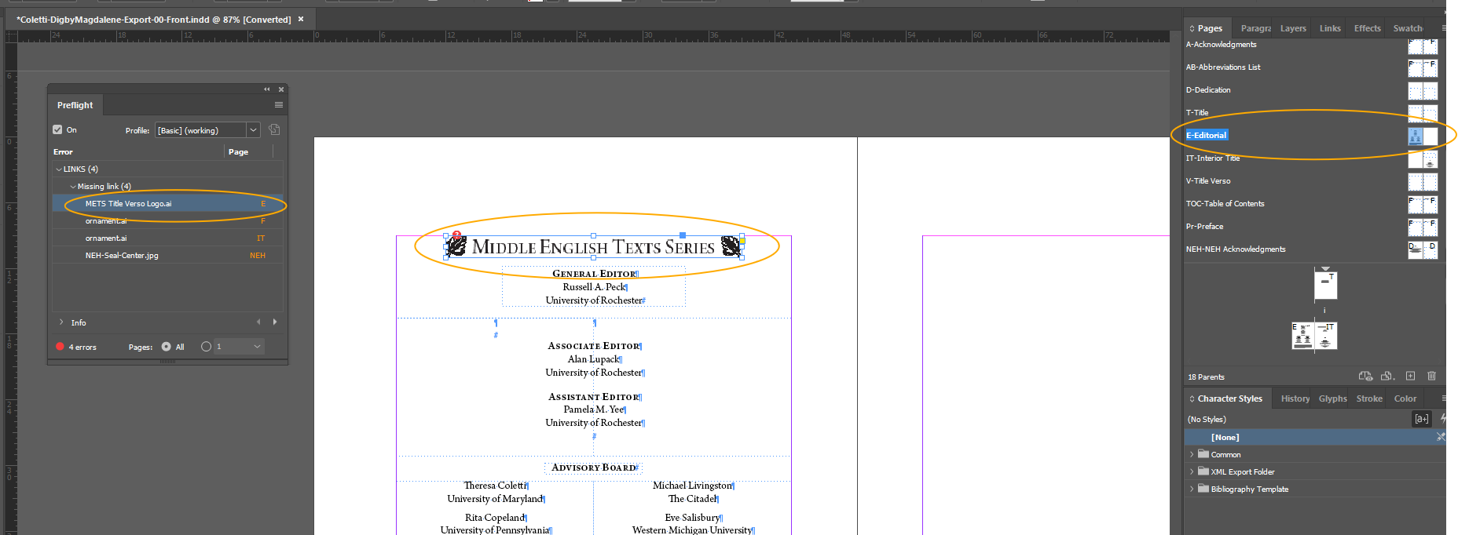
- You’ll see a red question mark icon at the top left corner of the image frame.
- 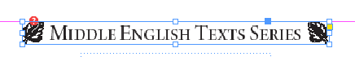
- Click on the red question mark icon. This will open the Locate window.
  - The top of the Locate window will hold an abbreviated breadcrumb file path of where InDesign expects this image to be located.
    - In this case, C:\Users\RCL-ROBS\Creative Cloud… Images\METS Title Verso Logo.ai
  - The File Explorer window will open either the C: drive or the last folder on your workstation from which you have imported images
    - In this example’s case, it has opened the last folder an image was imported from
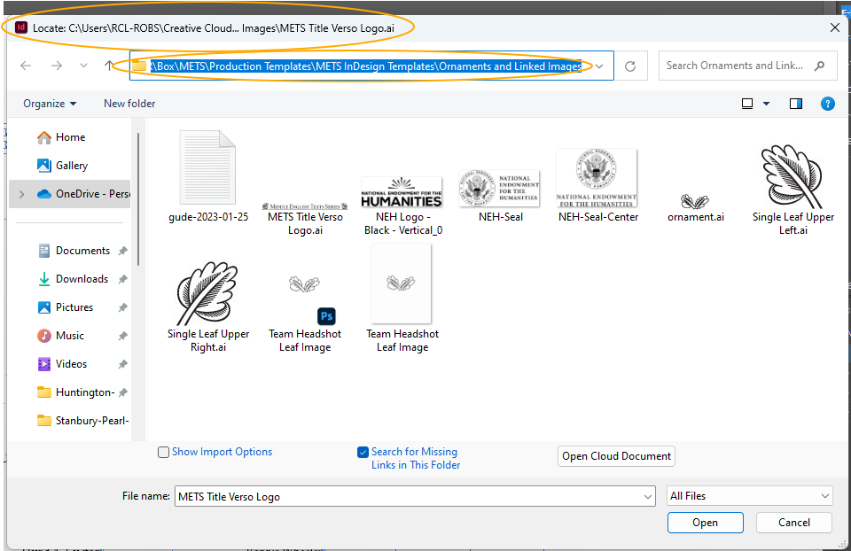
  - Select the image METS Title Verso Logo.ai. Then click Open.
  - Two windows will open after you click Open.
    - Relink: This is the original image being relinked manually.
    - Information: InDesign automatically searches the folder you are linking to for images with matching file names as any other images with missing links. In this case, in the front matter, it should find the rest of the images and re-link them for you.
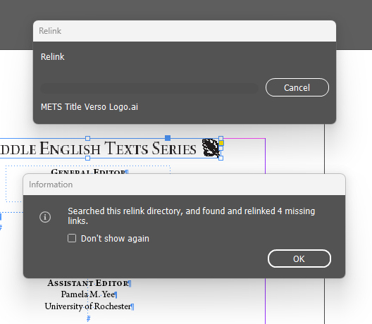
  - Click OK on the Information window.
- At this point, all Front Matter images should be relinked. The Preflight Panel will be cleared of any errors, and you’ll have a green circle indicating no errors exist.
  - 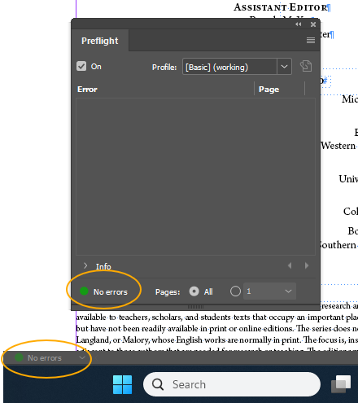
- If the Information window does not pop up for you and the other images are not automatically relinked, then repeat this process with any other missing link items in the Preflight Panel.

Update Date on Interior Title Page
We leave the Publication Year as “20xx” on the Interior Title Page until the edition is fully typeset and the Managing Editor is entering any final corrections. Update this date to the year in which the print edition will be published.
- Open the Interior Title Page in the front matter.
- Ctrl+Shift+Click the bottom text frame that contains the Publication Year information.
- Double click in the text frame, or use the Type Tool to click into the Publication Year.
- Replace “20xx” with the correct year.

Update Volume Title in Running Headers on Body Parent Pages
Our Running Headers on all Body Parent Pages have filler text for “Volume Title” on all verso pages. You can update this in the Front Matter before you sync all the rest of the documents so you don’t have to fix this individually on each InDesign file.
- Go to the Pages menu
- Double-click the pages next to B-Body Parent Page.
- Click into the running header on the verso page and replace the filler text “Volume Title” with the title of the edition. If the title is very long, enter a shortened version of the title.
- Save.
- Repeat this process for PB-Prose Body and B2-Body Two Column Parent Pages, if used in the edition. Save the document.

Add Files to the Book and Sync the Book
- Open the Book in InDesign. There should be a small, dark gray square that appears in the middle of the screen. The name of the book will appear at the top of the square.
- There is a taskbar at the bottom of the Book. Click the + sign. This will open an Add Documents window.
- Select the appropriate folder, then click the file numbered 01 (usually an Introduction file), then click Open. This will add that file next to the Book.
- Continue to add all files for an edition in number order. This will ensure that the first are in the correct order. Once all files have been added, save the Book.
- Make sure no files are selected in the Book panel, then click the Hamburger Menu > Synchronize Options
  - Verify that all options are checked, including Parent Pages
  - Then click Synchronize.
    - N.B. Make sure you click Synchronize. If you click OK, the book will not synchronize any changes; it will only save the changes you made to the Options menu.
  - This will ensure that any changes made in the Front Matter’s Styles or Parent Pages are made globally throughout the Book.

Set Pagination
Select the file numbered 01 (usually an Introduction file) in the Book panel > Hamburger Menu > Document Numbering Options
- Select the option Start Page Numbering at
- Set the page number start to 1
- Click OK.
- This will set the pagination for the rest of the edition.
- Check that each new section begins on a recto page.
  - The only exceptions are Facing Page sections, which should always begin on a verso page. In order to make Facing Page sections start on a verso page, go to the end of the previous section and insert a blank page so its final page is a recto page. This will automatically reflow the next section to start on a verso page. Then, delete the opening blank page in the Facing Page section.
  - If a blank page has been inserted, double check that it has [None] Parent Page applied.
  - If you find a non-facing-page section that begins on a verso page, go to the end of the previous section and insert a blank page so it ends on a verso page. This will automatically reflow the next section to start on a recto page.
- Update the pagination in the Front Matter’s Table of Contents
  - If the edition has any visual material (images or tables), they should already be listed at the end of the ToC under “List of Illustrations,” including their page numbers. Check that they appear in the correct location, are labeled with the correct figure number, and are linked correctly in InDesign. (See Cook-Lydgate’s ToC for sample List of Illustrations.) Confirm that images include captions and credits.

Changing Section Names on all Documents
Section Names are changed by altering Parent Pages. Since we use the same Parent Pages for most Documents, you have to change them for each Document. You will go into the Parent Pages used in a particular document and change the filler text to the relevant headings for each document; use the titles found in the edition’s Table of Contents.
- Open the InDesign Book, then open the first numbered file (01, usually an Introduction) in the Book.
- Check the Parent Pages used in the document.
  - For most files, you will find F-First Parent Page and B-Body Parent Page.
  - For Prose texts, you will find PF-Prose First and PB-Prose Body.
  - Glossaries and Indices use GF-Glossary First, B2-Body Two Column, I-Index of First Lines, and IP-Index of Proper Names
- Double-click the pages next to the relevant Parent Page.
- Click into the headers and update the filler text with the appropriate title found in the table of contents.
  - Any First Pages will be the title of the work in that file.
  - Any recto pages on the Body parent pages should be the title of the work in that file. Changing the Parent Page here will apply the header throughout your open document.
- Save each document.
- Save the Book.

Finalize Cross-References
Any cross-references that require page numbers have not yet been added, since pagination was not set until now. In past steps of print production, the Managing Editor capitalized placeholders for cross-references, which can now be replaced with current pagination.
- Open the first Introduction, and skim for any capitalized cross-references. Usually, these are uppercase SEE or uppercase section headings, like INTRODUCTION, PP. If you run a search, make sure to capitalize your search terms and click the Aa button, which makes the search case-sensitive.
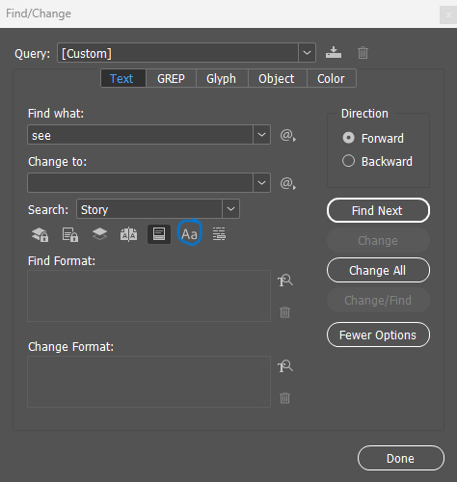
- Read the sentence where the cross-reference appears to get a sense of where the Volume Editor might be referring to. Use any context clues, like section titles, number, or directionals, like “above” or “below” to find the target. Once you’ve found it, add in the correct line page, or note number and then rewrite the capitalized placeholders in lowercase.
- If you are unsure where the target is and prefer to leave the cross-reference blank, ask the Managing Editor or turn the capitalized placeholder pink, so the Volume Editor can easily spot it and either correct or confirm the target. To change font colors, highlight the desired phrase, click the fill button in the top toolbar (see image below) and choose your desired color.
- Repeat the steps above for all remaining Introductions, Explanatory Notes, and Textual Notes sections to catch all cross-references. If the edition has additional back matter, open them and skim for capitalized placeholders, or check with the Managing Editor to see which additional sections need targets added to cross-references.
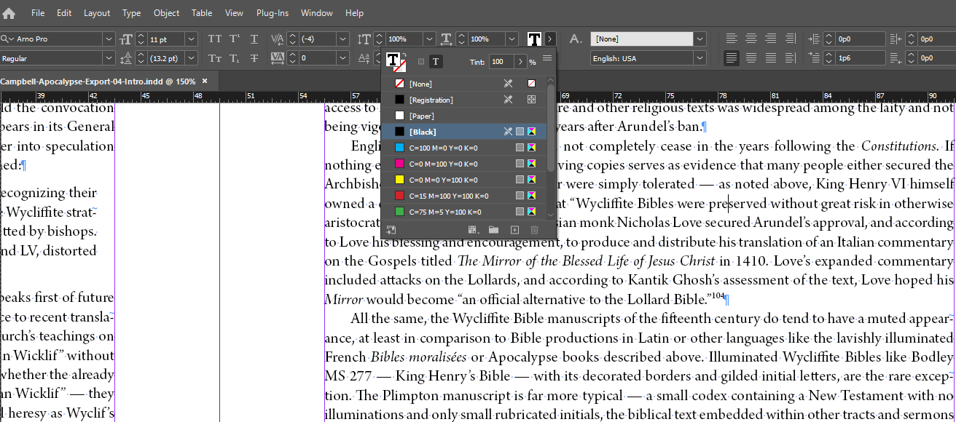

Link Images in Files (if applicable)
Because we use Box for most of our initial InDesign formatting, links for images aren’t always preserved properly when opened using different Box accounts. The Managing Editor will want to go back through and update these links on their machine before packaging the files to send off to MIP.
- If a document contains a missing link, an error window will appear when you open the document in InDesign stating that there is a missing link, with the number of missing links present in that particular document. Click OK to continue opening the document.
- Open the Preflight Panel.
  - There’s a quick view of the Preflight Panel found along the bottom status bar of InDesign. Click the down arrow, then click Preflight Panel.
- The Preflight Panel will look like this:
- 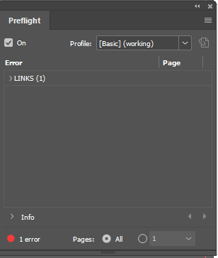
- Expand any drop-down arrows to show the list of Missing Links, to look like this:
- 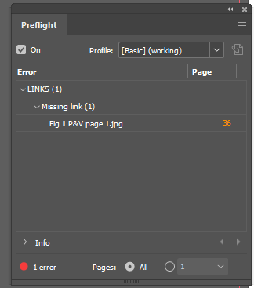
- Each missing link will contain the file name of the image which has a missing link. The Page column on the right will tell you either the Parent Page (an orange letter) or the page number (orange number) in the document where the missing links are. Clicking on one of the missing link entries will open the page / Parent Page of the document where the image is located.
- Double-click on the file name of the missing image; this will open the document to the correct page and automatically select the image in question.
- 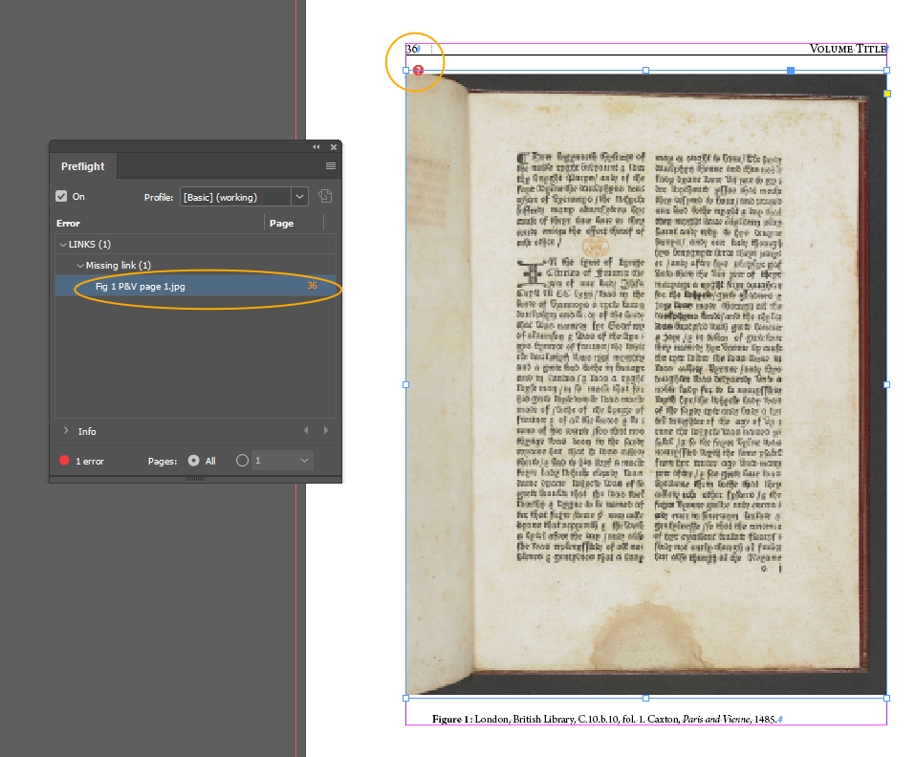
- You’ll see a red question mark icon at the top left corner of the image frame.
- Click on the red question mark icon. This will open the Locate window.
  - The top of the Locate window will hold an abbreviated breadcrumb file path of where InDesign expects this image to be located.
    - In this case, J:\Published Volumes (PDFs)\Huds…xton\Images\Fit 1 P&B page 1.jp
  - The File Explorer window will open either the C: drive or the last folder on your workstation from which you have imported images
    - In this example’s case, it has opened the last folder an image was imported from.
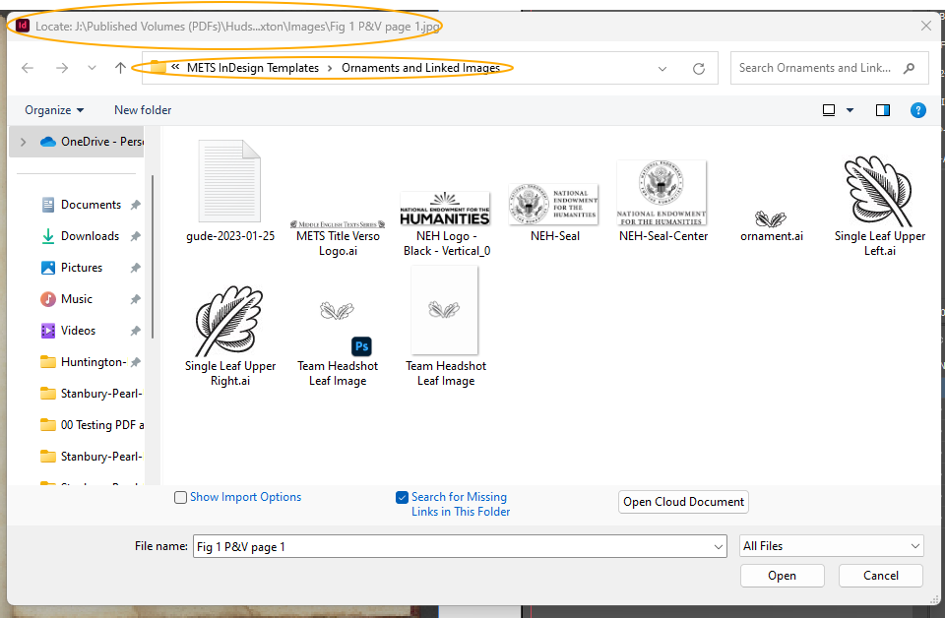
- Navigate to the correct folder in Box and select the correct image file. Then click Open.
- Briefly, a Relink window with a progress bar will open and close by itself. This is InDesign re-linking the image.
- Repeat this process for all images with missing links in an InDesign document listed in the Preflight Panel. When you have addressed all images, the Preflight Panel will be cleared of any errors, and you’ll have a green circle indicating no errors exist.

Create PDF of the Full Book to send back to Volume Editors for Final Proof
Open the edition’s Book panel > Hamburger menu > Export Book to PDF
- Select the Editor-Title-Print > PDFs folder and click Save. This will open an Export Adobe PDF window.
- General > Export As: Pages
- General > Include: Hyperlinks
- Advanced > Accessibility Options > Display Title: Document Title
- Then click Export.
NB: When the Managing Editor returns this full PDF, make sure to indicate to the Volume Editor that pink font indicates a place where you’d like them to add, confirm, or correct the cross-reference.

Enter Corrections from Volume Editors
Once any notes and corrections from Volume Editors have been received, the Managing Editor will enter corrections into the appropriate InDesign Files and delete any pink font.
- NB: MIP will check for the following, so we don’t need to:
  - Widows/orphans:
  - Hyphenated words that break across lines
  - Number ranges (like pages in citations, foliation ranges, or date ranges) that break across lines
- Save the files and save the book using updated files.
- If pagination has changed, correct the page numbers in the Table of Contents.

