Read the entire instructions before you try to follow them. Knowing where you are going will help.
It helps to have the Formatting Reference and the Style Reference documentation as you move through this workflow.
First, Show Hidden Characters (ctrl+alt+i) and the Highlight Override feature ([a] at the top of the Paragraph Style menu). Don’t do anything before turning these on.

Dramatis Personae / Cast List

The Dramatis Personae / Cast List is a list of all the principal characters within a drama text. At METS, we refer to this aspect of the text using either the term Dramatis Personae or Cast List. For all intents and purposes, these terms are interchangeable here.
First, check and see whether the Dramatis Personae needs to be in its own InDesign document or if it will be placed above the body text of the play. This will be decided conditionally.
- If the Cast List is less than a full page, it should be kept with the rest of the Drama text in the same InDesign Document.
  - Continue following the formatting instructions below.
- Otherwise, if the Cast List is a full page or longer, it should be made into its own InDesign Document.
  - If the Cast List is not already in its own Word document, copy and paste it into its own Word document. You will also want to put the Drama Text into its own Word document.
  - N.B.: You never want to Cut / Paste these into new files. We want to preserve the original Production file as one complete document.
  - Place the Cast List in its own InDesign document.
  - Then, continue following the formatting instructions below
    - Fixing Stanzas
    - Initial Styling: Styling Dramatis Personae / Cast List
    - Initial Styling: Adding formatting back into the
    - Tagging Texts, First Steps
    - Semantic Tagging (if applicable)
    - Final Pagination Adjustment

Fixing Stanzas by Editing “End of Paragraph” and “Forced Line Breaks”

Typically, verse formatting issues come from the paraphs – which are really end of paragraph symbols (^p) – that show up at the end of each line. We want the majority of lines to have a forced line break (^n) End of paragraph symbols are what indicates the end of a stanza and adds extra space between lines. Right now, InDesign thinks that every line break is actually a stanza break, so there’s an extra space between lines.
See below for an example of a Verse text upon import into InDesign. There will be end of paragraph symbols at the end of every line.
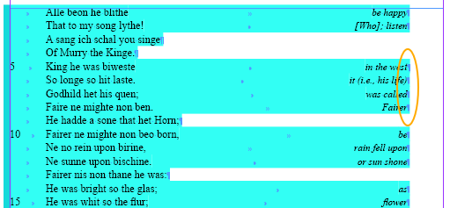
Turn all end of paragraph symbols into forced line break symbols:
- Ctrl+F
- A menu pops up. In the Find What box, select the @ to the right of the box and choose end of paragraph.
- In the Change to box, selected the @ to the right of the box and choose forced line break. Then select Change All.
- This transforms all of the text into a single line group (or stanza).
- You’ll want to complete this step to the Dramatis Personae and to the Drama Text itself.
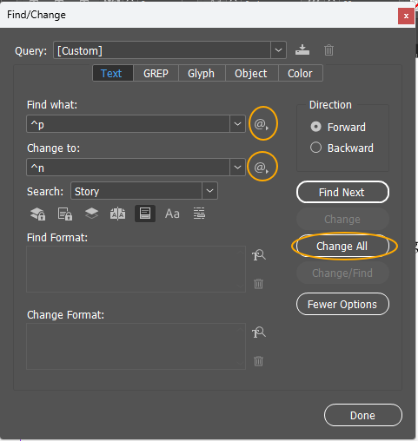
Sample verse before fixing end of paragraph symbols:
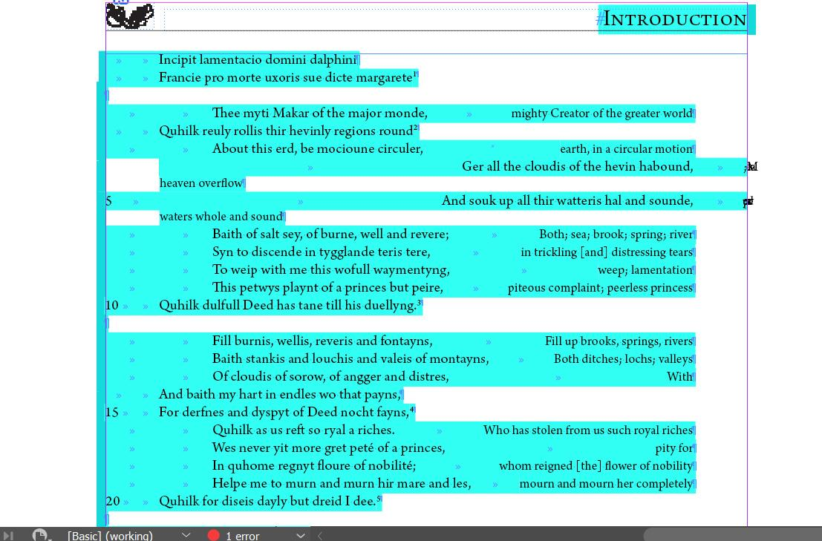

Sample verse after fixing end of paragraph symbols:
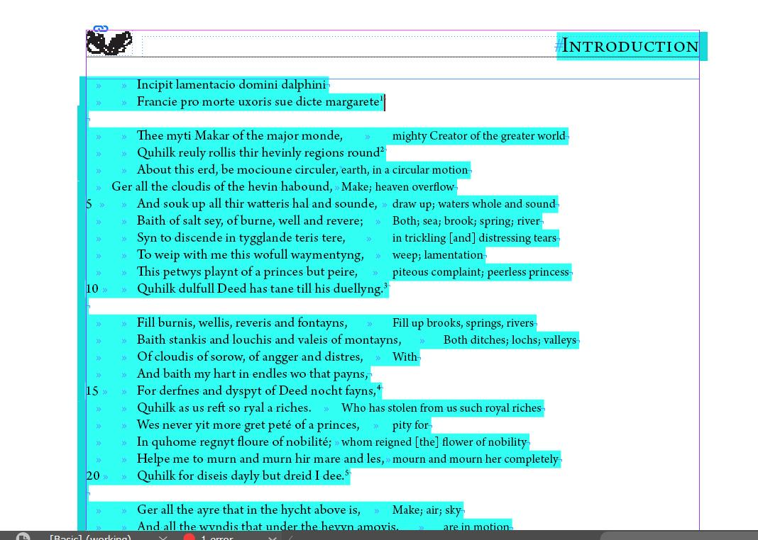

Initial Styling and Alignment

You will format your text one stanza at a time. This will preserve much of the original document’s formatting so that you can fix things like stanza spacing and italics at the same time.

Styling Dramatis Personae / Cast List
We start with the Cast List, whether it is in its own document or at the top of the text document.
- Double check that all end of paragraphs have been changed into forced line breaks, from the last step.
- If the Cast List is inside the text document:
  - Add an end of paragraph symbol after the final name within the list.
  - If there is a heading (Dramatis Personae) also add an end of paragraph symbol there. If there isn’t (most old texts will not have a heading) and the Cast List is not transcribed directly from a manuscript, add the heading Dramatis Personae and press enter.
  - Click into the heading and select the Heading Paragraph Style to change it to small caps.
- If the Cast List is a separate document, then you do not need to add a heading within the text frame. This heading information will be updated later in the Final Steps of the InDesign workflow
- Click into the list of names and select the Cast List Paragraph Style.
  - All names should remain flush with the left margin. We will not be including any indentation to represent grouped names or family units.
This is what the beginning of your text should look like if the Cast List is in the same InDesign document as the Drama Text. Note that the heading (here, Characters) has had the Heading Paragraph Style applied. There are the forced line break symbols at the end of each name except the last name in the list. There should not be any extra end of paragraph symbols between Paragraph Styles.
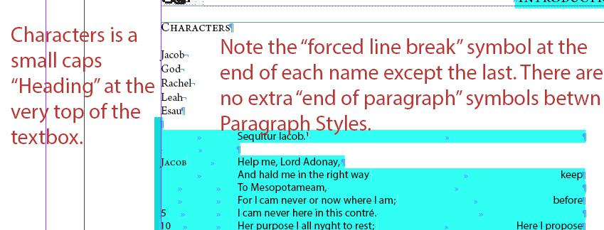
- Then, restyle the names in the Cast List.
  - Names should be styled with the Small Caps Character Style. If there is any additional description following the names, it will remain in roman font.
  - See below for an example.
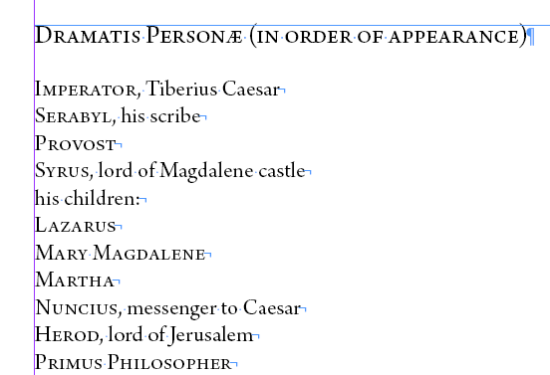

Stanza Formatting
Line Group Paragraph Style should be applied to all stanzas of the Drama Text.
- This should have been applied when you imported the Word document, but sometimes the style mapping doesn’t stick.
- Click anywhere in the text and double check that Line Group Paragraph Style has been applied. If it hasn’t, go ahead and apply it.
  - Since there are forced line breaks between all lines at this point, InDesign reads these stanzas as a single Paragraph, so you can change the Paragraph Style for all the text with one click now.
- If the import created a new Paragraph Style that had been applied instead of Line Group, delete it now.
  - See below for an example. There, the new Paragraph Style Normal is applied to all the text instead of Line Group. You can tell Normal is a new Paragraph Style because there is a save icon to the right of the Paragraph Style name. You would first apply Line Group, then delete the Normal Paragraph Style.
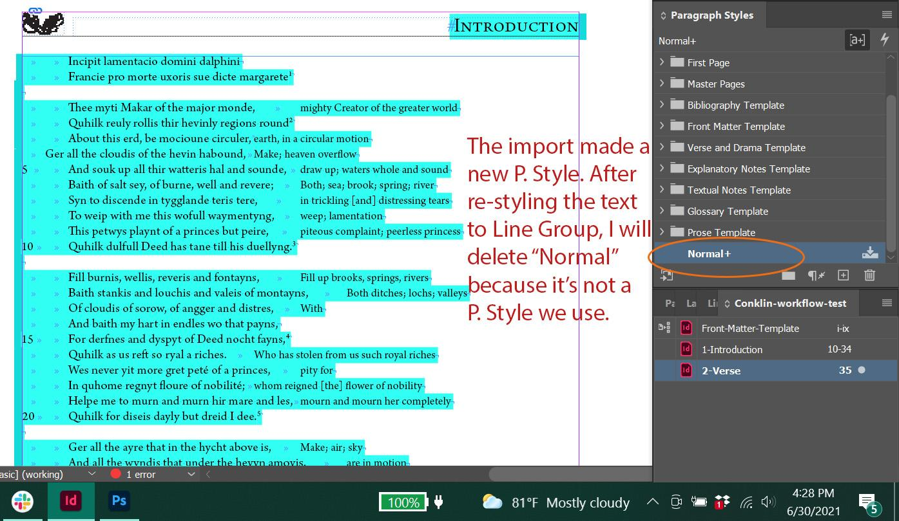
- Then, add an end of paragraph symbol to the end of the stanza.
  - Go to the end of the last line of the stanza (or gloss, if there is one) and press enter. Then delete the extra forced line break symbol that is at the end of the line.
- See below for an example. The first stanza is formatted correctly, with an end of paragraph symbol at the end of the last line. The second stanza still needs to be corrected, as there is still a forced line break at the end of its last line.
  - N.B.: Please note that the example image does not have the highlight override turned on, for clarity of seeing the hidden characters. When you are formatting, you should always have the highlight override feature turned on.
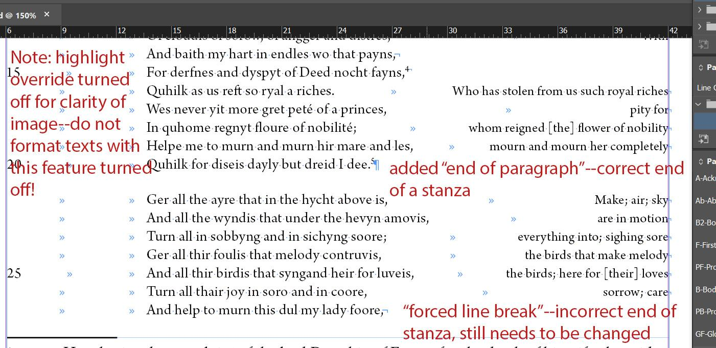

Incipits and Explicits
Check the beginning and end of the Text for Incipits and Explicits.
- If there is an incipit, add an end of paragraph symbol (aka press enter) after the final word or punctuation of the incipit. This tells InDesign that that place is the end of a Paragraph Style, and therefore ensures separation of the Incipit and the Line Group paragraph styles when applied.
- Click anywhere into the incipit and select Incipit from the Paragraph Style drop-down.
- Remove the override. Refer to the Formatting Reference (section Overrides) as needed for overrides.
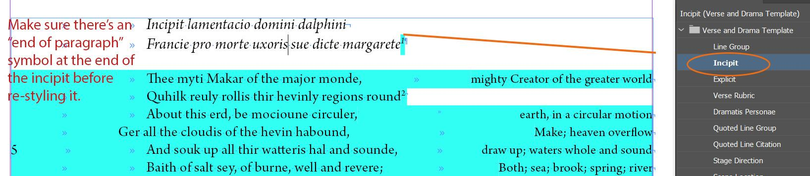
- For an explicit, add an end of paragraph symbol to the end of the final line (or gloss) of the poem before the Explicit.
- Click into the explicit and select Explicit Paragraph Style.
- Remove the override. Refer to the Formatting Reference (section Overrides) as needed for overrides.
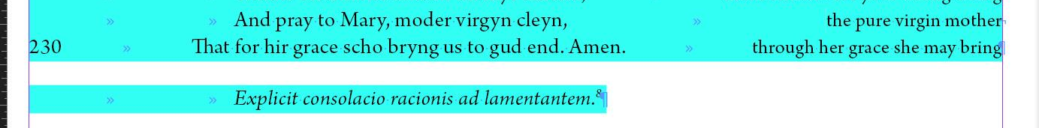

Stage Directions, Scene Locations, and Speakers
- Stage Directions receive the Stage Directions Paragraph Style.
  - Stage Directions should be flush with left margin. Make sure there is an end of paragraph symbol at the end of each stage direction, then clear the override.
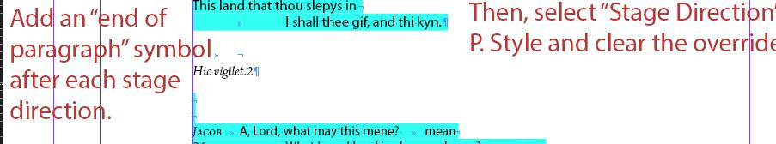
  - If there are any glosses for words or phrases in a Stage Direction, each gloss should be in its own individual footnote, with a footnote number placed immediately following the original language word or phrase being glossed. If this has not already been done, then insert a footnote by the appropriate word and add the gloss to the footnote.
    - To add a footnote in InDesign, go to menu Type > Insert Footnote. Then copy the gloss into this newly made footnote.
- Scene Locations receive the Scene Location Paragraph Style.
  - There should be one tab inserted before any text so the scene location is in line with the rest of the text. Make sure there is an end of paragraph symbol at the end of each stage direction, then clear the override.
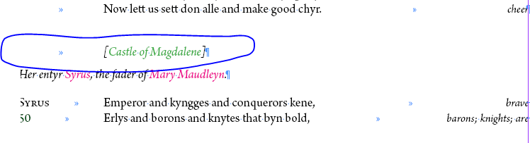
  - If there are any glosses for words or phrases in a Scene Location, each gloss should be in its own individual footnote, with a footnote number placed immediately following the original language word or phrase being glossed. If this has not already been done, then insert a footnote by the appropriate word and add the gloss to the footnote.
    - To add a footnote in InDesign, go to menu Type > Insert Footnote. Then copy the gloss into this newly made footnote.
- Speakers receive the Speaker Character Style.
  - Select the entire phrase, including brackets if present, and apply the Speaker Character Style. This applies Small Caps to the Speaker name. (In the example below, you can see the Speaker Character Style has been applied because the override has been removed from the names Jacob and God.)
  - Speakers should always be flush with the left margin. There should be a tab between the Speaker and the beginning of the line of text.
  - If the speaker also requires the tag Person Name: in such cases, apply Speaker Person Name or Speaker Person Name Latin (see the Style Reference for further instructions).
  - If the speaker also requires the Latin tag apply Speaker Latin (see the Style Reference for further instructions).
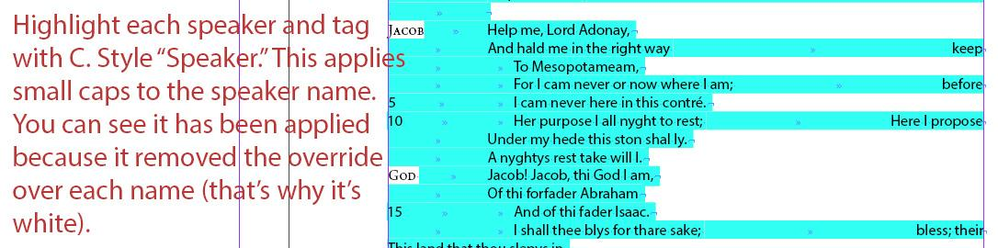

Internal Headings
Finally, look for Headings within the Text.
- These may be Chapters or Acts. Make sure there is an end of paragraph symbol at the end of the stanza before the heading and at the end of the heading itself.
  - Then, apply Heading Paragraph Style to all Chapter headings or Act headings within texts; this applies small caps, as well as the appropriate spacing around the heading.
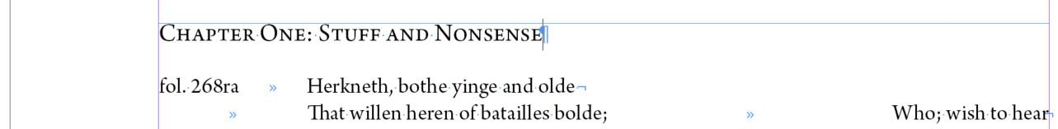
- These may be Stanza Numbers. Make sure there is an end of paragraph symbol at the end of the stanza before the heading and at the end of the heading itself. Stanza numbers should be in numerical form with one tab before them.
  - Apply Stanza Number Paragraph Style. This applies the correct spacing between the stanzas and the heading.
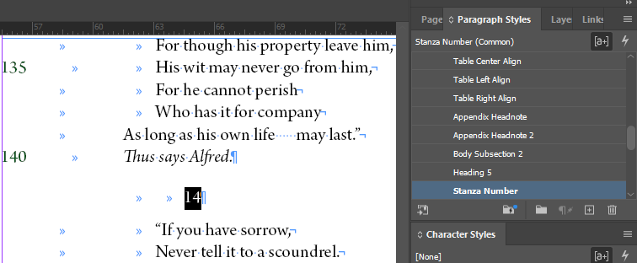
- These may be Fitts numbers. Make sure there is an end of paragraph symbol at the end of the stanza before the heading and at the end of the heading itself. Fitt numbers should be in numerical form with two tabs before them.
  - Apply Fitt Number Paragraph Style. This applies the correct spacing between the stanzas and the heading.
- These may be smaller Stanza headings that include speaker information. These headings don’t need additional padded space around them, but they do need to be marked as distinct from the text for the digital edition.
  - Apply Heading 5 Paragraph Style.
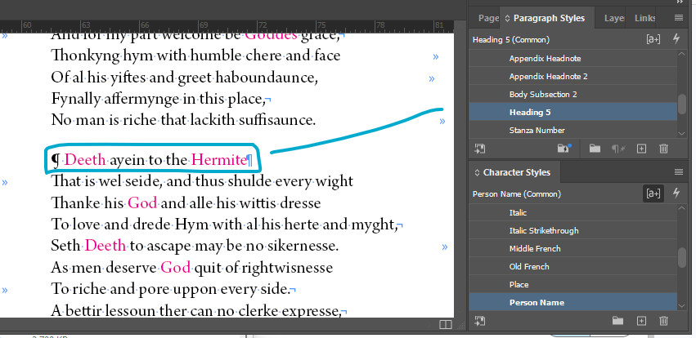

Adding formatting back into the Text
Once those Paragraph Styles have been fixed, move on to applying some initial formatting Character Styles to each stanza (not footnotes or glosses; those come later). For each stanza, move through the bullet points below before moving on to the next stanza:
- Language tags (see Style Reference, section Character Styles – Languages, for full list, especially for French)
- Title (this is very rare).
- Any other formatting that is covered by pure formatting tags with no semantic meaning (see the section Character Styles – Formatting Only in the Style Reference)
- Caesura (see Formatting Reference, section Caesura, for full instructions)
- Check em-dashes (between clauses) and en-dashes (between number ranges) for correctness (see Formatting Reference, sections Em-dash and En-dash, for full instructions)
- Clear overrides. Refer to the Formatting Reference (section Overrides) for additional information about overrides.
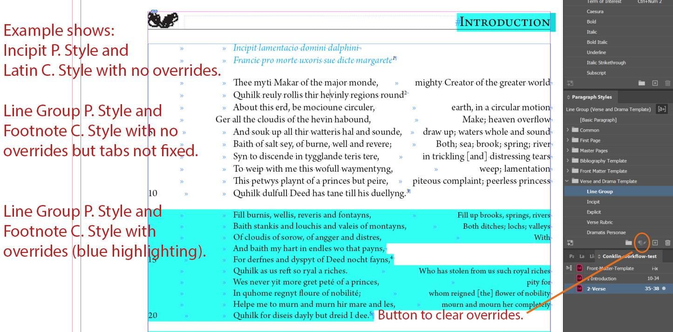

Alignment Corrections
Check for alignment issues in your stanza. If your lines still look weird it is likely because there are too many or too few tabs OR because the forced line break is in a weird place. Either of these issues can create strange spacing or split a single line across multiple lines. Work line-by-line, doing the following:
- First, make sure line numbers, folio numbers, and Speakers are flush with the left margin. You may have to delete a tab. This usually fixes the major issues in a line, so you may be able to skip the next two steps.
- Typically, there should be a single tab between the folio number / line number / Speaker and the start of the line of verse. There should also be a single tab at the start of each line of verse.
  - It helps to have the original Word document open at this point. Drama often has indentations that the editor has included to indicate that one line of text is split across dialogue between multiple speakers.
  - If your text has additional indentations, refer to the Indentations section in the Formatting Reference
  - If the text follows our standard indentation, you may need to delete or add tabs to fix the alignment.
- Glosses align right and should be flush with the right margin. You may need to delete or add tabs between the end of a line and the gloss to align the gloss properly. Use as few tabs as possible to ensure correct alignment.
- Delete any extra spaces that have been added in around line numbers, at the end of a line, before a gloss begins, or after the glosses end. We only want tabs in between line numbers, the text, and the glosses.
Ex. A sample of verse text that is partially formatted.
- The tabs to the left of both the incipit and the first stanza have been corrected. The text follows standard indentation for all verse, so there should be a single tab at the beginning of every line.
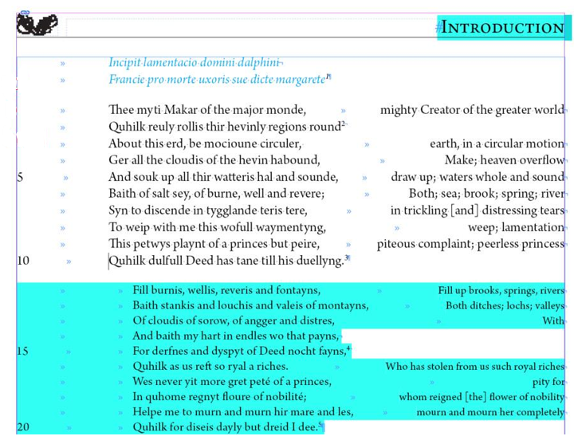
- Check to make sure that the forced line break symbol appears after the last word on each line. This will either be the end of a line of verse or the end of a gloss. If a tab appears between the last word and the forced line break, delete it. Otherwise, it can mess up the formatting.
- As you complete each stanza, check it against the original before moving on to the next stanza and repeating the steps above.
See below for an example of two stanzas that have all the initial styling and alignment applied.
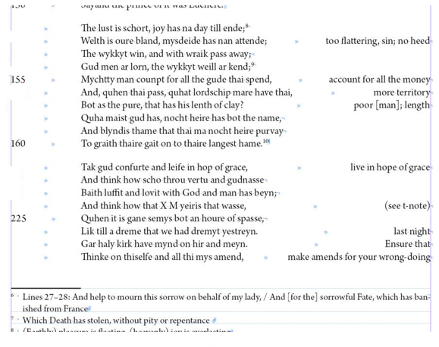
After completing initial formatting of all stanzas, move on to Tagging, First Steps.

Tagging Texts, First Steps

This round requires great attention to detail. This is why it is its own step.

Round One: Line Numbers and Foliation
- Tag Line Numbers and Foliation [fol. 6r]
  - Foliation: Select the entire phrase, including brackets, and apply the Foliation Character Style.
  - Line Numbers: Select the line numbers and apply the Line Number Character Style.
  - Be sure you are only selecting the numbers/phrase in question. Be careful you don’t accidentally apply these character styles to the line break from the previous line or the tab that follows them.
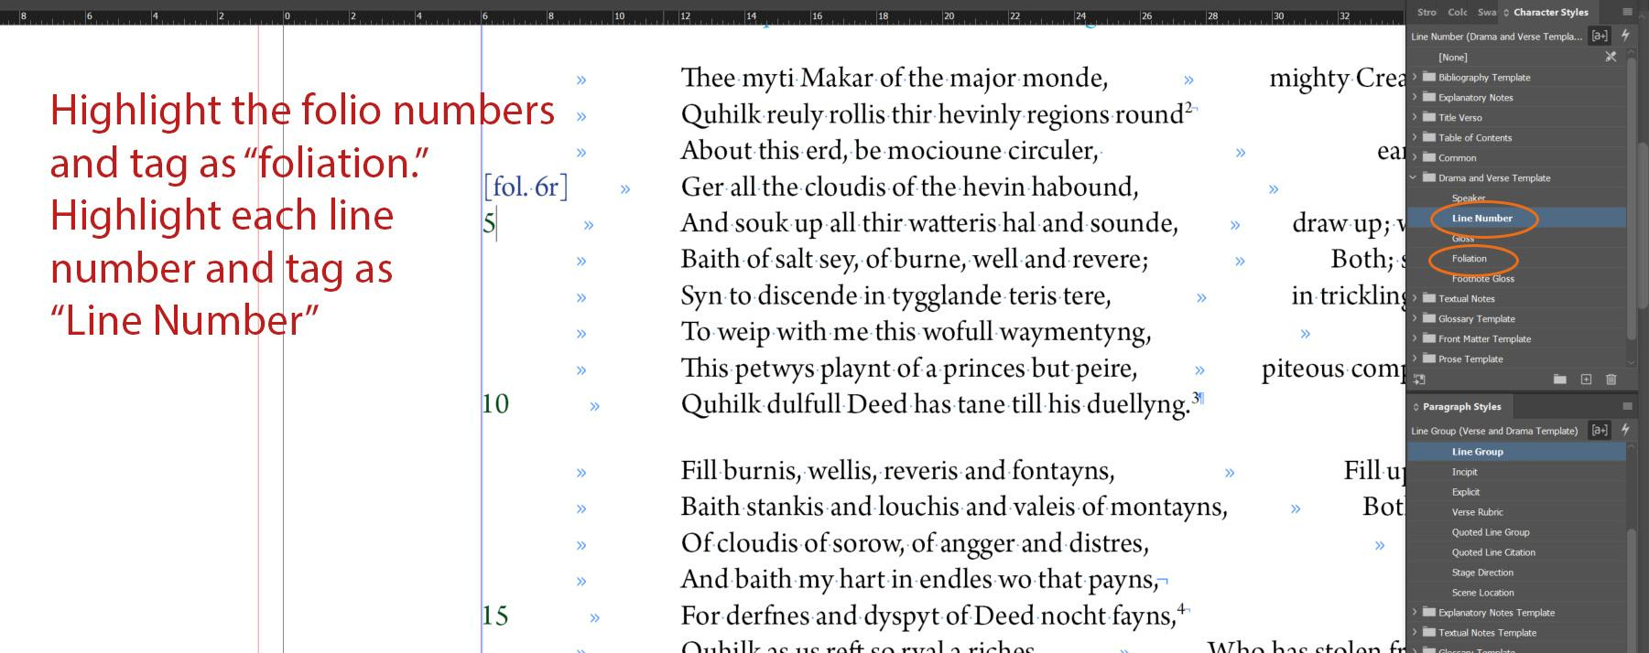
  - It is possible that Foliation will coincide with Speaker Name, and in that case Speaker Name takes precedence. If this occurs, the folio number may be included along the right margin with the Glosses. Style the foliation on an unnumbered line above the Speaker Name.
    - If there is a Scene Location above the Speaker name, add the foliation in the left margin of the Speaker Name.
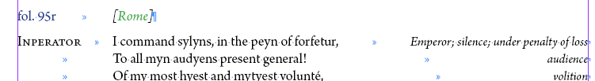
    - Otherwise, add a line above the relevant Speaker name and style it with the Heading 5 Paragraph Style.
    - Add the foliation in and apply the Foliation Character Style.
    - Delete the foliation information and any extra semi-colons and spaces from the Glosses.
Before:
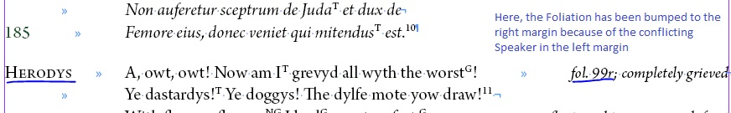

After:
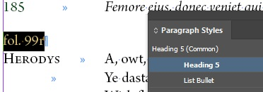

    - Exception: stanzas that are preserved as a unit with speaker changes. In Print, we keep the Foliation with the Glosses. In Export, we will insert the Foliation on a blank unnumbered line and styled Heading 5 paragraph style.
  - It is possible foliation will coincide with Stage Directions as well. In these cases, we will also want to put the foliation on an unnumbered line above the Stage Directions.
    - Add a line above the relevant Stage Directions and style it with the Heading 5 Paragraph Style.
    - Add the foliation in and apply the Foliation Character Style.
    - Delete the foliation information and any extra spaces from the left margin next to the Stage Directions.
Before:
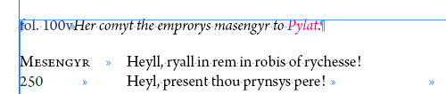
After:
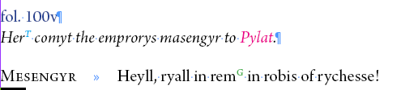

Round Two: Glosses
- Select the entire gloss phrase, including all punctuation and any (see note) phrases, and apply the Gloss Character Style.
  - This action will apply italic styling to the phrase and set it in a smaller font.
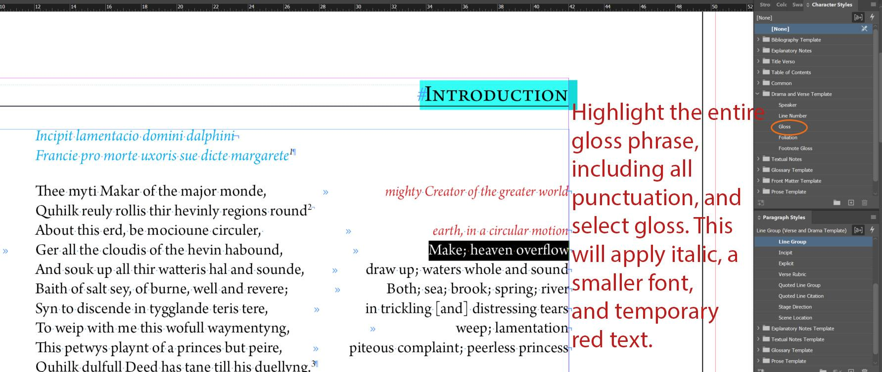

Round Three: Footnote Glosses
- Check that the spacing between the Reference number in the Footnote and the text of the footnote itself is correct.
  - We want this spacing to be only one tab. When Word documents are imported, however, this spacing is usually a tab and a space. We’ll want to fix this using the Find/Change menu.
  - Refer to the guidelines in the Formatting Reference (section Footnotes spacing).
- Apply the Footnote Gloss Character Style to any information that is providing direct elucidation of the original language phrase in question. This includes:
  - Any direct translations provided by the editor
  - Any language designations that indicate whether a word comes from a particular language like Latin or Old French
  - Scripture references if the line being glossed is a paraphrase or a restatement of a particular Bible verse.
    - These may be applied on a case-by-case basis evaluation to see if the reference is helping explain the gloss or if the editor is providing extra explanatory note context in the footnote.
- We do not apply Footnote Gloss Character Style to the following:
  - Line ranges indicating which lines are being translated
  - See note or See t-note phrases that follow any glosses
- See below for an example of footnotes formatting in progress.
  - Footnotes 1-4 have been correctly tagged with the Footnote Gloss Character Style.
  - Note that in Footnote 4, the line range has not been tagged. This is correct.
  - Footnote 5 has not yet been tagged.

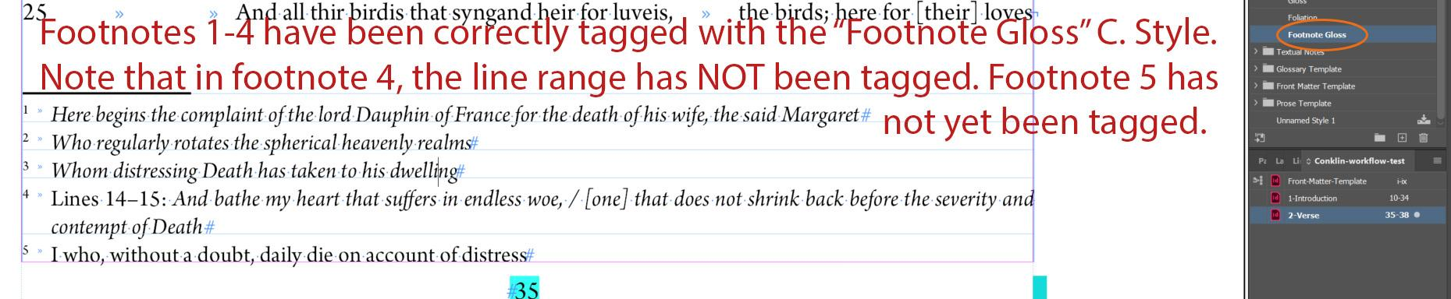
- Refer to the Formatting Reference (sections Em-dash and En-dash) as needed for application of em- and en-dashes.
- Clear overrides. Refer to the Formatting Reference (clear Overrides) for additional information about overrides.
Sample of Short Stanza at the end of this stage / prior to semantic tagging
- The first line of verse begins at the top of the text box, indicated by the blue line.
- Folio numbers and line numbers align with the left margin.
- Folio numbers have been tagged with the Foliation Character Style.
- Line numbers have been tagged with the Line Number Character Style.
- There is a single tab at the start of each line of verse, including between the folio numbers / line numbers and the text of the line.
  - This is the standard indentation for all verse, but a text may require additional indentation.
- Glosses align right and forced line breaks appear at the end of the glossed phrase or at the end of the unglossed line.
- The opening Incipit has the Incipit Paragraph Style and Latin Character Style applied. There is a single end of paragraph symbol after the incipit.
- The text has the Line Group Paragraph Style applied. There is a single end of paragraph symbol after each stanza.
- The entire gloss phrase has had the Gloss Character Style applied to it, including any semi-colons between individual glosses in the gloss phrase.
- Footnotes have the Footnote Paragraph Style applied.
- The Footnote Gloss Character Style has been applied to the appropriate phrase.
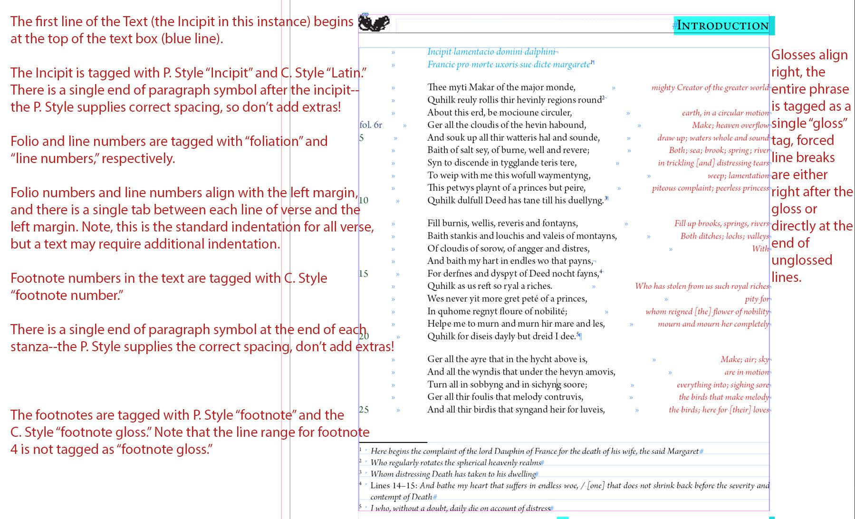

Final Basic Formatting Check

Double check that no extra spaces have been added before and/or after tabs, as well as extra spaces between forced line breaks and end of paragraph marks. It is recommended that you use the Find / Change function to check for any instances of extra spaces before and/or after tabs as well as extra spaces before forced line breaks and end of paragraph marks.
- Enter the hidden character you are searching for (tab, forced line break, or end of paragraph mark) into the initial Find and Change fields by clicking the @ symbol to the right of them and selecting the appropriate character.
- Add a space before or after the hidden character, as needed for your search parameters.
- Begin by clicking “Find.”
  - If no search results appear, then there aren’t any instances and you can move on to the next check.
  - If there are search results, then go ahead and fix these, either manually or using the Change fields. In most cases, the extra space character should be deleted, so you can fill in the Change field with only the hidden character and click Change All.
- N.B.: Use the Find / Change function very carefully. This function is very robust and can be very precise, but making any global changes of this nature can have unintended ramifications.
Also check that character styles have not been applied to any hidden characters like tabs, forced line breaks, or end of paragraph marks. It is recommended you use the Find / Change function for this task.
- Enter the hidden character you are searching for (tab, forced line break, or end of paragraph mark) into the initial Find field by clicking the @ symbol to the right of them and selecting the appropriate character.
- Enter the Character Style you want to check for in the Find Format field. Clicking into the field will open a Find Format Settings window, where you can select the appropriate Character Style. Then click Ok.
  - It is recommended to check the following Character Styles:
    - Line Number
    - Gloss
    - Footnote Number
    - Italic
    - Latin
    - Middle French / Old French
- Begin by clicking “Find.”
  - If no search results appear, then there aren’t any instances and you can move on to the next check.
- If there are search results, then we will want to fix them, either manually or globally using the Change fields.
  - If you use the Change fields, you will need to set them carefully. The Change What field should be the hidden character, entered the same way as before. The Change Format field should be set to [None]. Then, click Change All.
- N.B.: Use the Find / Change function very carefully. This function is very robust and can be very precise, but making any global changes of this nature can have unintended ramifications.
Move on to Semantic Tagging

Semantic Tagging

This step is much more time-consuming and requires that you read the text for meaning. Do not use Ctrl+F for this work; see the Formatting Reference (section Don’t use Ctrl+F to tag repeated names or places!) for more information if you have questions.
We complete semantic tagging for any files we consider a main Text within an edition. We do not apply semantic tags in Appendix files, even if Appendix files have been edited for this edition and/or come with their own set of Textual Notes.

Tag only the text, not the glosses or footnotes.
Make sure to tag all parts of the Text – including Cast List, Rubrics, Incipits, Explicits, Stage Directions, Scene Locations, etc. – if they are in the original language. If these appear in Modern English, check the Introduction or the Textual Notes to make sure that they are editorial interventions and do not tag.
For this round, tag using the following Character Styles:
- Animal Name
- Person Name
- Place
- Date

Keep Reference documents open while tagging.
The Style Reference document is where we have defined when and where we apply these Character Styles. It also contains examples of what to tag and what not to tag.
- There are section headings for each of the following tags:
  - Animal Name
  - Date
  - Person Name
  - Place
It also helps to refer to the Explanatory Notes files for the edition you are working on. In these notes, the editor(s) often give more context about important people, places, or dates mentioned by the text; if you are unsure whether a phrase is a Person Name or a Place name, check these Explanatory Notes to see what commentary the editor has included.

Record any questions you have as queries in Asana.
Semantic tagging is interpretative work, and Middle English can be tricky. It’s normal to have questions about what is happening in a text and whether a particular word should be tagged (especially when it comes to questions of heaven and hell). Do the best you can, and also record the questions that you have as subtasks nested under the relevant formatting task in Asana. For full guidelines on how to record queries in Asana, see the Queries in Asana documentation.

Nested Tagging
You may run into issues with nested tagging, where you need to apply more than one Character Style to the same bit of text (i.e., when the text inserts a Middle French phrase that also contains a person name). It’s not possible to apply more than one Character Style at a time in InDesign, so we need to document any instances in the edition’s oXygen Interventions spreadsheet.
- Refer to the Formatting Reference (section Nested Tagging) for more instances of nested tagging.
- For how to fill in the oXygen Interventions spreadsheet, go to the Best Practices – oXygen Interventions documentation.
- Of note for Drama in particular: Keep an eye out for when Speakers are referred to with proper names; these will need both Speaker and Person Name applied. The Speaker Character Style takes priority here, so any instances of Person Name will need to be included in the oXygen Interventions spreadsheet.

Final Pagination Adjustment before Moving on to the next Text

First, make sure that the hashtag that indicates the end of the text appears after the final punctuation on the page. Pagination should be more or less set before you move onto a new document. See the Completing a Text Frame section and the Document Pagination section of the Formatting Reference for more details.

