Read the entire instructions before you try to follow them. Knowing where you are going will help.
It helps to have the Formatting Reference and the Style Reference documentation as you move through this workflow.
First, Show Hidden Characters (ctrl+alt+i) and the Highlight Override feature ([a] at the top of the Paragraph Style menu). Don’t do anything before turning these on.

Initial Styling and Alignment

This is one example of what the text may look like on import:
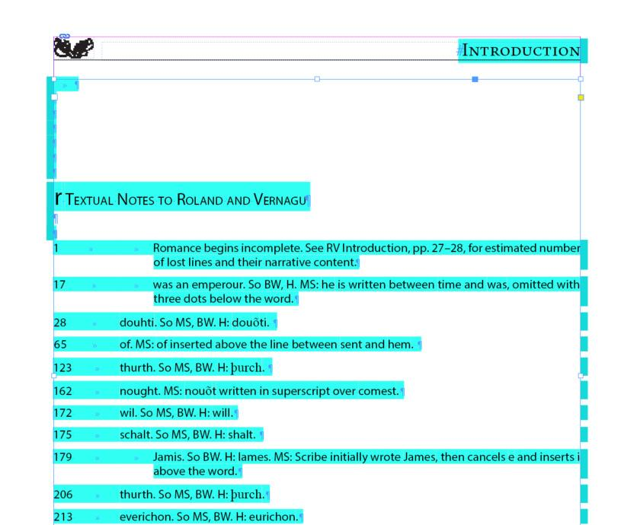
First, delete the heading and the extra end of paragraph symbols at the start of the document. Note that the text begins at the very top of the text frame.
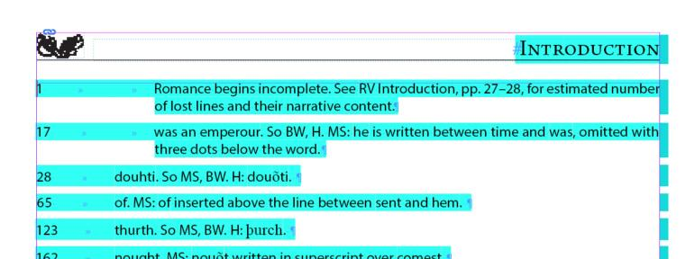
Work from the start of the document to the end, formatting as you go.

Headnotes
Headnotes include one or more paragraphs of further contextual explanation that occur before the Textual Notes for a Text begin in the Textual Notes document. They may occur at the very start of the Textual Notes document or following headings at various points in an Textual Notes document; it can vary from edition to edition.
- If there is additional formatting in Headnotes, use the formatting that has been imported.
  - Refer to the section Character Styles – Formatting Only in the Style Reference for the full list of Character Styles to use for formatting. If, for instance, the phrase is italic, highlight the entire phrase and then apply the Italic Character Style.
  - Language tags, only Arabic and Hebrew, in order to remove overrides (see Style Reference, section Character Styles – Languages, as needed)
  - Check em-dashes (between clauses) and en-dashes (between number ranges) for correctness (see Formatting Reference, sections Em-dash and En-dash, for full instructions)
  - Middle English characters (see Formatting Reference, section Middle English Characters)
  - Ellipses (see Formatting Reference, section Ellipses)
  - Backslash between lines: if there are quoted verse lines within a paragraph separated by a backslash [/], make sure there is a space on either side of the backslash
- Apply Body First Paragraph Style to the first paragraph of a headnote.
- Apply Body Paragraph Style to any following standard paragraphs of a headnote.
- If there are more complicated headnotes that include lists of any kind, block quotes, etc., refer to the relevant sections in the Introduction instructions.

Headings
If the Textual Notes have multiple sections and headings, you will use either the Heading Paragraph Style or the Heading 4 Paragraph Style.
- Make sure there is an end of paragraph symbol at the end of the heading, then click into it.
- Select the appropriate Paragraph Style:
  - If the heading comes above a headnote, apply the Heading Paragraph Style.
  - If a headnote comes above the heading, apply the Heading 4 Paragraph Style.
  - If there are no headnotes around the heading, apply the Heading 4 Paragraph Style.
  - Textual Notes for Prose Texts use headings to indicate which paragraph number the notes refer to.
    - These headings should follow the format Book ##, [Prologue / Chapter / Prayer / Epilogue] ##, Paragraph ## (as applicable).
- Remove the override. Refer to the Formatting Reference (section Overrides) as needed for overrides.
See below an example of a Heading with the Heading Paragraph Style applied. There is a headnote beneath it that has not been formatted yet.
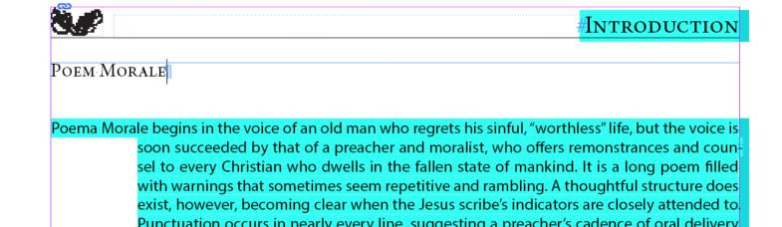

Format Textual Notes

Format each Textual Note fully before moving on to the next note.

Alignment Correction
As you move through the textual notes, first adjust the spacing between the left margin, any reference numbers, and the beginning of the text of the notes. Generally, this involves deleting any extra spaces and inserting 1 tab.
- Textual Notes for Verse and Drama Texts will have line numbers alongside the left margin. There should be no spaces between the left margin and the line number and only one tab between the line number and the beginning of the text of the note.
- Textual Notes for Prose Texts will not have line numbers alongside the left margin. There should be only one tab between the left margin and the beginning of the text of the note.
- There should not be any extra end of paragraph symbols between notes. Delete them as you find them.

Edit the Formatting of the Note
Next, format the content of the note using Character Styles.
- Catchphrases should always be italicized. Apply the Italic Character Style to the entire phrase.
- Catchphrases that include multiple complete lines will include a backslash [/] between lines. Make sure there is a space on either side of the backslash.
  - Ex. Textual / Note, not Textual/Note
- Ellipses (see Formatting Reference, section Ellipses)
- Subscripts that indicate which word instance is being cited should have Subscript Character Style applied.
- Middle English characters that don’t automatically display should be entered using the Glyphs Panel (see Formatting Reference, section Inserting Middle English Characters with Glyphs Panel)
- Refer to the Style Reference (section Character Styles – Formatting Only) for the full list of Character Styles to use for any other formatting. If, for instance, the phrase is italic, highlight the entire phrase and then apply the Italic Character Style.
- Language tags, only Arabic and Hebrew, in order to remove overrides (see Style Reference, section Character Styles – Language, as needed)
- Check em-dashes (between clauses) and en-dashes (between number ranges) for correctness (see Formatting Reference, sections Em-dash and En-dash, for full instructions)
Once all the formatting issues have been resolved, select the correct paragraph style for each explanatory note. Depending on how complicated a note is, you may be applying multiple paragraph styles; read the following instructions carefully to make sure you apply the correct paragraph styles.

Textual Notes: First Paragraph
- Click into each note and apply Textual Note Entry Paragraph Style to the first paragraph.
- Remove any remaining overrides. Refer to the Formatting Reference (section Overrides) as needed for overrides.
Sample of correctly formatted Textual Notes for a Verse Text:
Note the following in the example below:
- The first textual note begins at the top of the text frame, as indicated by the blue line along the top.
- Numbers align left with a single tab between the number and the start of the note.
- Catchphrases and variants have Italic Character Style applied to them.
- Any subscripts have Subscript Character Style applied.
- Any number ranges use an en-dash.
- These notes have the Textual Note Entry Paragraph Style applied.
- There are no extra end of paragraph symbols between notes; the whitespace is built into paragraph styles instead.
- All Middle English characters have been changed using the Glyphs panel, and there are no overrides.
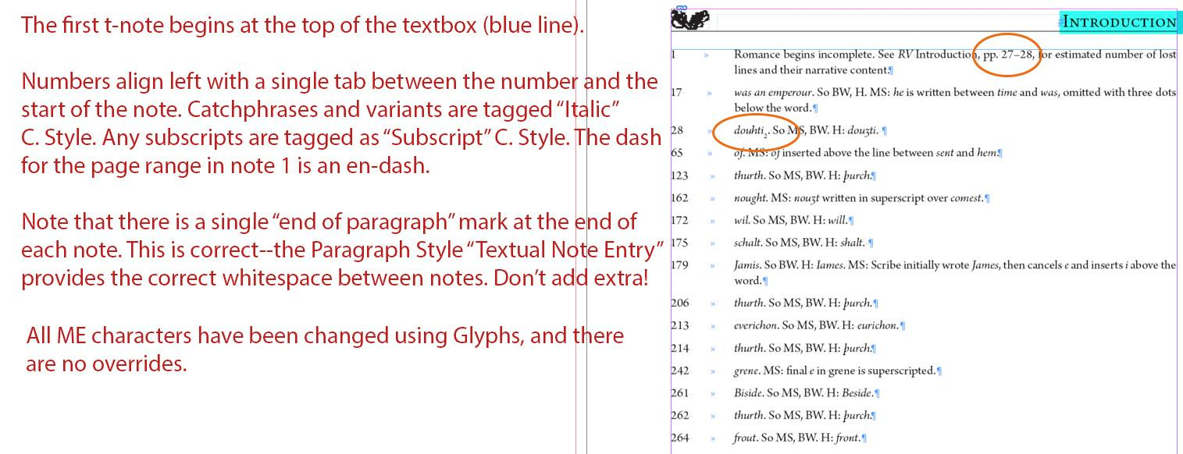
Sample of correctly formatted Textual Notes for a Prose text:
Note the following in the example below:
- The headings have Heading 4 Paragraph Style applied.
- There is a single tab between the left margin and the beginning of the note.
- The catchphrases are italicized using the Italic Character Style.
- Any phrases offset from a sentence use an em-dash.
- These notes have the Textual Note Entry Paragraph Style applied.
- There are no extra end of paragraph symbols between notes; the whitespace is built into paragraph styles instead.
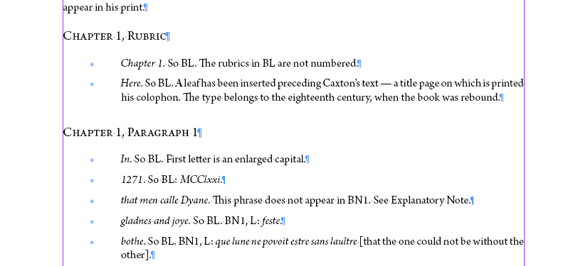

Following Indented Paragraphs
- If the note has a second (or more) paragraph, use the Textual Note Multi Paragraph Paragraph Style for any additional paragraphs that require indentations. Do not apply this style to any block quotes or any paragraphs after block quotes.
  - The Textual Note Multi Paragraph Paragraph Style has built-in indentation, so there shouldn’t be any additional tabs.
  - See below for an example.
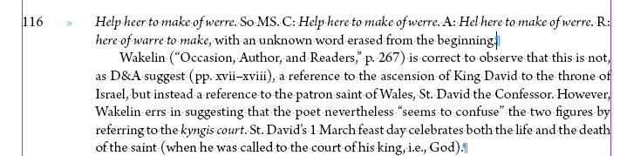

Prose Block Quote
- Use the Notes Block Quote Paragraph Style for all prose block quotes.
  - This paragraph style is found in the Explanatory Notes Template folder within the Paragraph Styles Panel. It is the same style that we use when styling block quotes of this type in Explanatory Notes files.
  - Note that any spacing and indentation is built into the Paragraph Style.
- See below for an example.
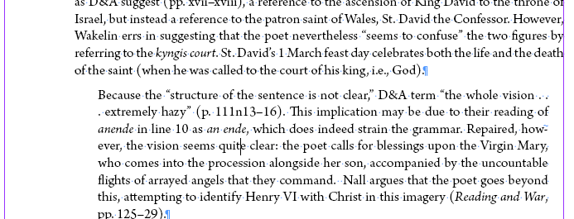

Verse Block Quote
- Use Notes Line Group Paragraph Style for all verse block quotations.
  - This paragraph style is found in the Explanatory Notes Template folder within the Paragraph Styles Panel. It is the same style that we use when styling block quotes of this type in Explanatory Notes files.
  - Note that any spacing and indentation is built into the Paragraph Style.
- If there are Glosses:
  - Make sure there is one tab between the line and the gloss phrase.
  - Highlight the entire glossed phrase and apply the Italic Character Style. We don’t apply Gloss Character Style in any apparatus files.
  - See example below: Five of the seven lines have had the Italic Character Style applied, with the final two lines still untagged.
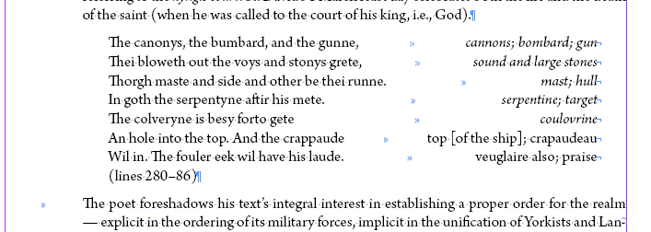
- Change the end of paragraph symbols within each stanza to a forced line break. You can do this one of two ways:
  - Keyboard: click into the end of the line, use the keyboard shortcut Shift+Enter, then delete the extra end of paragraph symbol.
  - Find / Change: Ctrl+F. Set Find to end of paragraph symbol (^p) and set Change to a forced line break (^n). Change each symbol individually by clicking Find Next, then clicking Change (not Change All).
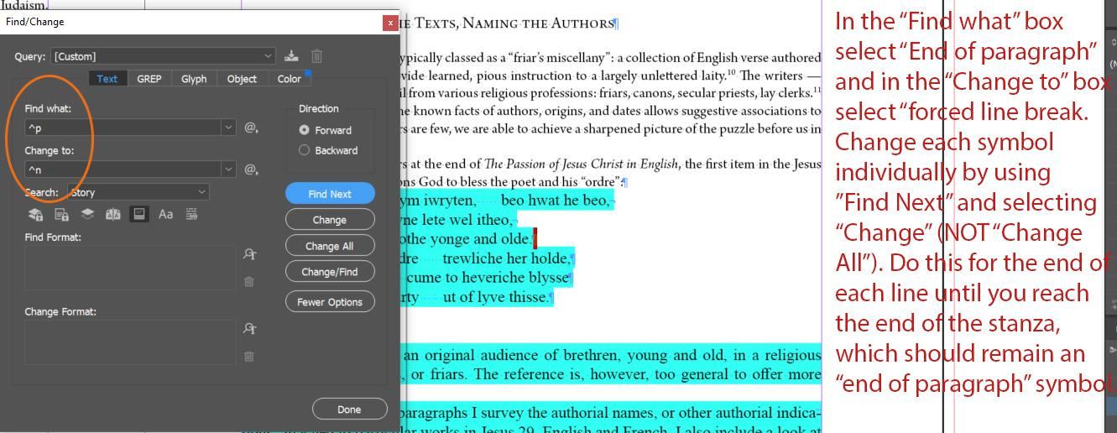
- Repeat for each line until you reach the end of the stanza.
  - There should be line number citation information that appears at the end of the quote.
- The final line of the stanza should have an end of paragraph symbol.
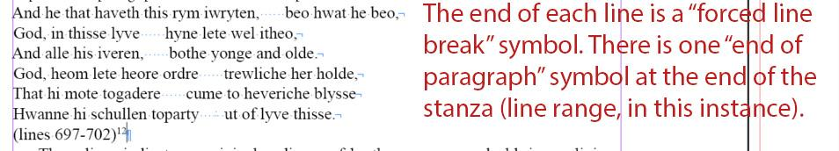

Verse Block Quote with Columns
- Columns are required for any block quotes that provide full line translations or show a comparison of lines between two different witnesses.
- Use Notes Line Group Columns-Print Paragraph Style for all verse block quotations that require columns.
- It is important to note: This Paragraph Style mimics the look of columns, but it does not apply the columns setting to the text. Instead, we use tabs to make columns.
- Make sure there is a tab between the text that should be “in the left column” and the text “in the right column”
- See below an example:
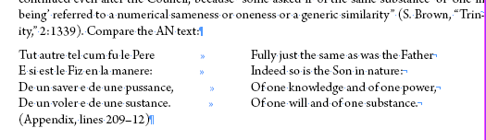
- Change the end of paragraph symbols within each stanza to a forced line break. You can do this one of two ways:
  - Keyboard: click into the end of the line, use the keyboard shortcut Shift+Enter, then delete the extra end of paragraph symbol.
  - Find / Change: Ctrl+F. Set Find to end of paragraph symbol (^p) and set Change to a forced line break (^n). Change each symbol individually by clicking Find Next, then clicking Change (not Change All).
- Repeat for each line until you reach the end of the stanza.
  - There should be line number citation information that appears at the end of the quote.
- The final line of the stanza should have an end of paragraph symbol.
In some cases, the lines are too long for the space we have available to us on the page. We’ll have to do some adjusting here by placing the words that need to be wrapped on their own line, separated by a forced line break.
- You can tell the left column line needs to be wrapped to the next line when the text starts pushing the corresponding line in the right column further along the page.
- When the right column line needs to be wrapped, it will automatically wrap itself to the next line with no break.
- See below for an example where the last line needs to be wrapped for both columns.
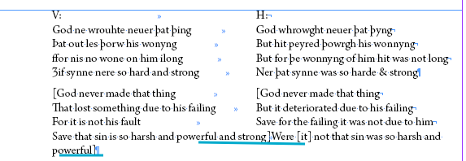
- When any column line needs to be wrapped, add another line to the block quote. Mak sure it has a forced line break at the end of it.
- Any text that has been wrapped from the left column line should be entered at the start of the line.
- Any text that has been wrapped from the right column line should have a tab in front of it, so it aligns with the right column.
- See below for a correctly formatted example:

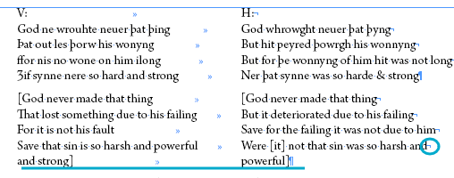
- If the left column line needs wrapped text but the right column does not, there should be text in the left column and blank space in the right column.
  - And vice versa if the right column needs wrapped text but the left column does not.
  - See below for a correctly formatted example:
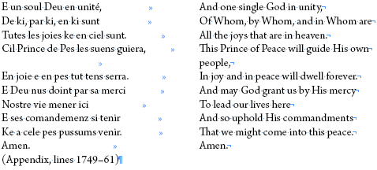

At this point, note in the oXygen Interventions spreadsheet, Sheet 3: Additional Changes to TEI, if there are any block quotes with columns. Note their location and if there are stanzas in the columns.

Paragraphs After Quotations
- If there is a paragraph after a block quote, either prose or verse, apply the Textual Note After Quote Paragraph Style.
- Add one tab between the margin and the start of the paragraph in order to align it correctly.
- See example below: the paragraph after the verse block quote is indented from the left margin, but it doesn’t have any further indentations to the paragraph.
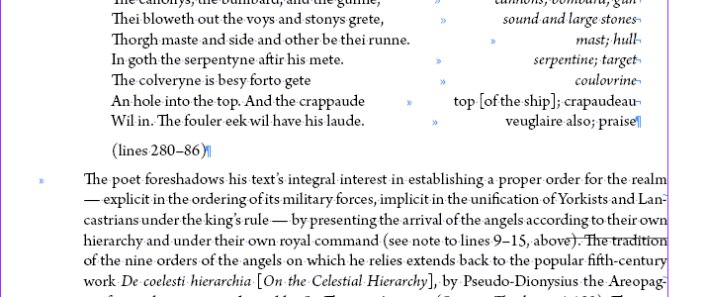

After Notes
After the final paragraph of the explanatory note, if you haven’t already, adjust the spacing between it and the next note
- Make sure there is only one end of paragraph symbol at the end of each note and no extra hard returns between notes.

Final Pagination Adjustment before Moving on to the next Document

First, make sure that the hashtag that indicates the end of the text appears after the final punctuation on the page. Pagination should be more or less set before you move onto a new document. See the Completing a Text Frame section and the Document Pagination section of the Formatting Reference for more details.

