Read the entire instructions before you try to follow them. Knowing where you are going will help.
It helps to have the Formatting Reference and the Style Reference documentation as you move through this workflow.
First, Show Hidden Characters (ctrl+alt+i) and the Highlight Override feature ([a] at the top of the Paragraph Style menu). Don’t do anything before turning these on.

Initial Styling and Alignment

This is one example of what the text may look like on import:
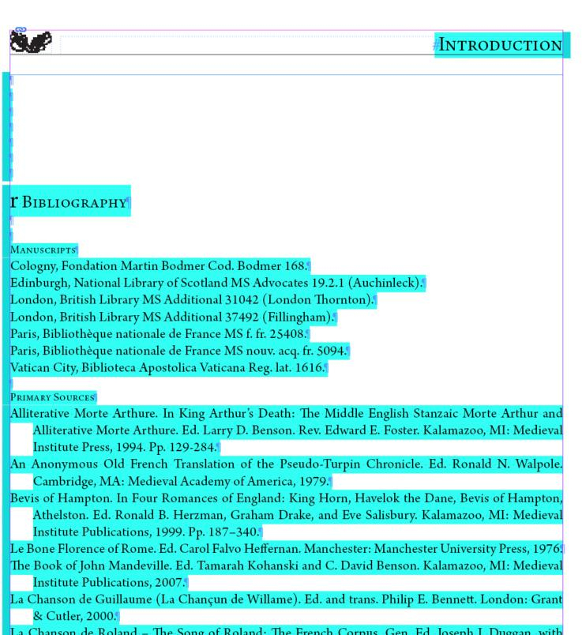
First, delete the heading (r Bibliography) and any extra end of paragraph symbols at the start of the document. Note that the text begins at the very top of the text frame.
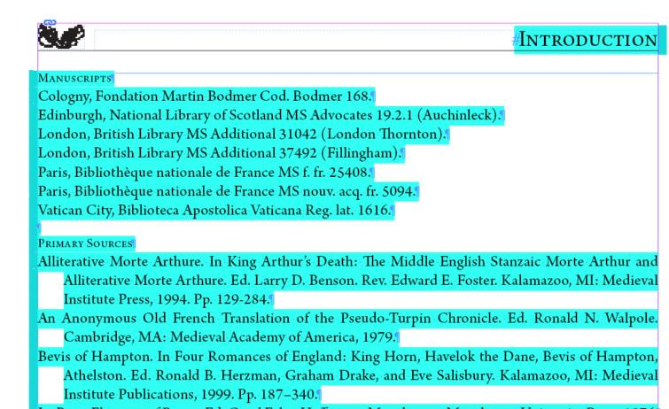

Headings
Fix the Headings first. A Bibliography should have three headings: Manuscripts, Primary Sources, and Secondary Sources.
- Make sure there is an “end of paragraph” symbol at the end of the heading and then click into it.
- Apply the Heading Paragraph Style.
- Remove the override. Refer to the Formatting Reference (section Override) as needed for overrides.
See below an example of Headings with the Heading Paragraph Style applied. There are several bibliography entries beneath them that have not been formatted yet.
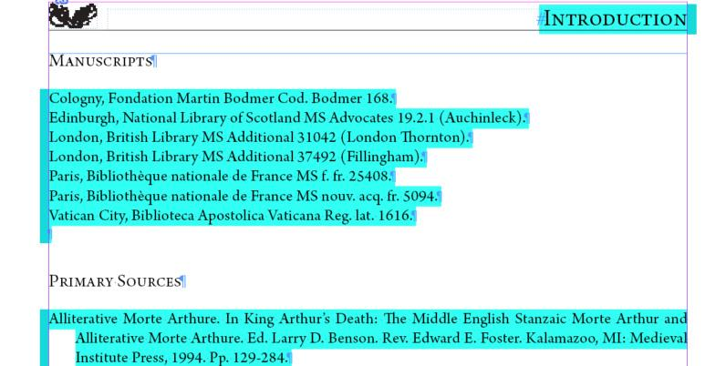

Format Bibliography Entries

Format each Bibliography Entry fully before moving onto the next one.

Alignment Correction
- All alignment information is built into the paragraph style you will apply. If there are any extra tabs or end of paragraph symbols integrated into a bibliography entry, delete them.

Edit the Formatting of the Entry
Next, format the content of the entry using Character Styles.
- Refer to the Style Reference (Character Styles – Formatting Only) for the full list of Character Styles to use for any other formatting. If, for instance, the phrase is italic, highlight the entire phrase and then apply the Italic Character Style.
- Check em-dashes (between clauses) and en-dashes (between number ranges) for correctness (see Formatting Reference, sections Em-dash and En-dash, for full instructions)
- See below for an example of an em-dash (first circle) vs an en-dash (second circle).
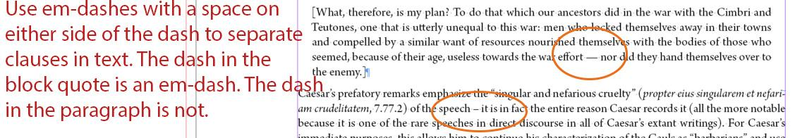
- See below for an example of an en-dash (first circle) vs a dash (second circle).
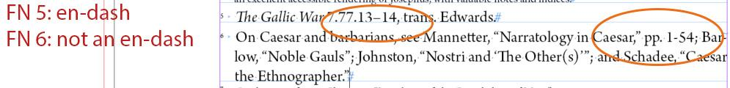
- Middle English characters (see Formatting Reference, section Middle English Characters)
- Ellipses (see Formatting Reference, section Ellipses)

Final Styling
- Apply the Bibliography Entry Paragraph Style to all entries.
- Delete any extra end of paragraph symbols between entries.
See below for an example of a correctly formatted page of a Bibliography. Note the following:
- The first heading begins at the top of the text frame.
- All headings have the Heading Paragraph Style applied.
- Each bibliography entry has the Bibliography Entry Paragraph Style applied.
- Titles are italicized by applying the Italic Character Style.
- Page ranges have en-dashes in them.
- There is a single end of paragraph symbol after each bibliography entry.
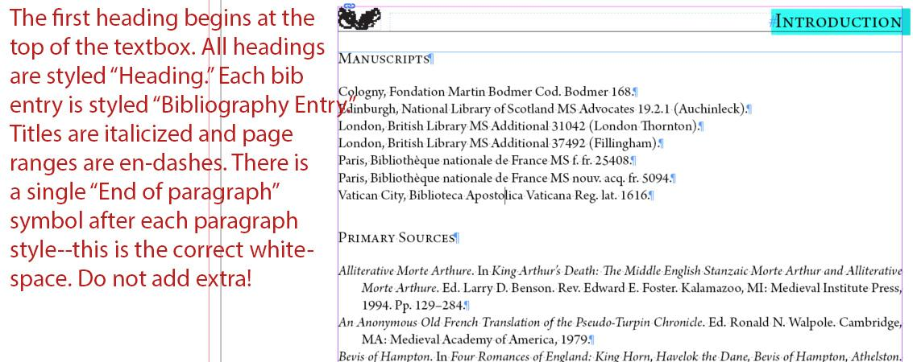

Long URLs
In rare cases, there will be long URLs that will be difficult for InDesign to handle. This is because we do not use automatic hyphenation in the Bibliography Entry Paragraph Style.
If the URL is too long to fit on the line it is on, InDesign will try to push the entirety of that URL to a line where it can display all together without hyphenation. If the URL is longer than around 108 characters, there will not be a place for the entire URL to display, which confuses InDesign. It pushes the URL, as well as anything after it, into the void of overset text, no matter how many pages you add and thread together.
Ex. The URL “https://venn.lib.cam.ac.uk/cgi-bin/search-2018.pl?sur=Dew&suro=c&fir=John&firo=w&cit=&cito=c&c=all&z=all&tex=&sye=1483&eye=1500&col=GonH&maxcount=50” is too long for InDesign to handle. When you first import the bibliography, it will look scary. See an example below:
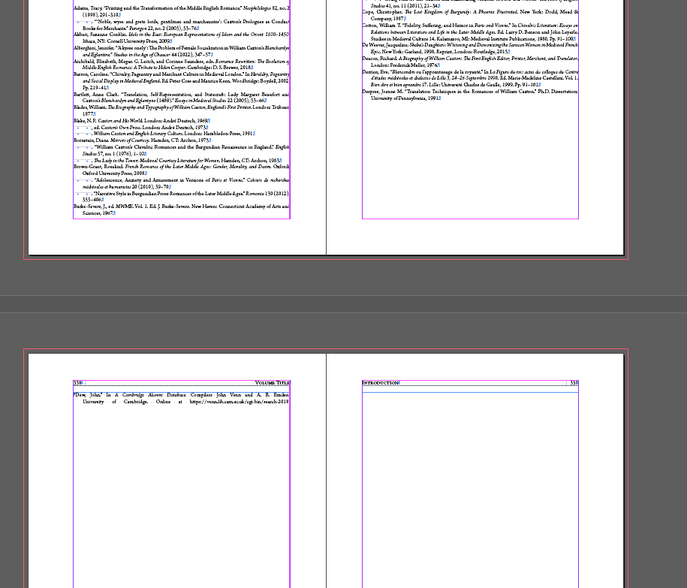
- To fix this, you will need to add a break in the URL to allow the text to wrap across lines.
- Add a space character after the last character you can see in the URL.
  - This should be around 108 characters into the URL.
- This should allow the URL to wrap properly and let the rest of the text flow onto the pages correctly.
- Make sure to note this in the oXygen Interventions spreadsheet; you will need to take out the extra space in the final TEI-XML file otherwise the link will not work as intended.

Final Pagination Adjustment before Moving on to the next Document

First, make sure that the hashtag that indicates the end of the text appears after the final punctuation on the page. Pagination should be more or less set before you move onto a new document. See the Completing a Text Frame section and the Document Pagination section of the Formatting Reference for more details.

