Read the entire instructions before you try to follow them. Knowing where you are going will help.
It helps to have the Formatting Reference and the Style Reference documentation as you move through this workflow.
First, Show Hidden Characters (ctrl+alt+i) and the Highlight Override feature ([a] at the top of the Paragraph Style menu). Don’t do anything before turning these on.

Abbreviations / Headnote

You will use predominantly one Paragraph Style in this section:
- The Body First Paragraph Style should be applied to the first paragraph that contains all the abbreviations.
- If there is any subsequent text in a separate paragraph beneath the abbreviations, apply Body Subsection Paragraph Style.
Character Styles will need to be applied according to these specific guidelines:
- The word “Abbreviations” should have the Small Caps Character Style.
- Any abbreviations for parts of speech, including end periods, should have the Bold Character Style. There should be a colon (:) separating the abbreviation from its spelled-out parts of speech. The separating colon has no Character Style applied.
- Any spelled-out parts of speech should remain Regular font; no Character Styles should be applied.
- The hidden character hashtag indicating the end of the text frame should appear immediately after the punctuation on the page. See the Formatting Reference, section Completing a Text Frame, for more details.
See below for an example of a correctly formatted Abbreviations headnote:
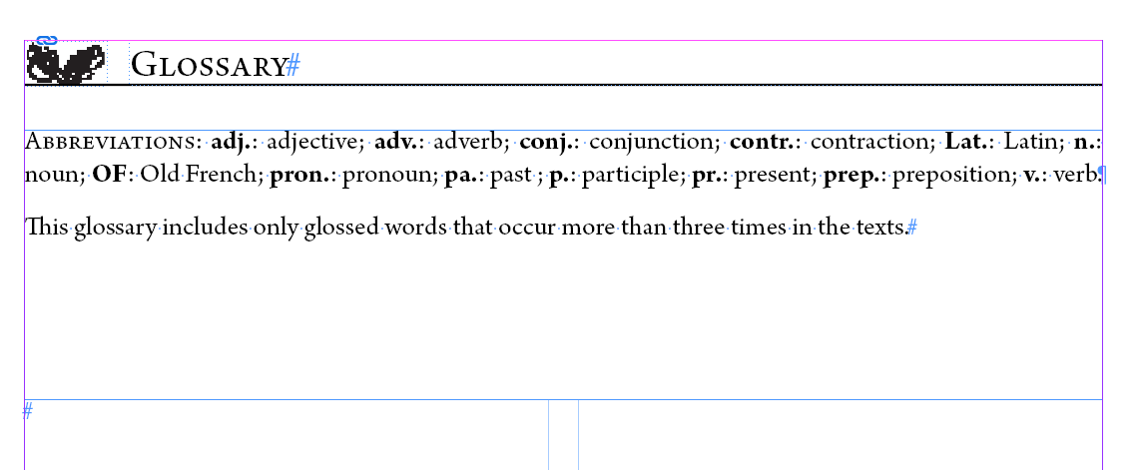
When you have finished styling any and all text that goes into the top text frame, we’ll want to get the spacing consistent.
- Right click the top text frame that contains the abbreviations > Fitting > Fit Frame to Content
  - This will snap the text frame borders to as close to the content as possible.

Glossary Entries

Adjust the sizing of the text frames.
- If the top of this text frame is no longer flush with the bottom of the text frame containing the Abbreviations, then click and drag the top edge of the frame so it is flush with the bottom edge of the text frame that contains the abbreviations
You will use two Paragraph Styles in this section:
- Each individual entry should have the Glossary Entry Paragraph Style applied.
- Entries are alphabetized.
- We add an ornamental division between alphabetical sections.
  - There should be an existing dash on its own line. If there isn’t, insert a dash (shift+-).
  - Apply the Ornamental Division Paragraph Style to the dash. This will create a prominent line division between the sections.
With the paragraph style applied, there should be no extra spaces between entries.
If you imported the document with most paragraph styles as Glossary Entry, then most should be tagged already; you just have to undo the overrides and reformat the text:
- Headwords are bolded – use Bold Character Style
- Definitions are italicized – use Italic Character Style
- Commas and semicolons separating variant headwords and different definitions should be in Regular font, not italic or bold.
  - Italicized commas are allowed if the entire phrase is a single gloss or definition rather than multiple, different definitions.
  - Ex: "Hezekiah, thirteenth king of Judah" is a single gloss, so the comma is italicized.
  - Ex: "chance, fortune" are 2 separate definitions for the headword so these are separated by non-italic (regular) commas
- The part of speech (v., n., adj., etc.) are Regular font and in parentheses
  - Do not add parts of speech to backlist volumes which do not already contain them.
- There are two spaces between the headword/part of speech (if present) and the definition
  - Ex.: wight (n) a person
  - Ex.: slee slay
- Cross-references at the end of definitions should be separated from the main definition by a semi-colon and the word ‘see’, followed by the headword with the Bold Character Style applied to it
  - Ex.: …; see biteche
- Middle English phrase variants should be bolded, with a tilde (~) in place of the headword in the phrase, followed by a comma in Regular font, then the definition for the phrase variant in italics
  - Ex.: force (n.) power, necessity; aggression; it is ~, it is necessary
See below for an example of correctly formatted glossary entries:
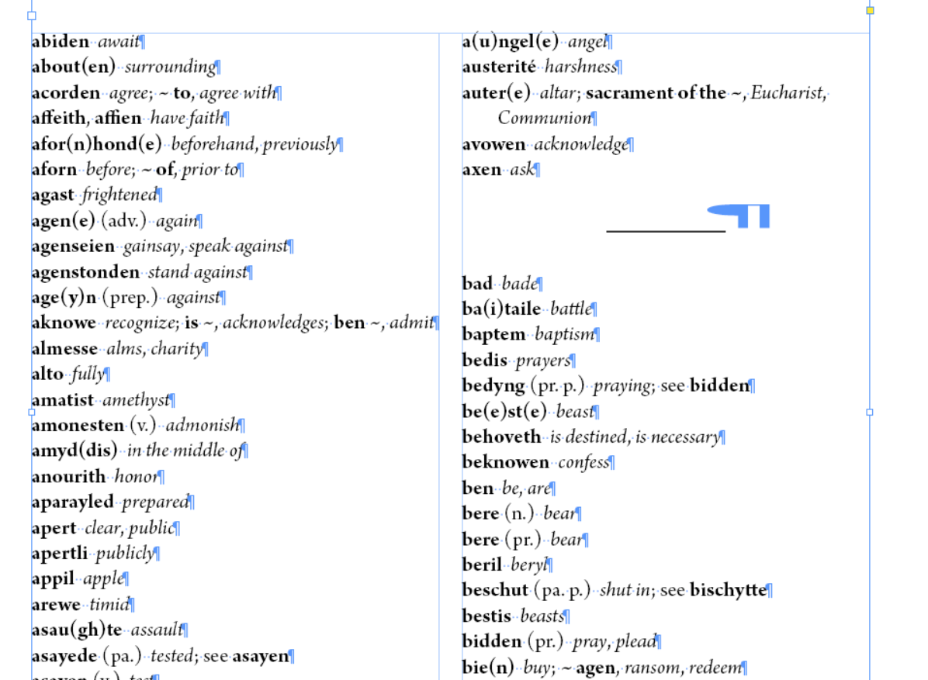

Final Pagination Adjustment before Moving on to the next Document

First, make sure that the hashtag that indicates the end of the text appears after the final punctuation on the page. Pagination should be more or less set before you move onto a new document. See the Completing a Text Frame section and the Document Pagination section of the Formatting Reference for more details.

