Style Separator saved as AutoText Entry Add-In
  - Charles Kenyon
This template can be saved in the Word Startup Folder and will add the Style Separator AutoText Entry and its keyboard shortcut in any Word document on the system.
The name of the entry is _sseparator.
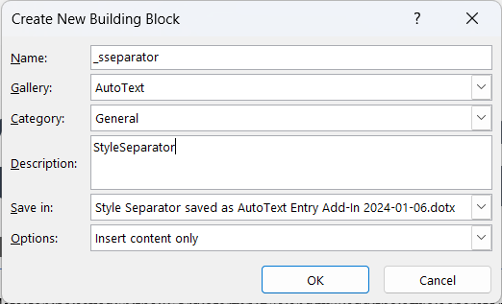
It has a keyboard shortcut assigned of Ctrl+Alt+Return. I have no idea what this will do on a Mac. This is the keyboard shortcut to insert a Style Separator in the Windows version already. Change it if you want, perhaps to Cmd+Opt+Return.
