Protocol

**Name: Metin Oktay Yilmaz**

**Course:**  Applied Signal Processing

**Matlab exercise:** e.g. 1

**Date: 28.03.2023**

## Task 1

Short summary of focus of the task.

Report on results and answers to questions stated in the task description.

1a) -1 < x < 0.875 for quantized values; -1.5 < x < 1.5 for original values

1b) Error for 4 bit quantization: 1.5 – 0.875 = 0.625;

Error for 5 bit quantization: 1.5 - 0.9375 = 0.5625

1c) Scaling factor = 0.67

1d) Error for 4 bit quantization: 1.005 – 0.875 = 0.13;

Error for 5 bit quantization: 1.005 - 0.6875 = 0.313

## Task 2

2a)

$H_{1}\left(z\right)=\left(0.9689z^{6}-0.1198z^{5}+0.9689z^{4}\right)/\left(z^{6}–1.188z^{5}+0.7129z^{4}\right)$

$$H_{2}\left(z\right)=(0.01226 z^{6} + 0.01718 z^{5} + 0.01226 z^{4}) /(z^{6} - 1.332 z^{5} + 0.5005 z^{4})$$

$$H_{3}\left(z\right)= ( z^{6}- 0.5911 z^{5}+ z^{4}){/(z}^{6}- 1.111 z^{5}+ 0.9147 z^{4})$$

$$G = {[ 0.6347 0.9689 0.0123 1.0000]}^{T}$$

2b) Following plot shows that the filter does not fulfill the requirement at 4 bit, therefore the word length has to be increased. Upon trial-error, 6 bit word length is found to be the shortest word length that meets the requirements.

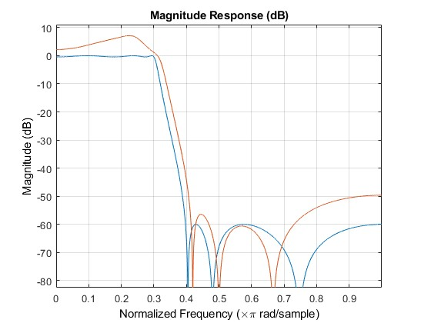

Figure 1: 4 bit word length filter response

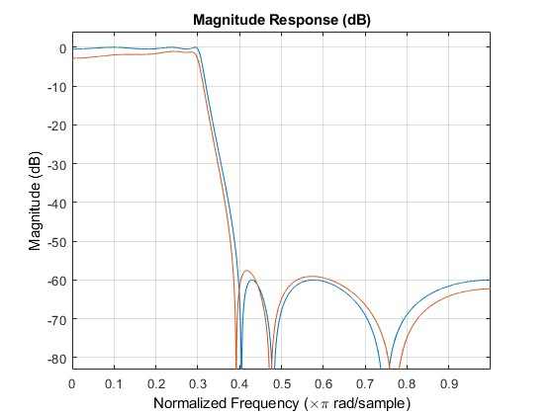

Figure 2: 6 bit word length filter response

2c) 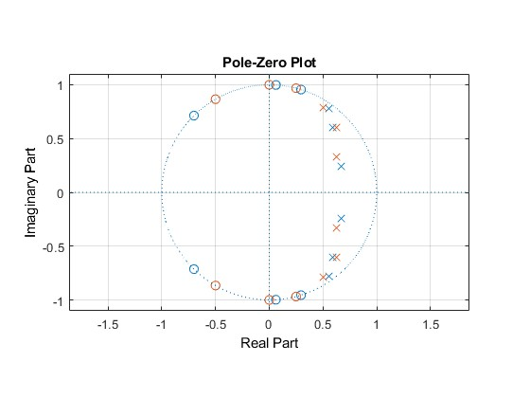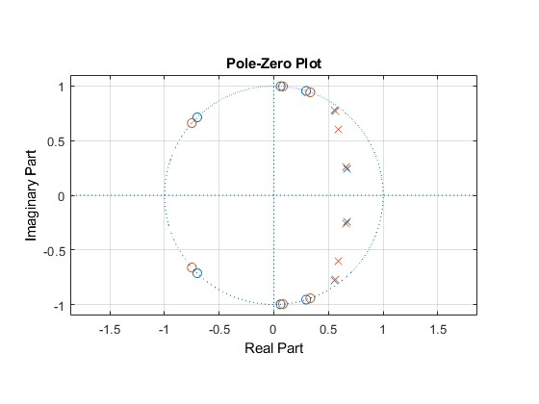

**NOTE for writing of protocol:**   
(delete this information in the protocol)

* Do not insert pages showing the content, the list of tables and list of figures!
* Do no repeat (copy) the task description.
* Produce a compact, but informative protocol.
* Do not upload your solution as rar- or zip-files!