Q1. Create a function to reverse a list in Python. Use an AI tool to suggest alternative implementations. Test and compare the performance of each version.
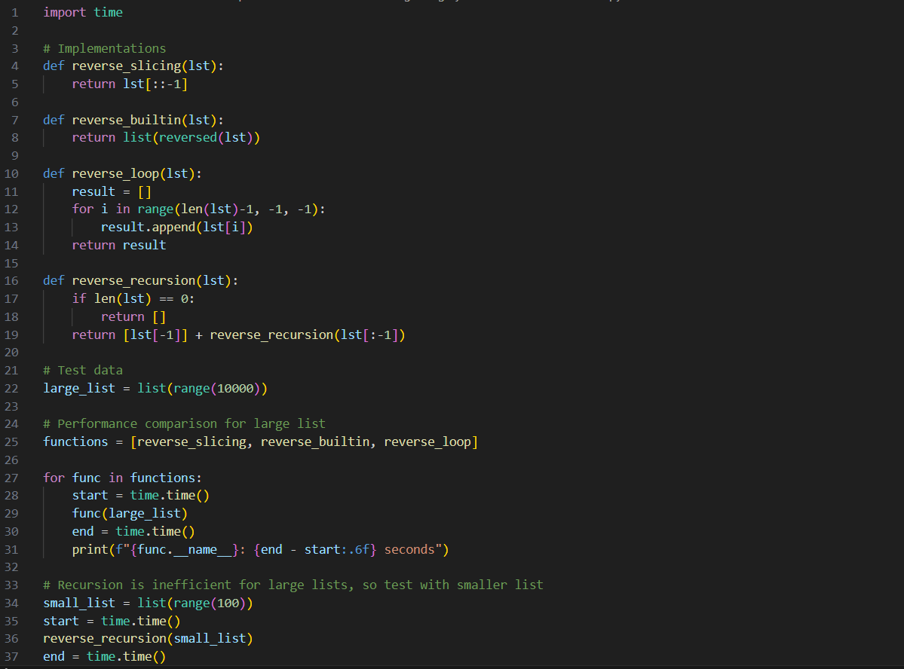

- Slicing: lst[::-1]
- Built-in reversed(): list(reversed(lst))
- Loop-based: Iterating backward and appending
- Recursion: Reversing by repeatedly calling the function on smaller slices
- Best choice: Use slicing (lst[::-1]) or list(reversed(lst)) for speed and readability.

- Loop method: Works fine but is slower and more verbose.
- Recursion: Not recommended for large lists due to inefficiency and Python’s recursion depth limit.
PRACTICAL OUTPUT: -
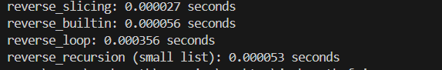

Q2. Design a few-shot prompt to guide an AI tool in writing code for a basic linked list with methods for insert and delete. Analyse the resulting code for correctness and completeness.
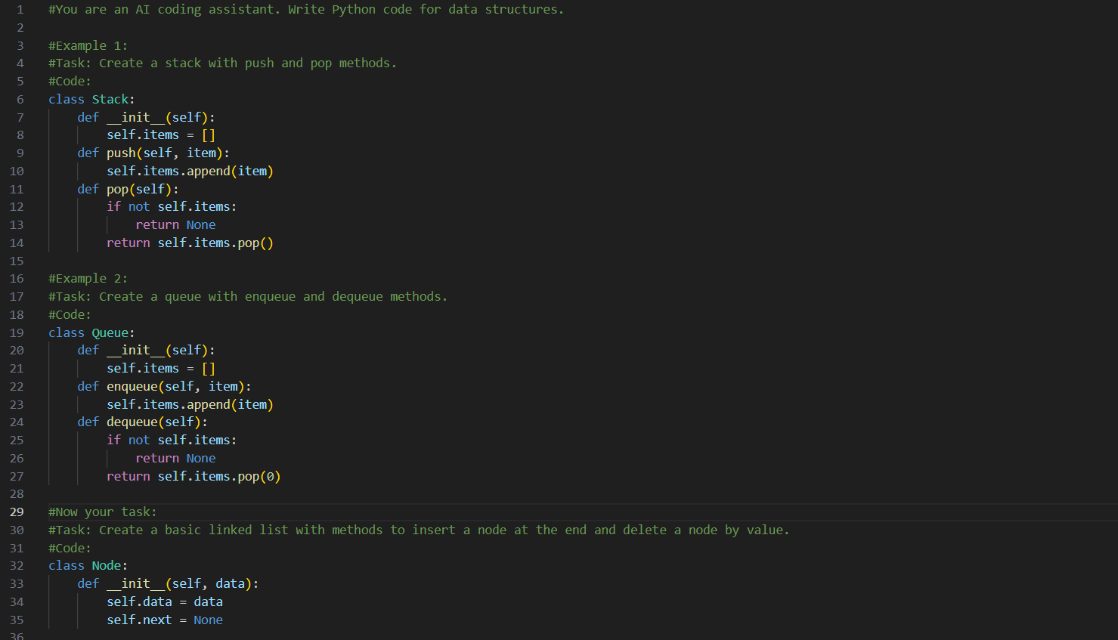

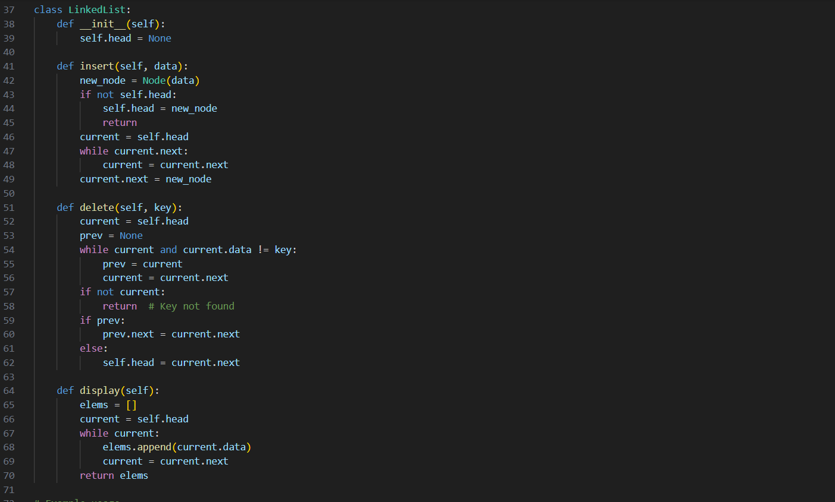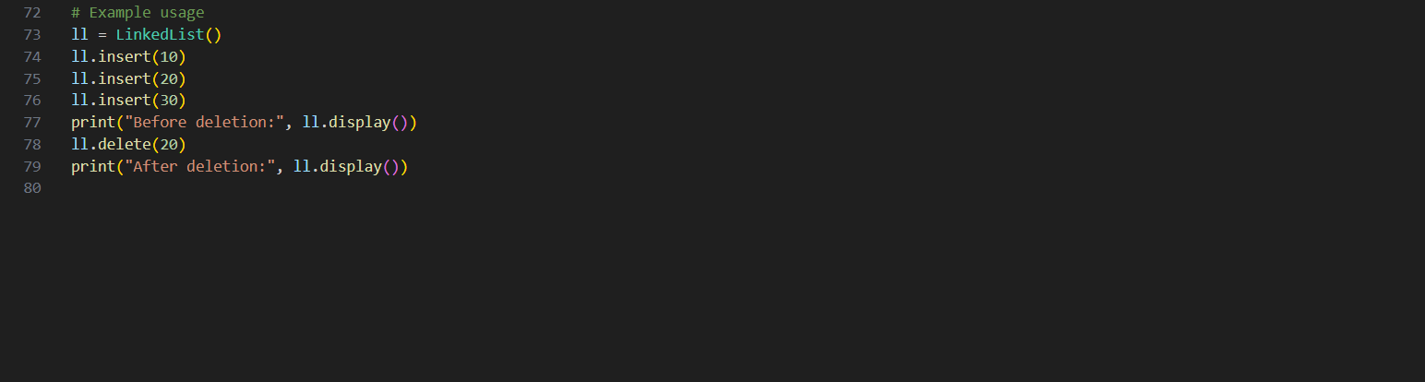
Analysis of Correctness & Completeness
- Correctness:
  - insert correctly adds nodes at the end.
  - delete removes the first occurrence of a matching value.
  - Handles edge cases: empty list, deleting head, deleting non-existent value.
  - display provides a readable list of elements.

- Completeness:
  - Covers essential linked list operations (insert, delete, display).
  - Could be extended with methods like search, insert_at_position, or length.
  - Works for both small and larger lists.
- Efficiency:
  - insert runs in $O(n)$due to traversal; could be optimized with a tail pointer.
  - delete runs in $O(n)$, which is expected for singly linked lists.

PRACTICAL OUTPUT: -
