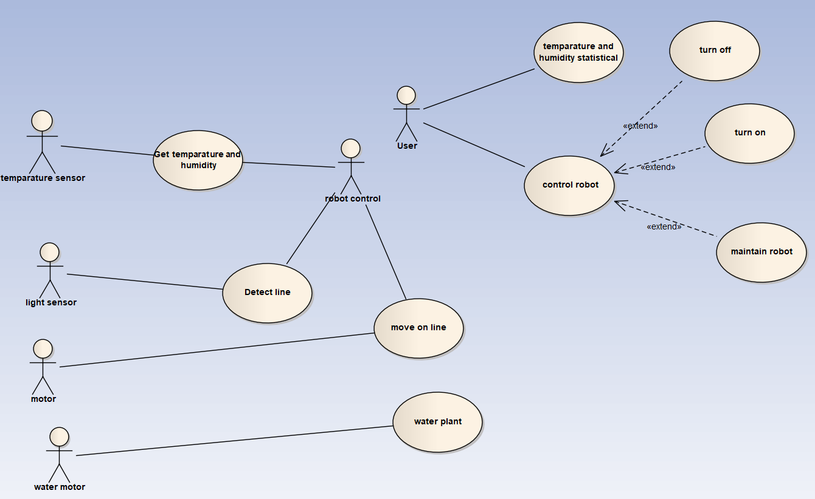

|  |  |
| --- | --- |
| **Name** | Get temparature and humidity |
| **Brief Description** | The robot will get data from sensor about temparature and humidity |
| **Actor(s)** | Temparature sensor, robot |
| **Basic Flow** | The use case starts when the system put the sensor into the ground  1. The sensor will provide data  2. The sensor interrupt the robot  3. The robot reads data from sensor  4. The robot sends data to server |
| **Alternative Flow** | (none) |
| **Pre-conditions** | (none) |
| **Post-condition** |  |
| Success | The system has a new record |
| Failure | The system is not changed. |
| **Extension Point** |  |
| (none) |  |

|  |  |
| --- | --- |
| **Name** | Detect line |
| **Brief Description** | The robot will see if it is on line |
| **Actor(s)** | Light sensor, robot control |
| **Basic Flow** | The use case starts whenever the robot is online  1. The light sensor will read the data  2. The robot will read the data  3. The robot will command the motor based on the data  4. Use case ends |
| **Alternative Flow** | (none) |
| **Pre-conditions** | (none) |
| **Post-condition** |  |
| Success | The system is not changed |
| Failure | The system is not changed. |
| **Extension Point** |  |
| (none) |  |

|  |  |
| --- | --- |
| **Name** | Temparature and humidity statistical |
| **Brief Description** | The user will monitor temparature and humidity of the farm in many views(chart , raw data, …) |
| **Actor(s)** | User |
| **Basic Flow** | The use case starts when user goes to monitor page  1. The user will see the chart and raw data  2. Use case ends |
| **Alternative Flow** | (none) |
| **Pre-conditions** | (none) |
| **Post-condition** |  |
| Success | The system is not changed |
| Failure | The system is not changed. |
| **Extension Point** |  |
| (none) |  |