1. **Login**

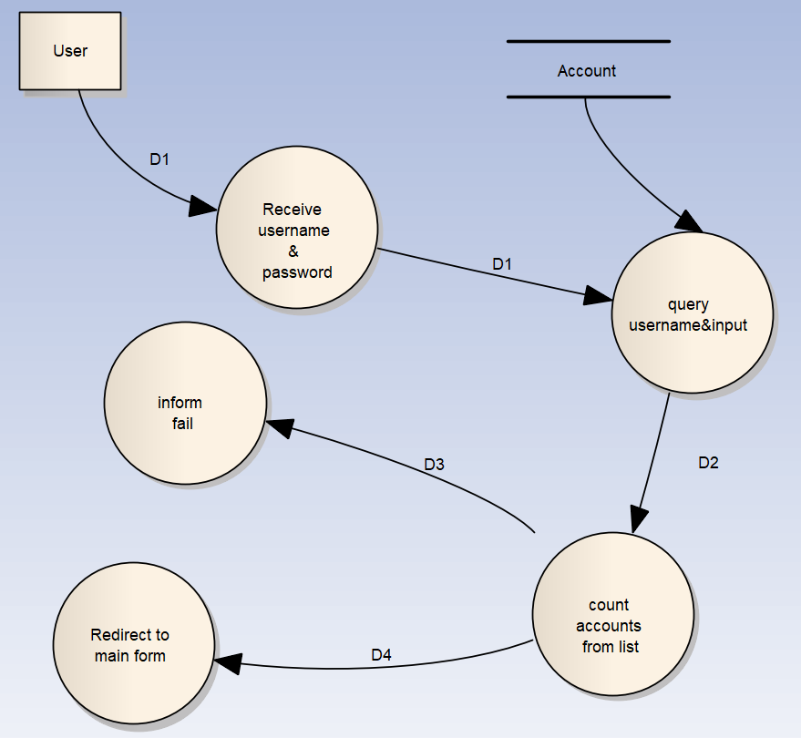

* 1. **Description**:

D1 : username and passwrod

D2 : list of accounts

D3 : no accounts in list message

D4 : one account in list message

* 1. **Algorithm**

S1 : receive username and password from user.

S2 : connect to the database

S3 : query the account table in the database with the username and password provided

S4 : get the query result then compare .

S5 : if in the query result has one account proceeds S7 or else proceeds S6.

S6 : inform fail login then go back to S1.

S7 : inform successfully then redirects to main form.

1. **Add food**

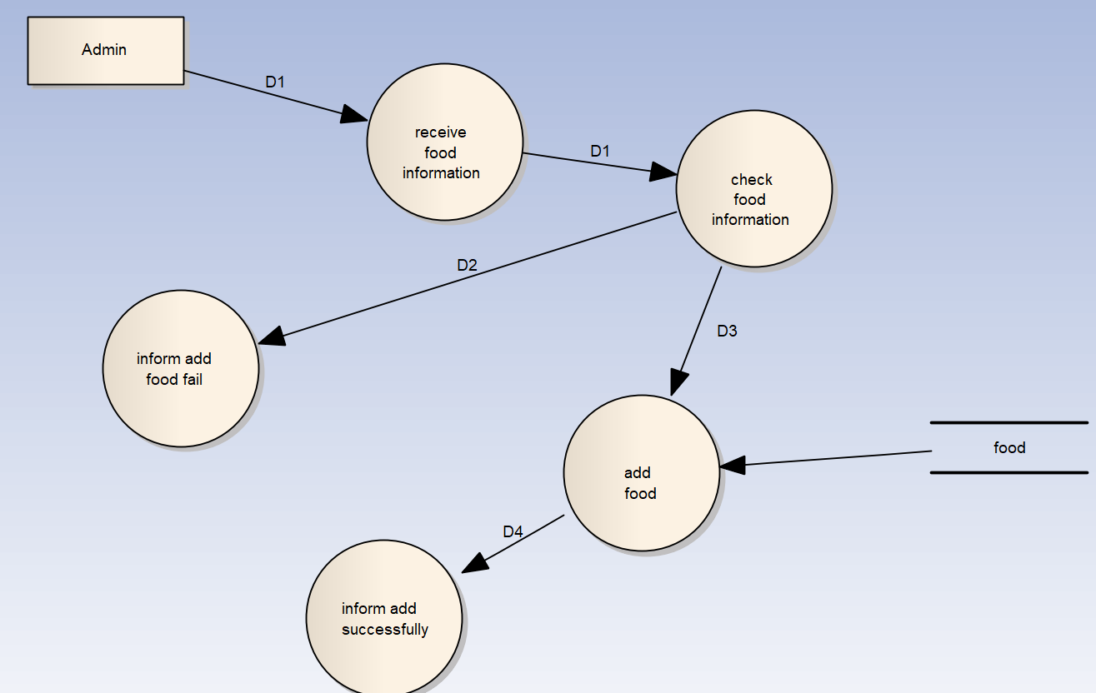

* 1. **Description**:

D1 : food information

D2 : invalid information message

D3 : add food successfully message

* 1. **Algorithm**:

S1 : receive food information

S2 : check information validity .If the information is valid then proceed S4 or else proceed S3.

S3 : inform that adding fool is fail return to S1.

S4 : open connection to the database.

S5 : add food to the database.

S6 : close database connection.

S7 : inform add successfully.

1. **Update food**

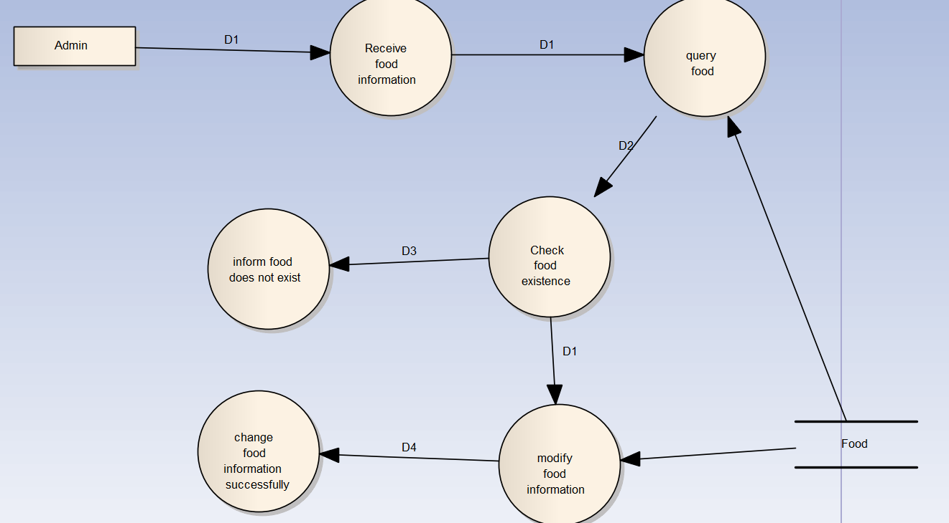

* 1. **Description**

D1 : food information

D2 : list of food

D3 : Cannot find food message

D4 : modify food successfully message

* 1. **Algorithm**

S1 : Receive food information about the food to update

S2 : open database connection

S3 : query to get food list in the database.

S4 : Check the food list . If the food list contains one food then proceeds S6 or else proceeds S5.

S5 : inform that food does not exist.

S6 : modify the food information then saves to the database.

S7 : close database connection.

S8 : inform that update food successfully.

1. **Delete food**

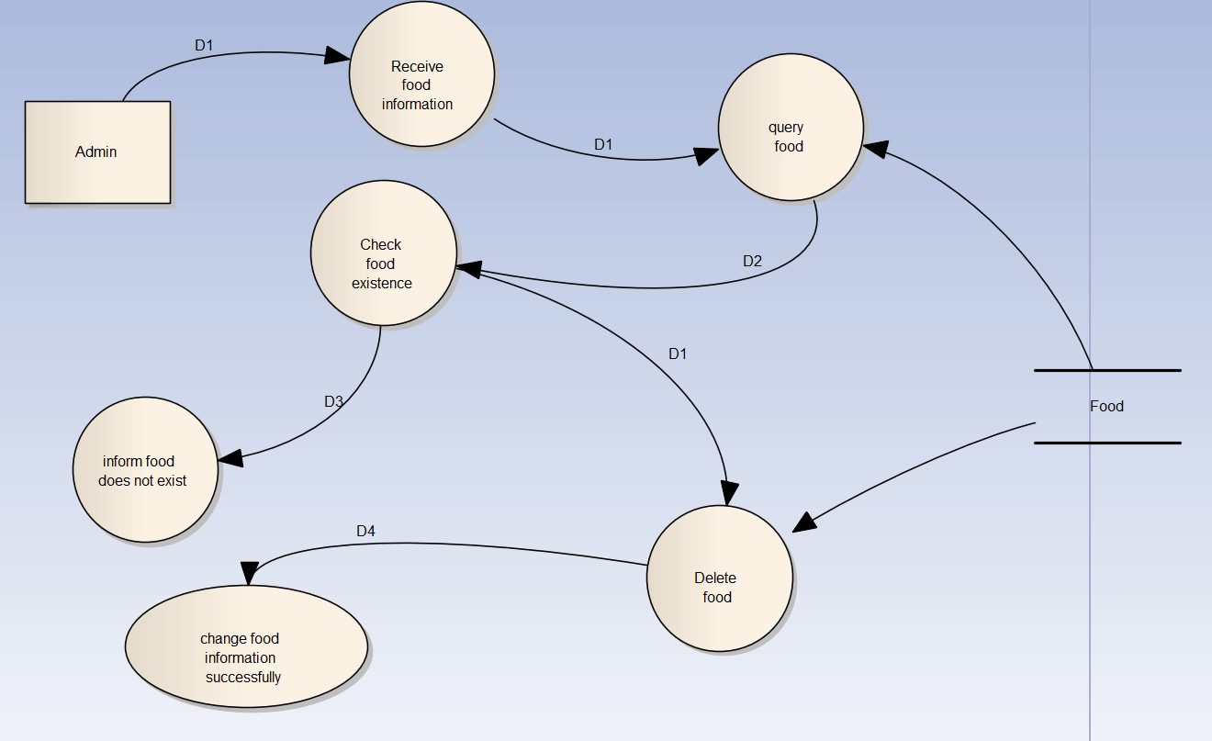

* 1. **Description**

D1 : food information

D2 : list of food

D3 : Cannot find food message

D4 : delete food successfully message

* 1. **Algorithm**

S1 : Receive food information about the food to update

S2 : open database connection

S3 : query to get food list in the database.

S4 : Check the food list . If the food list contains one food then proceeds S6 or else proceeds S5.

S5 : inform that food does not exist.

S6 : delete the food information in the database.

S7 : close database connection.

S8 : inform that delete food successfully.