Digital Calculator
Christopher Metz
Abstract—This paper introduces a digital calculator GUI application designed to streamline numerical computations with user friendly interfaces. The application offers a range of arithmetic operations including addition, subtraction, multiplication, and division, all accessible through a graphical user interface. This paper outlines the conceptualization, features, and future enhancements of the digital calculator GUI application. Emphasizing its role in facilitating efficient and accurate numerical calculations.
—————————— u —————————
- Introduction
Developing the JavaScript Calculator web application is to provide users with a simple and efficient tool for performing basic mathematical operations. Calculators are essential for both educational and practical use, enabling users to perform calculations quickly and accurately. The application provides a straightforward user interface that anyone can use.
The JavaScript Calculator allows users to input numbers and perform operations such as addition, subtraction, multiplication, and division. The user interface features a display area to show the entered and calculated values, and a keypad that includes numeric and operation buttons.
- Background
Calculators have been an essential tool for mathematical operations since their inception. Various online calculators exist today, such as:
- Google Calculator.
- Microsoft's Calculator app.
- Desmos Graphing Calculator.
These tools serve different purposes but share the common goal of simplifying calculations. The JavaScript Calculator project focuses on basic operations while providing a clean and intuitive interface.
- Proposed Application
The JavaScript Calculator was developed using HTML, CSS, and JavaScript. The structure of the application is simple and user friendly. The HTML provides the basic layout, CSS is used for styling, and JavaScript handles the functionality.
HTML Structure
The index.html file serves as the foundational layout of the calculator. Here is a breakdown of its key components:
Head Section: The head section contains metadata about the page, including its title, and it links to the external CSS file (styles.css). This ensures that the styling is applied correctly to the HTML elements.
Body Section: The body section holds the main content of the page. The calculator layout is constructed using a table, which is an effective way to align elements in rows and columns.
Header: The header of the page is a simple div element with the class header. It contains a welcome message for users of the calculator.
Table Layout: The table (id="calcu") is the main structure for the calculator interface. It contains the following components:
Display: The first row of the table spans four columns (colspan="4") and contains an input element (id="result"). This is where the calculator displays the user's input and the results of calculations.
Button Rows: Each subsequent row of the table contains four columns, each holding a button for a calculator operation or a number. The buttons are defined as input elements with the type set to "button". The value attribute of each button determines its label, while the onclick attribute specifies the JavaScript function that should be called when the button is clicked.
JavaScript: The page ends by linking to the script.js file, which contains the JavaScript functions that handle the calculator's operations. This allows the calculator to react to user input and display results accordingly.
CSS Styling
The styles.css file provides the visual styling for the calculator. Here is what it accomplishes:
Table Styling: The table, identified by #calcu, is styled to be centered and have a specific width. The border-collapse property is set to collapse to merge adjacent table cells into a single border. This provides a cleaner look. The table rows (tr) and cells (td) are also styled for alignment and padding.
Header Styling: The header class is styled to create a welcoming appearance for the header section. It includes properties for text alignment, font size, and colors.
Input Styling: The #result element is styled to have a specific width and text alignment. This ensures that the displayed input and results are easily readable.
Button Styling: The input[type="button"] elements are styled uniformly to create consistent buttons across the calculator. This includes properties such as background color, text color, padding, and margins. The styling also includes hover effects to enhance the user experience.
c. JavaScript Functionality
The script.js files code handles the calculator's functionality. The key functions include:
dis(val): This function handles input display. It appends the clicked value to the display if it is not a number or a decimal point. Otherwise, it formats the input with commas for easier readability.
clr(): This function clears the display.
solve(): This function evaluates the mathematical expression entered in the display. It removes any commas before evaluating the expression and formats the result with commas for readability. The function also checks for division by zero and catches any errors during evaluation.
evaluateExpression(expression): This function evaluates a mathematical expression safely using JavaScript's new Function constructor. It checks for division by zero and handles errors gracefully.
addCommasToInput(input): This function adds commas to a numeric input for better readability. It separates the integer and decimal parts and formats the integer part with commas.
d. User Interaction
The user interacts with the calculator using the buttons. Clicking a button triggers the corresponding function, either displaying the input, solving the expression, or clearing the display.

- Experimental Results
Introduction
The experimental results aim to validate the core functionalities of the JavaScript Calculator application. We test various scenarios to ensure that the calculator works as intended, handling input correctly, performing calculations, and displaying accurate results.
- Test Cases
  - Basic Input Validation
  - Figure 1.1: User Input with Incorrect Format
  - To test the input functionality, we enter an invalid value into the calculator. For example, inputting a non-numeric character like "abc" should be ignored, ensuring that only valid characters are displayed.
  - 1.1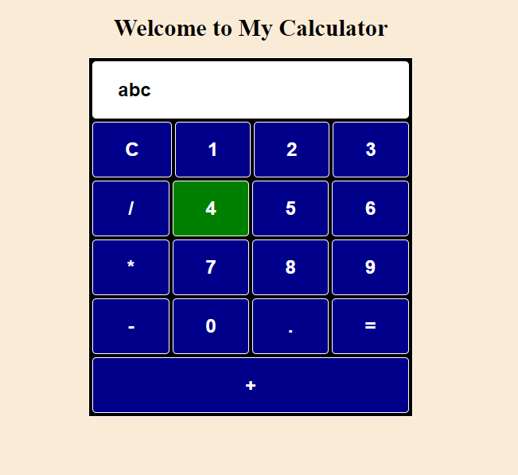
  - 1.1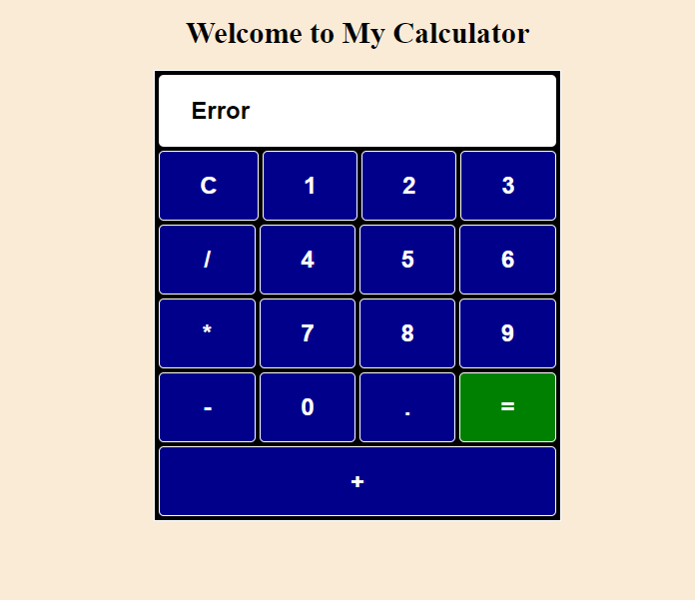

- Figure 1.2: User Input with Correct Format
  - Next, we test valid input scenarios. Entering numeric values such as "1234" should display correctly on the calculator's screen.
  - 1.2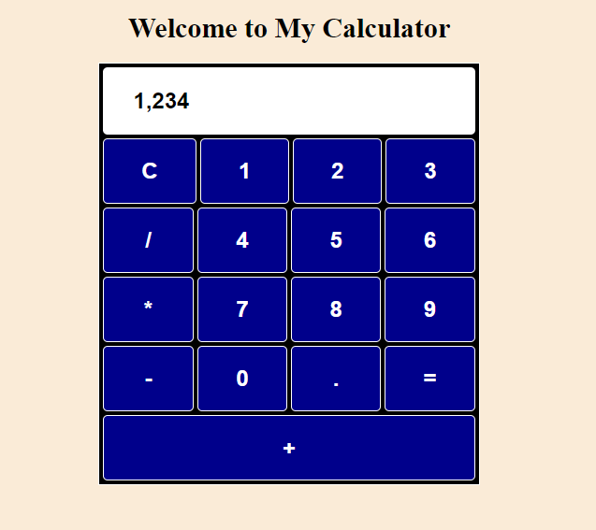
- Performing Calculations
  - Figure 2.1: Performing Addition
  - We enter "12 + 34" and press the "=" button to test addition. The result should display as "46," correctly formatted with commas for clarity.
  - 2.1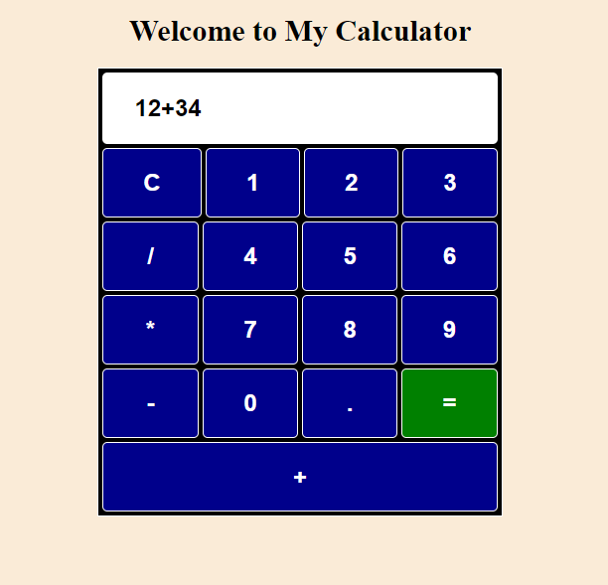
  - 2.1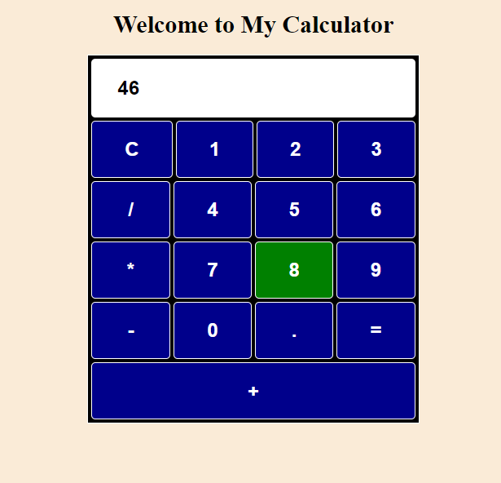
- Figure 2.2: Performing Subtraction
  - We enter "56 - 14" and press the "=" button to test subtraction. The result should display as "42."
  - 2.2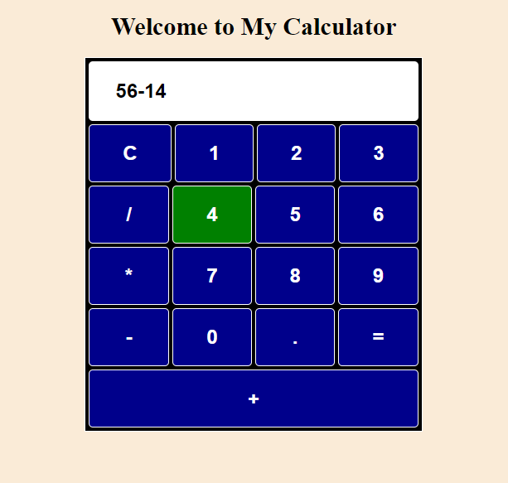
  - 2.2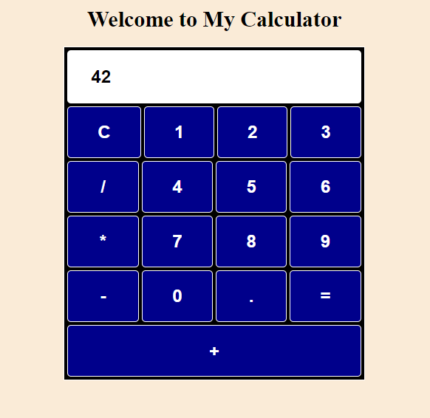

- Figure 2.3: Performing Multiplication
  - We enter "7 * 8" and press the "=" button to test multiplication. The result should display as "56."
  - 2.3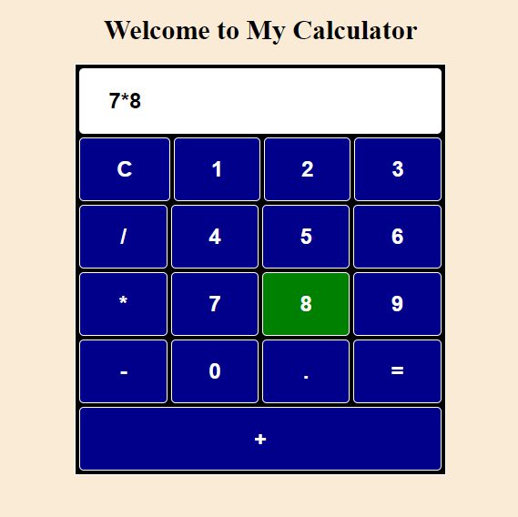
  - 2.3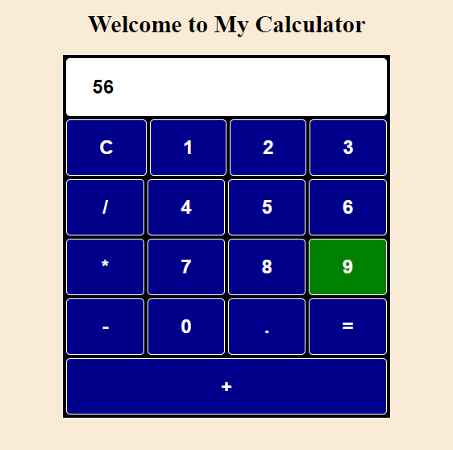
- Figure 2.4: Performing Division
  - We enter "48 / 6" and press the "=" button to test division. The result should display as "8."

  - 2.4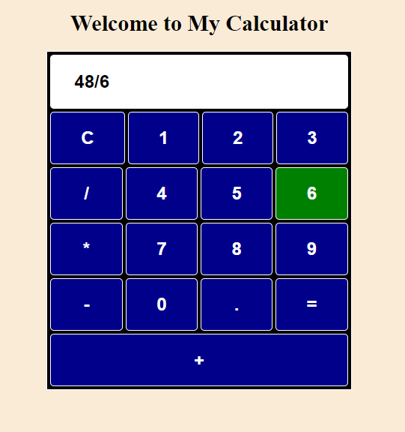

  - 2.4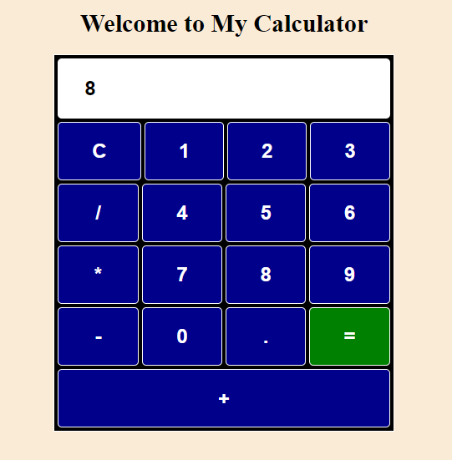
- Error Handling
  - Figure 3.1: Division by Zero
  - We test division by zero by entering "12 / 0" and pressing the "=" button. The calculator should display "Undefined."
  - 3.1 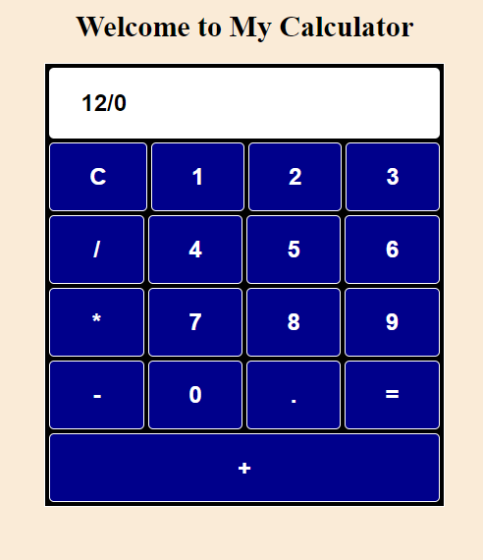
  - 3.1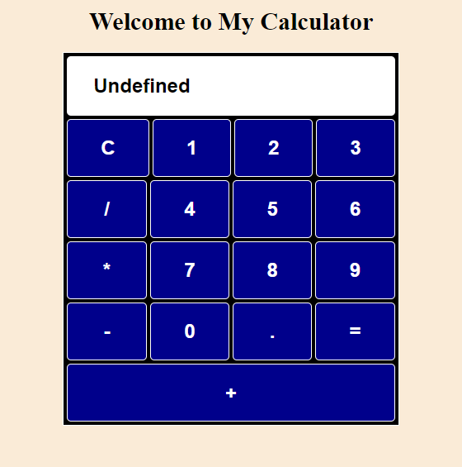
- Figure 3.2: Invalid Expression
  - We enter an invalid expression, such as "12 ++ 34," and press the "=" button. The calculator should display "Error."
- 3.2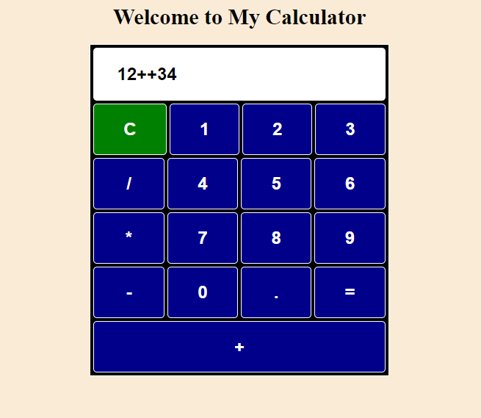
- 3.2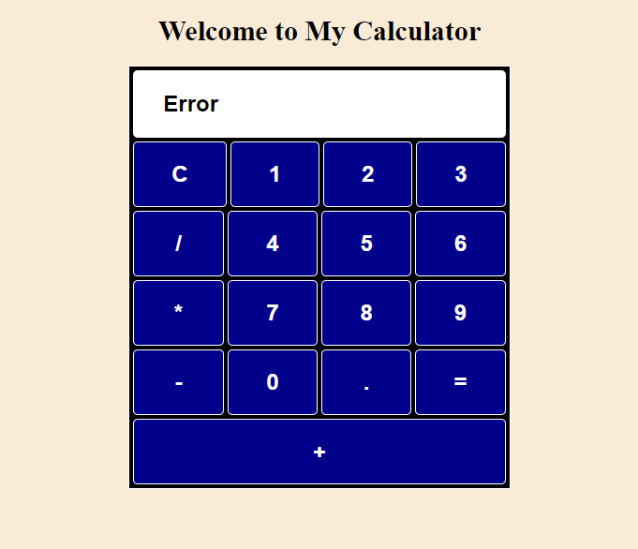
- Clearing Input
  - Figure 4.1: Clearing Input
  - To test the clear functionality, we enter any value and press the "C" button. The display should be cleared immediately.
  - 4.1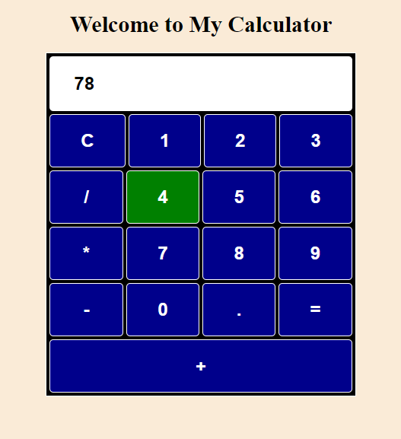
  - 4.1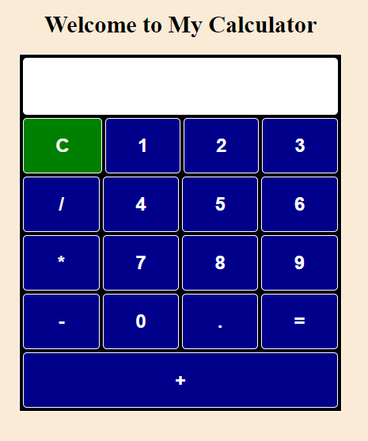
Conclusion
I developed the JavaScript Calculator project independently. During its development, I utilized examples from my web development courses as a starting point, particularly focusing on the user interface and handling mathematical operations. The examples provided me with insights into structuring the HTML layout and using JavaScript functions effectively. The Visual Studio Code editor was great in helping me write and format the code.
In the future, I would like to expand the calculator's functionality by incorporating advanced mathematical operations, such as square roots, exponents, and trigonometric functions. This would enhance the calculator's utility for a wider range of users, especially students.
Additionally, I plan to improve the user interface by incorporating more CSS styling, using a framework like Bootstrap for better design and usability. This would enhance the user experience by making the application more visually appealing and intuitive to use.
Another potential improvement is to add a history log, which would display previous calculations. This feature would help users keep track of their recent operations, aiding in complex calculations. The history log could be implemented using local storage or a simple list element that appends recent calculations.
In summary, developing the JavaScript Calculator was a pleasant experience that allowed me to apply foundational web development concepts. Moving forward, I aim to enhance its functionality and user experience, ensuring it remains a valuable tool for its users.
References
[1] Web Applications CSCI 4135 Lecture Slides
[2 Web Applications CSCI 4135 Live Coding Examples

[3] https://developer.mozilla.org/en-US/docs/Web/JavaScript
[4] https://developer.mozilla.org/en-US/docs/Web/HTML
[5] https://developer.mozilla.org/en-US/docs/Web/CSS

