# **Goal status agency**

|  |  |
| --- | --- |
| Goal Status across {{agency_name}} | |
| {{previous_quarter_and_year}} | {{current_quarter_and_year}} |
|  |  |

{{agency_abbreviation}}’s APGs changed from a status of **{{goal_change_summary_sentence}}**.

* {{r goal_status_breakdown_bullets}}

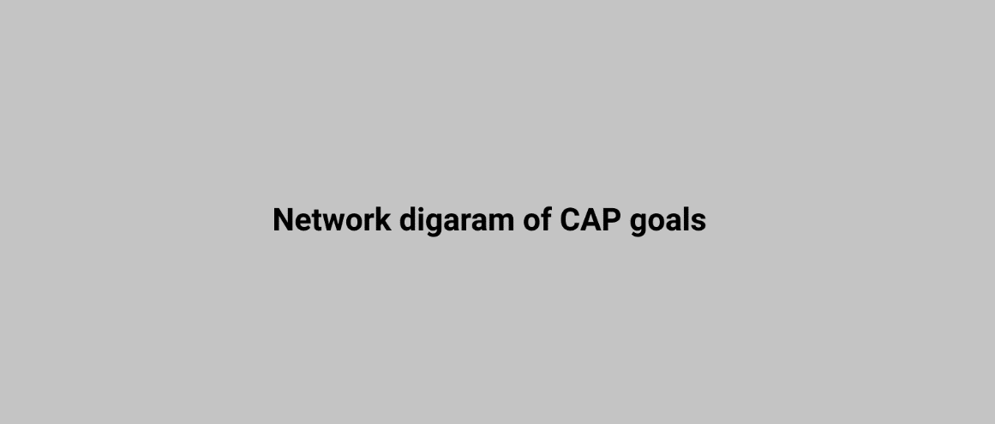

# **Recurring challenges**

|  |  |
| --- | --- |
| {{recur_challenge_1_count}} | {{recur_challenge_2_count}} |
| The challenge of **{{recur_challenge_1}}** has been reported for **{{recur_challenge_1_goal}}** for each of the last **{{recur_challenge_1_count}} quarters**. | The challenge of **{{recur_challenge_2}}** has been reported for **{{recur_challenge_2_goal}}** for each of the last **{{recur_challenge_2_count}} quarters**. |

|  |  |
| --- | --- |
|  | {{challenge_summary_text}} |

