|  |
| --- |
|  |
| Usage Guide |
| Enmask.com CAPTCHA plugin for WordPress |
| **Prepared by:**  Enmask.com  Date: 25th August 2011 |
|  |
|  |

|  |
| --- |
| *In this document we will be showing you how to download/install the EnMask CAPTCHA plugin, configure the plugin and use it.* |

Table of Contents

Introduction 3

Features of the plugin 4

Download and Install the plugin 5

Admin end configuration 9

Using user section 11

Changing default language of WordPress 15

Deactivating Plugin 16

Translations included in zip file 17

Styling Enmask Captcha 18

Appendix 19

References 20

# Introduction

The EnMask Captcha is based on regular text with matching encrypted fonts, so your users can see it clearly without the difficult to read distorted images based Captcha solutions. EnMask Captcha is a free hosted (cloud based) services, different Captcha challenge text and fonts are served each time it is requested. It is easy for human to read but tough for spammers.

EnMask Captcha is resolution independent; ideal for mobile devices, not matter how you scale it the Captcha text is clear.

Enmask.com is founded with the ideas of helping people to control their online content, privacy and freedom. We are a group of passionate people, based in Silicon Valley. We strive to provide the best service. Please feel free to give us your feedback [support@enmask.com](mailto:support@enmask.com) and you will find we are a bunch of real people working hard to make online experience a little better .

Enmask.com provides 2 services:

1. Best CAPTCHA solution using regular text
2. Prevent unwanted searches or surveillance

The EnMask Captcha plugin provides excellent user experience for your WordPress environment.

**\* Please go to** [**www.enmask.com**](http://www.enmask.com) **to register so we can provide services and answer your questions. \***

# Features of the plugin

1. Configure from Admin panel
2. Setting to hide the CAPTCHA from logged in users and/or admins
3. Setting to show the CAPTCHA on the forms for comments, registration, lost password, login, or all
4. Valid HTML
5. Allows **Trackback** and **Pingback**
6. I18n language translation support (please check the zip files to see what languages are included)

# Download and Install the plugin

For downloading the plugin please visit following location:

[http://www.Enmask.com/en-US/Solutions](http://www.enmask.com/en-US/Solutions)

Download the zip file from above location; we will need the zip file in our next step.

Installing Plugin steps:

Method A:

1. Please login to the admin section of your WordPress.
2. Click the “Plugins” link in left menu area. (Note: Please see the image below for help)

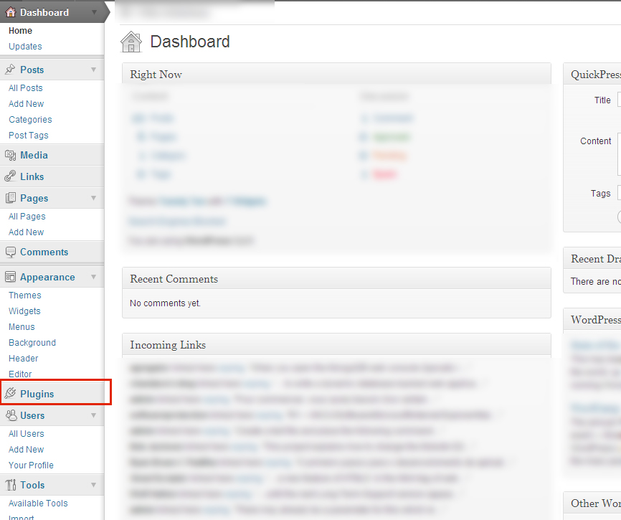

1. Click “Add new” button, to add new plugin

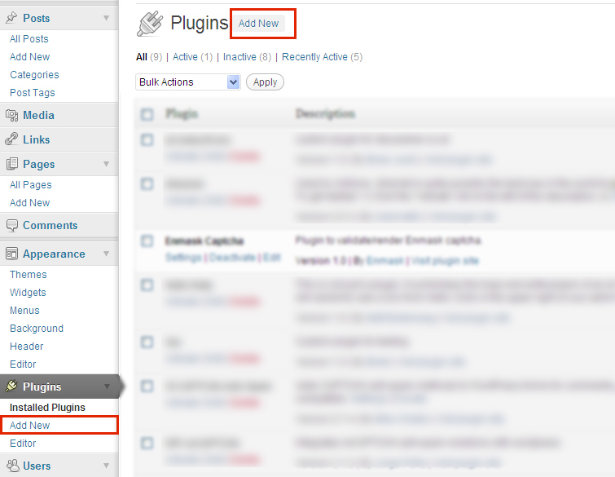

1. Click “Upload” link, for uploading the new plugin that you have downloaded from “Plugin” page.

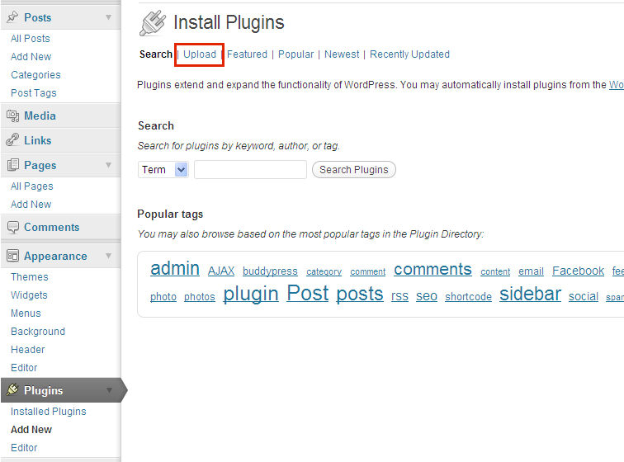

1. Browse the zip file and Install it. [Note: do not extract the zip file]
2. Congratulation the Enmask CAPTCHA plugin for WordPress is installed.
3. Activate the plugin.

Method B:

1. Download the plugin zip file from following URL:

<http://www.enmask.com/en-US/Solutions>

2. Extract the zip file so that you will get "wp_enmask" folder.

3. Upload the folder to the '/wp-content/plugin/' directory

4. Activate the plugin through the 'Plugins' menu in WordPress.

# Admin end configuration

Step1: After activating your plugin you will be directed to plugin page. Here you will see the followings:

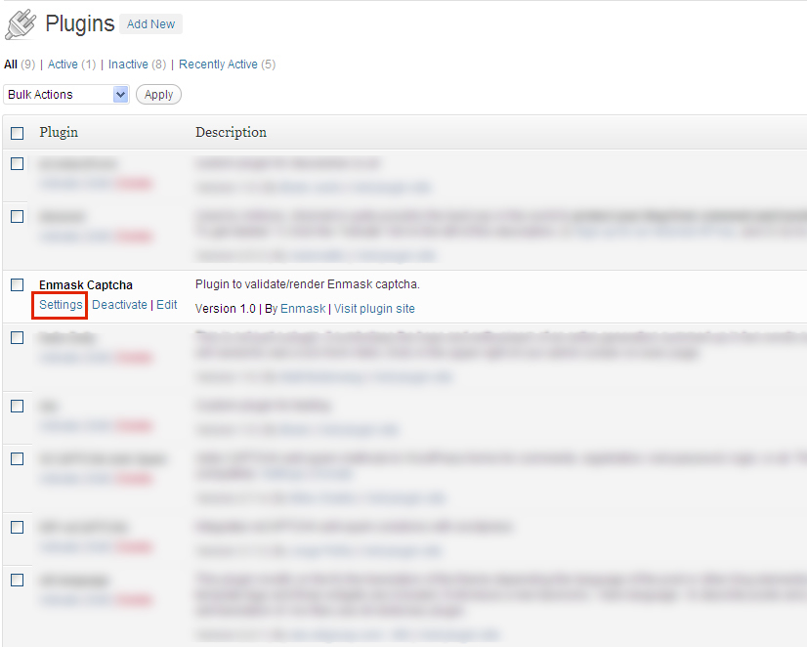

Click the “settings” link, so you will be redirected to “Enmask CAPTCHA Settings” page.

Step 2: Enmask CAPTCHA Settings

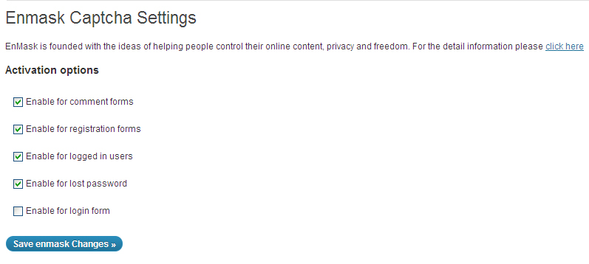

Select the checkboxes as per your requirement.

You can show the CAPTCHA in comment forms, registration forms, lost password form, login form or all of them.

You can also enable the CAPTCHA for logged in user.

After you are done with changing settings, click the “Save Enmask Changes”. With this you are done.

# Using user section

Enmask CAPTCHA in WordPress comment section:

CAPTCHA looks as follows in comment section.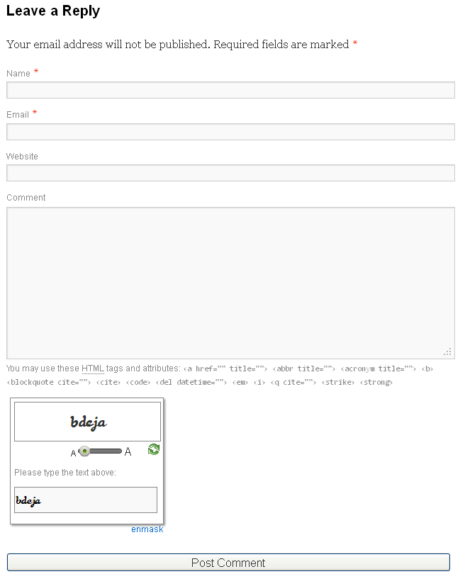

Enmask CAPTCHA in WordPress registration page:

CAPTCHA looks as follows in Registration page:

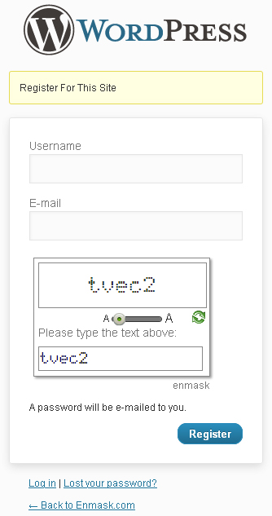

Enmask CAPTCHA in WordPress lost password section:

CAPTCHA looks as follows in lost password page:

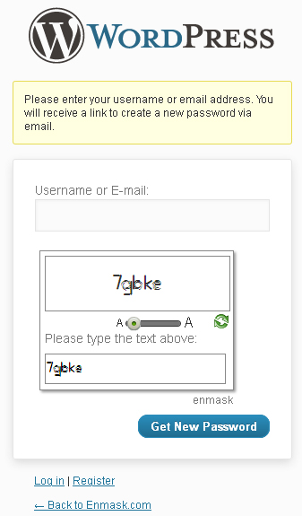

Enmask CAPTCHA in WordPress login section:

CAPTCHA looks as follows in login page:

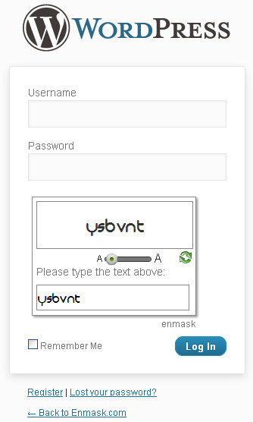

# Changing default language of WordPress

For changing default language of WordPress:

Open the wp-config.php file from your root directory of your WordPress installation.

Find the line that looks like:

*define('WPLANG', '');*

Change the line to:

*define('WPLANG', 'es_ES'); // to change WordPress default language to Spanish.*

*define('WPLANG', 'ja'); //to change WordPress default language to Japanese.*

*define('WPLANG', 'zh_CN'); // to change WordPress default language to Chinese simplified.*

*define('WPLANG', 'zh_TW'); // to change WordPress default language to Chinese traditional.*

*Please refer:* [http://codex.WordPress.org/WordPress_in_Your_Language](http://codex.wordpress.org/WordPress_in_Your_Language) for the language codes.

*‘OR’*

You can install any language plugins that support *.mo and .po* files to change your default WordPress language dynamically.

[http://WordPress.org/extend/plugins/xili-language](http://wordpress.org/extend/plugins/xili-language) (language switching plugin)

# Deactivating Plugin

**Steps for deactivating a plugin:**

1. In administrator section, go to “Plugins”=> “Plugins” in the left menu.
2. Look for “Enmask CAPTCHA” plugin.
3. Click on “Deactivate” link.

# Translations included in zip file

1. Spanish
2. French
3. Chinese simplified
4. Chinese traditional
5. Russian
6. Japanese
7. German
8. Portuguese

All the translations have been carried out using [Google translator](http://translate.google.com). If you find any translation error(s) please [let us know](mailto:manager@enmask.com?subject=Translation%20error) your suggestions.

# Styling Enmask Captcha

EnMask.com CAPTCHA uses encrypted text and paired with matching web fonts and it provides the flexibility to change the styling of the CAPTCHA the way you like. You can use CSS style to change the colors and other attributes.

The EnMask.com CAPTCHA can be modified, see these classes are highlighted in bold below. Every aspect of the CAPTCHA can be changed including the font size, background colors, foreground colors, borders etc. by changing the EnMask CAPTCHA CSS Classes.

(Note: the font family of the CAPTCHA challenge, and the CAPTCHA response should not be changed)

Sample markup with Enmask classes

<div class="**enmask-captcha-widget-container**">

<div class="**enmask_captcha_widget**">

<!-- This is CAPTCHA challenge text that user sees. -->

<div class="**enmask_captcha_text**">{CAPTCHA text}</div>

<!-- The refresh button-->

<span class="**refresh_icon**"></span>

<!-- The Slider -->

<div class="**enmask_font_slider_container**">

<span class="**enmask_resize_A enmask_small_A**">A</span>

<div class="**dragdealer**">

<div class="**red-bar handle**" style="left: 0px;">

</div>

<span class="clear"></span>

</div>

<span class="**enmask_resize_A enmask_big_A**">A</span>

</div>

<span class="clear"></span>

<div class="**enmask_response_container**">

<label class="**enmask_label**">{Enmask label text}</label>

<span class="clear"></span>

<input type="hidden" />

<!-- This is the text box where user enters their response.-->

<input type="text" class="**enmask_response_textbox**" autocomplete="off" />

</div>

<!-- The Enmask.com link -->

<div class="**enmask_link_container1**">

<div class="**enmask_link_container**">

<a target="BLANK" rel="external" href="http://enmask.com/">enmask.com</a>

</div>

</div>

<span class="clear"></span>

</div>

</div>

**Note: This is a sample of markup generated by the enmask CAPTCHA javascript, not markup you should use to create the CAPTCHA. The only markup needed for that is <script type=”text/javascript” src=**<http://enmask.com/dev/Scripts/Enmask.Captcha.js> **data-enmask=”true” data-enmask-name=”{name for the CAPTCHA}”></script>**

# Appendix

**I18n:** Abbreviated form of Internationalization. (Where 18 stands for the number of letters between the first ‘i*’* and last ‘*n’* in the world ‘internationalization’, a usage coined at DEC in the 1970s or 80s) .

**Trackback**: Trackback was designed to provide a method of notification between websites: it is a method of person ‘*A’* saying to person ‘*B’*, "This is something you may be interested in." To do that, person ‘*A’* sends a Trackback ping to person ‘*B’* .

**Pingback**: *Yvonne* writes an interesting article on her Web log. *Kathleen* reads *Yvonne's* article and comments about it, linking back to *Yvonne's* original post. Using pingback, *Kathleen's* software can automatically notify *Yvonne* that her post has been linked to, and *Yvonne's* software can then include this information on her site .

# References

x

|  |  |
| --- | --- |
| [1] | (2011) Enmask.com. [Online]. [http://www.Enmask.com](http://www.enmask.com) |
| [2] | (1994, Oct.) w3c.org. [Online]. <http://www.w3.org/2001/12/Glossary#I18N> |
| [3] | (2003) WordPress.org. [Online]. [http://codex.WordPress.org/Introduction_to_Blogging#Trackbacks](http://codex.wordpress.org/Introduction_to_Blogging#Trackbacks) |
| [4] | (2003) WordPress.org. [Online]. [http://codex.WordPress.org/Introduction_to_Blogging#Pingbacks](http://codex.wordpress.org/Introduction_to_Blogging#Pingbacks) |
|  |  |

x