Evaluation Report - MetaMath

Pedro Lealdino Filho

2/12/2017

load(file = "DataOMSU.RData")

# Contents

# The project MetaMath

In March 2014, the MetaMath project started wiht the objective to improve the quality of STEM education in Russia by modernizing and improving the curricula in the field of Mathematics. The process of modernization started from the fundamental revision of the way math studies are organized in all Russian universities offering degrees in STEM. After ensuring the consistency of the math curricula with the Bologna principles and best European standards, the further steps were token to modernize the content and teaching methods by introducing principles of blended learning and new educational techonologies.

This report describes the results from the three years project, its methodologies and the quantitative analysis of the modernized courses of Russian universities.

summary(DataOMSU)

## student university course pretest   
## Min. :648.0 OMSU :82 course :82 Min. : 6.00   
## 1st Qu.:668.2 ASPU : 0 calculus : 0 1st Qu.:22.00   
## Median :688.5 ATSU : 0 courseone : 0 Median :28.00   
## Mean :688.5 BSU : 0 coursetwo : 0 Mean :28.68   
## 3rd Qu.:708.8 GTU : 0 data antalysis : 0 3rd Qu.:34.00   
## Max. :729.0 KAI : 0 discrete mathematics: 0 Max. :59.00   
## (Other): 0 (Other) : 0   
## postest treatment diff   
## Min. : 9.00 mod:45 Min. :-7.00   
## 1st Qu.:34.00 old:37 1st Qu.: 9.00   
## Median :47.00 Median :17.00   
## Mean :47.02 Mean :18.34   
## 3rd Qu.:58.25 3rd Qu.:28.00   
## Max. :88.00 Max. :44.00   
##

## Including Plots

You can also embed plots, for example:

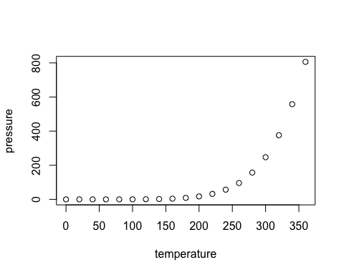

Note that the echo = FALSE parameter was added to the code chunk to prevent printing of the R code that generated the plot.