Phase 2 - Project Specification

**Grupo 2:**

Diogo Lança – fc53495

Meuri Canhanga – fc42559

Miguel Silva – fc58974

Pedro Santos – fc46417

Renato Ribeiro – fc57433

1. Phase 1 summary

For the project, we selected a subset of a **dataset** of around 21 million **user reviews** in multiple languages of around 300 different games on Steam (video game digital distribution service). This dataset has **1,07 GB** worth of user reviews, **last updated on 25 January of 2021**. Worth noting that the dataset was downloaded from Kaggle[1] in a **CSV** **format**.

1. Use Cases

|  |  |  |
| --- | --- | --- |
| **Services** | **Role** | **Functionalities** |
| Normal | Anyone | User sign in |
| User login |
| Suggest games on the main page based on recommendations |
| Search for a game |
| User | Review a game |
| Edit a review |
| Set a review of another user has helpful |
| Delete Review |
| Filter Reviews |
| See all Reviews |
| Set a game has recommended/not recommended |
| Delete account |
| See the total number of games in user possession |
| See total playtime (since account creation) |
| User logout |
| Admin | Add games |
| Remove games |
| Remove Reviews (case of wrong/ inappropriate content) |
| Remove users (case they don’t comply with the laws reserved to the service) |

1. Preliminary architectural design

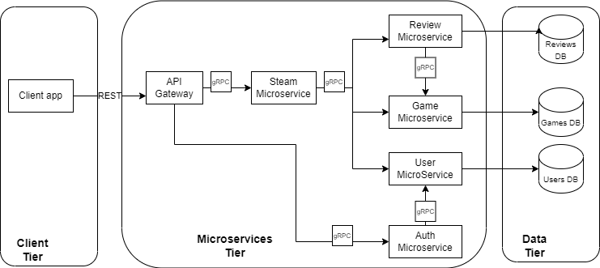

1. API Specification

Following this .pdf file on the attachments, we included a YAML with the API specifications. Nevertheless, to reinforce our ideas, it’s worth showing the UI for a simple and easier understanding of our specifications.

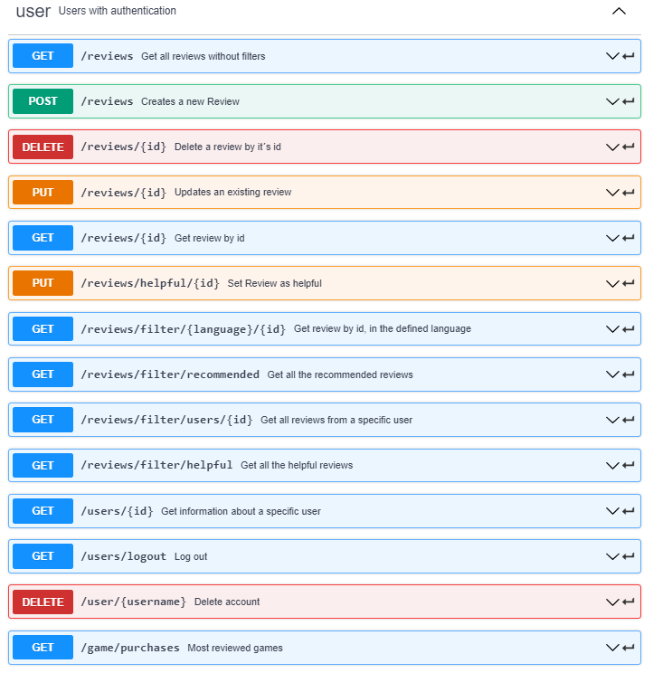

1. Dataset source: <https://www.kaggle.com/najzeko/steam-reviews-2021>