How to create private DNS in route53

Contents

**1.** **Requirements** 1

**2.** **Create Private Hosted Zone** 1

**3.** **Create DNS Record** 3

# **How to Create Private DNS for Single EC2**

# **Requirements**

* A private hosted zone only responds to queries coming from within the associated VPC and it is not used for hosting a website that need to be publicly accessed.
* A private hosted zone is a container that holds information about how you want Amazon Route 53 to respond to DNS queries for a domain and its subdomains within one or more VPCs that you create with the Amazon VPC service.
* This allows us to use custom DNS names for our internal resources without exposing the names or IP addresses to the public Internet.

# **Create Private Hosted Zone**

* Login into AWS Console 🡪 Switch to **route 53** 🡪 Click on **Hosted Zone**

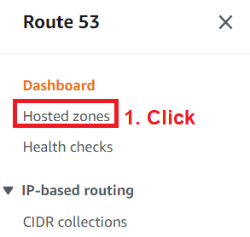

* Click **Create hosted zone**
* 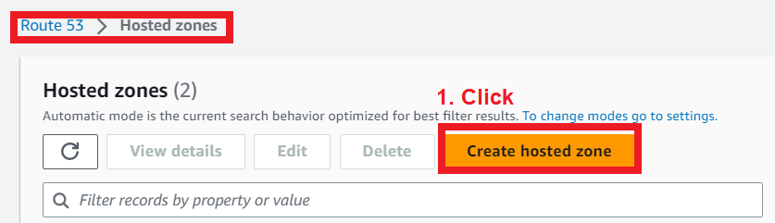
* Click
* 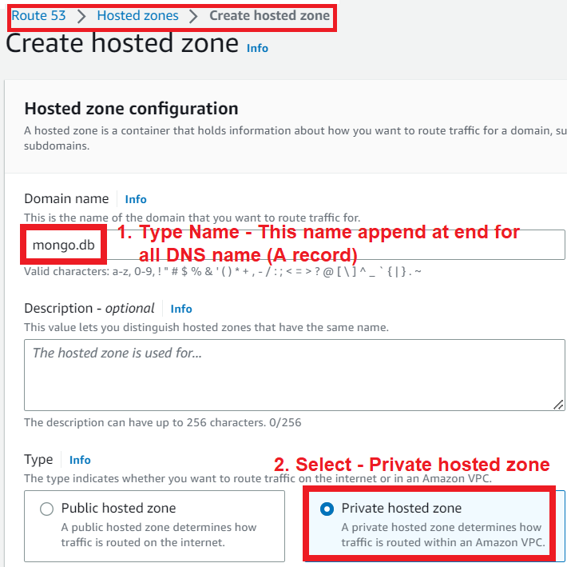
* Select all VPC
* 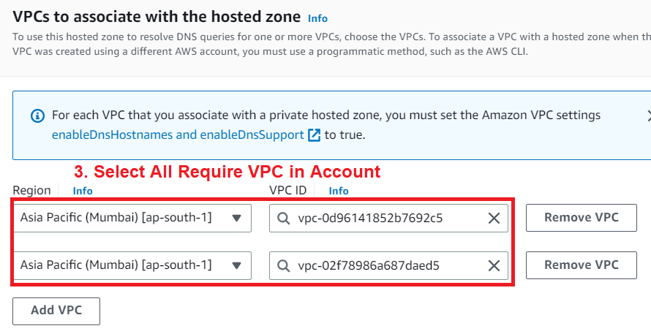
* Add requrei tags 🡪 click
* 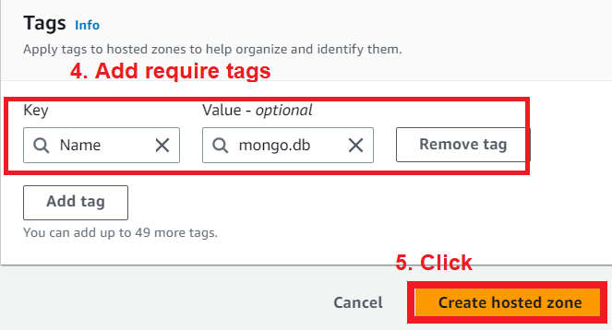

# **Create DNS Record**

* Click on Created Hosted Zone.
* 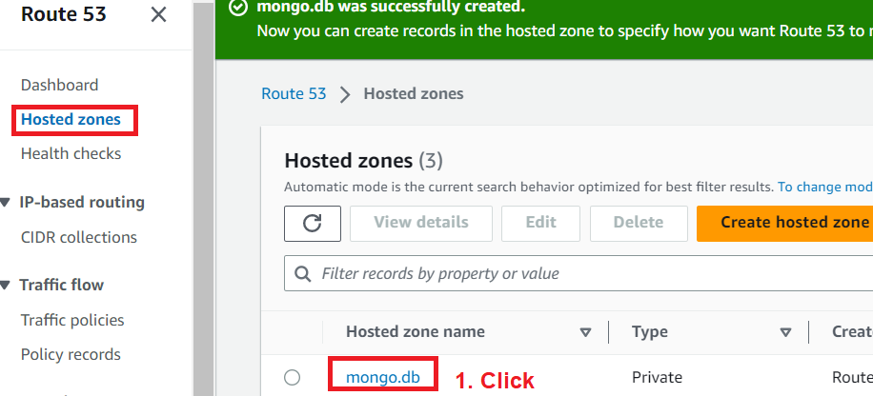
* Click
* 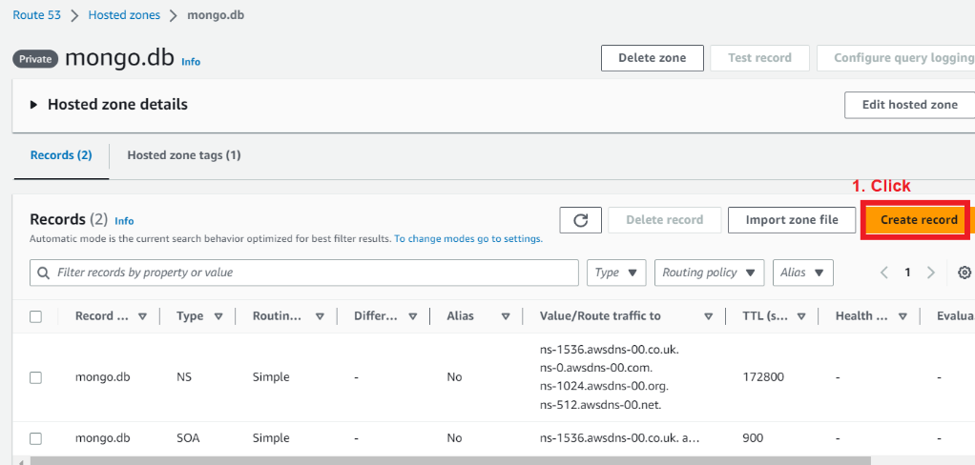
* Click
* 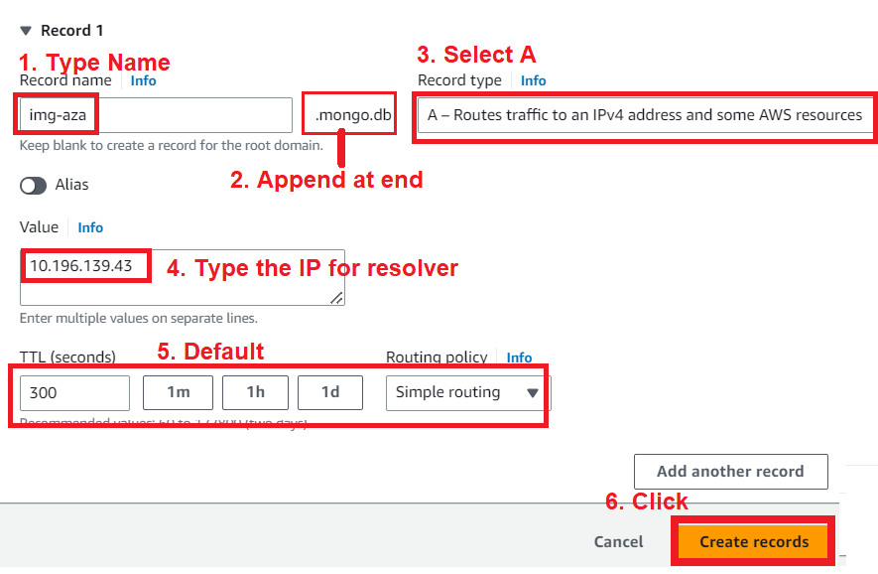

# **How to Create Private DNS for ALB**

# **Create Private Hosted Zone**

* Login into AWS Console 🡪 Switch to **route 53** 🡪 Click on **Hosted Zone**

* Click **Create hosted zone**
* A screenshot of a computer

  Description automatically generated
* Click
* 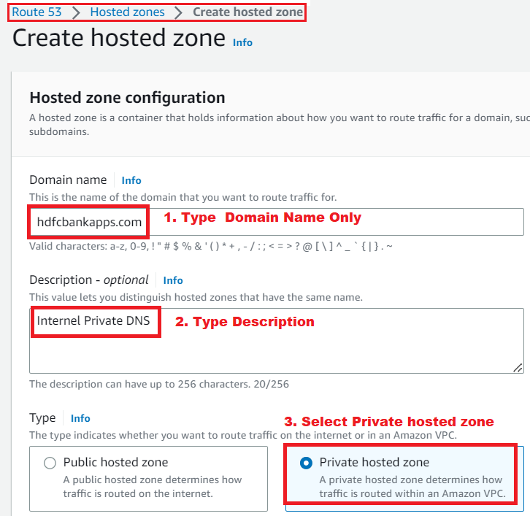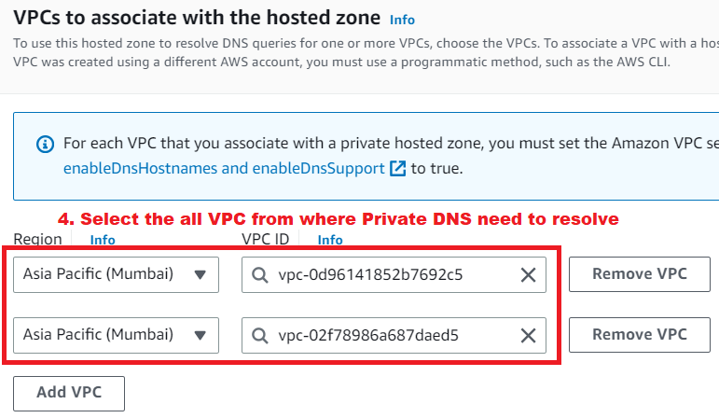

# **Create DNS Record**

* Click on Created Hosted Zone.
* 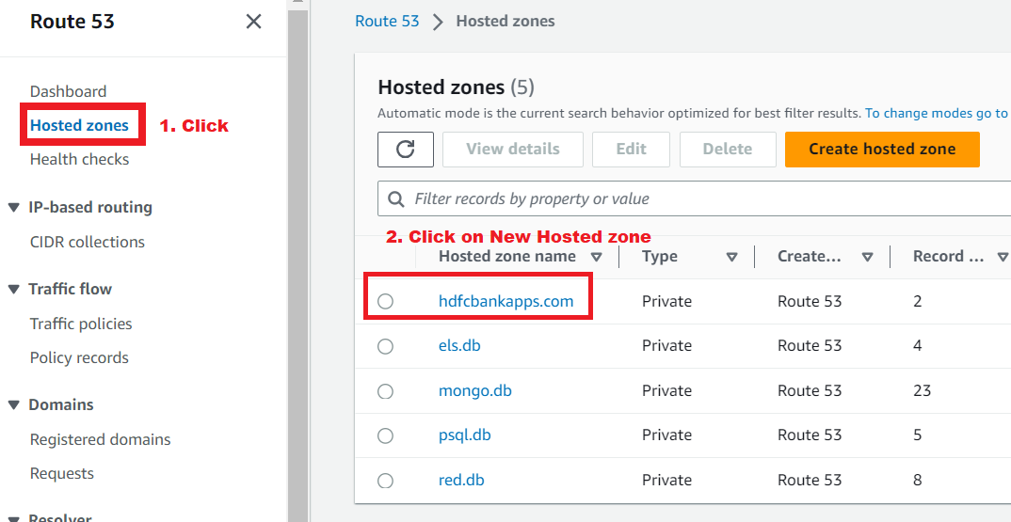
* Click on **Create record**
* 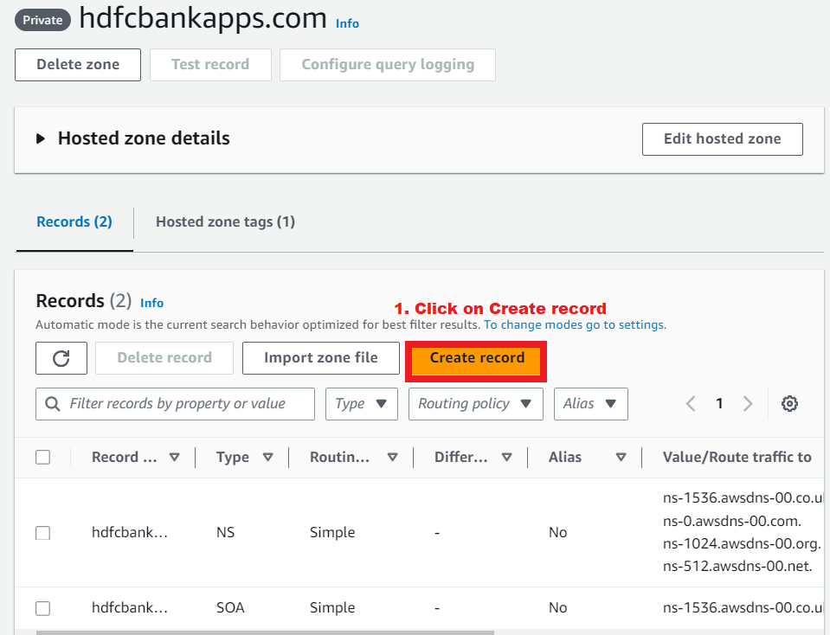
* Click
* 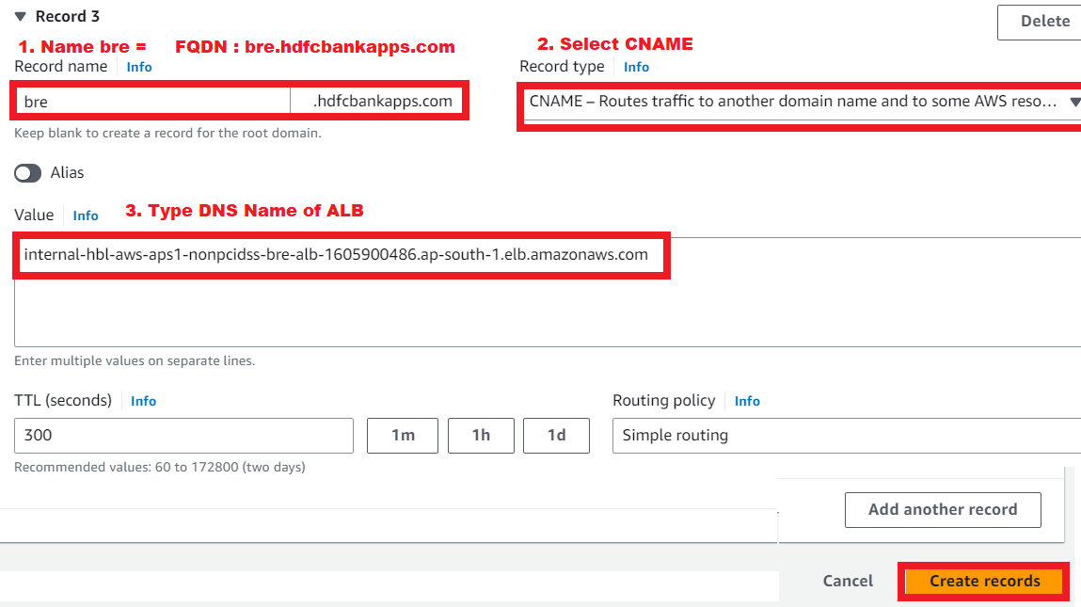
* a