How to Create Private Link Between Account

Contents

1. Introduction 2

2. Requirement 2

**3.** **Account A** 3

**3.1.** **Target Group – Account A** 3

**3.2.** **NLB** 6

**3.3.** **Endpoint Service – Account A** 9

**3.3.1.** **Create endpoint service** 9

**3.3.2.** **Allow Principle for endpoint service** 10

**4.** **Account B** 11

**4.1.** **Target Group** 11

**4.2.** **NLB – Account B** 14

**4.3.** **Endpoint Service – Account B** 17

**4.3.1.** **Create endpoint service** 17

**4.3.2.** **Allow Principle for endpoint service** 18

**5.** **Create Endpoint** 19

**5.1.** **How to get endpoint service name.** 19

**5.2.** **Create Endpoint – Account-A** 19

**5.3.** **Create Endpoint – Account-B** 21

**6.** **Accept the Endpoint Request** 23

**6.1.** **Accept Request – Account-A** 23

**6.2.** **Accept Request – Account-B** 24

**7.** **Update the Security Group of EC2** 24

**8.** **How to Connect to Cross Account EC2.** 24

# Introduction

* AWS Private link provides private connectivity between VPCs, AWS services, and your on-premises networks without exposing your traffic to the public internet.
* In this account Private Link use for private connectivity between EC2 instances across 2 different accounts.
* Diagram

  Description automatically generated

# Requirement

* We need to create Private Link between AWS Account A to AWS Account B for following instances.

1. Instance Name = hbl-aws-aps1-lentra-nonpcidss-prod-archive_2-db-ec2-01

Instance id = i-09d1d25e01b3f99cb

Instance IP = 10.196.139.94

Availability zone =  ap-south-1b

Subnet ID = subnet-0a955270c51f28413

Availability Zone ID = aps1-az3 (From Subnet)

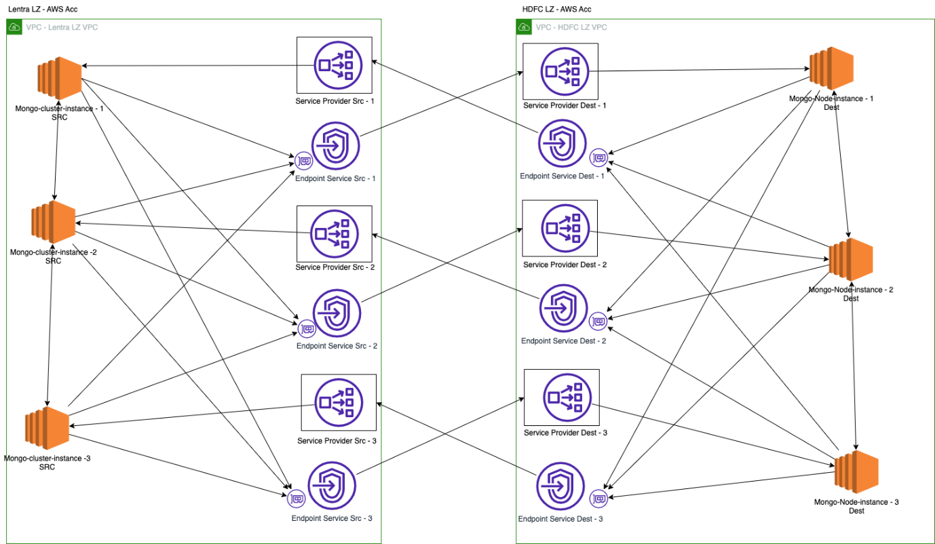

# **Account A**

## **Target Group – Account A**

* We need to **create target group** for above instances.
* Type = **target** in search bar 🡪 Click on **Target Group**

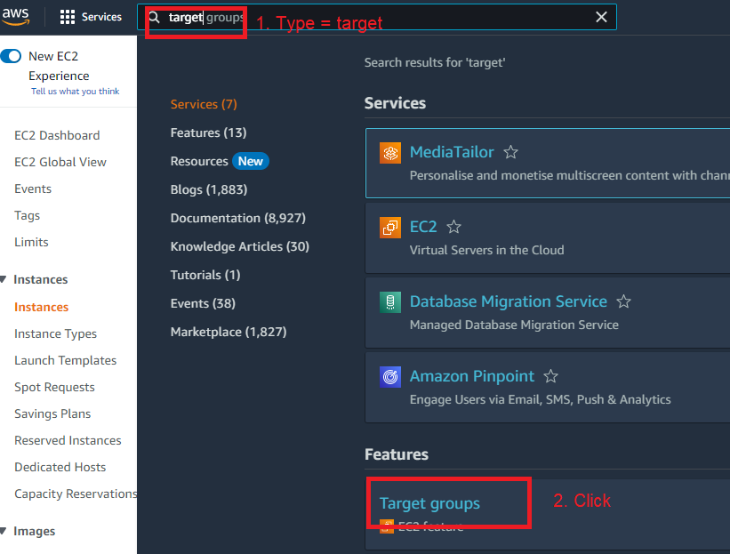

* Click on **Create target group**

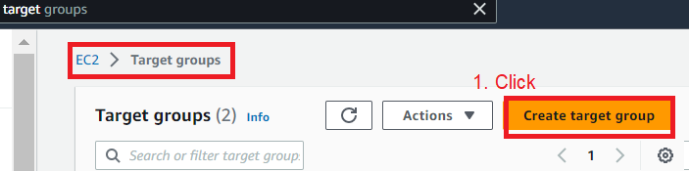

* Select the following

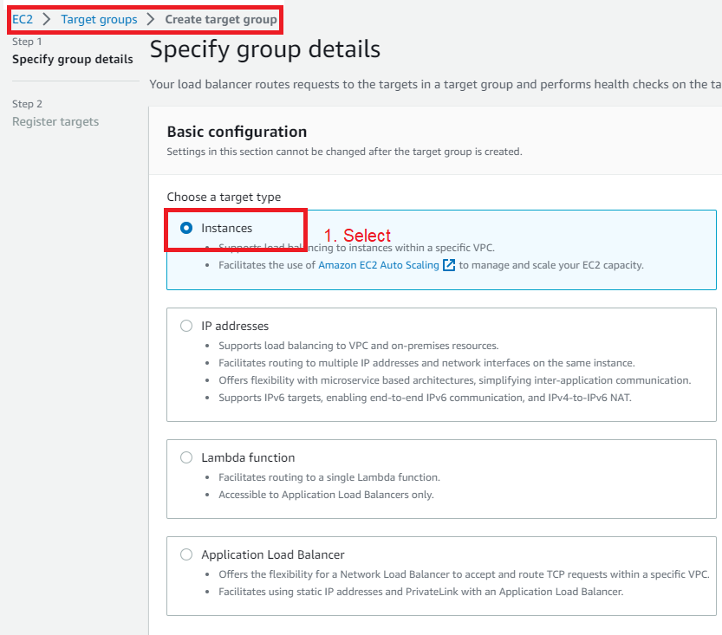

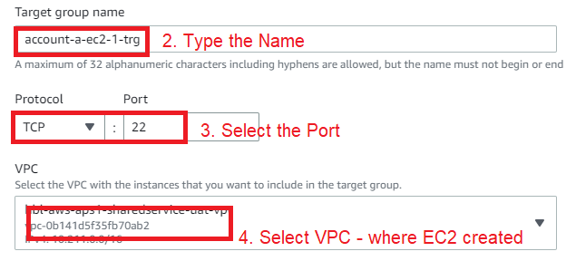

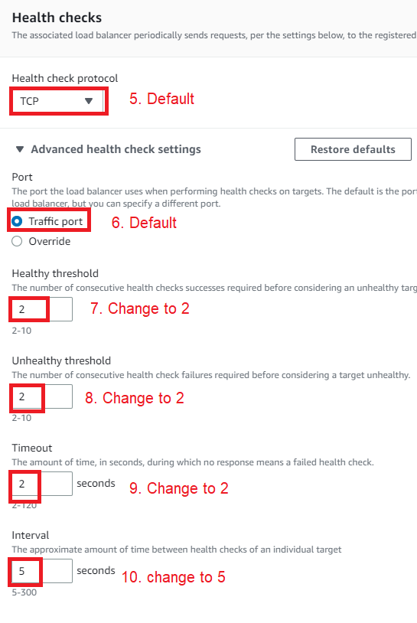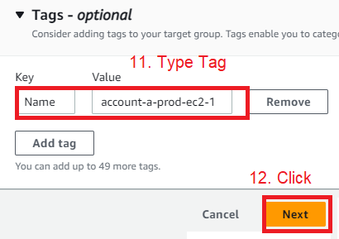

Select the Target **EC2** 🡪 Type the Require **Port** 🡪 Click on **Include as pending below**

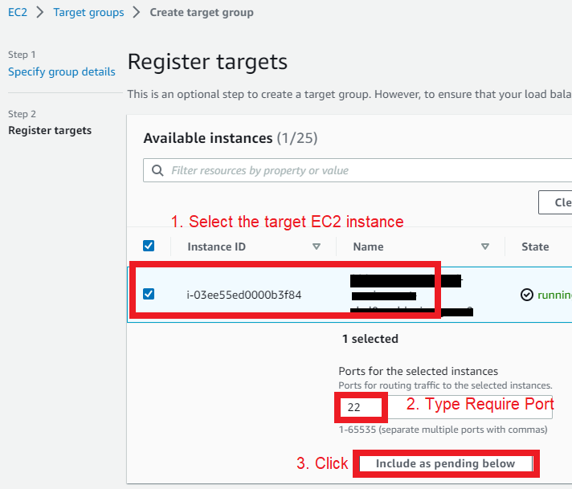

Review the target group 🡪 Click on **Create target group**

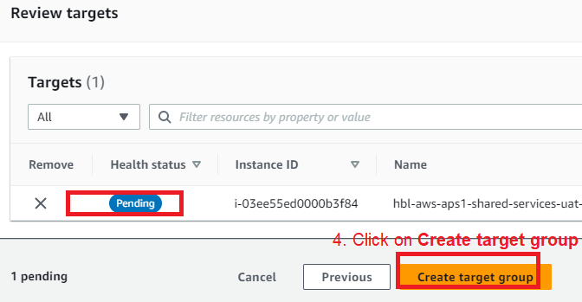

## **NLB**

* We need to **create 5 Network Load Balancer** for above instances.
* Type = **load** in Search bar 🡪 Click on **Load Balansers**

* Click on **Create load Balancers**

* Click on NLB

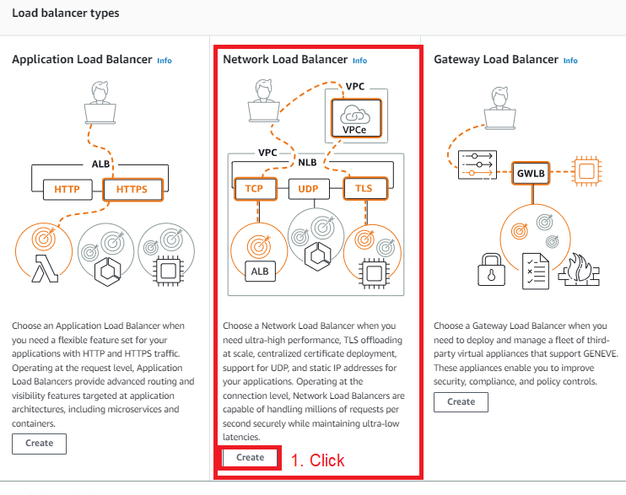

* Select the Following

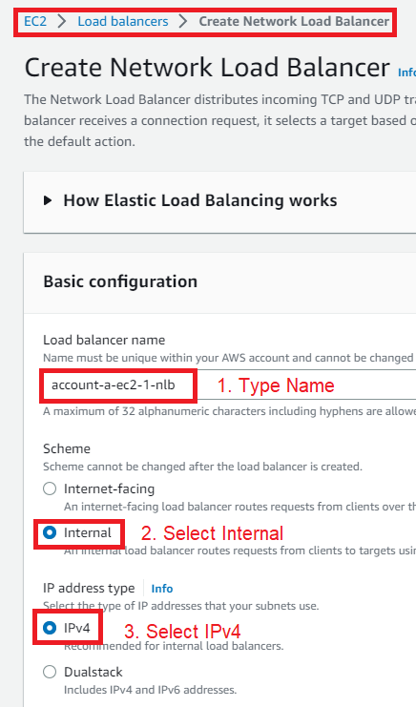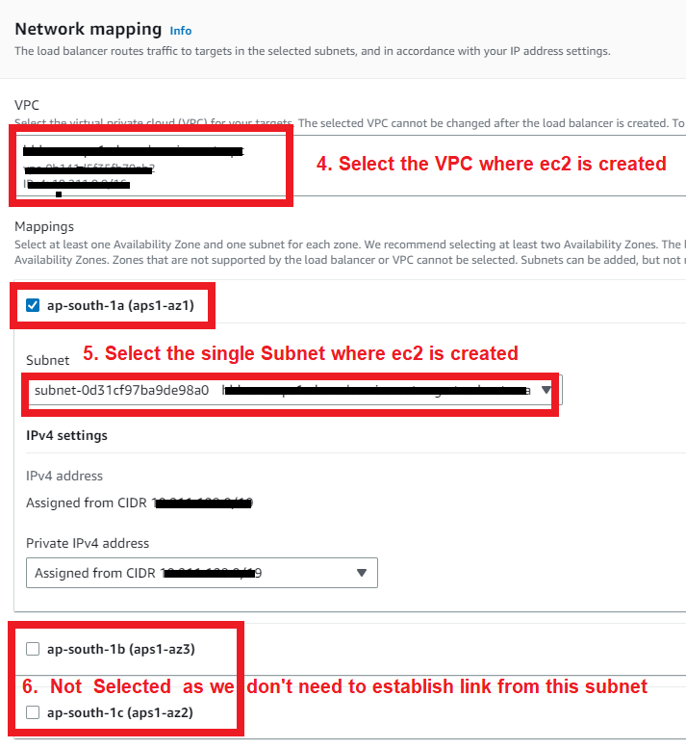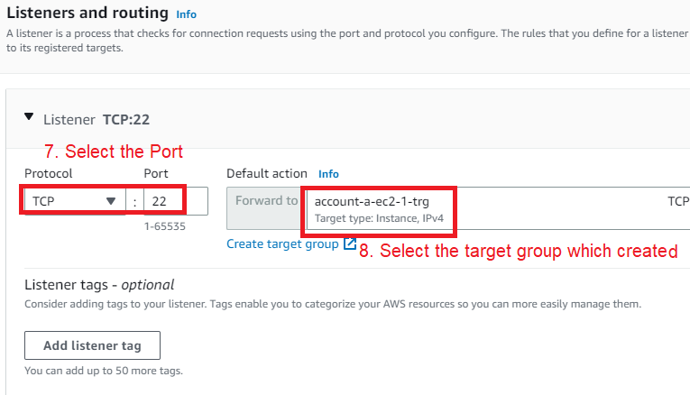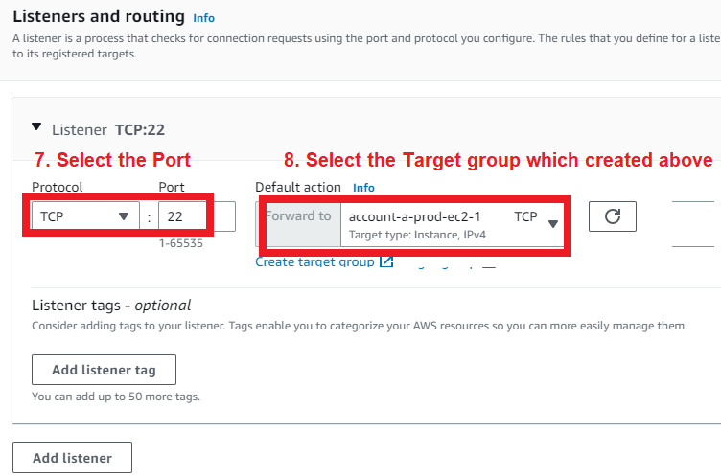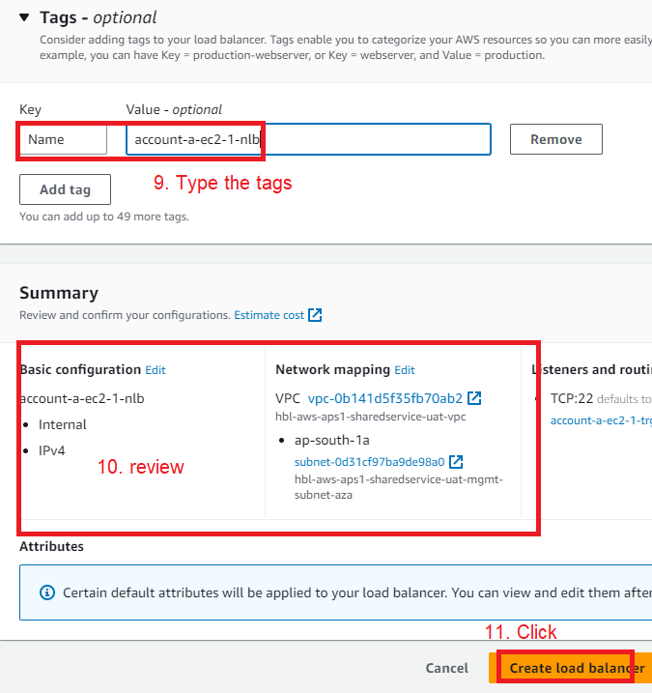

## **Endpoint Service – Account A**

### **Create endpoint service**

* We need to **endpoint Service** for endpoint traffic.
* Type = **endpoint** in search bar 🡪 Click **Endpoint Service**

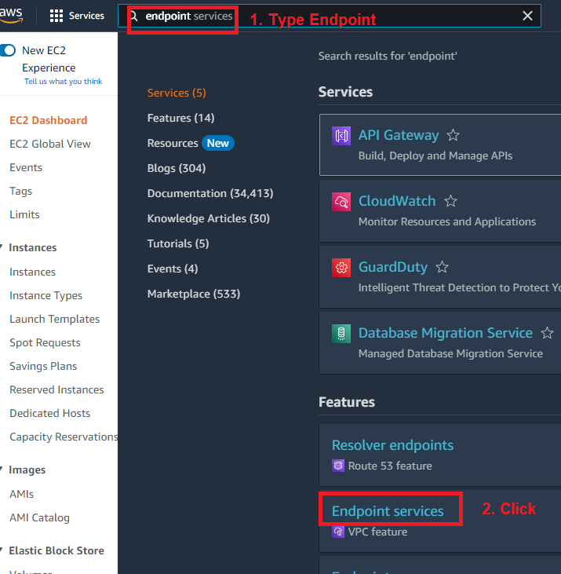

* Click on Create endpoint services.

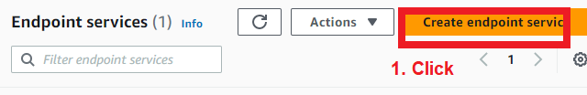

* Select the Following

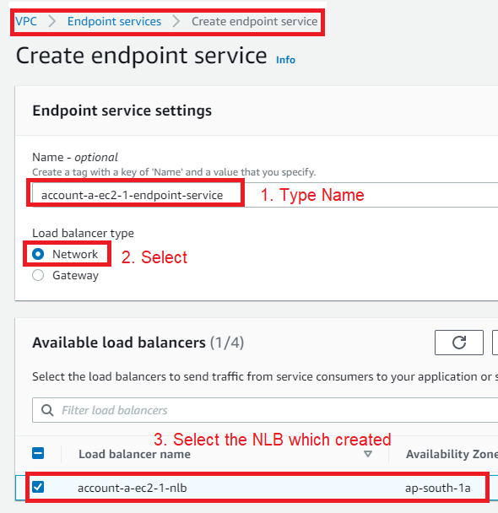

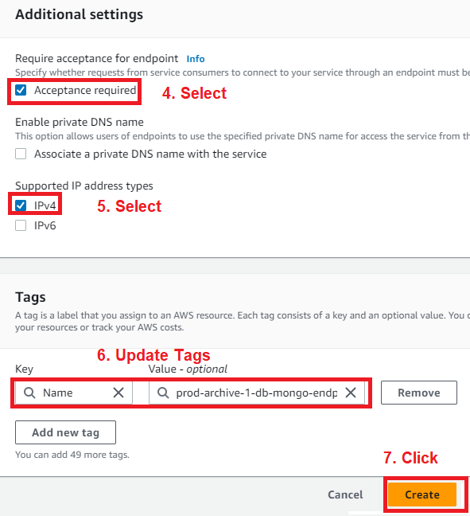

### **Allow Principle for endpoint service**

* Select the Created **Endpoint Service** 🡪 Click on **Allow principals** 🡪 Click **Allow principals**

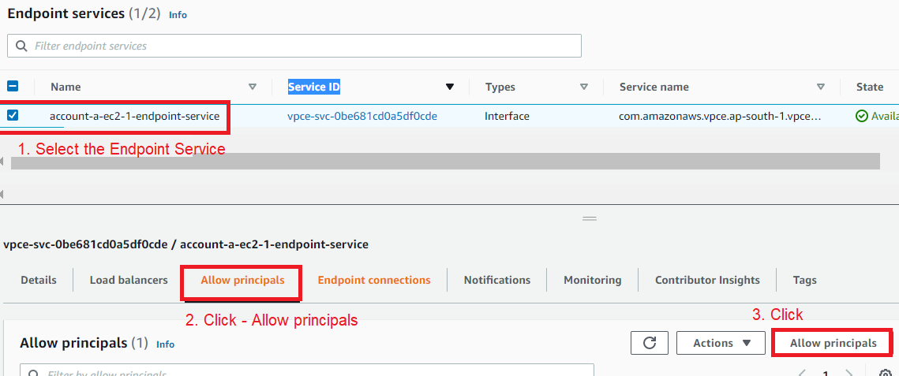

* Type the **ARN of Account B** 🡪 Click **Allow principals**

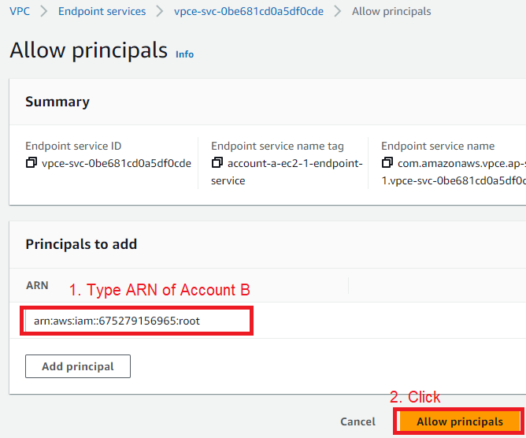

# **Account B**

## **Target Group**

* We need to **create target group** for above instances.
* Type = **target** in search bar 🡪 Click on **Target Group**



* Click on **Create target group**



* Select the following



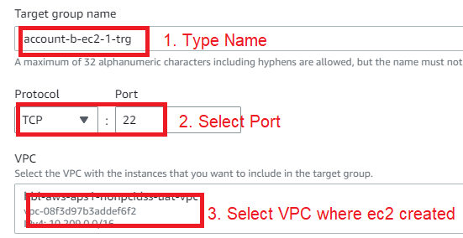

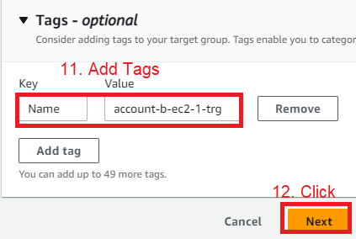

Select the Target **EC2** 🡪 Type the Require **Port** 🡪 Click on **Include as pending below**

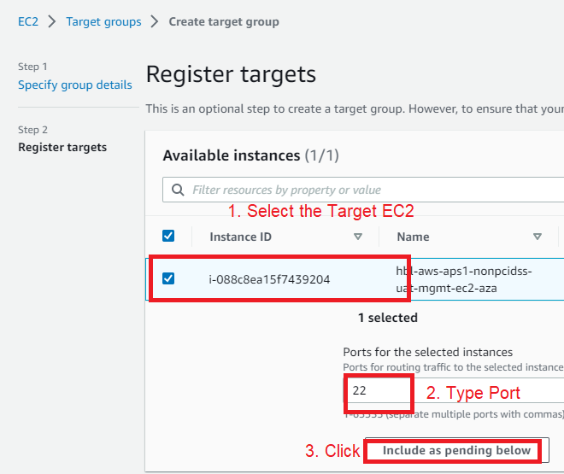

Review the target group 🡪 Click on **Create target group**



## **NLB – Account B**

* We need to **create 5 Network Load Balancer** for above instances.
* Type = **load** in Search bar 🡪 Click on **Load Balansers**

* Click on **Create load Balancers**

* Click on NLB



* Select the Following

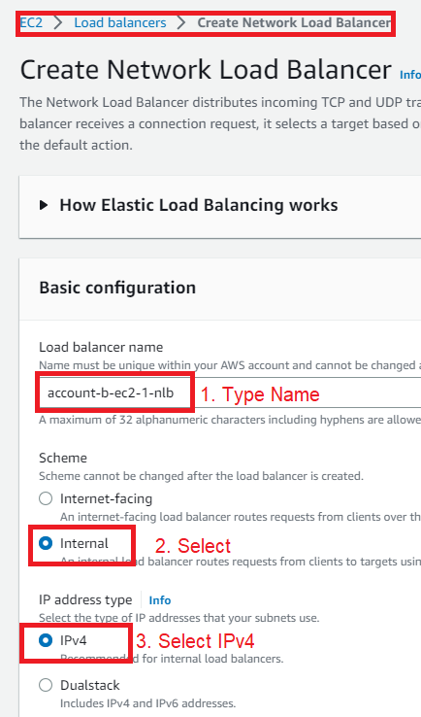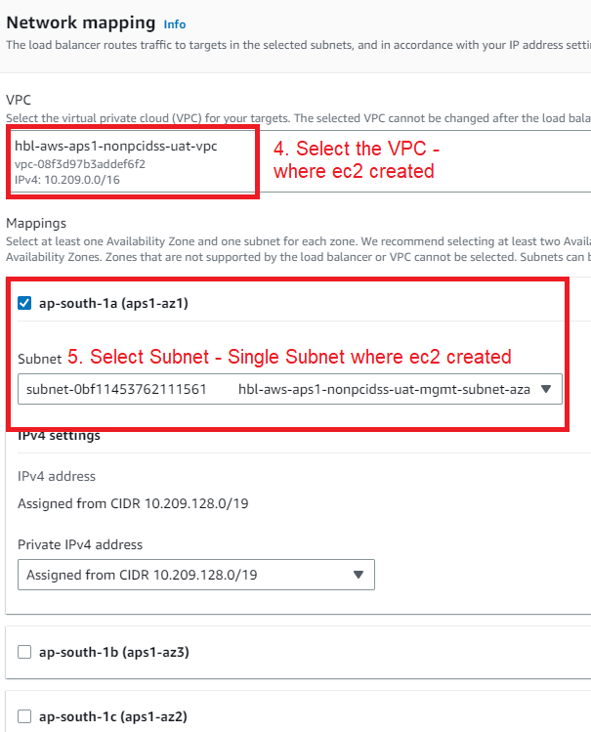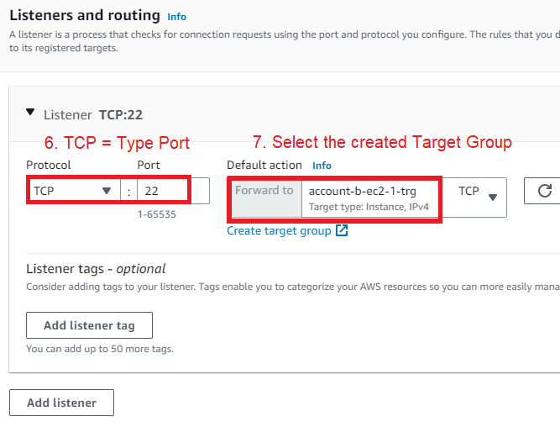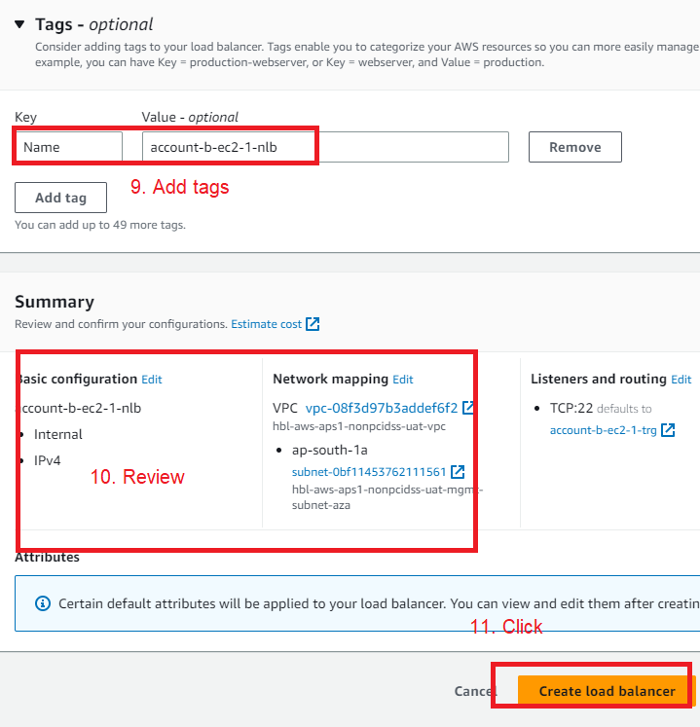

## **Endpoint Service – Account B**

### **Create endpoint service**

* We need to **endpoint Service** for above instances.
* Type = **endpoint** in search bar 🡪 Click **Endpoint Service**



* Click on Create endpoint services.



* Select the Following

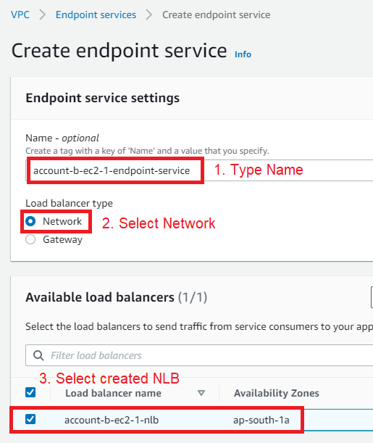



### **Allow Principle for endpoint service**

* Select the Created **Endpoint Servive** 🡪 Click on **Allow principals** 🡪 Click **Allow principals**



* Type the **ARN of Account B** 🡪 Click **Allow principals**



# **Create Endpoint**

* **Endpoint Service Name** of cross Account is required to create endpoint

## **How to get endpoint service name.**

* Open **VPC Dashboard** 🡪 Click on **Endpoint Service** 🡪 Select the Created Endpoint Service 🡪 Copy and Provide the **Service Name** to Cross Account Owner

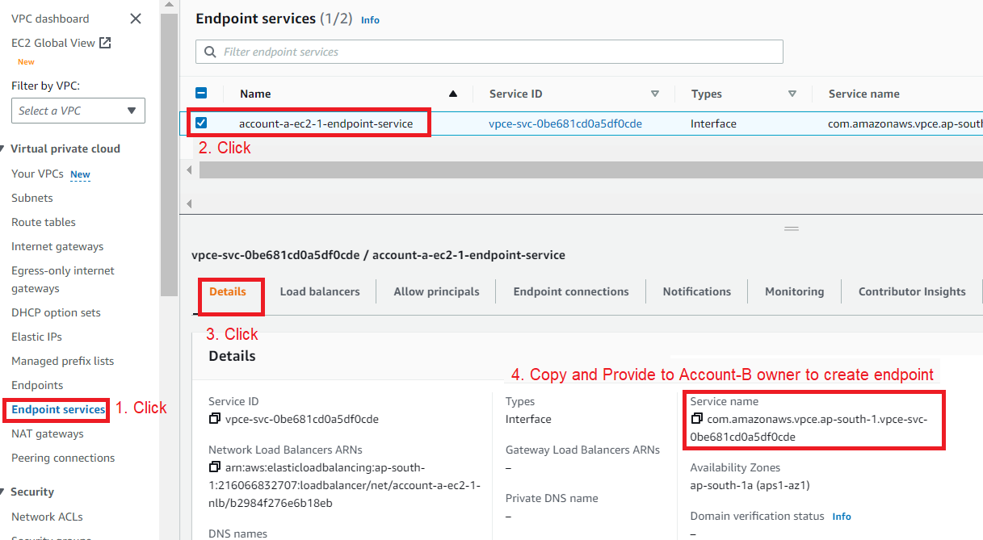

## **Create Endpoint – Account-A**

* **Endpoint Service Name** of **Account B** = com.amazonaws.vpce.ap-south-1.vpce-svc-0cb0097722a2cb011
* Open **VPC Dashboard** 🡪 Click on **Endpoint** 🡪 Click **Create endpoint**

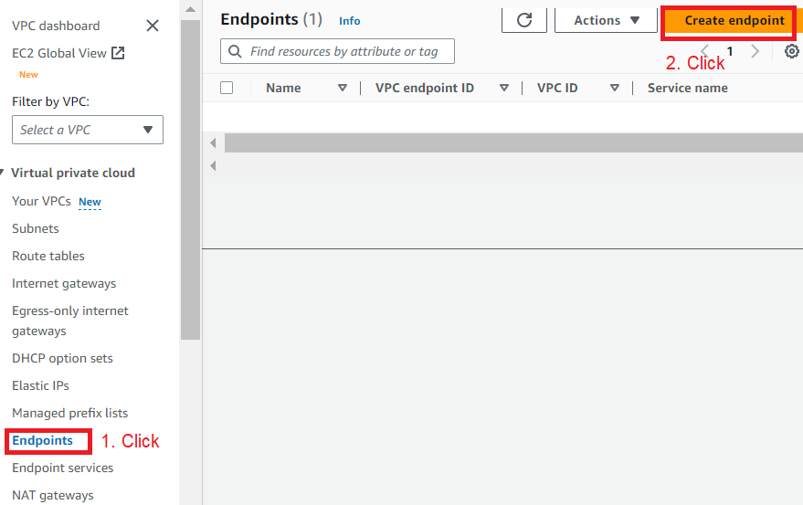

* Type **Name** 🡪 Select **Other endpoint services** 🡪 Type the **Other Account endpoint service name** in service name 🡪 Click **Verify**

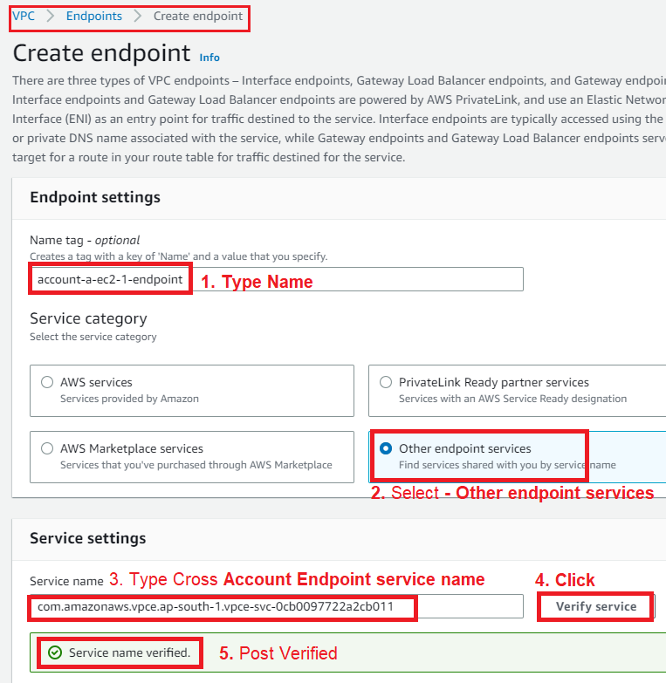

* Select the VPC 🡪 Select IPv4

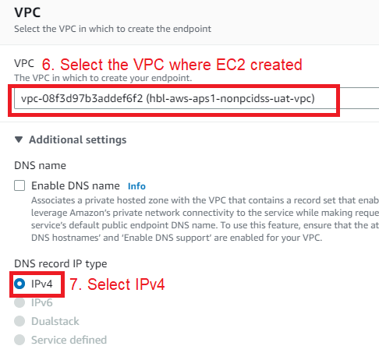

* Select the **Availability Zone** in Subnet Section 🡪 Select the **Subnet ID** (Where EC2 created)

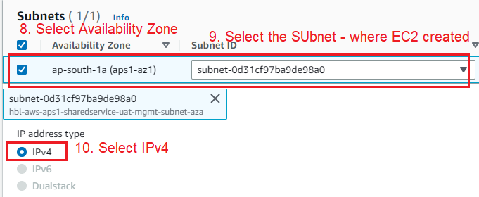

* Select the Security Group

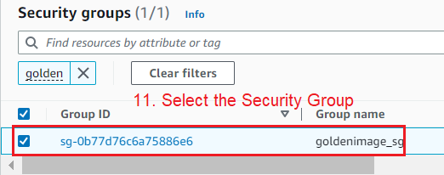

* Add Tags 🡪 Click **Create endpoint**

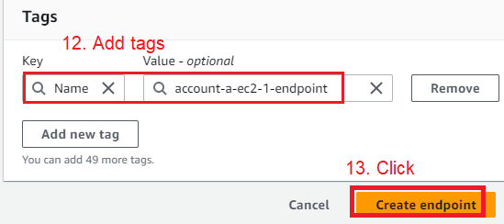

## **Create Endpoint – Account-B**

* Endpoint Service Name of Account A = com.amazonaws.vpce.ap-south-1.vpce-svc-0be681cd0a5df0cde
* Open **VPC Dashboard** 🡪 Click on **Endpoint** 🡪 Click **Create endpoint**



* Type **Name** 🡪 Select **Other endpoint services** 🡪 Type the **Other Account endpoint service name** in service name 🡪 Click **Verify**

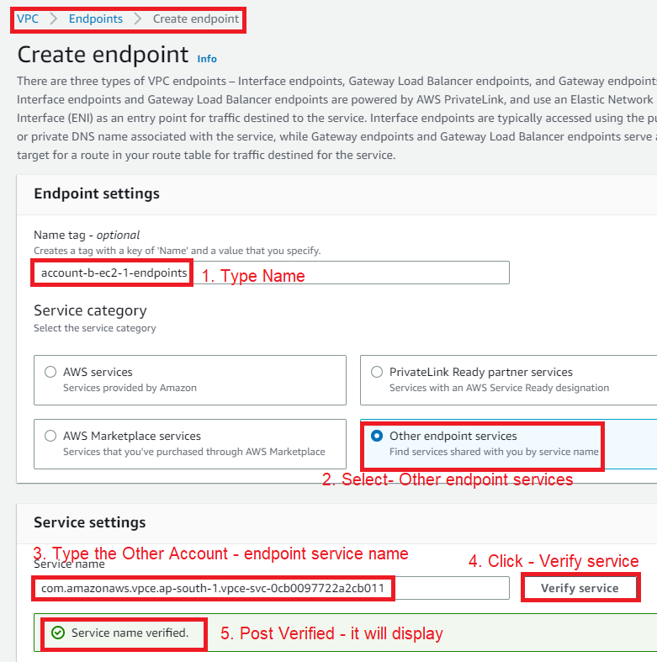

* Select the **VPC** (where EC2 created) 🡪 Select **IPv4**



* Select the Availability Zone in Subnet Section 🡪 Select the Subnet ID (Where EC2 created)

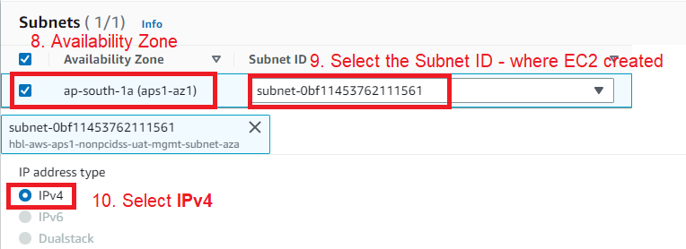

* Select the **Security Group** 🡪 Add Tag 🡪 Click **create endpoint**

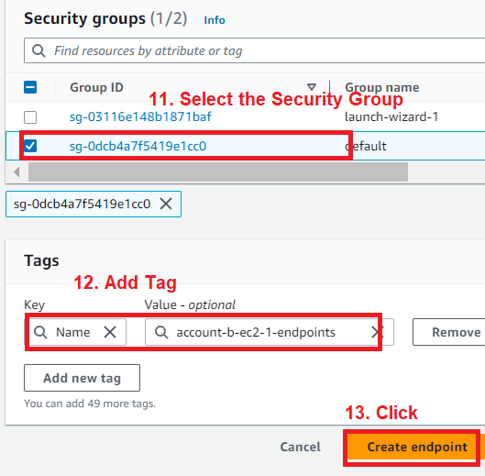

# **Accept the Endpoint Request**

* To establish Connection **Cross Account Admin** must **accept** the Endpoint Creation request.

## **Accept Request – Account-A**

* Click **VPC Dashboard** 🡪 Click **Endpoint Service** 🡪 Select Created Endpoint Service 🡪 Click Endpoint Connect 🡪 Select the Request 🡪 Click **Action** 🡪 Click **Accept endpoint connection request**

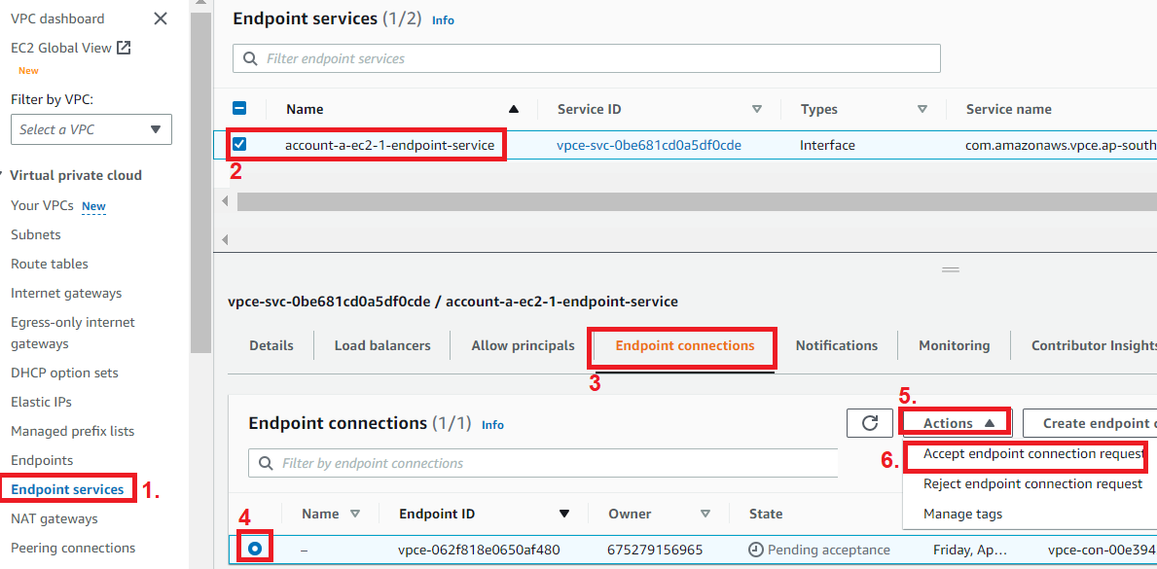

## **Accept Request – Account-B**

* Click **VPC Dashboard** 🡪 Click **Endpoint Service** 🡪 Select Created Endpoint Service 🡪 Click Endpoint Connect 🡪 Select the Request 🡪 Click **Action** 🡪 Click **Accept endpoint connection request**

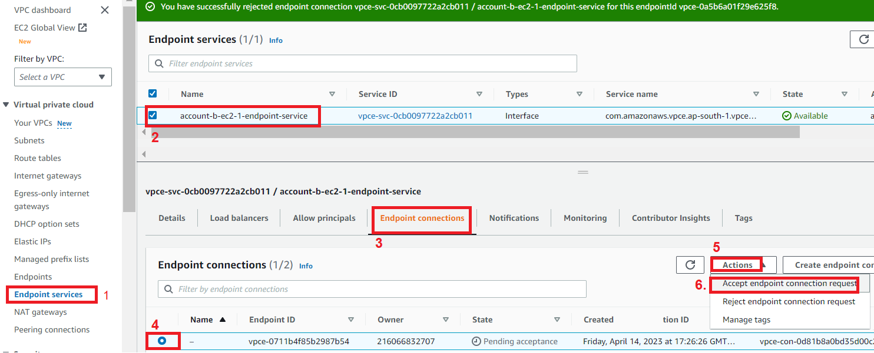

# **Update the Security Group of EC2**

* Update the Security Group of EC2 which accept the Request.

# **How to Connect to Cross Account EC2.**

* Open **VPC Dashboard** 🡪 Click **Endpoints** 🡪 Select Created endpoint 🡪 Click **Subnet** 🡪Ip address reflected in IPv4 address – This Can use to access Cross Account EC2.

