Large Mixed-Content Test Document
A ~10 MB ODT with text, images, tables and graphs, for load and rendering tests. Generated content; not for publication.

1. Section 1: collaborative editing under load
The quick brown fox jumps over the lazy dog while the collaborative editor reflows the paragraph and repaints the affected tiles. Real-time editing keeps every view in sync as text is inserted, styles are applied and tables are resized. This document exists to exercise loading, layout and rendering of a large mixed-content file across the whole stack. The quick brown fox jumps over the lazy dog while the collaborative editor reflows the paragraph and repaints
The quick brown fox jumps over the lazy dog while the collaborative editor reflows the paragraph and repaints the affected tiles. Real-time editing keeps every view in sync as text is inserted, styles are applied and tables are resized. This document exists to exercise loading, layout and rendering of a large mixed-content file across the whole stack. The quick brown fox jumps over the lazy dog while the collaborative editor reflow
The quick brown fox jumps over the lazy dog while the collaborative editor reflows the paragraph and repaints the affected tiles. Real-time editing keeps every view in sync as text is inserted, styles are applied and tables are resized. This document exists to exercise loading, layout and rendering of a large mixed-content file across the whole stack. The quick brown fox jumps over the lazy dog while the collaborative editor reflows the paragraph and re
The quick brown fox jumps over the lazy dog while the collaborative editor reflows the paragraph and repaints the affected tiles. Real-time editing keeps every view in sync as text is inserted, styles are applied and tables are resized. This document exists to exercise loading, layout and rendering of a large mixed-content file across the whole stack. The quick brown fox jumps over the lazy dog while the collaborative editor reflows the paragraph and repaints the affected tiles. Real-time editing keeps every view in sync as text is inserted, styles are applied and tables are r

1.1 Measurements
Metric | Q1 | Q2 | Q3 | Q4
row 1 | 6718.25 | 848.46 | 7666.38 | 2375.49
row 2 | 317.80 | 7889.05 | 3467.08 | 6235.96
row 3 | 6161.38 | 1493.91 | 1838.89 | 1152.87
row 4 | 156.03 | 4872.16 | 9648.40 | 654.91
row 5 | 5414.93 | 4663.86 | 6018.02 | 898.31
row 6 | 5793.66 | 2702.89 | 5568.20 | 6449.25
Table 1: sampled metrics for section 1.

Figure 1: synthetic illustration.

2. Section 2: collaborative editing under load
The quick brown fox jumps over the lazy dog while the collaborative editor reflows the paragraph and repaints the affected tiles. Real-time editing keeps every view in sync as text is inserted, styles are applied and tables are resized. This document exists to exercise loading, layout and rendering of a large mixed-content file across the whole stack. The quick brown fox jumps over the lazy dog while the collaborative editor reflows t
The quick brown fox jumps over the lazy dog while the collaborative editor reflows the paragraph and repaints the affected tiles. Real-time editing keeps every view in sync as text is inserted, styles are applied and tables are resized. This document exists to exercise loading, layout and rendering of a large mixed-content file across the whole stack. The quick brown fox jumps over the lazy dog while the collaborative editor reflows the paragraph and repaints the affected tiles. Real-time editing keeps every view in sync as text is inse
The quick brown fox jumps over the lazy dog while the collaborative editor reflows the paragraph and repaints the affected tiles. Real-time editing keeps every view in sync as text is inserted, styles are applied and tables are resized. This document exists to exercise loading, layout and rendering of a large mixed-content file across the whole stack. The quick brown fox jumps over the lazy dog while the collaborative editor reflows the paragraph and repaints the affecte
The quick brown fox jumps over the lazy dog while the collaborative editor reflows the paragraph and repaints the affected tiles. Real-time editing keeps every view in sync as text is inserted, styles are applied and tables are resized. This document exists to exercise loading, layout and rendering of a large mixed-content file across the whole stack. The quick brown fox jumps over the lazy dog while the collaborative editor reflows the paragraph and repaints the affected tiles. Real-time editing keeps every view in sync as text is inserte

2.1 Measurements
Metric | Q1 | Q2 | Q3 | Q4
row 1 | 3396.81 | 2875.10 | 949.40 | 8886.87
row 2 | 8333.84 | 7342.62 | 5702.26 | 3360.39
row 3 | 5278.91 | 6019.21 | 6586.81 | 4088.66
row 4 | 4427.32 | 1834.78 | 1075.30 | 9009.54
row 5 | 3318.49 | 5879.93 | 9735.65 | 1909.09
row 6 | 5181.44 | 3969.58 | 3185.94 | 5133.07
row 7 | 6378.69 | 9463.74 | 6418.70 | 3309.88
row 8 | 7263.10 | 6142.18 | 2627.93 | 8703.41
row 9 | 772.63 | 9121.16 | 4511.64 | 6115.85
row 10 | 115.00 | 373.00 | 6105.17 | 1087.98
row 11 | 6644.54 | 7011.62 | 1799.03 | 5737.68
Table 2: sampled metrics for section 2.
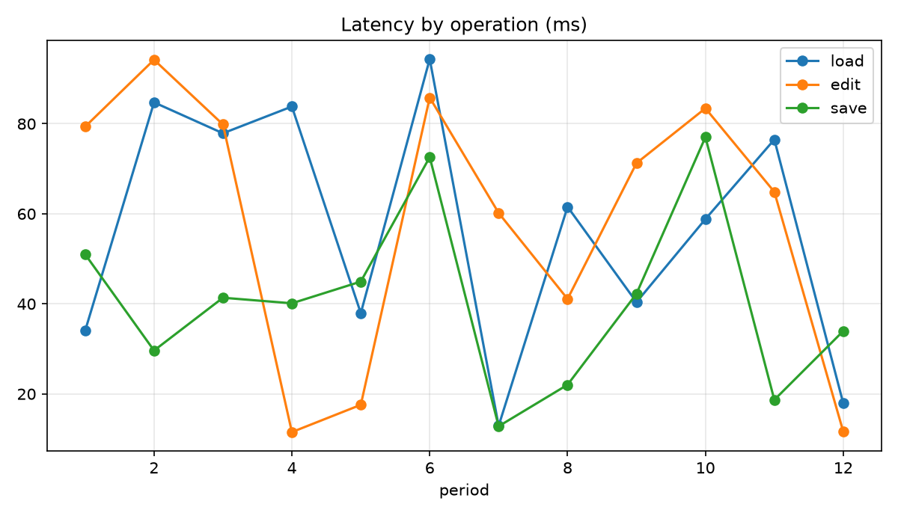
Graph 1: line chart.

3. Section 3: collaborative editing under load
The quick brown fox jumps over the lazy dog while the collaborative editor reflows the paragraph and repaints the affected tiles. Real-time editing keeps every view in sync as text is inserted, styles are applied and tables are resized. This document exists to exercise loading, layout and rendering of a large mixed-content file across the whole stack. The quick brown fox jumps over the lazy dog while the collaborative editor reflows the p
The quick brown fox jumps over the lazy dog while the collaborative editor reflows the paragraph and repaints the affected tiles. Real-time editing keeps every view in sync as text is inserted, styles are applied and tables are resized. This document exists to exercise loading, layout and rendering of a large mixed-content file across the whole stack. The quick brown fox jumps over the lazy dog while the collaborative editor reflows the paragraph and repaints the affected tiles. Real-time editing keeps every view in sync as text is inserted, styles are applied and tables are resized. T
The quick brown fox jumps over the lazy dog while the collaborative editor reflows the paragraph and repaints the affected tiles. Real-time editing keeps every view in sync as text is inserted, styles are applied and tables are resized. This document exists to exercise loading, layout and rendering of a large mixed-content file across the whole stack. The quick brown fox jumps over the lazy dog while the collaborative editor reflows the paragraph and repaints the affected tiles. Real-time editing keeps every view i

3.1 Measurements
Metric | Q1 | Q2 | Q3 | Q4
row 1 | 6141.51 | 5985.97 | 5035.86 | 9482.71
row 2 | 4359.15 | 3606.76 | 189.10 | 9145.61
row 3 | 1927.68 | 1667.68 | 8589.61 | 2300.08
row 4 | 4239.21 | 6253.28 | 7012.38 | 6554.59
row 5 | 3799.35 | 6665.05 | 7167.49 | 3861.57
row 6 | 5703.46 | 2604.62 | 3583.85 | 9537.14
row 7 | 6959.29 | 8700.76 | 8083.03 | 6169.66
row 8 | 2496.10 | 1685.00 | 6037.94 | 5812.67
row 9 | 7403.23 | 594.91 | 4200.73 | 8666.27
row 10 | 9072.82 | 6378.01 | 7807.27 | 7876.69
Table 3: sampled metrics for section 3.

Figure 2: synthetic illustration.

4. Section 4: collaborative editing under load
The quick brown fox jumps over the lazy dog while the collaborative editor reflows the paragraph and repaints the affected tiles. Real-time editing keeps every view in sync as text is inserted, styles are applied and tables are resized. This document exists to exercise loading, layout and rendering of a large mixed-content file across the whole stack. The quick brown fox jumps over the lazy dog while the collaborative editor reflows the paragraph and repaints the affected tiles. Real-time editing keeps every view in sync as text is inserted, styles are applied and tables are re
The quick brown fox jumps over the lazy dog while the collaborative editor reflows the paragraph and repaints the affected tiles. Real-time editing keeps every view in sync as text is inserted, styles are applied and tables are resized. This document exists to exercise loading, layout and rendering of a large mixed-content file across the whole stack. The quick brown fox jumps over the lazy dog while the collaborative editor reflows the paragraph and repaints the affected tiles. Real-time editing keeps every view in sync as text is inserted, styles are applied and tables are resized. This document exist
The quick brown fox jumps over the lazy dog while the collaborative editor reflows the paragraph and repaints the affected tiles. Real-time editing keeps every view in sync as text is inserted, styles are applied and tables are resized. This document exists to exercise loading, layout and rendering of a large mixed-content file across the whole stack. The quick brown fox jumps over the lazy dog while the collaborative editor reflows the paragraph and repaints the affected tiles. Real-time editing keeps every view in sync as text is inserted, styles are applied an
The quick brown fox jumps over the lazy dog while the collaborative editor reflows the paragraph and repaints the affected tiles. Real-time editing keeps every view in sync as text is inserted, styles are applied and tables are resized. This document exists to exercise loading, layout and rendering of a large mixed-content file across the whole stack. The quick brown fox jumps over the lazy dog while the collaborative editor reflows the paragraph and repaints the affecte

4.1 Measurements
Metric | Q1 | Q2 | Q3 | Q4
row 1 | 6994.97 | 9610.20 | 8835.25 | 9371.22
row 2 | 8237.46 | 3443.06 | 5924.08 | 5308.82
row 3 | 1058.13 | 9151.40 | 4930.77 | 6359.62
row 4 | 8210.99 | 4251.14 | 7889.99 | 618.90
row 5 | 4119.88 | 9817.68 | 9750.22 | 8373.88
row 6 | 4146.11 | 7003.67 | 9441.48 | 6601.10
row 7 | 6032.58 | 3296.94 | 5296.40 | 1125.30
row 8 | 1857.91 | 8038.14 | 2873.47 | 7770.73
row 9 | 8465.83 | 6997.74 | 8012.45 | 7222.15
row 10 | 8596.54 | 778.34 | 2746.03 | 9488.46
row 11 | 1691.44 | 5003.99 | 8647.11 | 6403.71
row 12 | 1729.13 | 509.07 | 9877.33 | 6465.64
Table 4: sampled metrics for section 4.
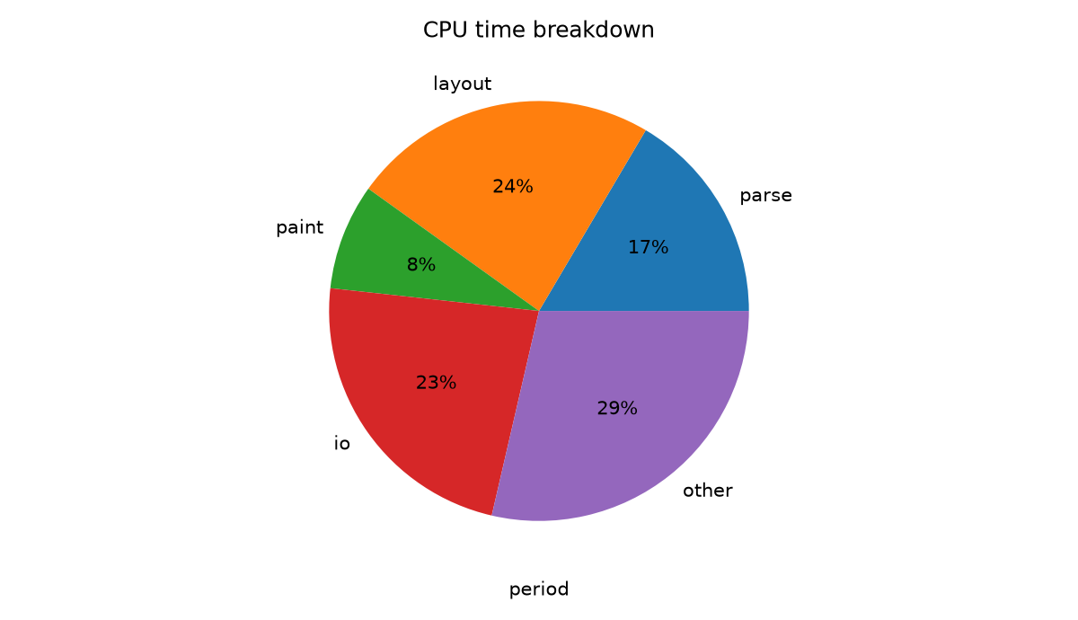
Graph 2: pie chart.

5. Section 5: collaborative editing under load
The quick brown fox jumps over the lazy dog while the collaborative editor reflows the paragraph and repaints the affected tiles. Real-time editing keeps every view in sync as text is inserted, styles are applied and tables are resized. This document exists to exercise loading, layout and rendering of a large mixed-content file across the whole stack. The quick brown fox jumps over the lazy dog while the collaborative editor reflows the paragr
The quick brown fox jumps over the lazy dog while the collaborative editor reflows the paragraph and repaints the affected tiles. Real-time editing keeps every view in sync as text is inserted, styles are applied and tables are resized. This document exists to exercise loading, layout and rendering of a large mixed-content file across the whole stack. The quick brown fox jumps over the lazy dog while the collaborative editor reflows the paragraph and repaints the affected tiles. Real-time editing keeps e
The quick brown fox jumps over the lazy dog while the collaborative editor reflows the paragraph and repaints the affected tiles. Real-time editing keeps every view in sync as text is inserted, styles are applied and tables are resized. This document exists to exercise loading, layout and rendering of a large mixed-content file across the whole stack. The quick brown fox jumps over the lazy dog while the collaborative editor reflows the paragraph and repaints the affected tiles. Real-time editing keeps every view in sy
The quick brown fox jumps over the lazy dog while the collaborative editor reflows the paragraph and repaints the affected tiles. Real-time editing keeps every view in sync as text is inserted, styles are applied and tables are resized. This document exists to exercise loading, layout and rendering of a large mixed-content file across the whole stack. The quick brown fox jumps over the lazy dog while the collaborative editor reflows the paragraph and repaints the affected tiles. Real-t

5.1 Measurements
Metric | Q1 | Q2 | Q3 | Q4
row 1 | 3981.11 | 5011.36 | 1415.90 | 4080.57
row 2 | 1982.91 | 6134.00 | 2659.55 | 4588.85
row 3 | 8220.71 | 1755.79 | 3988.17 | 8467.16
row 4 | 6894.93 | 9876.19 | 1467.90 | 6596.52
row 5 | 2253.84 | 3969.17 | 5859.71 | 2396.32
row 6 | 3242.97 | 9779.09 | 2102.45 | 1310.24
Table 5: sampled metrics for section 5.

Figure 3: synthetic illustration.

6. Section 6: collaborative editing under load
The quick brown fox jumps over the lazy dog while the collaborative editor reflows the paragraph and repaints the affected tiles. Real-time editing keeps every view in sync as text is inserted, styles are applied and tables are resized. This document exists to exercise loading, layout and rendering of a large mixed-content file across the whole stack. The quick brown fox jumps over the lazy dog while the collaborative editor reflows the paragraph and repaints the affected tiles. Real-time editing keeps every view in sync as text is inserted, styles are applied
The quick brown fox jumps over the lazy dog while the collaborative editor reflows the paragraph and repaints the affected tiles. Real-time editing keeps every view in sync as text is inserted, styles are applied and tables are resized. This document exists to exercise loading, layout and rendering of a large mixed-content file across the whole stack. The quick brown fox jumps over the lazy dog while the collaborative editor reflows the paragraph and rep
The quick brown fox jumps over the lazy dog while the collaborative editor reflows the paragraph and repaints the affected tiles. Real-time editing keeps every view in sync as text is inserted, styles are applied and tables are resized. This document exists to exercise loading, layout and rendering of a large mixed-content file across the whole stack. The quick brown fox jumps over the lazy dog while the collaborative editor reflows the paragraph and repaints the affected tiles. Real-t

6.1 Measurements
Metric | Q1 | Q2 | Q3 | Q4
row 1 | 9995.32 | 611.65 | 3857.68 | 6677.89
row 2 | 585.89 | 429.94 | 3321.80 | 764.27
row 3 | 5946.75 | 1199.66 | 6312.63 | 1749.77
row 4 | 8525.51 | 7890.47 | 3190.62 | 2133.39
row 5 | 187.50 | 1053.24 | 8031.99 | 6750.31
row 6 | 3330.47 | 6503.62 | 128.16 | 1723.59
Table 6: sampled metrics for section 6.
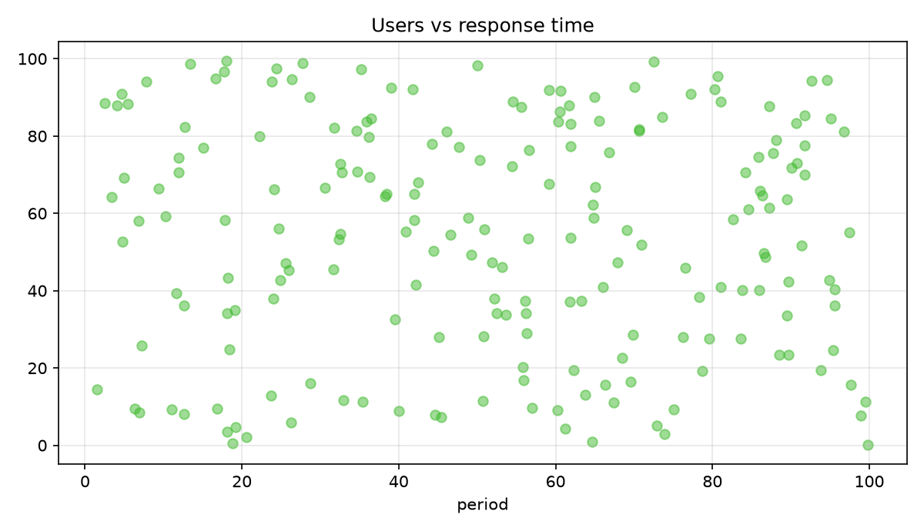
Graph 3: scatter chart.

7. Section 7: collaborative editing under load
The quick brown fox jumps over the lazy dog while the collaborative editor reflows the paragraph and repaints the affected tiles. Real-time editing keeps every view in sync as text is inserted, styles are applied and tables are resized. This document exists to exercise loading, layout and rendering of a large mixed-content file across the whole stack. The quick brown fox jumps over the lazy dog while the collaborative editor reflows the paragraph and repaints the affected
The quick brown fox jumps over the lazy dog while the collaborative editor reflows the paragraph and repaints the affected tiles. Real-time editing keeps every view in sync as text is inserted, styles are applied and tables are resized. This document exists to exercise loading, layout and rendering of a large mixed-content file across the whole stack. The quick brown fox jumps over the lazy dog while the collaborative editor reflows the paragraph and repaints the affected tiles. Real-time editing keeps eve
The quick brown fox jumps over the lazy dog while the collaborative editor reflows the paragraph and repaints the affected tiles. Real-time editing keeps every view in sync as text is inserted, styles are applied and tables are resized. This document exists to exercise loading, layout and rendering of a large mixed-content file across the whole stack. The quick brown fox jumps over the lazy dog while the collaborative editor reflows the paragraph and repaints the affected tiles. Real-time editing keeps every view in sync as text is inserted,
The quick brown fox jumps over the lazy dog while the collaborative editor reflows the paragraph and repaints the affected tiles. Real-time editing keeps every view in sync as text is inserted, styles are applied and tables are resized. This document exists to exercise loading, layout and rendering of a large mixed-content file across the whole stack. The quick brown fox jumps over the lazy dog while the collaborative editor reflows the paragraph and repaints the affected tiles. Real-time editing keeps every view in sync

7.1 Measurements
Metric | Q1 | Q2 | Q3 | Q4
row 1 | 4720.18 | 7181.04 | 3706.18 | 3506.22
row 2 | 5376.86 | 9809.47 | 6377.13 | 1041.80
row 3 | 7946.37 | 9773.46 | 5788.02 | 1892.12
row 4 | 7503.97 | 883.13 | 9617.80 | 2512.52
row 5 | 3017.17 | 7217.44 | 6561.02 | 6792.54
row 6 | 1958.94 | 409.86 | 4943.47 | 6296.70
row 7 | 1370.13 | 7018.12 | 7790.04 | 2903.92
row 8 | 9351.92 | 6467.52 | 9237.09 | 4875.36
row 9 | 8185.63 | 280.05 | 4189.96 | 5327.60
row 10 | 5788.74 | 7660.94 | 1583.12 | 974.54
row 11 | 3257.77 | 5205.72 | 4338.76 | 9544.28
row 12 | 8507.08 | 6055.94 | 6417.32 | 5512.89
Table 7: sampled metrics for section 7.

Figure 4: synthetic illustration.

8. Section 8: collaborative editing under load
The quick brown fox jumps over the lazy dog while the collaborative editor reflows the paragraph and repaints the affected tiles. Real-time editing keeps every view in sync as text is inserted, styles are applied and tables are resized. This document exists to exercise loading, layout and rendering of a large mixed-content file across the whole stack. The quick brown fox jumps over the lazy dog while the collaborative editor reflows the paragraph and repaints the affected tile
The quick brown fox jumps over the lazy dog while the collaborative editor reflows the paragraph and repaints the affected tiles. Real-time editing keeps every view in sync as text is inserted, styles are applied and tables are resized. This document exists to exercise loading, layout and rendering of a large mixed-content file across the whole stack. The quick brown fox jumps over the lazy dog while the collaborative editor reflows the paragraph and repaints the affected tiles. Real-time editing keeps every view in sync as text is inserted, styles are applied a
The quick brown fox jumps over the lazy dog while the collaborative editor reflows the paragraph and repaints the affected tiles. Real-time editing keeps every view in sync as text is inserted, styles are applied and tables are resized. This document exists to exercise loading, layout and rendering of a large mixed-content file across the whole stack. The quick brown fox jumps over the lazy dog while the collaborative editor reflows the paragraph and repaints the affected tiles. Real-time editing keeps every view in sync as text is inserted, styles are applied and tables are resized. This document exist
The quick brown fox jumps over the lazy dog while the collaborative editor reflows the paragraph and repaints the affected tiles. Real-time editing keeps every view in sync as text is inserted, styles are applied and tables are resized. This document exists to exercise loading, layout and rendering of a large mixed-content file across the whole stack. The quick brown fox jumps over the lazy dog while the collaborative editor reflows the paragraph and repaints the affected tiles.

8.1 Measurements
Metric | Q1 | Q2 | Q3 | Q4
row 1 | 3365.59 | 9384.51 | 1782.57 | 1598.02
row 2 | 3061.50 | 5720.59 | 3095.02 | 810.13
row 3 | 4036.16 | 2291.27 | 7887.95 | 5794.97
row 4 | 3202.47 | 6627.80 | 9204.55 | 9205.57
row 5 | 8899.61 | 598.00 | 329.96 | 8453.99
row 6 | 4055.08 | 4204.66 | 4459.02 | 8150.77
Table 8: sampled metrics for section 8.
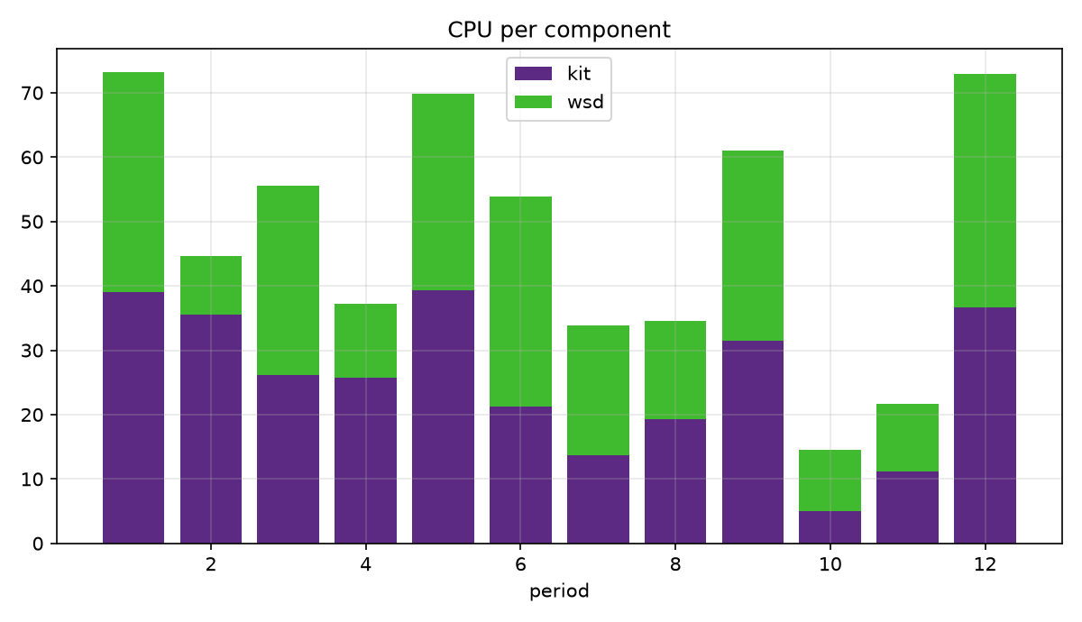
Graph 4: stacked chart.

9. Section 9: collaborative editing under load
The quick brown fox jumps over the lazy dog while the collaborative editor reflows the paragraph and repaints the affected tiles. Real-time editing keeps every view in sync as text is inserted, styles are applied and tables are resized. This document exists to exercise loading, layout and rendering of a large mixed-content file across the whole stack. The quick brown fox jumps over the lazy dog while the collaborative editor reflows the paragraph and repain
The quick brown fox jumps over the lazy dog while the collaborative editor reflows the paragraph and repaints the affected tiles. Real-time editing keeps every view in sync as text is inserted, styles are applied and tables are resized. This document exists to exercise loading, layout and rendering of a large mixed-content file across the whole stack. The quick brown fox jumps over the lazy dog while the collaborative editor reflows t
The quick brown fox jumps over the lazy dog while the collaborative editor reflows the paragraph and repaints the affected tiles. Real-time editing keeps every view in sync as text is inserted, styles are applied and tables are resized. This document exists to exercise loading, layout and rendering of a large mixed-content file across the whole stack. The quick brown fox jumps over the lazy dog while the collaborative editor reflows the paragraph and repaints the affected tile
The quick brown fox jumps over the lazy dog while the collaborative editor reflows the paragraph and repaints the affected tiles. Real-time editing keeps every view in sync as text is inserted, styles are applied and tables are resized. This document exists to exercise loading, layout and rendering of a large mixed-content file across the whole stack. The quick brown fox jumps over the lazy dog while the collaborative editor reflows the paragraph and repaints the affected tiles. Real-time editing keeps every view in sync as text is inserted, styles are applied and tables are resized. This document exis

9.1 Measurements
Metric | Q1 | Q2 | Q3 | Q4
row 1 | 9589.06 | 9580.43 | 8229.54 | 4946.46
row 2 | 4210.11 | 1718.68 | 2023.24 | 9345.31
row 3 | 5608.63 | 2261.40 | 5125.61 | 4565.60
row 4 | 1128.12 | 1809.15 | 871.32 | 1439.24
row 5 | 1399.43 | 7532.03 | 9774.45 | 8190.34
row 6 | 1941.23 | 5064.83 | 2866.33 | 7018.12
row 7 | 6557.93 | 3142.00 | 1467.82 | 8714.33
row 8 | 1005.35 | 6240.76 | 2121.93 | 6571.86
row 9 | 4521.22 | 4023.89 | 1414.39 | 5634.98
row 10 | 4078.60 | 4712.77 | 177.42 | 9689.59
row 11 | 1356.24 | 7144.90 | 4120.79 | 9633.15
Table 9: sampled metrics for section 9.

Figure 5: synthetic illustration.

10. Section 10: collaborative editing under load
The quick brown fox jumps over the lazy dog while the collaborative editor reflows the paragraph and repaints the affected tiles. Real-time editing keeps every view in sync as text is inserted, styles are applied and tables are resized. This document exists to exercise loading, layout and rendering of a large mixed-content file across the whole stack. The quick brown fox jumps over the lazy dog while the collaborative editor reflows the paragraph and repaints the affected tiles. Real-time editing keeps every view in sync as text is inserted, styles are applied and tables are
The quick brown fox jumps over the lazy dog while the collaborative editor reflows the paragraph and repaints the affected tiles. Real-time editing keeps every view in sync as text is inserted, styles are applied and tables are resized. This document exists to exercise loading, layout and rendering of a large mixed-content file across the whole stack. The quick brown fox jumps over the lazy dog while the collaborative editor reflows the paragraph and repaints the affected tiles. Real-time editin
The quick brown fox jumps over the lazy dog while the collaborative editor reflows the paragraph and repaints the affected tiles. Real-time editing keeps every view in sync as text is inserted, styles are applied and tables are resized. This document exists to exercise loading, layout and rendering of a large mixed-content file across the whole stack. The quick brown fox jumps over the lazy dog while the collaborative editor reflows the paragraph and re

10.1 Measurements
Metric | Q1 | Q2 | Q3 | Q4
row 1 | 8543.03 | 5757.77 | 9027.66 | 7084.94
row 2 | 2884.37 | 9671.36 | 3014.45 | 3958.05
row 3 | 8099.49 | 5789.67 | 9931.75 | 3699.43
row 4 | 2859.87 | 8600.69 | 3240.87 | 6318.35
row 5 | 453.83 | 6357.22 | 8174.88 | 7340.51
row 6 | 5732.38 | 3092.93 | 6400.16 | 7781.18
Table 10: sampled metrics for section 10.
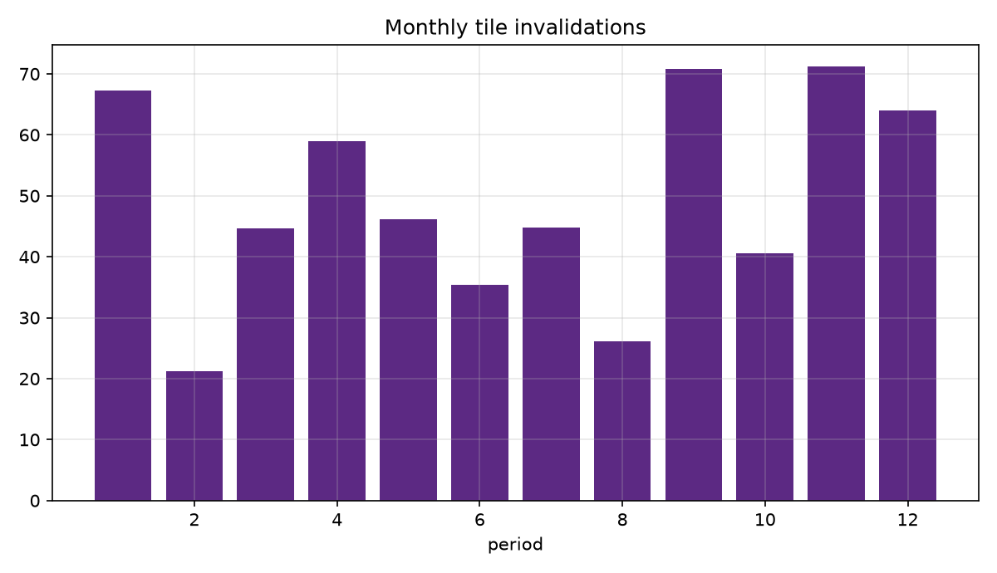
Graph 5: bar chart.

11. Section 11: collaborative editing under load
The quick brown fox jumps over the lazy dog while the collaborative editor reflows the paragraph and repaints the affected tiles. Real-time editing keeps every view in sync as text is inserted, styles are applied and tables are resized. This document exists to exercise loading, layout and rendering of a large mixed-content file across the whole stack. The quick brown fox jumps over the lazy dog while the collaborative editor reflows the paragraph and repaints the affected tiles. Real-time editing keeps
The quick brown fox jumps over the lazy dog while the collaborative editor reflows the paragraph and repaints the affected tiles. Real-time editing keeps every view in sync as text is inserted, styles are applied and tables are resized. This document exists to exercise loading, layout and rendering of a large mixed-content file across the whole stack. The quick brown fox jumps over the lazy dog while the collaborative editor reflows the paragraph and repaints the affected tiles. Real-time editing keeps every view in s
The quick brown fox jumps over the lazy dog while the collaborative editor reflows the paragraph and repaints the affected tiles. Real-time editing keeps every view in sync as text is inserted, styles are applied and tables are resized. This document exists to exercise loading, layout and rendering of a large mixed-content file across the whole stack. The quick brown fox jumps over the lazy dog while the collaborative editor reflows the paragraph and repaints
The quick brown fox jumps over the lazy dog while the collaborative editor reflows the paragraph and repaints the affected tiles. Real-time editing keeps every view in sync as text is inserted, styles are applied and tables are resized. This document exists to exercise loading, layout and rendering of a large mixed-content file across the whole stack. The quick brown fox jumps over the lazy dog while the collaborative editor reflows the paragraph and repaints the affected tiles. Real-time editing keeps every view in sync as text is inserted, styl

11.1 Measurements
Metric | Q1 | Q2 | Q3 | Q4
row 1 | 2460.71 | 2433.98 | 6102.39 | 1725.42
row 2 | 1268.86 | 820.32 | 7559.07 | 5954.90
row 3 | 5300.31 | 2418.09 | 9415.25 | 6472.55
row 4 | 6333.67 | 5518.35 | 2780.85 | 2010.47
row 5 | 7571.14 | 989.78 | 9437.95 | 1193.54
row 6 | 4664.48 | 7096.32 | 6681.96 | 5454.08
row 7 | 3905.96 | 1680.13 | 5172.51 | 6316.88
row 8 | 3818.26 | 1377.05 | 8653.34 | 4903.73
row 9 | 8651.72 | 7985.91 | 263.58 | 5925.70
row 10 | 9982.06 | 9298.37 | 2447.65 | 6354.59
Table 11: sampled metrics for section 11.

Figure 6: synthetic illustration.

12. Section 12: collaborative editing under load
The quick brown fox jumps over the lazy dog while the collaborative editor reflows the paragraph and repaints the affected tiles. Real-time editing keeps every view in sync as text is inserted, styles are applied and tables are resized. This document exists to exercise loading, layout and rendering of a large mixed-content file across the whole stack. The quick brown fox jumps over the lazy dog while the collaborative editor reflows the paragraph and repaints the affected tiles. Real-time editing keeps ev
The quick brown fox jumps over the lazy dog while the collaborative editor reflows the paragraph and repaints the affected tiles. Real-time editing keeps every view in sync as text is inserted, styles are applied and tables are resized. This document exists to exercise loading, layout and rendering of a large mixed-content file across the whole stack. The quick brown fox jumps over the lazy dog while the collaborative editor reflows the
The quick brown fox jumps over the lazy dog while the collaborative editor reflows the paragraph and repaints the affected tiles. Real-time editing keeps every view in sync as text is inserted, styles are applied and tables are resized. This document exists to exercise loading, layout and rendering of a large mixed-content file across the whole stack. The quick brown fox jumps over the lazy dog while the collaborative editor reflows
The quick brown fox jumps over the lazy dog while the collaborative editor reflows the paragraph and repaints the affected tiles. Real-time editing keeps every view in sync as text is inserted, styles are applied and tables are resized. This document exists to exercise loading, layout and rendering of a large mixed-content file across the whole stack. The quick brown fox jumps over the lazy dog while the collaborative editor reflows the paragraph and repaints the affected tiles. Real-t
The quick brown fox jumps over the lazy dog while the collaborative editor reflows the paragraph and repaints the affected tiles. Real-time editing keeps every view in sync as text is inserted, styles are applied and tables are resized. This document exists to exercise loading, layout and rendering of a large mixed-content file across the whole stack. The quick brown fox jumps over the lazy dog while the collaborative editor reflows the paragraph and repaints the affected tiles. Real-time editing keeps every view in sync as text is inserted, styles are applied and tables a

12.1 Measurements
Metric | Q1 | Q2 | Q3 | Q4
row 1 | 2735.36 | 6385.05 | 2227.75 | 8675.92
row 2 | 9841.59 | 574.82 | 2428.33 | 179.95
row 3 | 9782.87 | 4162.67 | 3137.73 | 1607.42
row 4 | 2509.00 | 2888.95 | 1128.47 | 3182.60
row 5 | 4999.48 | 2175.11 | 5614.28 | 3811.41
row 6 | 1654.37 | 7348.64 | 1441.00 | 5439.88
row 7 | 2976.14 | 3042.35 | 8280.05 | 7285.40
row 8 | 1331.39 | 1294.41 | 9251.46 | 1154.85
row 9 | 940.16 | 3967.48 | 2476.37 | 7313.42
row 10 | 5663.13 | 2276.48 | 6241.55 | 1114.69
row 11 | 2542.15 | 7833.11 | 4203.59 | 5536.92
row 12 | 3678.83 | 5806.59 | 3928.24 | 482.86
Table 12: sampled metrics for section 12.
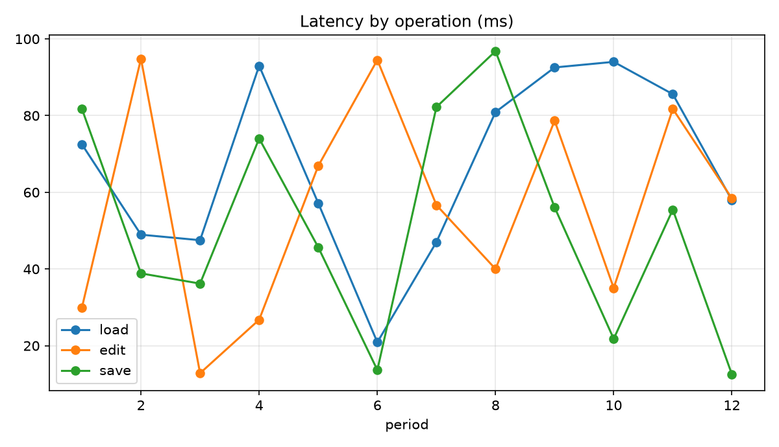
Graph 6: line chart.

13. Section 13: collaborative editing under load
The quick brown fox jumps over the lazy dog while the collaborative editor reflows the paragraph and repaints the affected tiles. Real-time editing keeps every view in sync as text is inserted, styles are applied and tables are resized. This document exists to exercise loading, layout and rendering of a large mixed-content file across the whole stack. The quick brown fox jumps over the lazy dog while the collaborative editor reflows the paragraph and repaints
The quick brown fox jumps over the lazy dog while the collaborative editor reflows the paragraph and repaints the affected tiles. Real-time editing keeps every view in sync as text is inserted, styles are applied and tables are resized. This document exists to exercise loading, layout and rendering of a large mixed-content file across the whole stack. The quick brown fox jumps over the lazy dog while the collaborative editor reflows the paragraph and repai
The quick brown fox jumps over the lazy dog while the collaborative editor reflows the paragraph and repaints the affected tiles. Real-time editing keeps every view in sync as text is inserted, styles are applied and tables are resized. This document exists to exercise loading, layout and rendering of a large mixed-content file across the whole stack. The quick brown fox jumps over the lazy dog while the collaborative editor reflows the paragraph and repaints the affected tiles. Real-time editing keeps every view in sync as text is inserted, styles are applied and tables are resized.
The quick brown fox jumps over the lazy dog while the collaborative editor reflows the paragraph and repaints the affected tiles. Real-time editing keeps every view in sync as text is inserted, styles are applied and tables are resized. This document exists to exercise loading, layout and rendering of a large mixed-content file across the whole stack. The quick brown fox jumps over the lazy dog while the collaborative editor reflows the paragraph and repaints the affected tiles. Real-time editing keeps every view in s
The quick brown fox jumps over the lazy dog while the collaborative editor reflows the paragraph and repaints the affected tiles. Real-time editing keeps every view in sync as text is inserted, styles are applied and tables are resized. This document exists to exercise loading, layout and rendering of a large mixed-content file across the whole stack. The quick brown fox jumps over the lazy dog while the collaborative editor reflows the paragraph and repaints the affected tiles. Real-time editing keeps every view in sync as text is inserted, styles are applied and tables are resized. This documen

13.1 Measurements
Metric | Q1 | Q2 | Q3 | Q4
row 1 | 6634.43 | 9468.43 | 3133.04 | 8289.99
row 2 | 3466.32 | 548.38 | 1321.22 | 5629.85
row 3 | 4397.15 | 6245.36 | 4285.27 | 2502.62
row 4 | 2078.81 | 1720.69 | 4892.81 | 5087.73
row 5 | 8433.37 | 1525.14 | 2720.57 | 6022.04
row 6 | 1450.20 | 9863.58 | 8305.74 | 4529.27
row 7 | 1445.14 | 723.88 | 525.29 | 1705.30
row 8 | 1230.63 | 1037.83 | 488.82 | 3967.36
Table 13: sampled metrics for section 13.

Figure 7: synthetic illustration.

14. Section 14: collaborative editing under load
The quick brown fox jumps over the lazy dog while the collaborative editor reflows the paragraph and repaints the affected tiles. Real-time editing keeps every view in sync as text is inserted, styles are applied and tables are resized. This document exists to exercise loading, layout and rendering of a large mixed-content file across the whole stack. The quick brown fox jumps over the lazy dog while the collaborative editor reflows the paragraph and repaints the affected tiles. Real-time editing keeps every view in sync as text is inserted, styles are applied and tables are resized.
The quick brown fox jumps over the lazy dog while the collaborative editor reflows the paragraph and repaints the affected tiles. Real-time editing keeps every view in sync as text is inserted, styles are applied and tables are resized. This document exists to exercise loading, layout and rendering of a large mixed-content file across the whole stack. The quick brown fox jumps over the lazy dog while the collaborative editor reflow
The quick brown fox jumps over the lazy dog while the collaborative editor reflows the paragraph and repaints the affected tiles. Real-time editing keeps every view in sync as text is inserted, styles are applied and tables are resized. This document exists to exercise loading, layout and rendering of a large mixed-content file across the whole stack. The quick brown fox jumps over the lazy dog while the collaborative editor reflows the paragraph and repaints
The quick brown fox jumps over the lazy dog while the collaborative editor reflows the paragraph and repaints the affected tiles. Real-time editing keeps every view in sync as text is inserted, styles are applied and tables are resized. This document exists to exercise loading, layout and rendering of a large mixed-content file across the whole stack. The quick brown fox jumps over the lazy dog while the collaborative editor reflows the paragraph and repaints the affected tiles. Real-time editing keeps every view in sync as text is inserted,
The quick brown fox jumps over the lazy dog while the collaborative editor reflows the paragraph and repaints the affected tiles. Real-time editing keeps every view in sync as text is inserted, styles are applied and tables are resized. This document exists to exercise loading, layout and rendering of a large mixed-content file across the whole stack. The quick brown fox jumps over the lazy dog while the collaborative editor reflows the paragraph and repaints the affected tiles.

14.1 Measurements
Metric | Q1 | Q2 | Q3 | Q4
row 1 | 870.82 | 6342.62 | 484.71 | 3654.40
row 2 | 9155.35 | 9482.23 | 8843.64 | 3012.08
row 3 | 6009.86 | 312.32 | 5783.21 | 1170.33
row 4 | 7340.53 | 8258.44 | 1197.73 | 4172.63
row 5 | 672.12 | 3377.51 | 2875.29 | 8858.94
row 6 | 697.16 | 3618.34 | 8622.85 | 6234.34
row 7 | 9592.15 | 9134.71 | 2901.24 | 9346.48
row 8 | 489.39 | 9557.61 | 2451.29 | 3225.61
row 9 | 7405.80 | 3470.36 | 6120.36 | 5177.12
Table 14: sampled metrics for section 14.
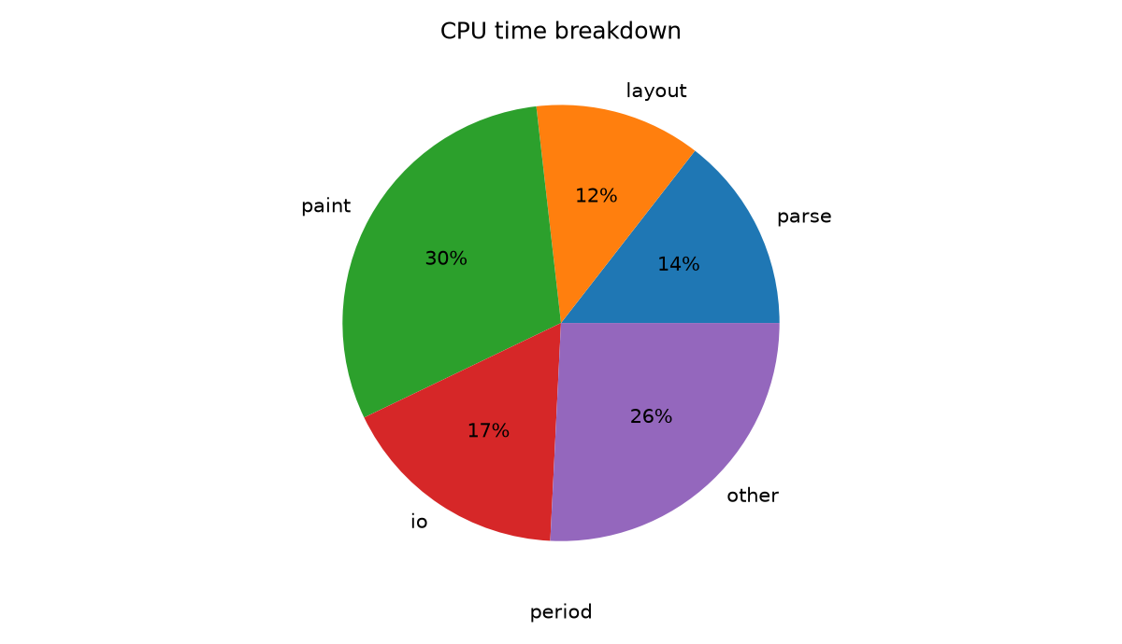
Graph 7: pie chart.

15. Section 15: collaborative editing under load
The quick brown fox jumps over the lazy dog while the collaborative editor reflows the paragraph and repaints the affected tiles. Real-time editing keeps every view in sync as text is inserted, styles are applied and tables are resized. This document exists to exercise loading, layout and rendering of a large mixed-content file across the whole stack. The quick brown fox jumps over the lazy dog while the collaborative editor reflows the paragraph and repaints the affected tiles. Real-time editing keeps every view in sync as text is inserted, styles are applied and tables are re
The quick brown fox jumps over the lazy dog while the collaborative editor reflows the paragraph and repaints the affected tiles. Real-time editing keeps every view in sync as text is inserted, styles are applied and tables are resized. This document exists to exercise loading, layout and rendering of a large mixed-content file across the whole stack. The quick brown fox jumps over the lazy dog while the collaborative editor reflows the paragraph and repaints the affected tiles. Real-time editing keeps
The quick brown fox jumps over the lazy dog while the collaborative editor reflows the paragraph and repaints the affected tiles. Real-time editing keeps every view in sync as text is inserted, styles are applied and tables are resized. This document exists to exercise loading, layout and rendering of a large mixed-content file across the whole stack. The quick brown fox jumps over the lazy dog while the collaborative editor reflows the paragraph and repaints the affected tiles. Real-time
The quick brown fox jumps over the lazy dog while the collaborative editor reflows the paragraph and repaints the affected tiles. Real-time editing keeps every view in sync as text is inserted, styles are applied and tables are resized. This document exists to exercise loading, layout and rendering of a large mixed-content file across the whole stack. The quick brown fox jumps over the lazy dog while the collaborative editor reflows the paragraph and repaints the affected tiles. Real-time editing keeps every view in sync as text is inserted, styles are applied and tables are resized. This document exists to

15.1 Measurements
Metric | Q1 | Q2 | Q3 | Q4
row 1 | 7158.48 | 8497.05 | 2532.73 | 227.07
row 2 | 959.75 | 3845.20 | 6539.53 | 592.56
row 3 | 7165.10 | 951.37 | 1530.03 | 4442.51
row 4 | 2337.79 | 334.61 | 6946.78 | 2972.47
row 5 | 228.87 | 4699.09 | 3760.88 | 9436.77
row 6 | 3960.16 | 4225.32 | 7464.44 | 7662.27
row 7 | 3836.23 | 6267.17 | 8671.23 | 5074.08
row 8 | 3442.79 | 3060.05 | 4152.11 | 9894.42
row 9 | 4484.44 | 1229.02 | 5522.16 | 8304.78
row 10 | 2055.31 | 6874.68 | 9287.79 | 4209.07
row 11 | 3169.39 | 7474.84 | 3939.17 | 2249.44
row 12 | 6750.64 | 3608.56 | 1577.71 | 2156.03
Table 15: sampled metrics for section 15.

Figure 8: synthetic illustration.

16. Section 16: collaborative editing under load
The quick brown fox jumps over the lazy dog while the collaborative editor reflows the paragraph and repaints the affected tiles. Real-time editing keeps every view in sync as text is inserted, styles are applied and tables are resized. This document exists to exercise loading, layout and rendering of a large mixed-content file across the whole stack. The quick brown fox jumps over the lazy dog while the collaborative editor reflows the paragraph and repaints the affected tiles. Real-time editing keeps every view in sync as text is inserted, styles are applied and ta
The quick brown fox jumps over the lazy dog while the collaborative editor reflows the paragraph and repaints the affected tiles. Real-time editing keeps every view in sync as text is inserted, styles are applied and tables are resized. This document exists to exercise loading, layout and rendering of a large mixed-content file across the whole stack. The quick brown fox jumps over the lazy dog while the collaborative editor reflows the paragraph and repaints the affected tiles. Real-time editing keeps every view in sync as text is inserted, styles are applied and tables are resized. This document exists
The quick brown fox jumps over the lazy dog while the collaborative editor reflows the paragraph and repaints the affected tiles. Real-time editing keeps every view in sync as text is inserted, styles are applied and tables are resized. This document exists to exercise loading, layout and rendering of a large mixed-content file across the whole stack. The quick brown fox jumps over the lazy dog while the collaborative editor reflows the paragraph and repaints the affected tiles. Real-time editing keeps every view in sync as text is inserte
The quick brown fox jumps over the lazy dog while the collaborative editor reflows the paragraph and repaints the affected tiles. Real-time editing keeps every view in sync as text is inserted, styles are applied and tables are resized. This document exists to exercise loading, layout and rendering of a large mixed-content file across the whole stack. The quick brown fox jumps over the lazy dog while the collaborative editor reflows the paragraph
The quick brown fox jumps over the lazy dog while the collaborative editor reflows the paragraph and repaints the affected tiles. Real-time editing keeps every view in sync as text is inserted, styles are applied and tables are resized. This document exists to exercise loading, layout and rendering of a large mixed-content file across the whole stack. The quick brown fox jumps over the lazy dog while the collaborative editor reflows the paragraph and repaints the affected tiles. Real-time editing keeps every view in sync as text is inserted, styles are applied and tables are resized. This document exi

16.1 Measurements
Metric | Q1 | Q2 | Q3 | Q4
row 1 | 7306.41 | 567.74 | 6861.18 | 3459.97
row 2 | 3572.01 | 4463.84 | 4502.30 | 3350.73
row 3 | 6829.45 | 1134.45 | 6283.13 | 4740.19
row 4 | 3934.78 | 9156.75 | 644.28 | 323.13
row 5 | 8818.43 | 6482.61 | 5210.92 | 9926.09
row 6 | 4203.87 | 7206.41 | 9204.51 | 500.55
row 7 | 2497.67 | 6147.23 | 8420.03 | 9394.09
row 8 | 7330.67 | 1215.85 | 1264.71 | 5375.36
row 9 | 24.57 | 4791.52 | 2019.35 | 3397.94
row 10 | 968.26 | 4256.11 | 416.51 | 2888.40
row 11 | 211.28 | 470.91 | 9002.12 | 7489.90
row 12 | 6181.41 | 3509.94 | 7931.26 | 8661.51
Table 16: sampled metrics for section 16.
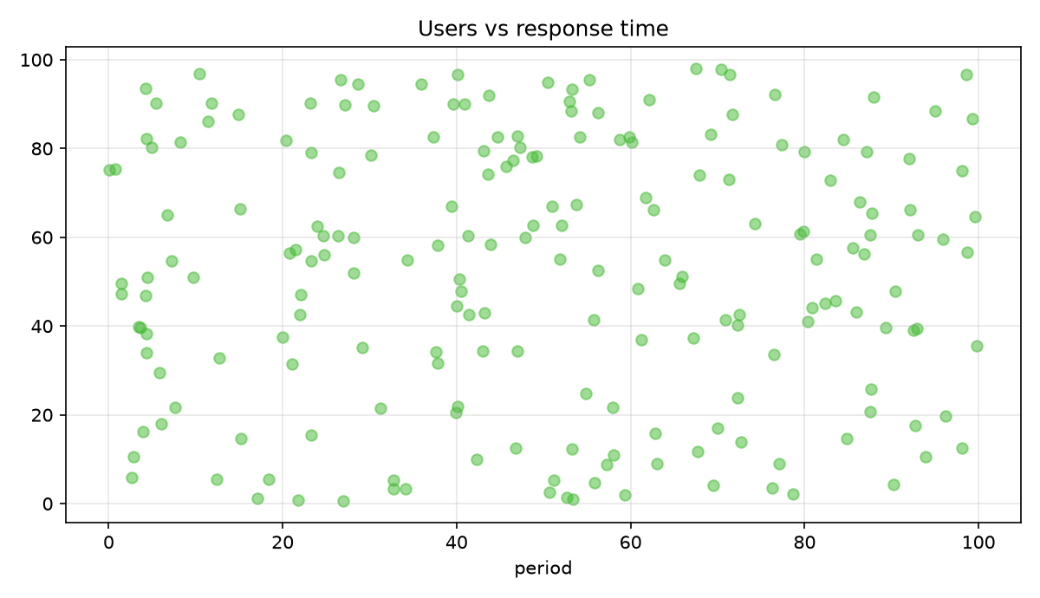
Graph 8: scatter chart.

Appendix A: figure gallery
Additional figures included to reach the target file size.

Figure 9: synthetic illustration.

Figure 10: synthetic illustration.

Figure 11: synthetic illustration.

Figure 12: synthetic illustration.

Figure 13: synthetic illustration.

Figure 14: synthetic illustration.

Figure 15: synthetic illustration.

Figure 16: synthetic illustration.

Figure 17: synthetic illustration.

Figure 18: synthetic illustration.

Figure 19: synthetic illustration.

Figure 20: synthetic illustration.

Figure 21: synthetic illustration.

Figure 22: synthetic illustration.

Figure 23: synthetic illustration.

Figure 24: synthetic illustration.

Figure 25: synthetic illustration.

Figure 26: synthetic illustration.

Figure 27: synthetic illustration.

Figure 28: synthetic illustration.

Figure 29: synthetic illustration.

Figure 30: synthetic illustration.

Figure 31: synthetic illustration.

Figure 32: synthetic illustration.

Figure 33: synthetic illustration.

Figure 34: synthetic illustration.

Figure 35: synthetic illustration.

Figure 36: synthetic illustration.

Figure 37: synthetic illustration.

Figure 38: synthetic illustration.

Figure 39: synthetic illustration.

