

${qr}

Office of the Registrar (Academic Affairs)

**${school}**

**${department}**

**FEES STRUCTURE FOR ${course} PROGRAMME (${mode})**

${table}

**NOTE:**

1. Fees may be reviewed according to prevailing circumstances
2. Fee is payable through the following bank and branches:

Cooperative Bank of Kenya Acc. No 01129079001600 (Nkrumah Rd Branch).

Standard Chartered Bank Acc. No. 0102092728000 (Treasury Square).

Equity Bank Acc. No. 0460297818058 (Digo Rd Branch).

National Bank Acc. No. 01038074211700 (TUM Branch). KCB Lamu Campus: Acc. No. 1118817192 (Mvita Branch).

KCB (TUM) Fee Collection Acc No. 1169329578 (Mvita Branch).

Barclays Bank Acc. No. 2034098894 (Nkrumah Rd Branch).

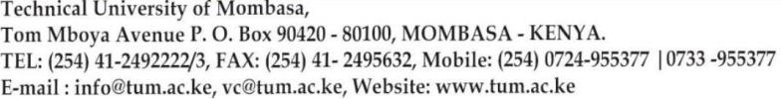 **TUM is ISO 9001:2015 Certified**