High Value Datasets

The high value dataset (here and there after denoted HVD) is a term regarding data coined by the European Comission via https://beopen-project.eu/storage/files/beopen-d42-transport-open-data-properties-and-specifications-for-open-science.pdf

The original definition for it is (https://op.europa.eu/en/publication-detail/-/publication/5b20f52a-db7e-11ea-adf7-01aa75ed71a1/language-en):

„High-value datasets means documents the re-use of which is associated with important benefits for society, the environment and the economy, in particular because of their suitability for the creation of value-added services, applications and new, high-quality and decent jobs, and of the number of potential beneficiaries of the value-added services and applications based on those datasets“

There are 5 tiers that a HVD can be:

* 1 star
** 2 star
*** 3 star
**** 4 star
***** 5 star
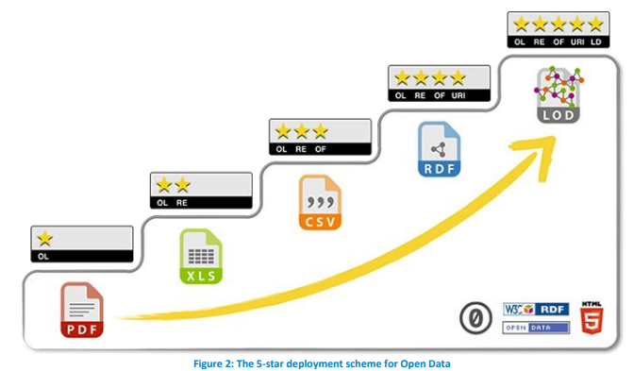
The acronyms above stand for:

OL – Open License – Data can be found on the web and used freely by any individual or organization.
RE – Machine Readable – Data can be ingested by most programming languages.
OF – Open Format – Data is structured in a one of many popular ways of storing data, e.g., via some well defined convention.
URI - Unified Resource Identifier – The data can be reached via a link on the web.
LD – Linked Data – The data can be linked with other data via one of it’s features.
HVD in Vilnius Municipality

Vilnius Municipality maintains aerial drone footage in its databases. An example image:

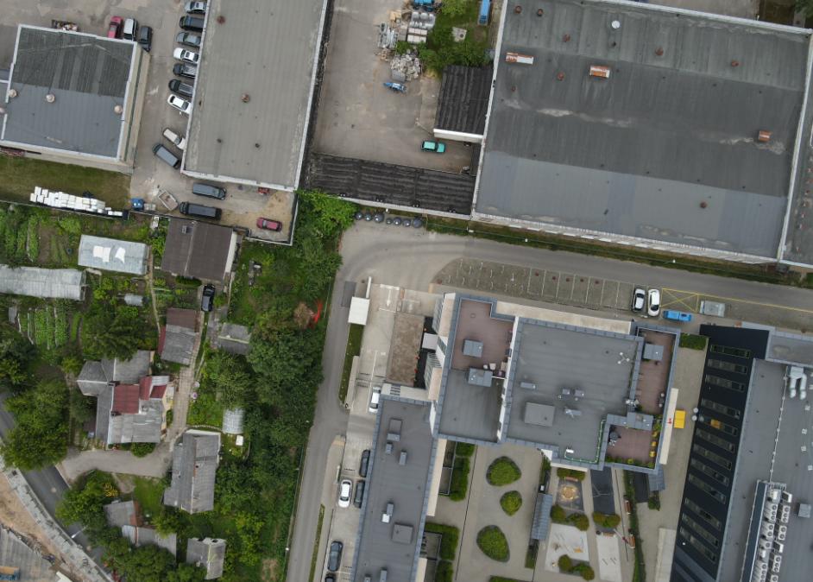
Along with this data, there are numerous meta fields associated with it:

```
ALL META FIELDS LISTED AS JSON
```

CONVERTING TO HVD

In order for the images to become a high value dataset, the following criteria need to be fulfiled:

* The images need to have encoded metadata which can be easily parsed from it.
* The metadata is generic enough to be linkable to other data sources.
* The datasets can be reached via an URL, preferably via an API.

Having the above three criteria fulfiled, we, by definition, will have a high value dataset.

