Labeling task for open/closed container identification

The objective of this task is to draw a bounding box around open hatch and closed hatch in a garbage container. Thus, the final bounding box classes are:
- open
- closed

Closed containers
The closed class is the most predominant class, because the vast majority of the garbage containers are closed.
Examples:
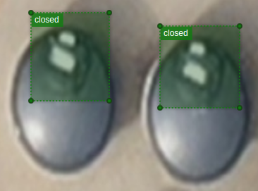
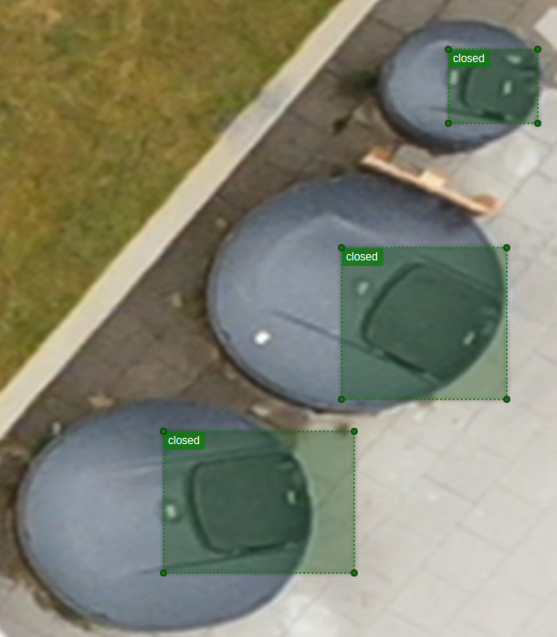

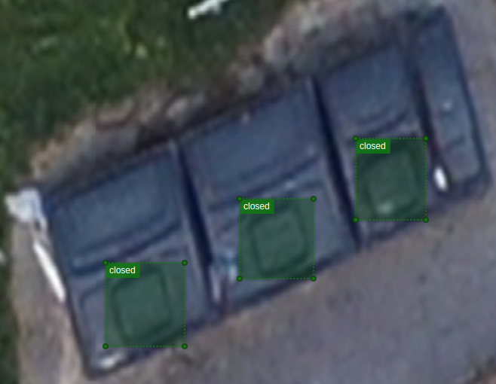
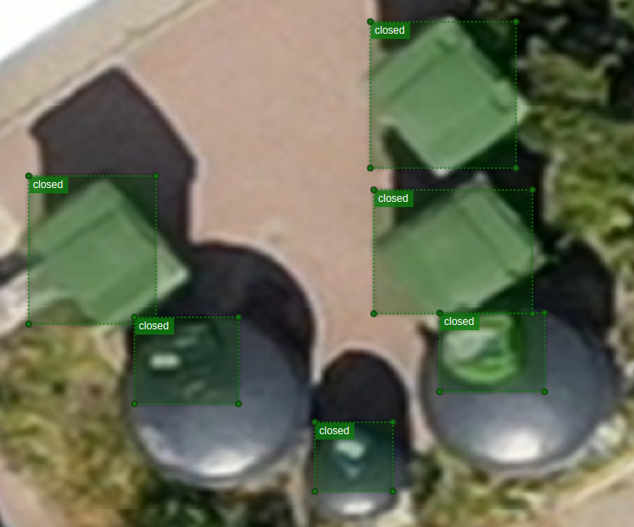

Open containers
The open class should be a minority in terms of counts. From the initial experiments, the open containers comprise up to 5% of all the labels.
Examples:
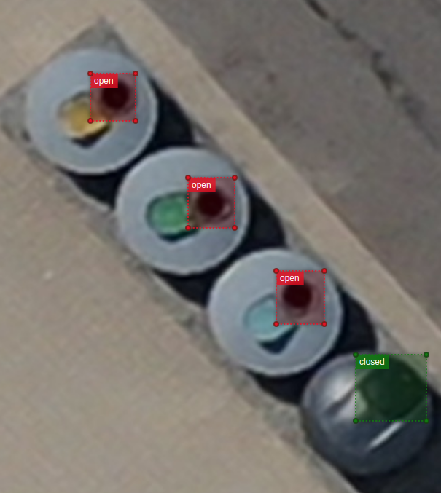
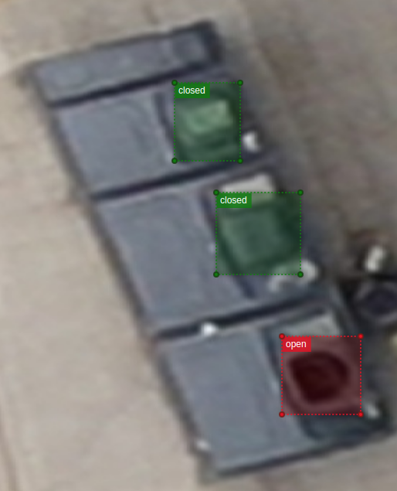
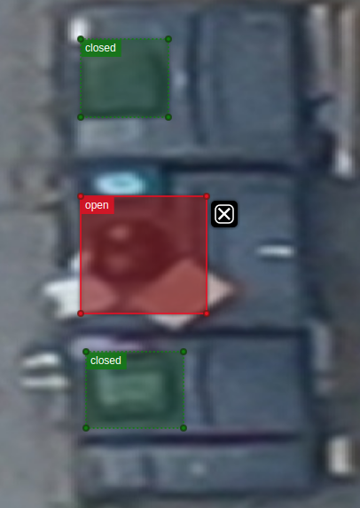
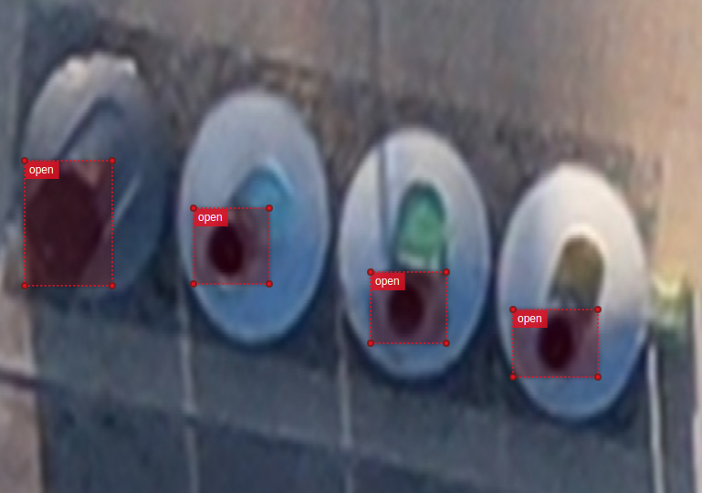

Objective

The objective is to get a .txt file for each image with the bounding boxes in YOLO format.
For example, if an image is titled container_1.png then the resulting file should be called container_1.txt.
The number of .txt files needs to be the same as the number of images.
The labels for the classes should be:
0 – closed
1 – open

YOLO format
A YOLO coordinate format is the following:
For each spotted object in a photograph, an entry in a txt file is
[class label, x, y, width, height]
where
class label – the assigned label of the object
x – the center x coordinate of the bounding box
y – the center y coordinate of the bounding box
width – the width of the bounding box
height – the height of the bounding box
