CH5115 PROJECT REPORT

# Q1) b) Implementing bocd on well-drilling NMR data

The given NMR data is plot and by viewing the plot we see that:

1. The mean of the DGP responsible for generation of the data is changing.
2. However, the (‘local’) variance seems to be more or less the same throughout

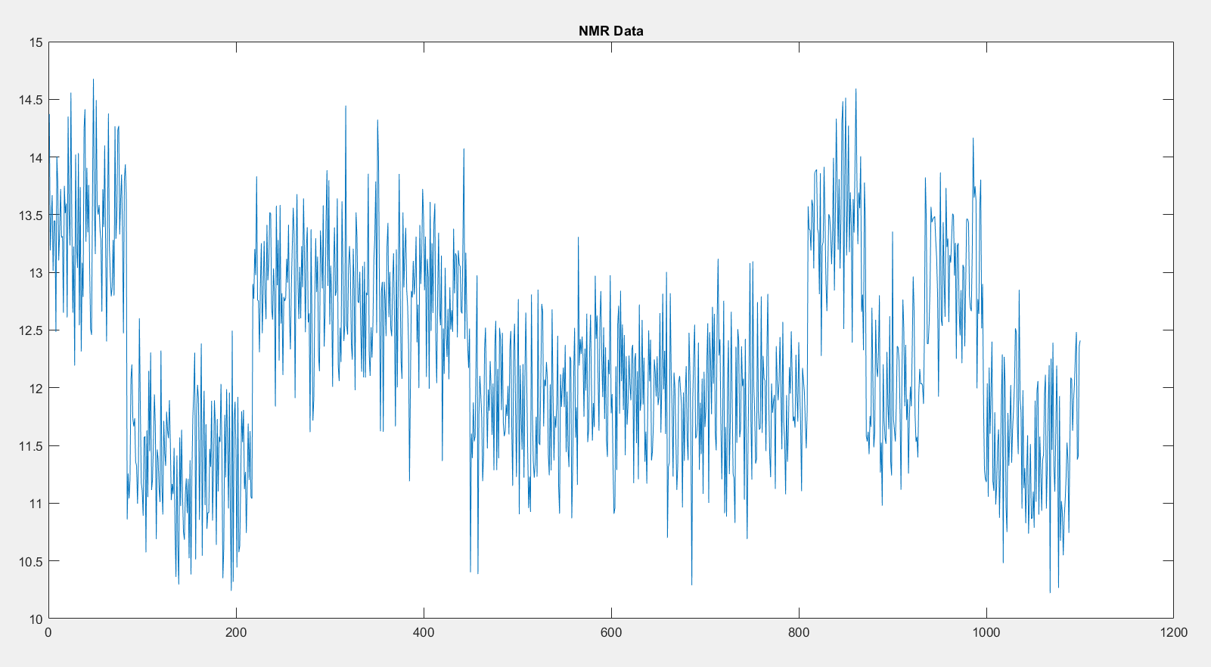

*Figure 1: Plot of the given data*

We assume that the DGP is piece-wise Gaussian, has multiple change-points in mean but has a constant standard deviation throughout.

A further simplifying assumption is that the changepoint occurrence is memoryless and is a geometric distribution with λCP = 250.

Note that we don’t need to perform predictions here so it is sufficient to get run-length posterior to solve the problem. And to get the run length posterior using the bocd algorithm we need:

**Joint probabilities of run length and data** P(rt|x1:t)**:**

These are obtained using the recursive equations set up in the paper.

**UPM Predictive/Predictive Probability:**

These are obtained from equation (11) in Mackay.[1] We have a Gaussian likelihood and we use a normal-gamma prior. Upon evaluating we get a t-distribution of the form:

$$p\left(x | D\right)=t_{2α_{i}}(x|μ_{i},\frac{β_{i}(κ_{i}+1)}{α_{i}κ_{i}})$$

Where α, μ, β and κ are the hyperparameters.

**Conditional prior on the change point P(rt|rt-1)**

We assume this to be a constant (‘Markov Property’; as a result of the geometric distribution assumption) = 1/λ.

With all these set, we simply follow ‘Algorithm 1’ in [1]. Initial value of the joint probabilities are defined as P(r1=1|r0=0) = predictive*(1-H), P(x = x1 , r1=0|r0=0) = predictive*(H) and for all other rt, it is set to be 0.

## Some MATLAB implementation details

### Computing pdf from t distribution:

MATLAB’s tpdf computes the pdf of t distributions with mean zero and variance 1. So, I accordingly transformed the given data: y = (x- μ)/(standard-deviation). This has mean 0 and variance 1, therefore, I find f(y) and using f(y), we can get f(x) as f(y)/ (standard-deviation).

This can be proved quite easily by computing and comparing their CDFs.

### Underflow errors:

After a certain iteration, the joint probabilities grow sufficiently small, that even the sum of the joint probabilities (evidence: P(x1:t)) goes to zero (mathematically it doesn’t obviously, but it is too small to be evaluated on MATLAB, and it is taken as good as zero)

Now since this term is in the denominator of the runlength distribution, the runlength probabilities blow up to infinity (inf)

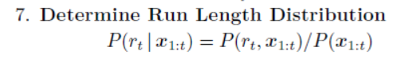

To resolve this I tried transforming all probabilities to **log-scale** as shown in [3]. Unfortunately that didn’t stop P(x1:t) going to zero (log P went to –Inf). I believe this is because we anyway need to convert it to the original scale to sum it up to find the evidence/sum of joint distribution probabilities. (products can be done in log-scale: it will simply be addition) I also tried exponential transformations but they too didn’t work.

Instead I normalized the joint probabilities such that their **sum is 1** in every iteration, i.e. divide every joint probability by its sum. This is correct, mathematically and is equivalent to substituting the joint probability by P(rt|x1:t)*Pevidence in the recursive equations (Pevidence will cancel from both sides).

This method worked for me.

### Update statements

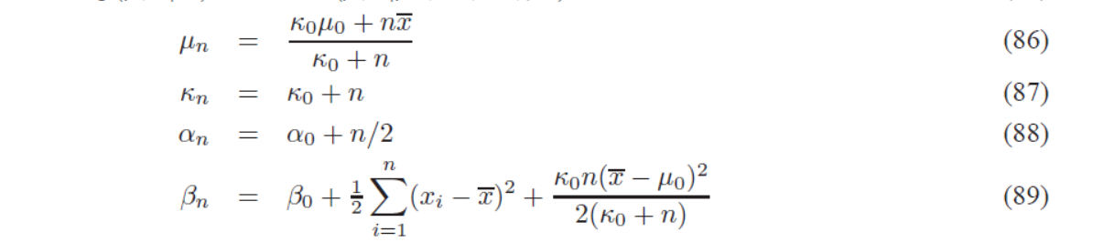

I borrowed these expressions from Murphy.[2] For our case n=1, because we are updating the parameters using one data point at once.

### Plotting (plot_rt_probs.m)

Mat2gray was used to form a grayscale image matrix from the matrix. I had to flip the axis and also do a 1-p to ensure higher probabilities correspond to black colour. This was inspired from [5]. To get a better gradient, I took a fractional power of all the elements. This results in an increase in value but obviously a<b => ax < bx for all positive x, so it is conserved. Here too, I tried log normalization as described in MATLAB forums but it didn’t yield the required results.

## Results

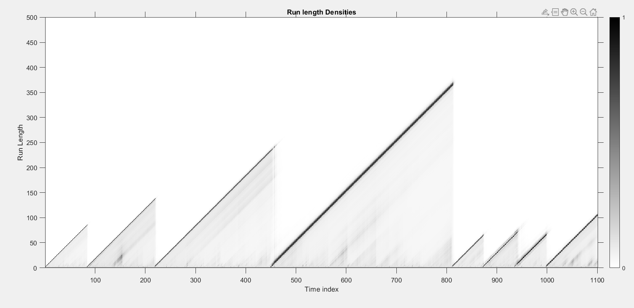

*Figure 1.2: Run length posterior plotted (in a form similar to how it is done in the paper)*

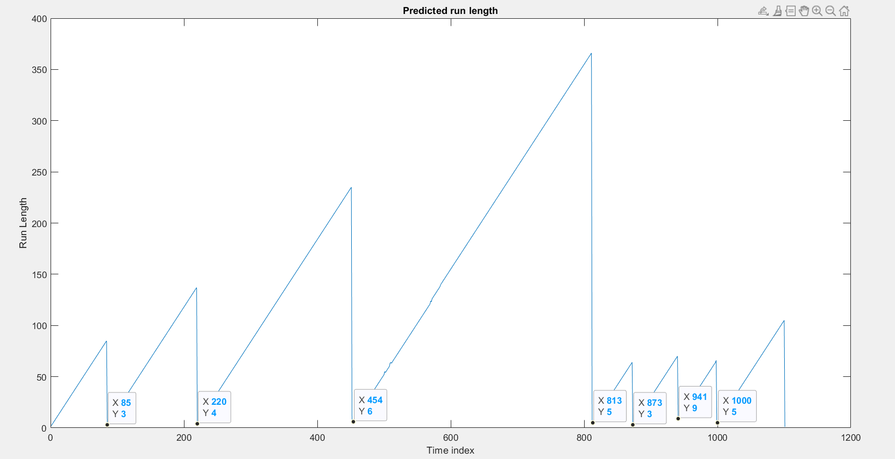

*Figure 1.3: Predicted run length (run length with the highest probability at that instant)*

Changepoints were found to be: 85, 220, 454, 813, 873, 941, 1000

# Q2) a) Fitting AR model and finding Change points

## AR(1) Model fitting

Following the plot of ACF and PACF of historic data

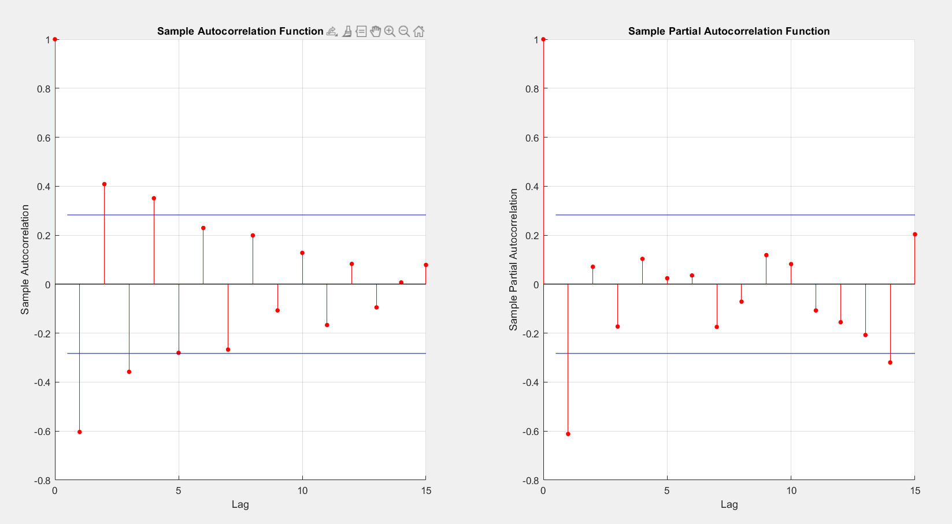

*Figure 2.1: Historic data correlations*

ACF exponentially dies, PACF goes to zero after step 1. This means that the model is AR(1).

Fitlm is used to fit an AR model. The constant term is deemed insignificant.

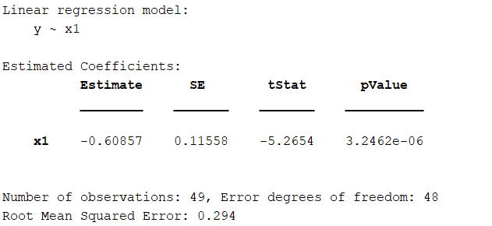

### Residual Analysis

The ACF and PACF are calculated. Both become zero at lags > 0, indicative of white noise. This is confirmed using the **Ljung-Box test,** where the null hypothesis that the residuals are white is not rejected.

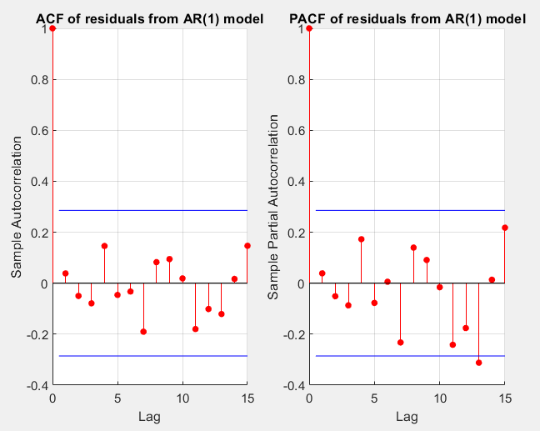

*Fig 2.2: Residual correlations*

## RLS + BOCD on new data

First RLS is performed on the new data with the initial parameters same as that of the AR model. This is done upto the first 200 data points.

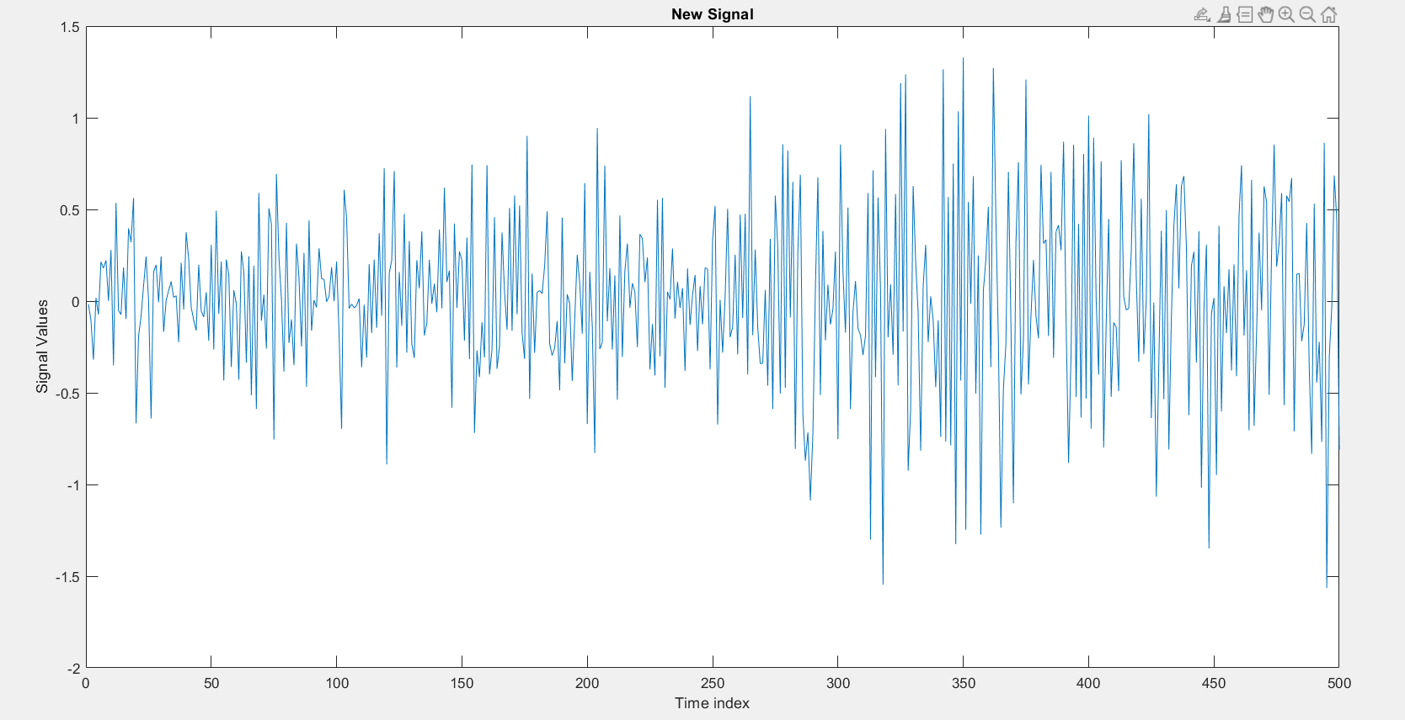

*Figure 2.3: The new signal values. We can see that the mean is constant but there seems to be a change in variance at some point near 300.*

Then we perform bocd, the code is same as the one used in the previous part with just different **initial hyper-parameter values**. As each new data point arrives, the **residual** **is passed to the bocd algorithm** andthe RLS model is continually updated. The iteration is stopped once there is a steep reduction in the predicted run length (close to 0 obviously, since, rt+1 can be rt + 1 or 0).

By observing the probability plot we see a drastic change in run length at 88 where r=3 is the maximum probable scenario. So we can consider that indices [86,87,88] belong to the new DGP. Also, note that plot is made after 200, so the **change point is estimated to be at 200+86 =** **286**.

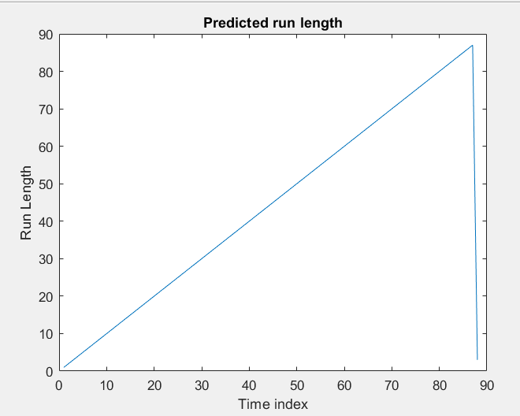

*Figure 2.4: Predicted run length for data-points after 200*

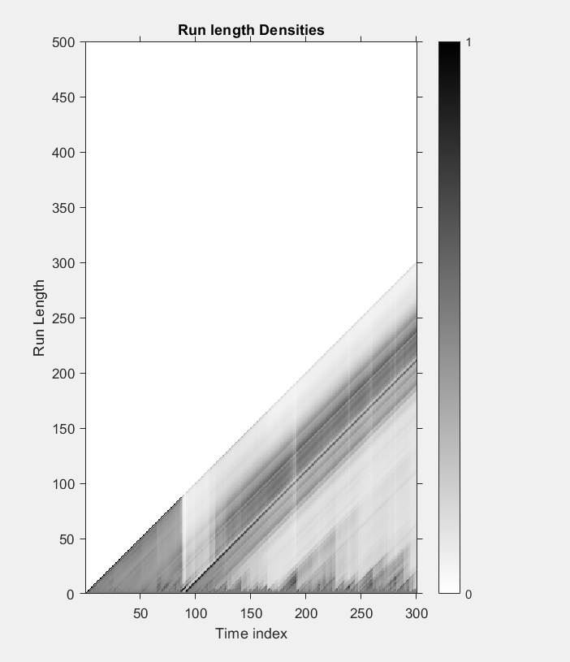

*Figure 2.5: Run length posterior. Note that run length posterior after the first change-point near 100 are irrelevant for our analysis.*

Model parameters (till 200 datapoints + historic data): -0.4019

# Q2) b) Update the model, Build a new model & find var(driving force)

## Updating the old model

We already performed rls for all data points during bocd computation. So we choose the theta estimate obtained at the data point with index (**change-point – 1)** and use it to compute the residuals.

The **AR(1) coefficient before corruption** of the channel is estimated as = **-0.4453**

**Variance of the residuals** is used as an estimator of the **Variance of the driving force.**

The residuals are found to be white, using the **Ljung-Box test,** confirming that the model is not an underfit.

**Estimate of the variance of the endogenous white noise driving force of the system = 0.0984**

## Building a new model after the change point

We expect the AR(1) model to be followed again because it is said that the variance of the white noise innovations change and not the form of the model itself.

This is confirmed by the PACFs which go to zero for all lags > 1

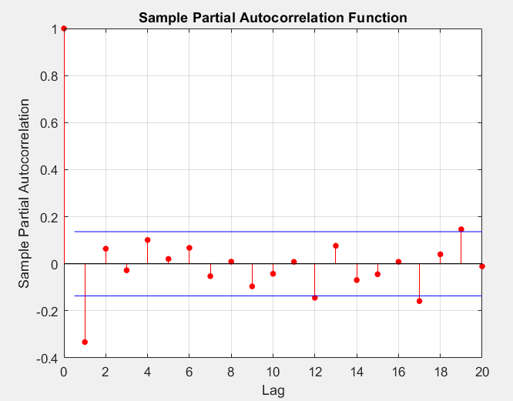

*Figure 2.6: PACF of the data points after the change point*

An AR(1) model is quickly built with again the constant term deemed insignificant.

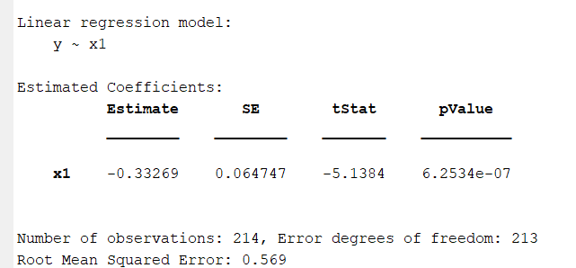

The residuals are verified to be **white** using the **Ljung-Box test.**

The **AR(1) coefficient after corruption** of the channel is estimated as = **-0.3327**

**Variance of the residuals** is used as an estimator of the **Variance of the driving force.**

**Estimate of the variance of the endogenous white noise driving force of the system = 0.3236**

## Summary:

### Before Corruption:

Model: y[k] = -0.4453*y[k-1] + ξ[k]; ξ[k] ~ GWN(0,σ2); estimate of σ2 =0.0984

### After corruption:

Model: y[k] = -0.3327*y[k-1] + ξ[k]; ξ[k] ~ GWN(0,σ2); estimate of σ2 =0.3236

# References:

1. R. P. Adams and D. J. C. MacKay, “Bayesian Online Changepoint Detection”, arXiv:0710.3742 [stat], Oct. 2007.
2. K. P. Murphy, “Conjugate bayesian analysis of the gaussian distribution,” tech. rep., 2007.
3. <http://gregorygundersen.com/blog/2019/08/13/bocd/>
4. <http://gregorygundersen.com/blog/2020/10/20/implementing-bocd/>
5. <https://github.com/gwgundersen/bocd/blob/master/bocd.py>