# Question 1) Graph + Code

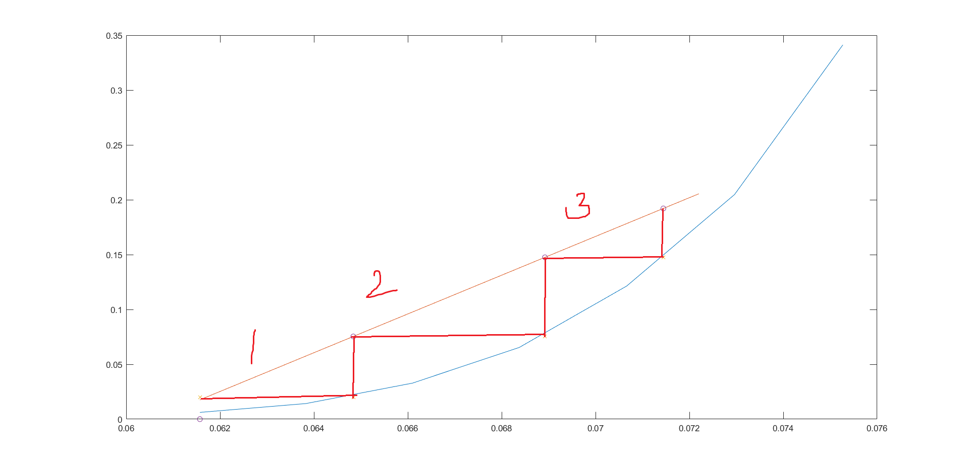

clear; close all;

X = [0.061571125 0.063829787 0.066098081 0.068376068 0.070663812 0.072961373 0.075268817 ];

Y = [0.006178288 0.014234875 0.032842582 0.065420561 0.121357433 0.204755614 0.341176471 ];

xl = 0.065:0.001:0.075;

yl = 0.1765.*ones(1,11);

xlol = linspace(0.06157,0.0722,10);

X_atminL = spline(Y,X,0.1765);

%determining number of trays

i = 0;

y = 0.02;

xcoords = zeros(1,4);

ycoords = zeros(1,4);

ycoords2 = ycoords;

while y <= 0.1765

i = i + 1;

x = spline(Y,X,y);

xcoords(i) = x;

ycoords(i) = y;

y = 0.01765 + 1.2*14.722*(x-0.06157);

ycoords2(i) = y;

end

xcoords(4)=0.06157;

ycoords(4) = 0.02;

plot(X,Y,xlol,0.01765 + 1.2*14.722.*(xlol-0.06157),xcoords,ycoords,'x',xcoords,ycoords2,'o');

a = [0.058 0.06 0.062 0.064 0.066 0.068 0.07 ];

b = [0.006140351 0.014035088 0.031798246 0.061403509 0.108223684 0.16995614 0.254385965 ];

figure();

plot(a,b);

# Question 2: Graph + Code

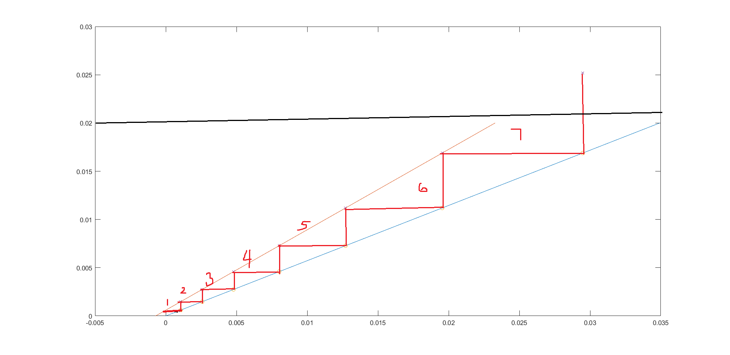

close all;

Vs = 176.4;

Yentry = 0.02;

Yexit = 0.03*0.02;

Xentry = 0;

gamma = 6;

P = 110*10^3;

pvap = 10.5 * 10^3;

k = P/gamma/pvap;

X = @(Y)(k*Y);

Xexit = X(Yentry);

Lsmin = Vs*((Yentry-Yexit)/(Xexit));

Ls = 1.5*Lsmin;

m = Ls/Vs;

i = 0;

y = Yexit;

xcoords = zeros(1,3);

ycoords = zeros(1,3);

ycoords2 = ycoords;

while y <= Yentry

i = i + 1;

x = X(y);

xcoords(i) = x;

ycoords(i) = y;

y = 0.03*0.02 + m*(x);

ycoords2(i) = y;

end

ys = 0:0.0005:0.02;

xs = (ys - 0.03*0.02)/m;

plot(X(ys),ys,xs,ys,xcoords,ycoords,'o',xcoords,ycoords2,'x');