# Question 1: Code + Graphs

**Equilibrium curve(X vs Y)**

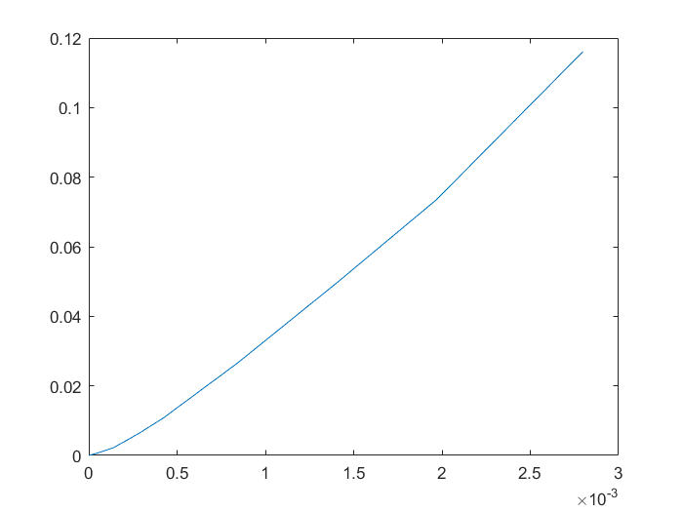

**F(y) vs y**

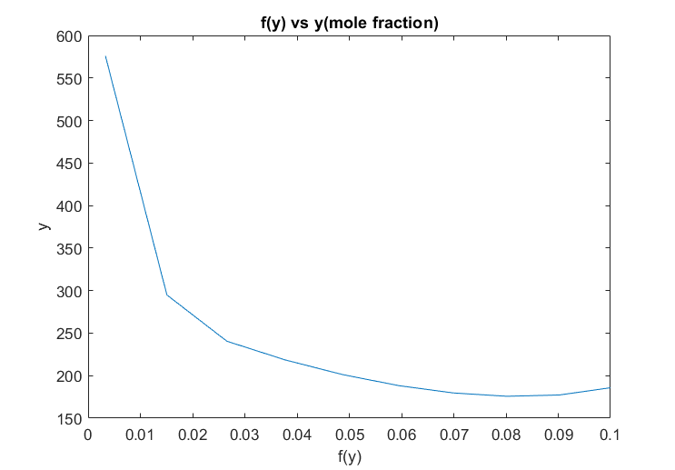

clear; close all;

yentry = 0.1;

Yentry = yentry/(1-yentry);

xentry = 0;

yexit = 0.03*0.1/(0.03*0.1+0.9);

Yexit = yexit/(1-yexit);

mw = 0.1*64+0.9*29;

Vs = 1500/mw*0.9;

xeqbm = [0 0.562 1.403 2.8 4.22 8.42 14.03 19.65 27.9]*10^(-4);

yeqbm = [0 0.792 2.23 6.19 10.65 25.9 47.3 68.5 104]*(10^(-3));

xy = spline(yeqbm,xeqbm);

%part a

Xeqbm = xeqbm./(1-xeqbm);

Yeqbm = yeqbm./(1-yeqbm);

figure(1);

title('EqbmPlot')

xlabel('Xeqbm')

ylabel('Yeqbm')

plot(Xeqbm,Yeqbm);

XY = spline(Yeqbm,Xeqbm);

Xexit = ppval(XY,Yentry);

Lsmin = Vs*(Yentry-Yexit)/(Xexit);

%Part b

kx=1.25;

ky=0.075;

cs = 0.781;

Ls = 1.25*Lsmin;

%operating line in terms of mole ratio

OL = @(val)(Vs/Ls).*(val - Yexit);

%n points on operating line

n = 10;

Y = linspace(Yexit,Yentry,n);

X = OL(Y);

x = X./(1+X);

y = Y./(1+Y);

%From n points, draw lines of slope -kx/ky and find intersection at eqbm

%curve. Substitute Xi in terms of the line equation & curve equation,

%equate them and set to zero

func = @(yi)(-ky/kx*(yi-y)+x) - ppval(xy,yi);

yi = fsolve(func,zeros(1,n));

%Value of function to be integrated

f = (1+Y)./((y-yi).*(1-y));

%Integrate yis using trapezoidal rule

AUC = trapz(y,f);

H = AUC*(Vs/(cs*3600*ky));

figure(2);

title('f(y) vs y(mole fraction)')

xlabel('y')

ylabel('f(y)')

plot(y,f)

# Question 2: Code + Graphs

clear; close all;

Ventry = 0.4*1.013*10^5/8.314/297;

yentry = 50/760;

xentry=0;

Vs = (1-yentry)*Ventry;

Yentry = yentry/(1-yentry);

yexit = 0.005;

Yexit = yexit/(1-yexit);

xeqbm = @(y)(760/346*y);

xexit = xeqbm(yentry);

Xexit = xexit/(1-xexit);

Lsmin = Vs*(Yentry-Yexit)/(Xexit);

Ratiomin = (Yentry-Yexit)/(Xexit);

Ls = 1.5*Lsmin*180/1000*3600;

m = 1.5*Ratiomin;

y = Yexit;

i = 0;

xcoords = zeros(1,6);

ycoords = zeros(1,6);

ycoords2 = ycoords;

while y <= Yentry

i = i + 1;

x = (y)/0.455;

xcoords(i) = x;

ycoords(i) = y;

y = Yexit + m*(x);

ycoords2(i) = y;

end

ypoints = linspace(Yentry,Yexit,10);

OL = 1/m.*(ypoints-Yexit);

Eqbm = ypoints/0.455;

figure();

plot(OL,ypoints,Eqbm,ypoints,xcoords,ycoords,'x',xcoords,ycoords2,'o');

%Kremser's method

K = 346/760;

A = m/(K);

N = log((yentry-K*xentry)/(yexit-K*xentry)*(1-1/A)+1/A)/log(A);

%efficiency

mu = 2*10^(-3);

pho = 0.81*1000;

abs = mu*0.455*180/pho;

Eo = 0.25;

N_actual = N/Eo;

