# Question 1-plots

**Operating lines**

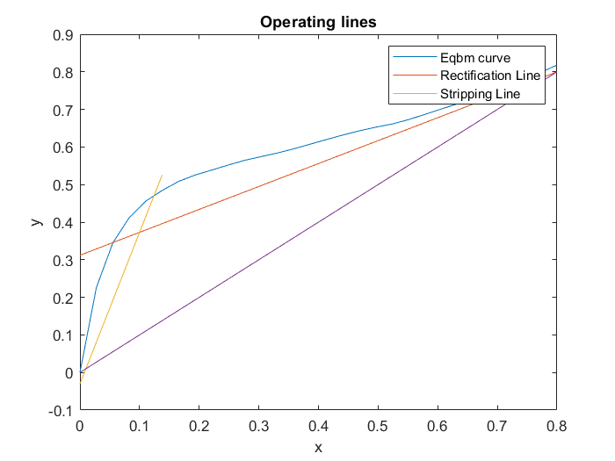

**Number of stages (stepping)**

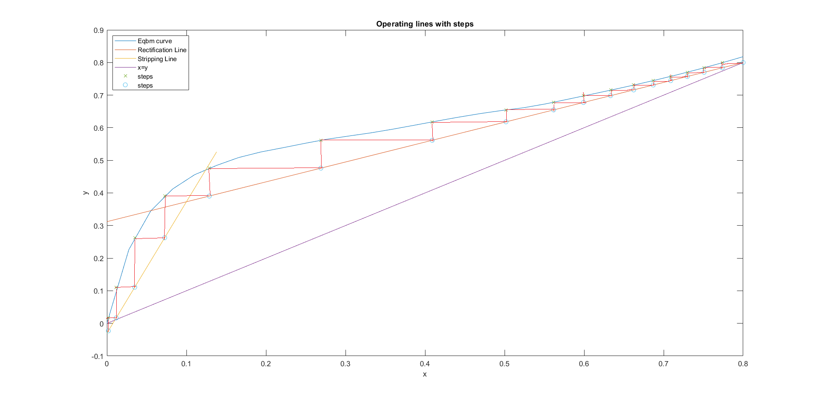

**Code**

clear; close all;

%Given data

xeqbm = [0,0.019,0.0721,0.0966,0.1238,0.1661,0.2337,0.2608,0.3273,0.3965,0.5079,0.5198,0.5732,0.6763,0.7472,0.8943];

yeqbm = [0,0.17,0.3891,0.4375,0.4704,0.5089,0.5445,0.558,0.5826,0.6122,0.6564,0.6599,0.6841,0.7385,0.7815,0.8943];

pp = spline(xeqbm,yeqbm);

xD = 0.8;

xB = 0.01;

zF = 0.1;

%Rmin evaluation

m_min = (0.8-ppval(pp,0.1))/(0.8-0.1);

Rmin = m_min/(-m_min+1);

R = 1.5*Rmin;

OL = @(x) (R/(R+1).*(x-0.8)+0.8);

ycoord = OL(0.1);

x = linspace(0,0.8,30);

%Getting stripping section operating line

m_s = (ycoord-0.01)/(0.1-0.01);

SL = @(x)(m_s.*(x-0.01) + 0.01);

figure();

plot(x,ppval(pp,x),x,OL(x),x(1:6),SL(x(1:6)),x,x);

title('Operating lines');

legend('Eqbm curve','Rectification Line','Stripping Line');

xlabel('x');

ylabel('y');

%Stepping process

i=0;%Step counter

y = xD;

PP = spline(yeqbm,xeqbm);

xcoords = zeros(1,7);

ycoords = zeros(1,7);

xcoords2 = zeros(1,8);

ycoords2 = zeros(1,8);

xcoords2(1)= xD;

ycoords2(1) = xD;

while y >= 0.01

i = i + 1;

x = ppval(PP,y);

xcoords(i) = x;

xcoords2(i+1)=x;

ycoords(i) = y;

if x > 0.1

y = OL(x);

else

y = SL(x);

end

ycoords2(i+1) = y;

end

%Plotting the steps

x = linspace(0,0.8,30);

figure();

plot(x,ppval(pp,x),x,OL(x),x(1:6),SL(x(1:6)),x,x);

title('Operating lines with steps');

xlabel('x');

ylabel('y');

hold on;

plot(xcoords,ycoords,'x',xcoords2,ycoords2,'o');

lgd = legend('Eqbm curve','Rectification Line','Stripping Line','x=y','steps','steps');

lgd.Location = 'northwest';

hold off;

%Part b

%choose (x,y) along the RL, get y*; evaluate 1/(y*-y) & integrate

x_above = linspace(0.10,0.8,30);

y_star_above = ppval(pp,x_above);

y_above = OL(x_above);

f_above = 1./(y_star_above-y_above);

NTU_above = trapz(y_above,f_above);

%Evaluating x,y at the tray just before the partial reboiler

y_start = ppval(pp,xB);

fun = @(x)(SL(x)-0.098);

x_start = fsolve(fun,0);

%choose (x,y) along the SL, get y*; evaluate 1/(y*-y) & integrate

x_below2 = linspace(x_start,zF,30);

y_star_below2 = ppval(pp,x_below2);

y_below2 = SL(x_below2);

f_below2 = 1./(y_star_below2-y_below2);

NTU_below2 = trapz(y_below2,f_below2);