# Question 1 MATLAB CODE AND PLOT

clear;close all; clc;

c = [3.9;6.8;9.9;12;16;23;35.7;61.8;80.2];

q= [9.6;11.6;14.9;17.6;21.0;25.6;32.1;38.2;40.1];

options = statset('MaxIter',500);

[beta,R,J,COVB,MSE] = nlinfit(c,q,@Freund,[1,1]);

[beta1,R1,J1,COVB1,MSE1] = nlinfit(c,q,@Lang,[0.00001,2*10000],options);

qlang = Lang(beta1,c);

qfreund = Freund(beta,c);

plot(c,q,'x',c,qlang,c,qfreund);

title('Equilibrium Adsorption curves');

legend('Data points','Langmuir', 'Freundlich');

xlabel('c');

ylabel('q');

function y = Freund(parms,c)

k = parms(1);

n = parms(2);

y = k.*(c.^(1./n));

end

function y= Lang(parms,c)

k = parms(1);

qm = parms(2);

y = qm.*(k.*c./(1+k.*c));

end

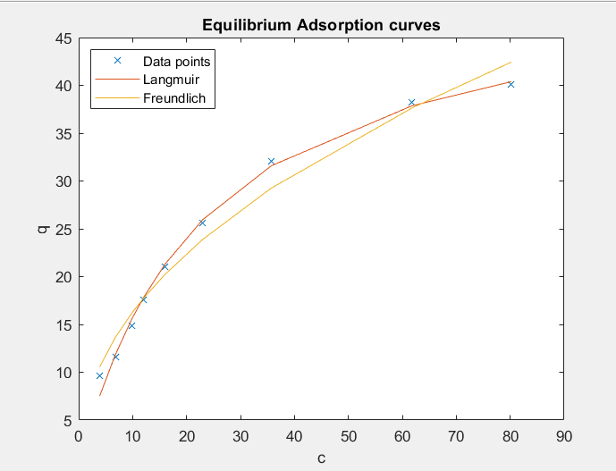

# Question 2 MATLAB CODE

clear; close all;

kl = 2.25*10^-5;%m/s

L = 10;%Litres

wmin = (3.5-0.1)/(50*0.1^(0.32))*L;%g

w = 2*wmin;%g

ci = 3.5;%mg/L

K = 50;%q should be in mg/g, c in mg/L

a = 5;%m^2/kg

time = integral(@dtbydc,3.5,0.1);

t_inhours = time/3600;

function val = dtbydc(c)

kl = 2.25*10^-5;%m/s

L = 10;%Litres

wmin = (3.5-0.1)/(50*0.1^(0.32))*L;%g

w = 2*wmin;%g

ci = 3.5;%mg/L

K = 50;%q should be in mg/g, c in mg/L

a = 5;%m^2/kg

%units of val

%c is the conc in solution, second term is the ideal c in soln

val = -1./(kl*(a*w/L).*(c-((ci-c)*L/(w*K)).^(1/0.32)));

end

# Question 3 MATLAB CODE AND PLOT

clear; close all;

%% Given data

u_superficial = 0.29;

t = [9.5,19,21,25.7,34.3,39,42,46.7,51.4,56.2,64.7,68.6,72.4,77.1,84.8,97.1,104.7,108.6];

te = 108.6;

c = [0,0.018,0.037,0.083,0.287,0.435,0.491,0.62,0.713,0.768,0.852,0.935,0.952,0.963,0.97,0.987,0.991,1];

L = 0.2;

ci = 0.11;

plot(t,c);

title('c/ci vs t');

ylabel('c/ci');

xlabel('time');

%% Part a

t_break = spline(c,t,0.03);

pp = spline(t,c);

n = 40;

time = linspace(9.5,108.6,n*(10));

ts = te - trapz(time,ppval(pp,time));

% Following code evaluates both the integrals numerically and minimises it.

% No need to run this part because we have already simplified it into a simple linear eqn in ts.

% min = trapz(time,ppval(pp,time));

% ts = 230;

% ar_diff = zeros(n*10-1,1);

% l = length(time);

% for i = 2:l-1

% ar_diff(i) = trapz(time(1:l),ppval(pp,time(1:l)))-(108.6-time(i));

% if min > abs(ar_diff(i))

% min = abs(ar_diff(i));

% ts = time(i);

% end

% end

us = L/ts*60; %m/h

LUB = L*(1-t_break/ts);

MTZ = (te-t_break)/te*L;%Since curve is NOT symmetric

%% Part b

V = 3000/60/60;%m^3/s

D = sqrt(4*V/(u_superficial*pi));

t_cycle = 8;

bed_density = 700;

L_used = 8*us;

L_scaleup = LUB + L_used;

sol_adsorbed = V*ci*t_cycle*3600;

avg_loading = sol_adsorbed/(L_scaleup*bed_density*pi*D^2/4);

max_loading = sol_adsorbed/(L_used*bed_density*pi*D^2/4);

