# Question 1

clear; close all;

F = 158.21;

xD = 0.9745;

R = 3.5;

m = R/(R+1);

yeqbm = [0.21 0.37 0.51 0.64 0.72 0.79 0.86 0.91 0.96 0.98];

xeqbm = [0.1 0.2 0.3 0.4 0.5 0.6 0.7 0.8 0.9 0.95];

pp = spline(yeqbm,xeqbm);

fun = @(x)(m*(x-xD)+xD);

y = xD;

zF = 0.43;

xcoords = zeros(1,7);

ycoords = zeros(1,7);

xcoords2 = zeros(1,8);

ycoords2 = zeros(1,8);

xcoords2(1)= xD;

ycoords2(1) = xD;

i = 0;

while y >= zF

i = i + 1;

x = ppval(pp,y);

xcoords(i) = x;

xcoords2(i+1)=x;

ycoords(i) = y;

y = fun(x);

ycoords2(i+1) = y;

end

x = linspace(0,1,15);

qline = @(x)(zeros(size(x))+zF);

plot(xeqbm,yeqbm,x,fun(x),x,qline(x),x,x,xcoords,ycoords,'x',xcoords2,ycoords2,'o');

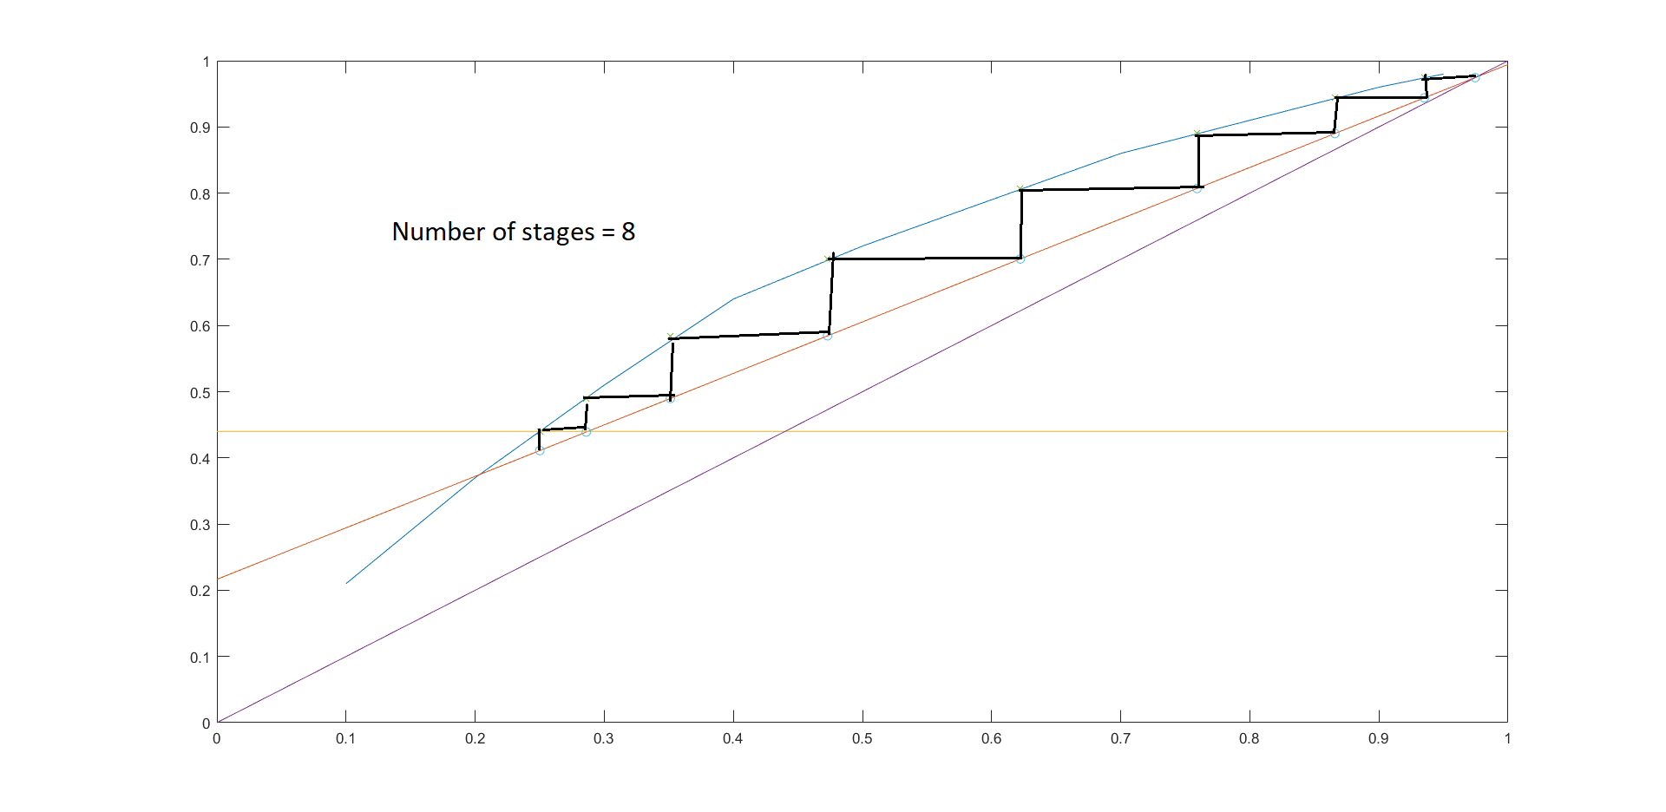

# Question 2

close all;clear;

xD = 0.97;

xW = 0.01;

zF = 0.67;

q = 0.7;

qline = @(x)(q/(q-1).*(x-zF) + zF);

xeqbm = [0,0.0296,0.0615,0.1106,0.1435,0.2585,0.3908,0.5318,0.663,0.7574,0.8604,1];

yeqbm = [0,0.0823,0.1555,0.266,0.3325,0.495,0.634,0.747, 0.829, 0.878, 0.932,1];

ec = spline(xeqbm,yeqbm);

%finding intersection of eqbm curve and q line

fun = @(x)(qline(x)-ppval(ec,x));

x_int = fsolve(fun,1);

m_min = (qline(x_int)-xD)/(x_int-xD);

ycept = (qline(x_int)-xD)/(x_int-xD)*(-xD) + xD;

R_min = (xD/ycept)-1;

R = 2*R_min;

R_OL = @(x)(R/(R+1)*(x-xD)+xD);

fun2 = @(x)(qline(x)-R_OL(x));

xint = fsolve(fun2,0);

yint = qline(xint);

pp = spline(yeqbm,xeqbm);

i = 0;

y = xD;

S_OL = @(x)((yint-xW)/(xint-xW)*(x-xW) + xW);

xcoords = zeros(1,13);

ycoords = zeros(1,13);

xcoords2 = zeros(1,14);

ycoords2 = zeros(1,14);

xcoords2(1)= xD;

ycoords2(1) = xD;

%Last stage wont be a tray but is the partial reboiler

while y>=xW

i = i + 1;

x = ppval(pp,y);

xcoords(i) = x;

xcoords2(i+1)=x;

ycoords(i) = y;

if x >= xint

y = R_OL(x);

else

y = S_OL(x);

end

ycoords2(i+1) = y;

end

x = linspace(0,1,15);

N_actual = i-1;

figure();

plot(xeqbm,yeqbm,x,R_OL(x),x,qline(x),x,x,x,S_OL(x),xcoords,ycoords,'x',xcoords2,ycoords2,'o');

figure();

plot(xeqbm,yeqbm,x,R_OL(x),x,x,x,S_OL(x),xcoords,ycoords,'x',xcoords2,ycoords2,'o');

figure();

%Min number of trays => R->infinity

xcoords = zeros(1,7);

ycoords = zeros(1,7);

xcoords2 = zeros(1,8);

ycoords2 = zeros(1,8);

y = xD;

xcoords2(1)= xD;

ycoords2(1) = xD;

i = 0;

while y>=xW

i = i + 1;

x = ppval(pp,y);

xcoords(i) = x;

xcoords2(i+1)=x;

ycoords(i) = y;

y = x;

ycoords2(i+1) = y;

end

N_th = i-1;

plot(xeqbm,yeqbm,xeqbm,xeqbm,xcoords,ycoords,'x',xcoords2,ycoords2,'o');

## Plot of q-line, Rectification line and Stripping line

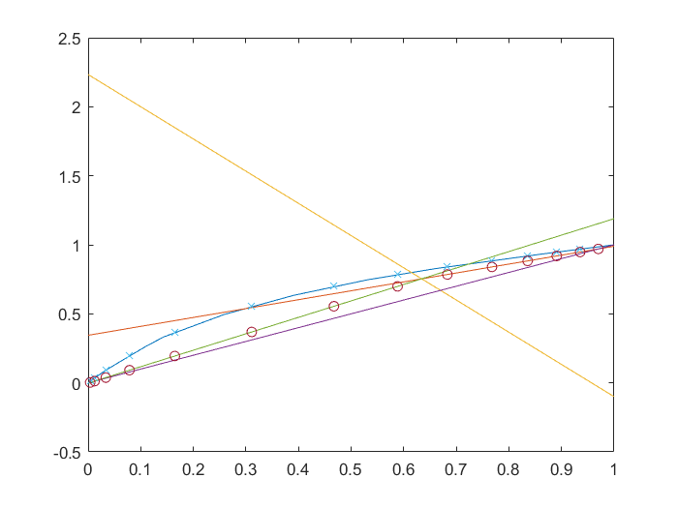

## Theoretical number of trays plot (last tray which is the partial reboiler is not drawn)

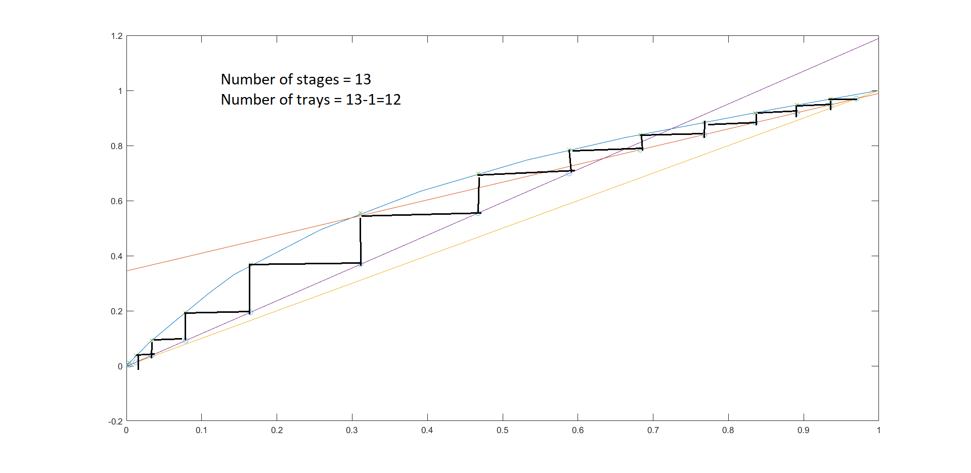

## Minimum number of trays (last tray which is the partial reboiler is not drawn)