# Question 5b)

Variance in the estimate vs Number of samples plots are shown below.

**Estimator-1: $\hat{θ}= min\left(y_{N}\right)-\frac{1}{N}$**

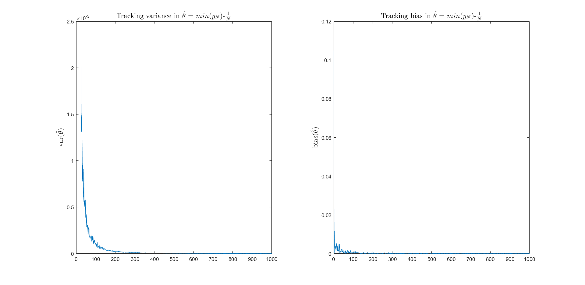

**Estimator-2: $\hat{θ}= \overline{y}-1$**

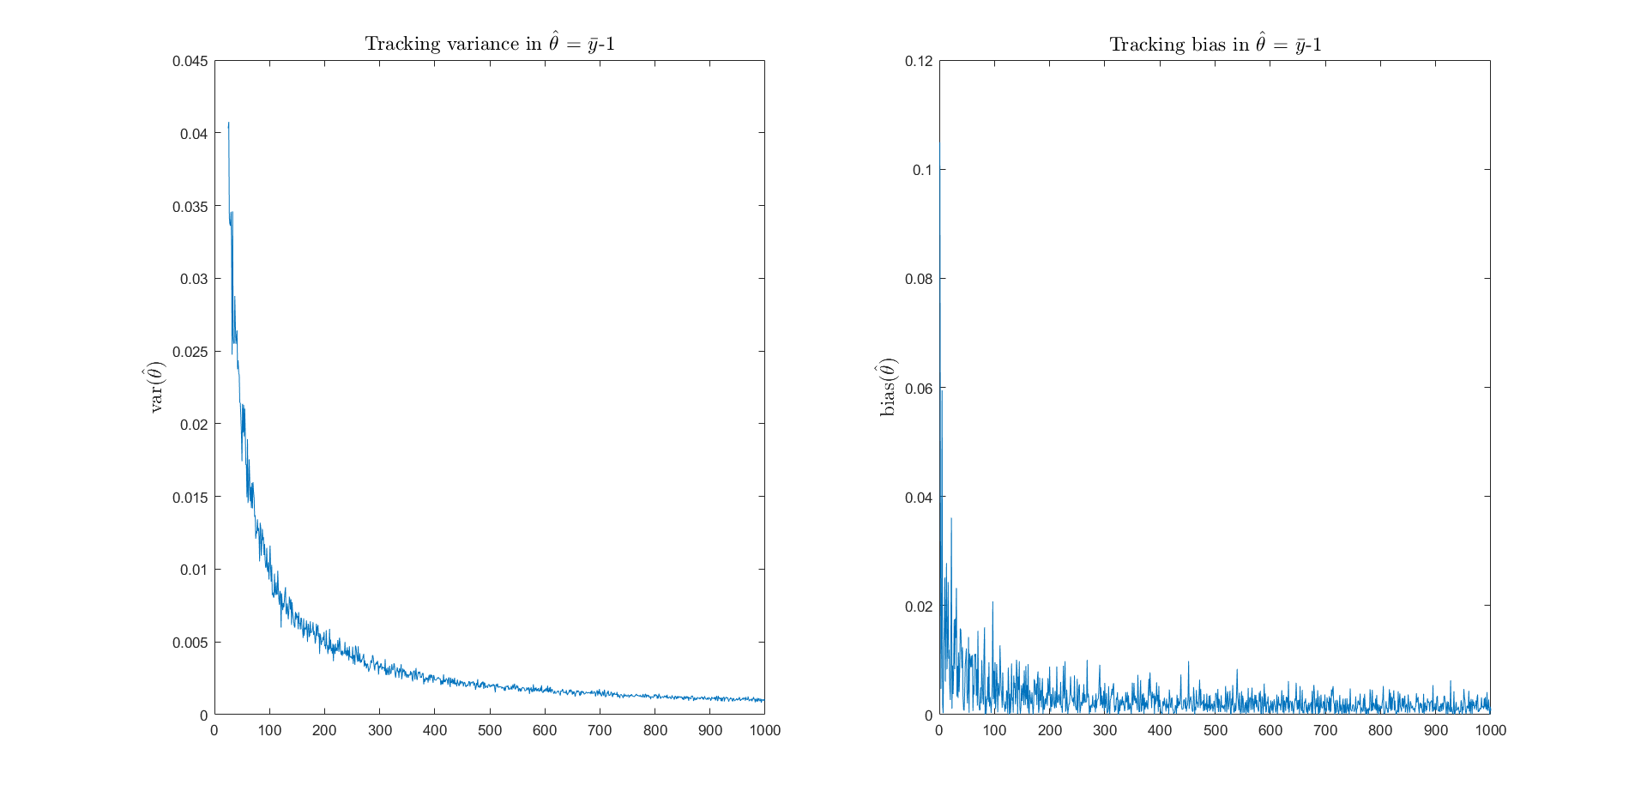

**Estimator-3: $\hat{θ}= \tilde{y}-ln(2)$**

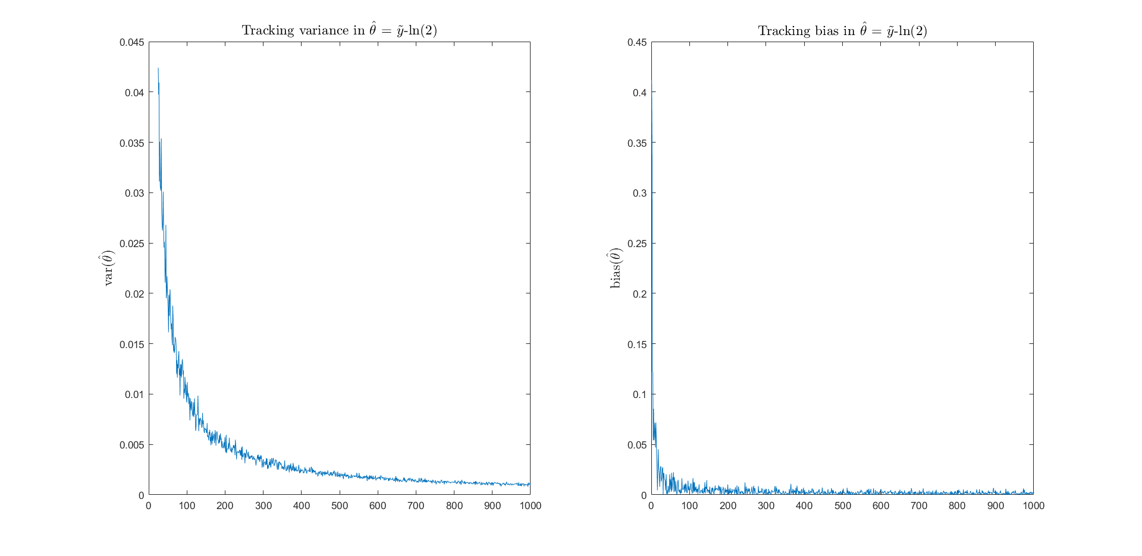

From the graphs we see that all the estimators are most likely unbiased, (It has been proven the first estimator is unbiased, so it is definitely unbiased) so it is reasonable to compare their efficiencies using their variance. Lower the variance the better is the efficiency.

Comparing the variance of the estimators, even at low N (number of samples), we see that the estimator-1 outperforms the other 2. In fact, we notice that the scale of the graph itself is lower (1*10-3) in the case of estimator 1. The variance in the simulated estimates for N=1000 case were found to be:

1. 9.1468*10-7
2. 9.3239*10-4
3. 9.6751*10-4

Clearly var(Estimator-1) is the lowest among the 3.

Therefore, **Estimator-1: $\hat{θ}= min\left(y_{N}\right)-\frac{1}{N}$ is the most efficient estimator among the 3.**

This as expected, because estimator-1 is the Minimum Variance Unbiased Estimator (MVUE).

# Question 2a)

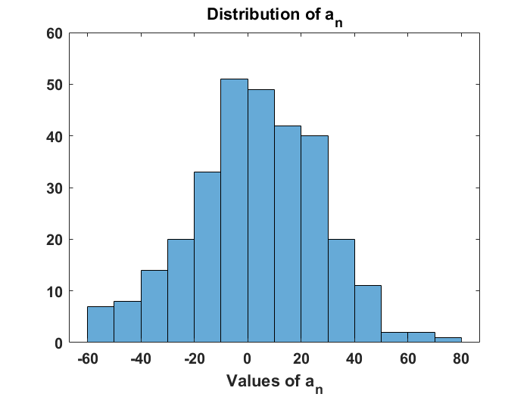

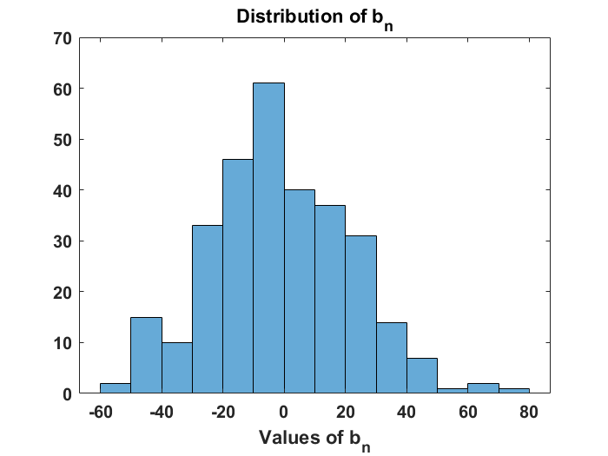

**N = 1000 samples** were taken per record, with total number of records **R = 300**.

From the above graphs we observe that **an** and **bn**seem to be **Gaussian distributed**, with their means as zeros. This is what we expected from our analytical calculations. Lilliefors test was done for both **an** and **bn** and the null hypothesis that the Random Variable is Gaussian was not rejected in both the cases.

# Question-2d)

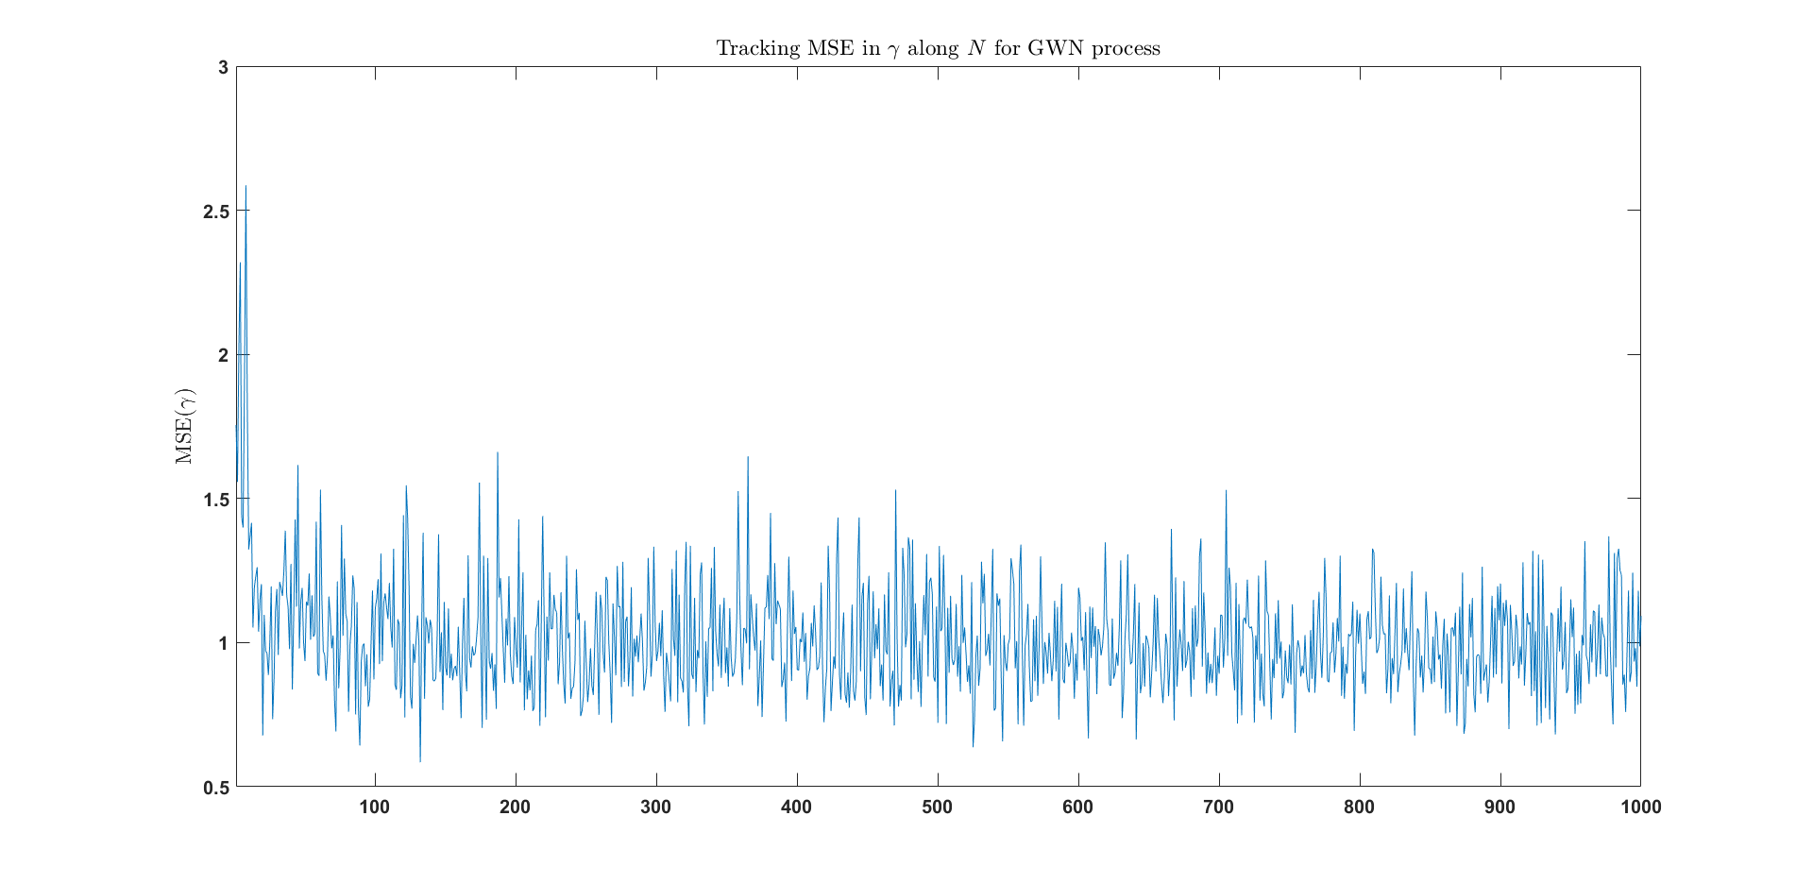

From the above MSE curve, it is apparent that the Mean squared error in estimating γ (the PSD) doesn’t converge to zero. This verifies the fact that the estimator **does not exhibit** mean squared convergence to the PSD.

**Bias** (N=1000, R=300) = **0.0847**

**Variance** (N=1000, R=300) = **1.085**

The bias value indicates that the estimator is indeed unbiased as shown earlier.