Numerical verification of consistency

# MSE along N

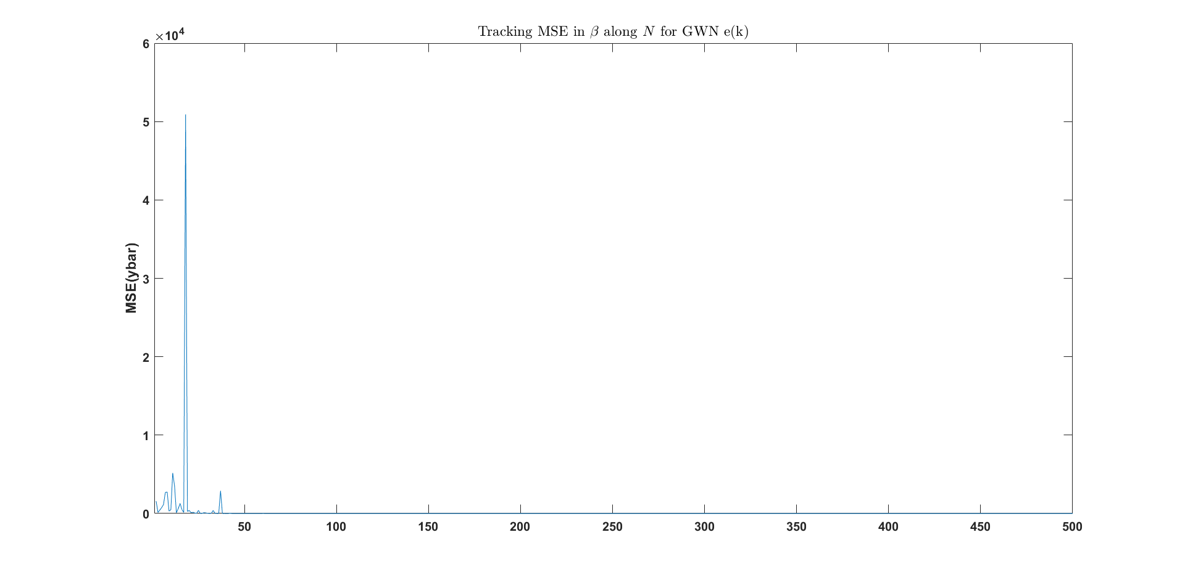

Since the initial MSEs are very high, the y-scale is also bit high. Hence, I am attaching a graph of the MSEs after the errors fall down to a reasonable range. This is after N = 50.

# MSE along N (zoomed)

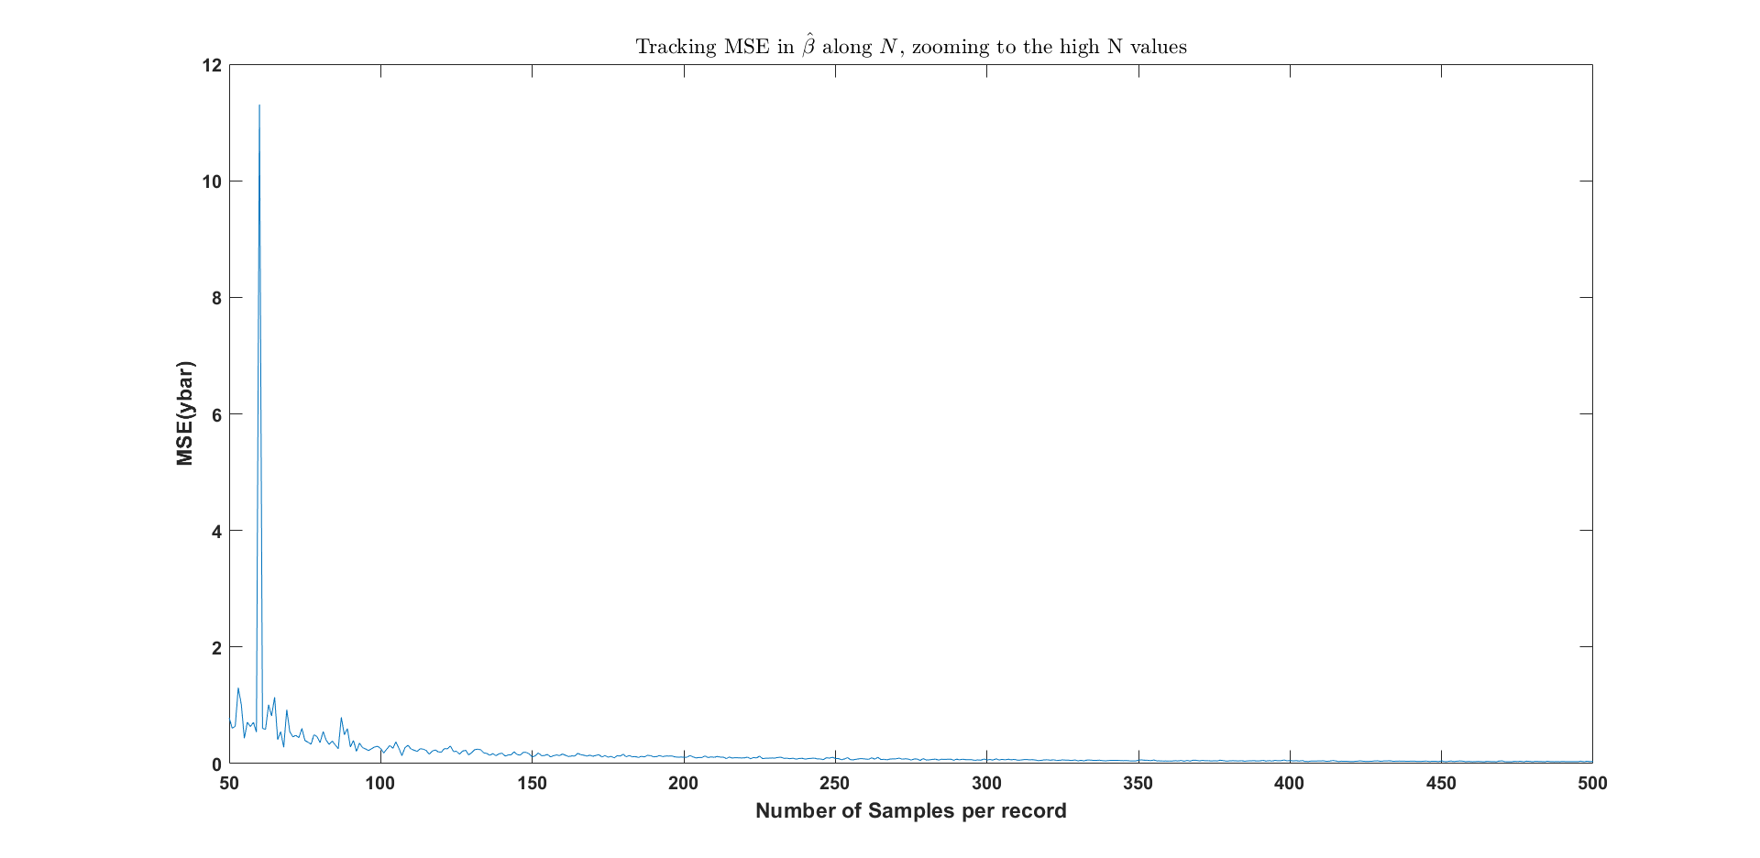

By examining the actual values, I saw that MSE<0.05 for sufficiently large number of samples.

# Comparing MSE at different σe2

σe2 = 0.5

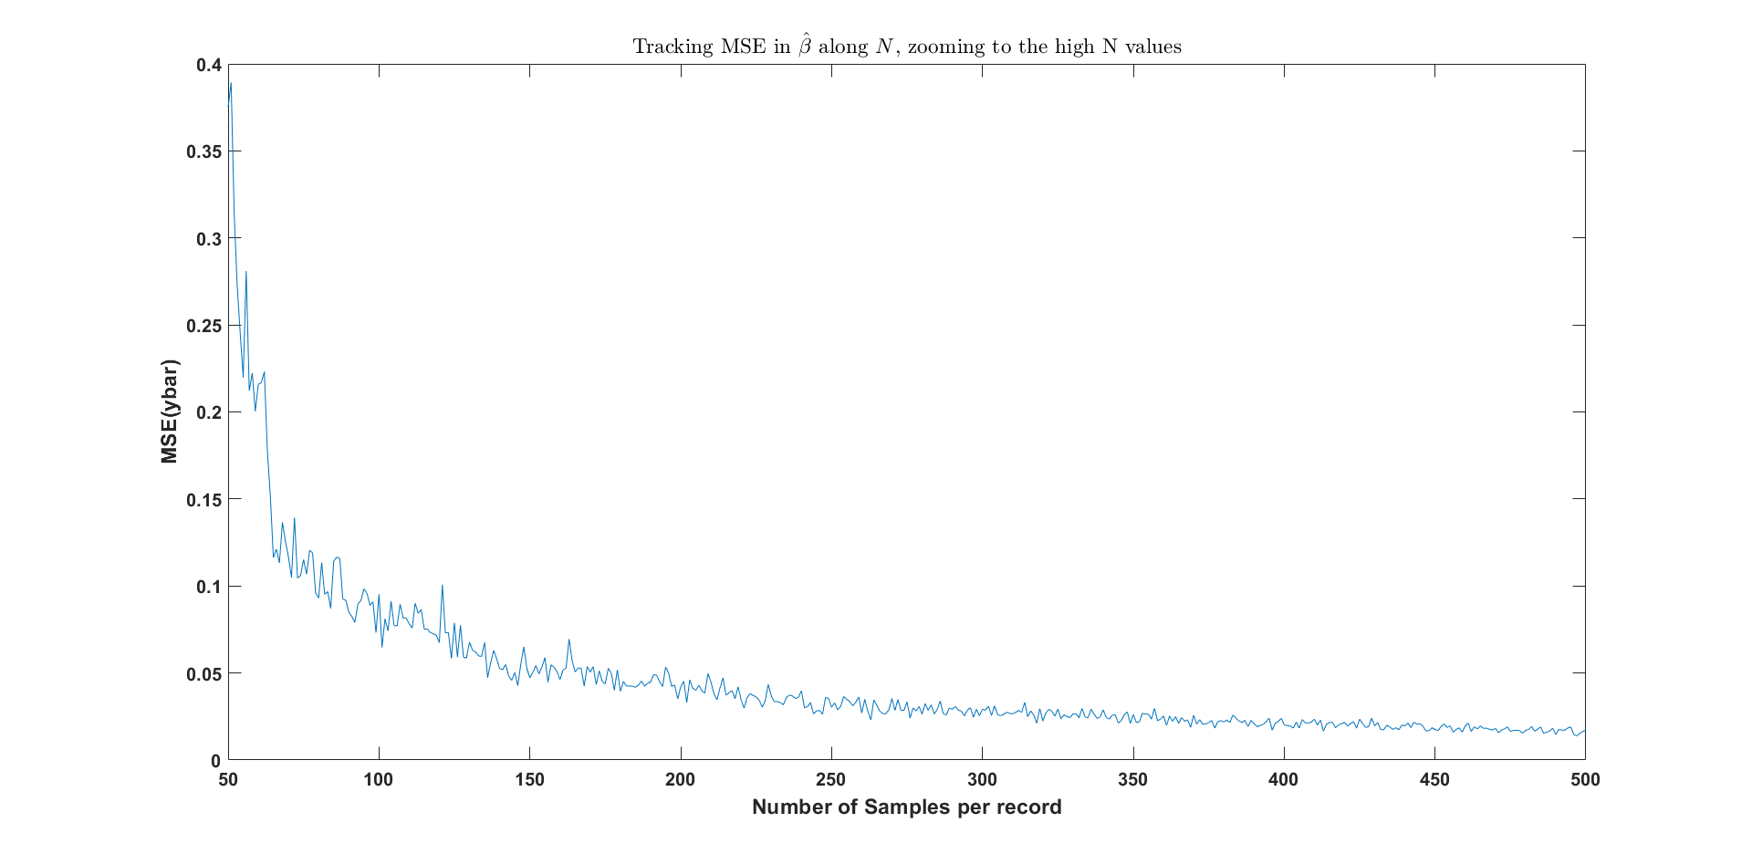

σe2 = 1



σe2 = 2

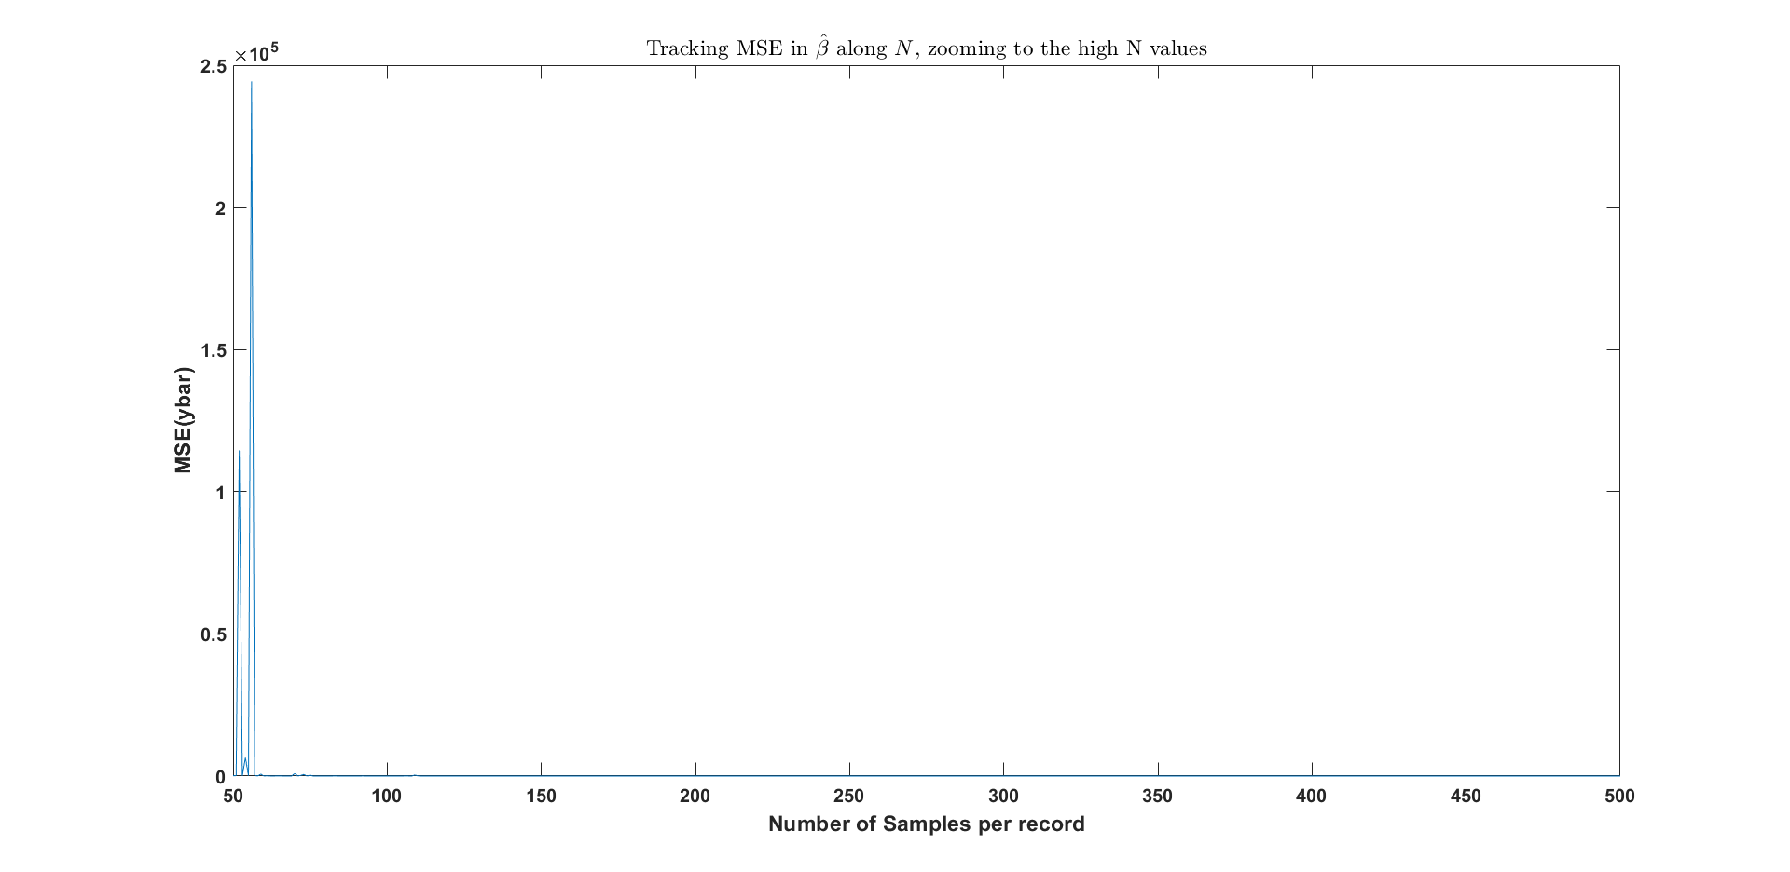

**From the above graphs we can see that the convergence is faster if the variance of the White Noise term is lower.**