CH5120 ASSIGNMENT 6

# Question-1

System Equation: $G\left(s\right)=\frac{5}{τs+1}e^{-0.15s}$

τ = 0.5

n = 24 (> p)

%% Controller Parameters

ySP=1; % Setpoint

m=4; % Control horizon

p=10; % Prediction horizon

Q=1; % Output weight

R=0.1; % Input weight

Constraints: $-0.4≤u\left(k\right)≤0.4$ and $\left|∆u\left(k\right)\right|<0.025$

As expected the controller is able to smoothly increase the output the set-point.

**Plots of inputs and output responses**

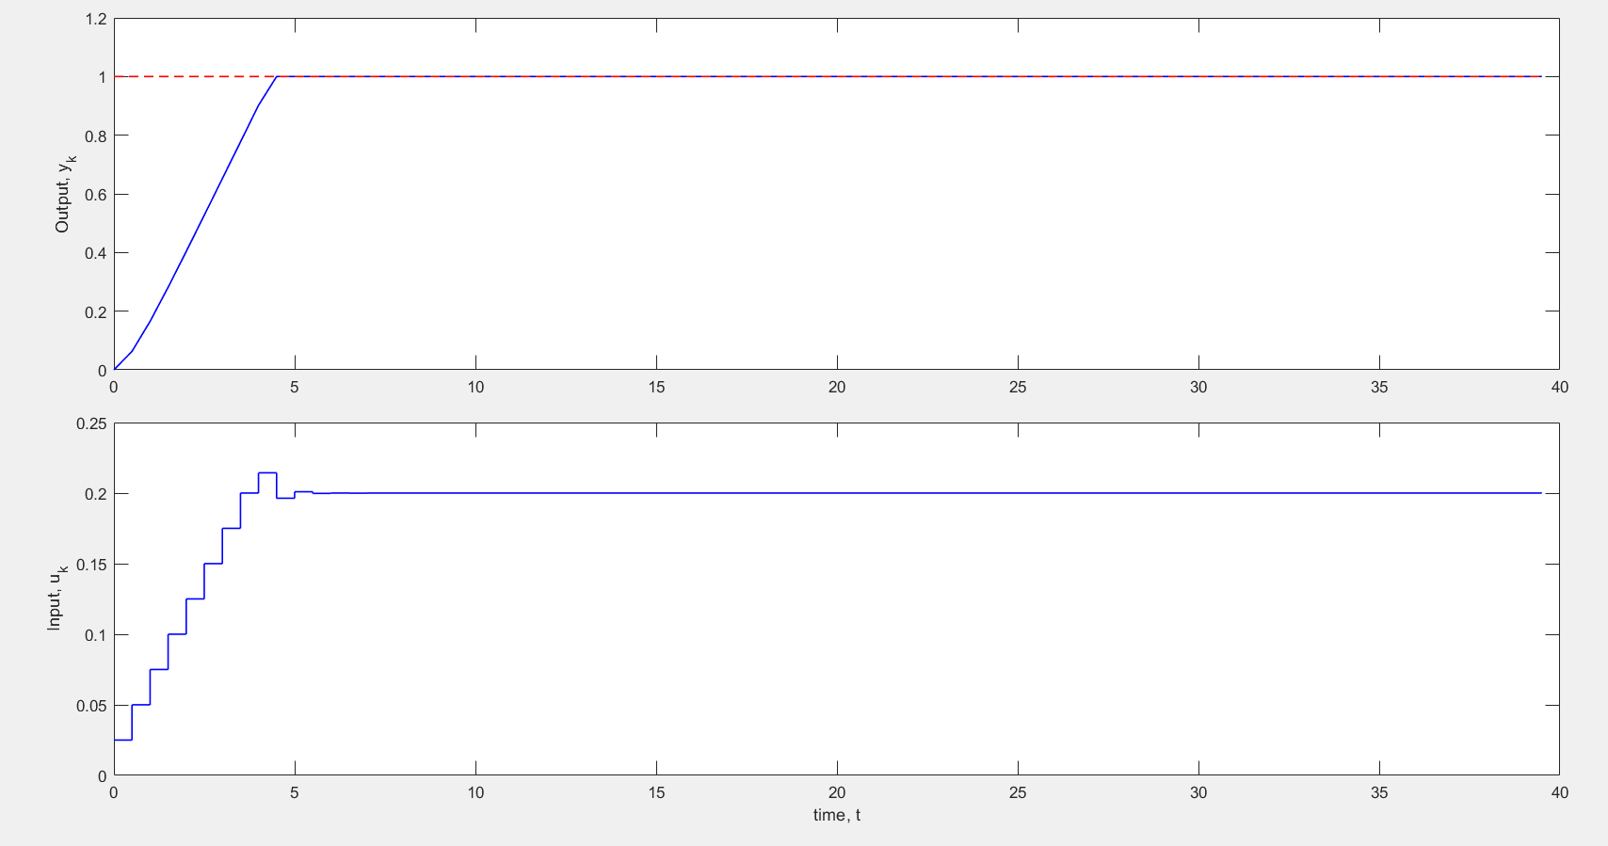

# Question-2

Disturbance Response:

$$y\left(s\right)=\frac{2.5}{20s+1}e^{-7s}u\left(s\right)+\frac{0.4}{10s+1}e^{-4s}d\left(s\right)$$

n=24;

% Please replace with your chosen n

h=5; % Sampling interval: Don't change

maxTime=50; % Run this case for 50 time-steps

%% Controller Parameters

ySP=1; % Setpoint

m=4; % Control horizon

p=10; % Prediction horizon

Q=1; % Output weight

R=0.04; % Input weight

Constraints: $-0.5≤u\left(k\right)≤0.5$ and $\left|∆u\left(k\right)\right|<0.05$

## Single disturbance

Disturbance is simply a step change given at t=0.

**Plots of inputs and output responses**

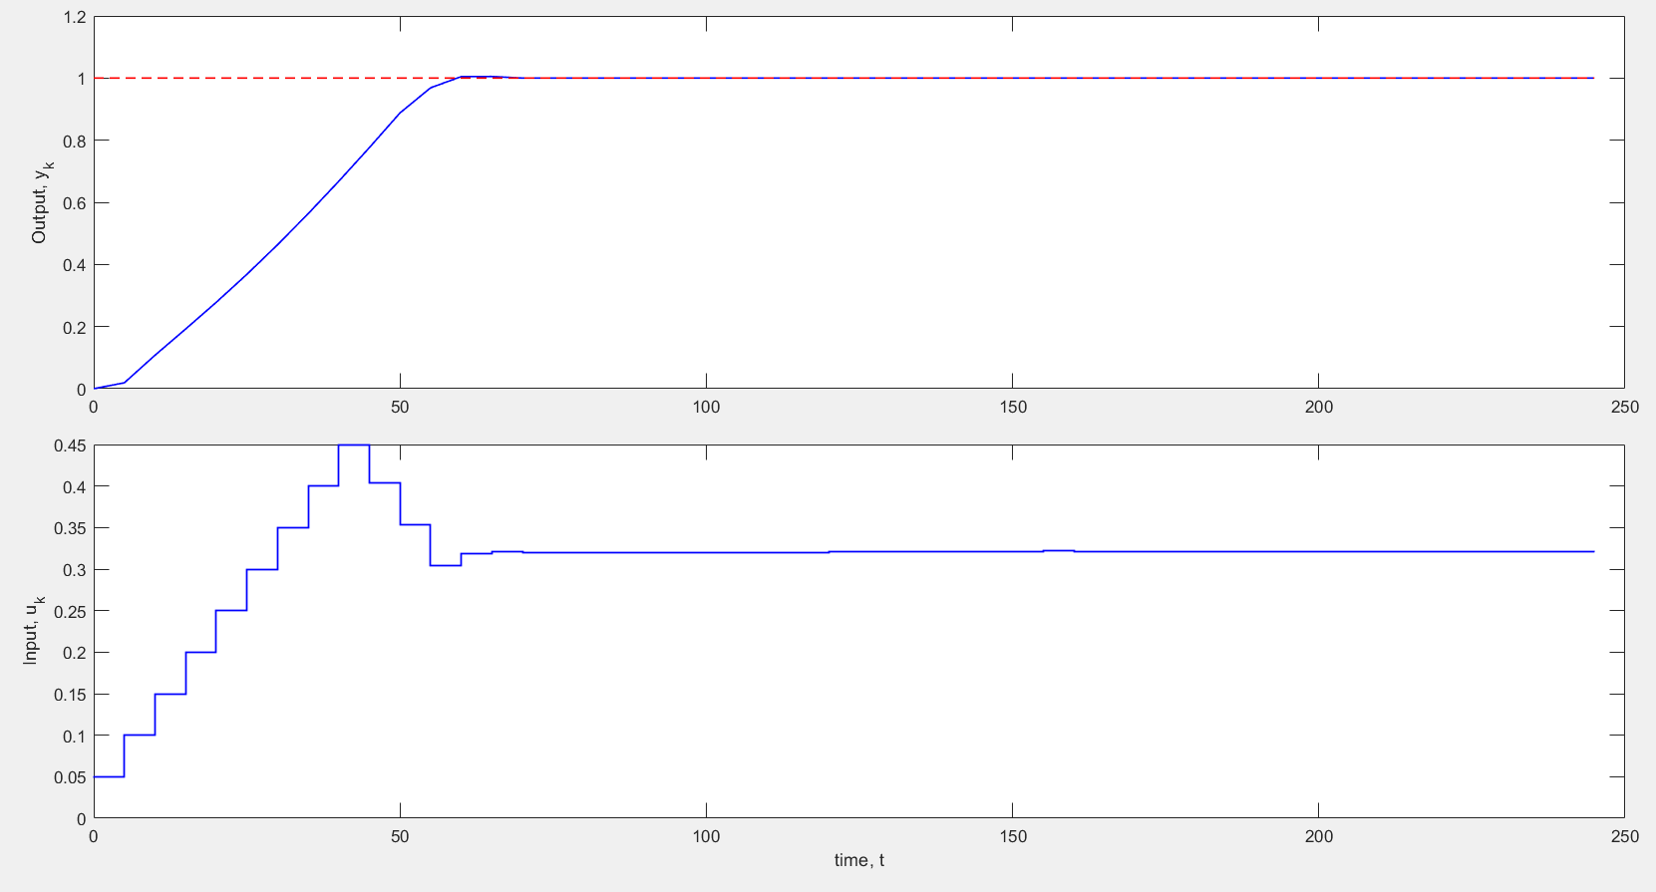

## Multiple Disturbance case

A series of step changes, with *d =* 0.5, 1.0 and –0.2 made at *k =* 0, 12, 20.

As expected we can see deviations in the y values some time after 12*h = 12*5 = 60, and at 20*5 = 100. Basically the effect of the sudden change in disturbance is seen some time after it happens (if there was no delay, the effect will be seen in the next time step itself) and over time the controller accommodates the change and the output is restored to its set-point.

**Plots of inputs and output responses**

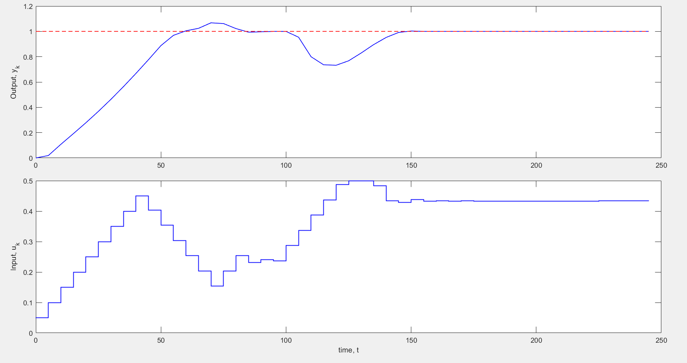

# Question-3

Here the tuning parameters remain the same and we remove the disturbance effects. Instead, this question deals with model-plant mismatch.

Model: $y\left(s\right)=\frac{2.5}{20s+1}e^{-7s}u\left(s\right)$

Plant: $y\left(s\right)=\frac{2.75}{18.5s+1}e^{-6.2s}u\left(s\right)$

I verified that the time taken to get reasonably close to the set-point value (~0 error) is more for the case with mismatch. This extra time is needed to incorporate the effects of the mismatch (bias in the model) in the process of optimization.

**Plots of inputs and output responses**

