CH5120 ASSIGNMENT 6

Question-1

Model Equation:

**τ = 0.5**

%% Controller Parameters

ySP=1; % Setpoint

m=4; % Control horizon

p=10; % Prediction horizon

Q=1; % Output weight

R=0.1; % Input weight

Constraints: and

Initial plant state is set to zero by default.

The measurement errors were set to zero using mpcsimopt

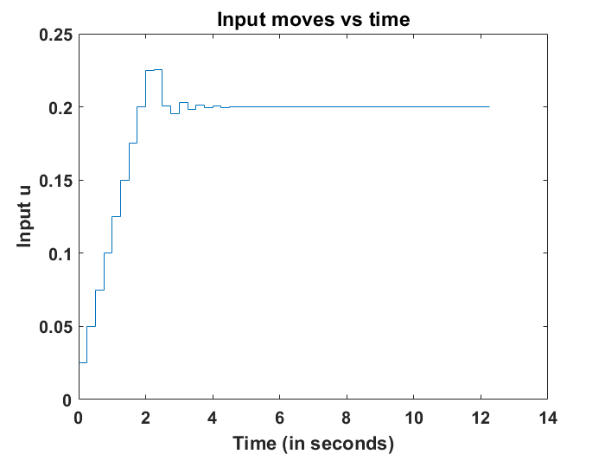

We can visually see that the input moves satisfy the constraint: .

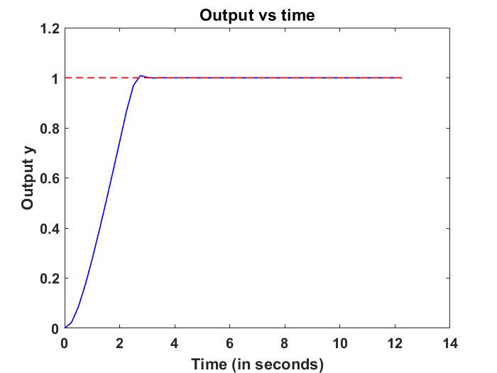

As expected the controller is able to smoothly increase the output the set-point.

# Question-2

Model Equation:

%% Controller Parameters

ySP=1; % Setpoint

m=4; % Control horizon

p=10; % Prediction horizon

Q=1; % Output weight

R=0.04; % Input weight

Constraints: and

Disturbance is simply a step change given at t=0.

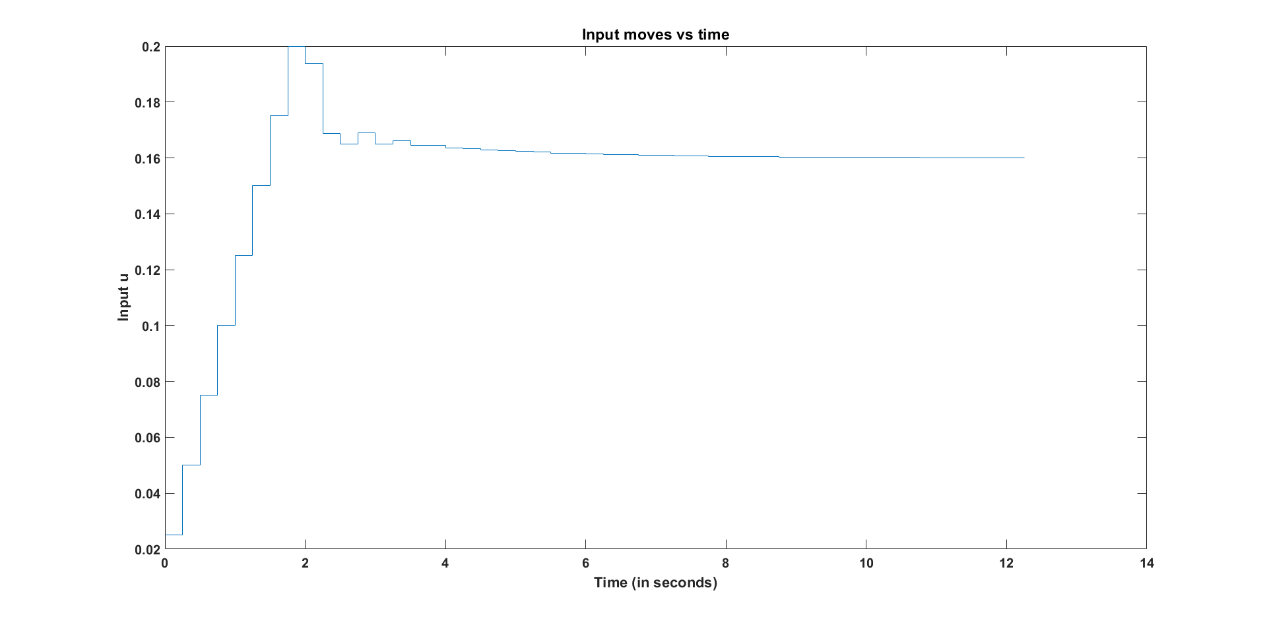

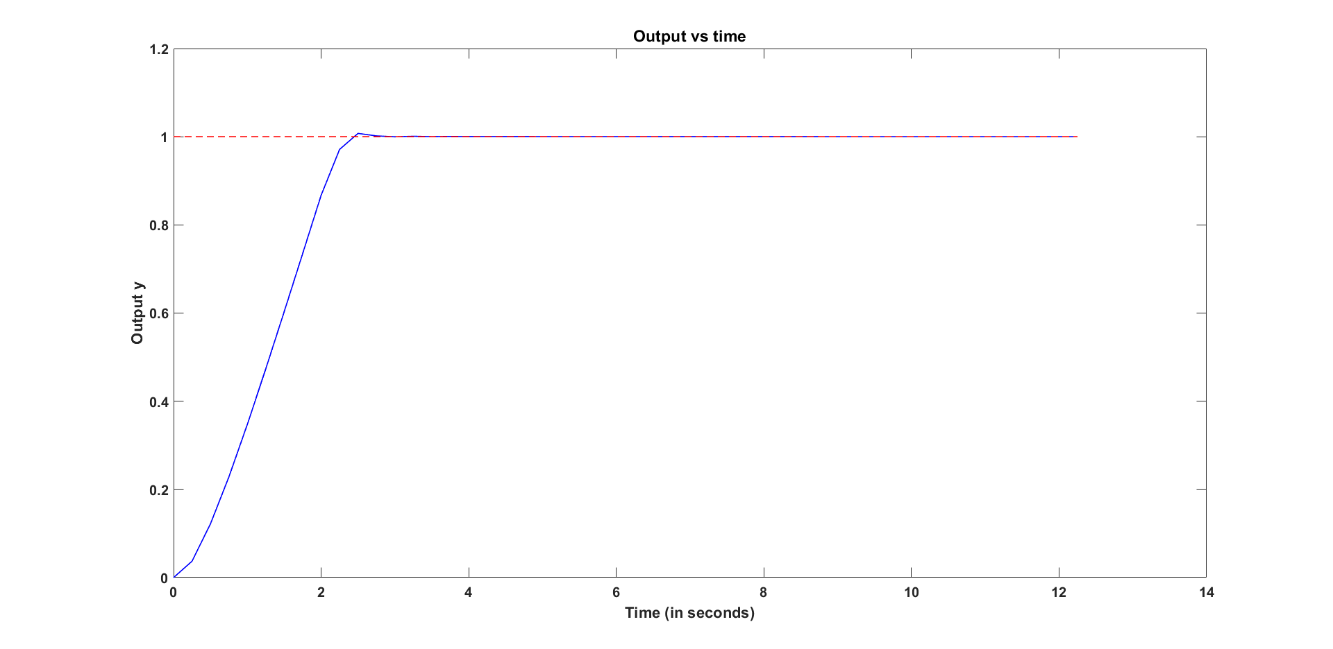

This is done in MATLAB by declaring the model incorporating the measured disturbance as a **2-input 1-output** model. Then using **setmpcsignals**, the input corresponding to the transfer function of the disturbance model, is termed as the ‘Measured Disturbance’.

The value of the disturbance is given as a vector to the **sim** function. (d(k) = 0.5)

Once again, the measurement errors are set to zero.

# Question-3

Here the tuning parameters remain the same and we remove the disturbance effects. Instead, this question deals with **model-plant mismatch**.

Model:

True Plant:

The time taken to get reasonably close to the set-point value (~0 error) is more for the case with mismatch. This extra time is needed to incorporate the effects of the mismatch (bias in the model).

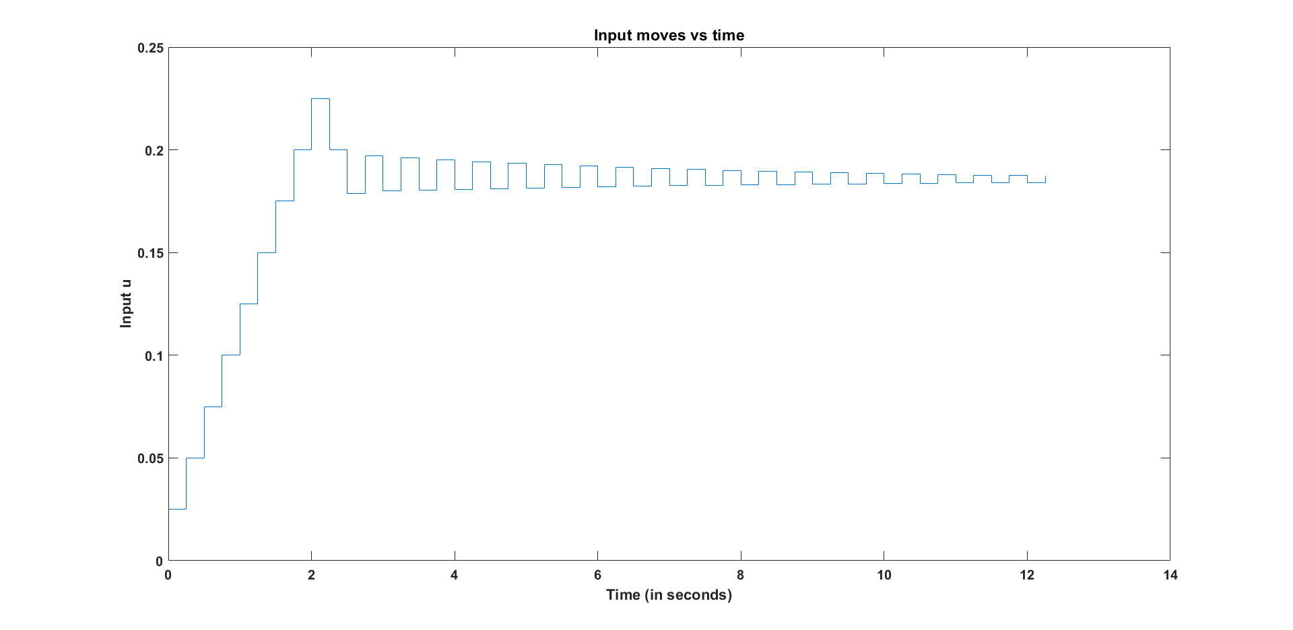

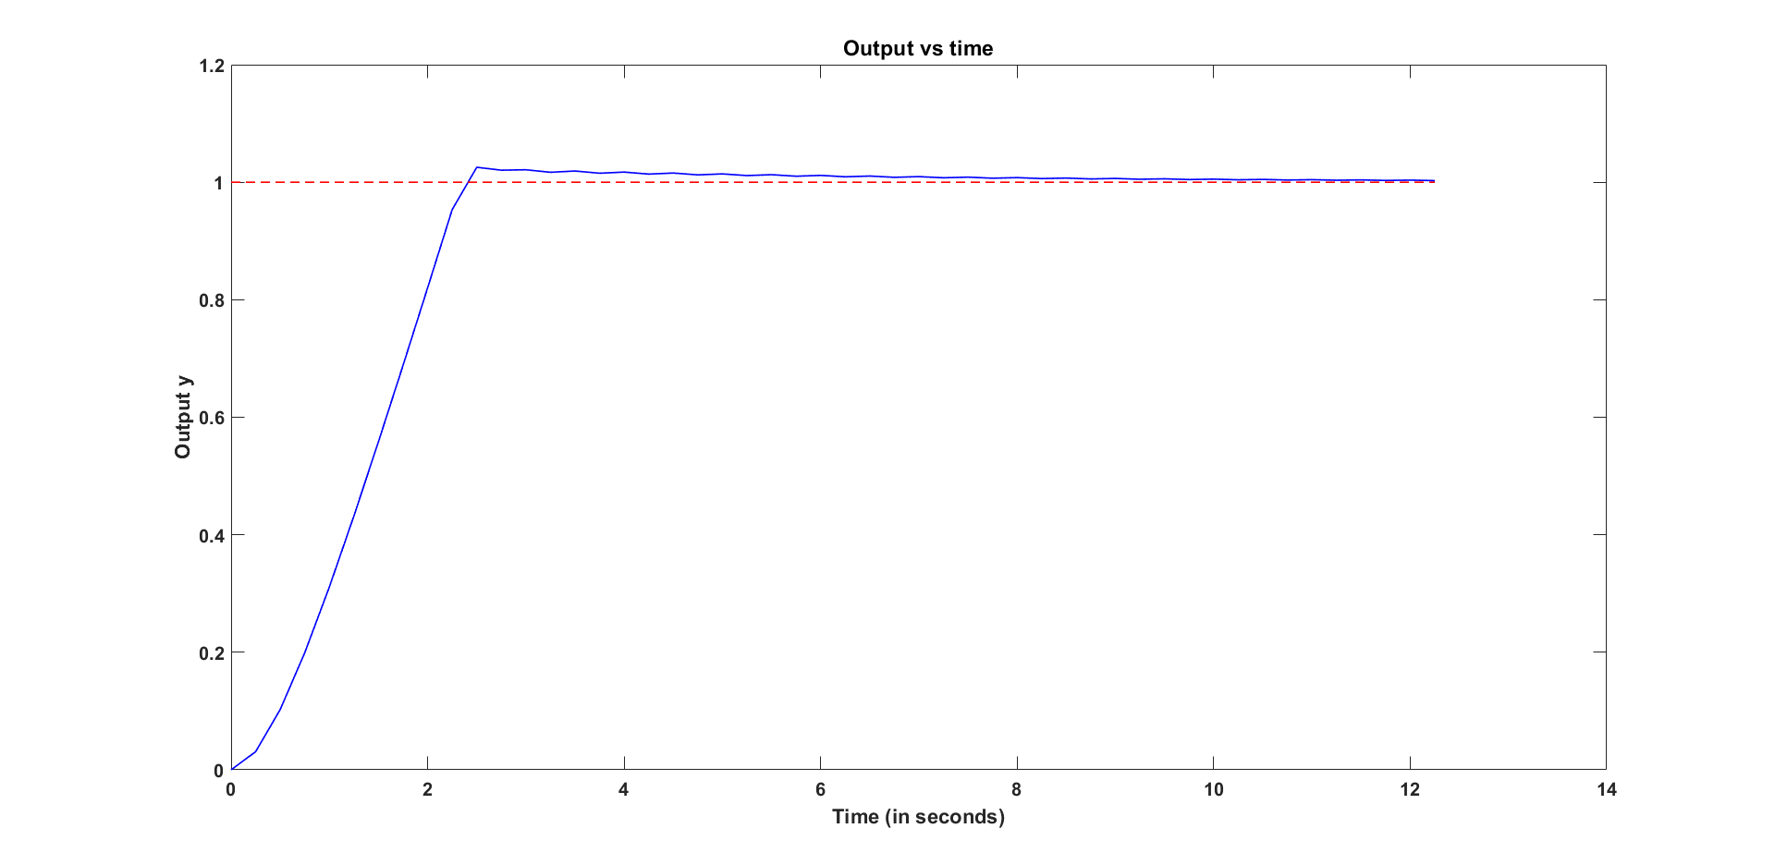

The mismatch effect was incorporating by updating the plant model in the options structure created using mpcsimopt().

The measurement errors were set to zero.