CH5120 ASSIGNMENT 6

# Question-1

System Equation:

τ = 0.5

%% Controller Parameters

ySP=1; % Setpoint

m=4; % Control horizon

p=10; % Prediction horizon

Q=1; % Output weight

R=0.1; % Input weight

Constraints: and

As expected the controller is able to smoothly increase the output the set-point.

**Plots of inputs and output responses**

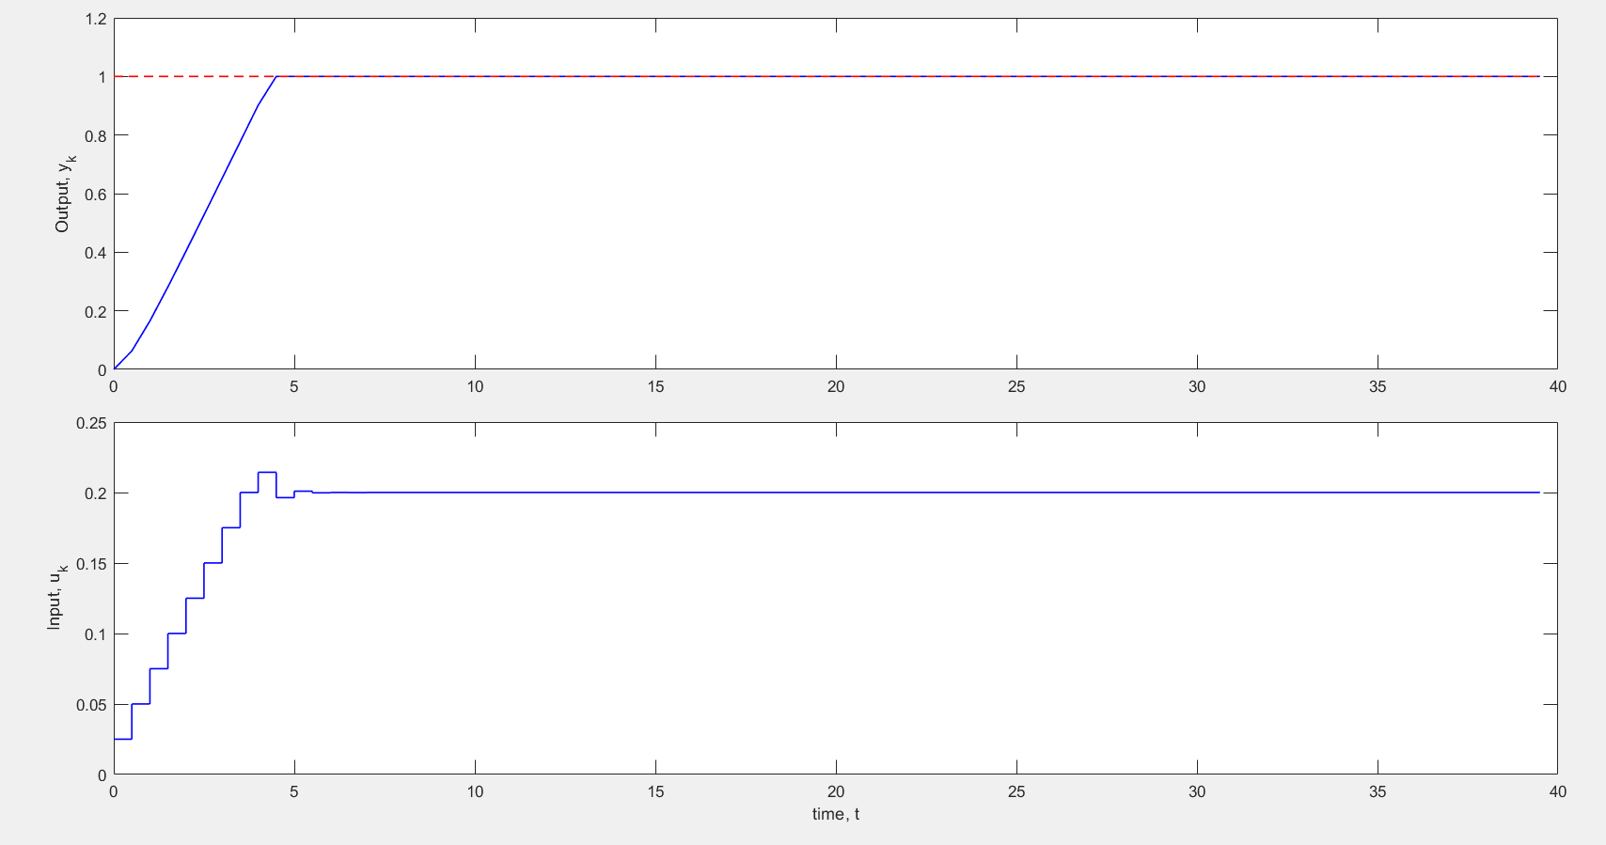

# Question-2

Disturbance Response:

n=24;

% Please replace with your chosen n

h=5; % Sampling interval: Don't change

maxTime=50; % Run this case for 50 time-steps

%% Controller Parameters

ySP=1; % Setpoint

m=4; % Control horizon

p=10; % Prediction horizon

Q=1; % Output weight

R=0.04; % Input weight

Constraints: and

## Single disturbance

Disturbance is simply a step change given at t=0.

**Plots of inputs and output responses**

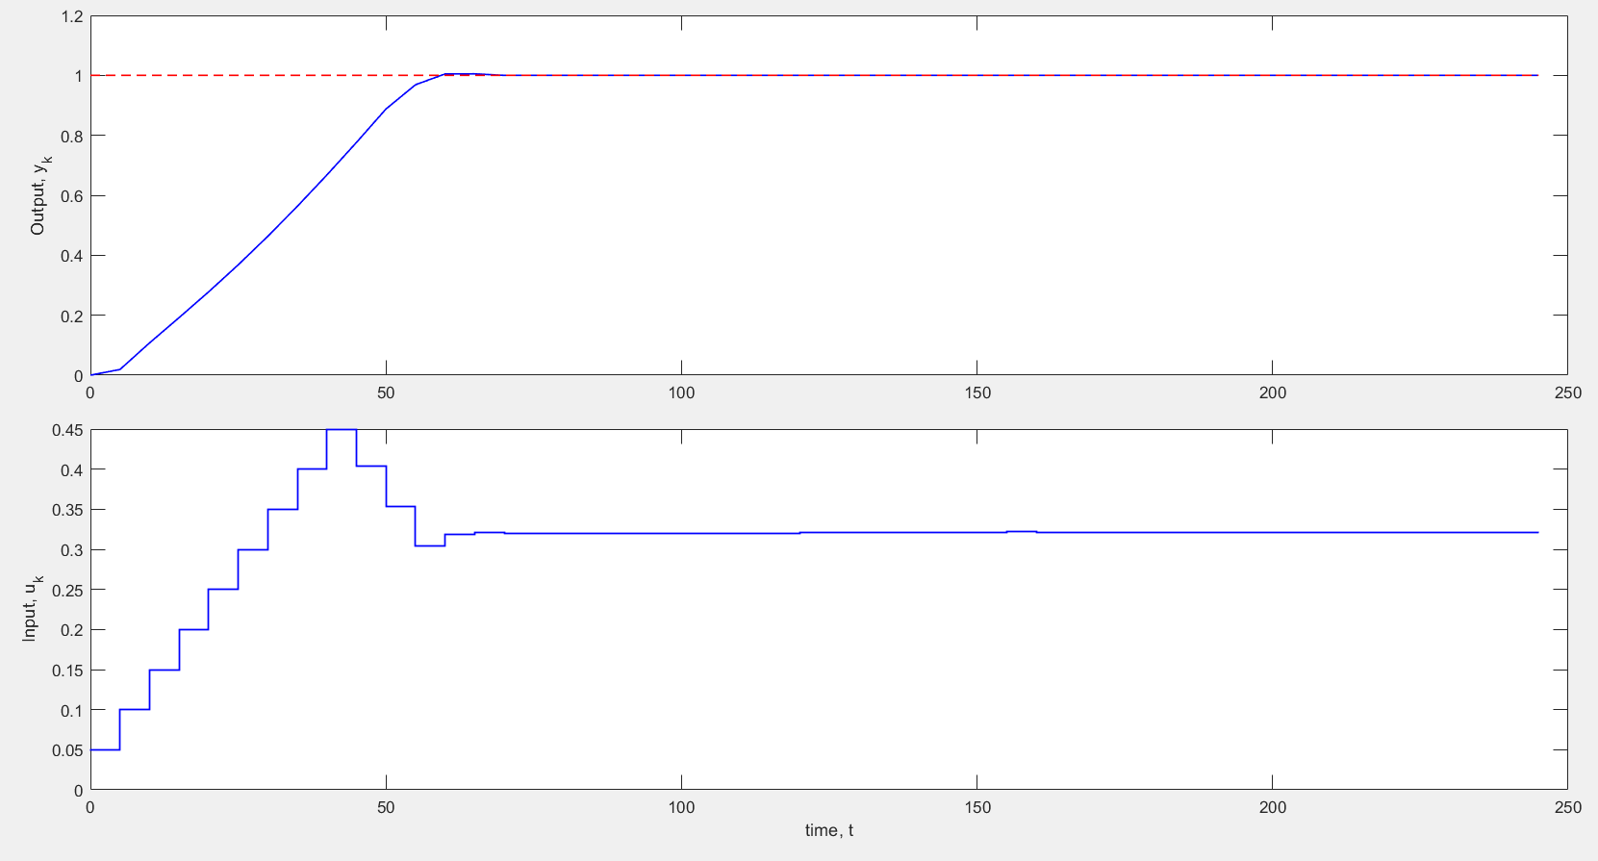

## Multiple Disturbance case

A series of step changes, with *d =* 0.5, 1.0 and –0.2 made at *k =* 0, 12, 20.

As expected we can see deviations in the y values at 13*h = 13*5 = 65, and at 21*5 = 105. Basically the effect of the sudden change in disturbance is seen the time instant after it and slowly it dies down.

**Plots of inputs and output responses**

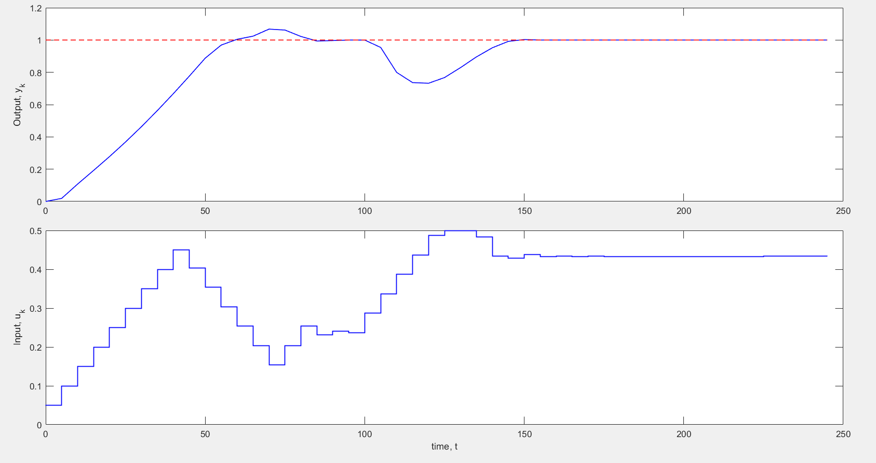

# Question-3

Here the tuning parameters remain the same and we remove the disturbance effects. Instead this question deals with model-plant mismatch.

Model:

Plant:

I verified that the time taken to get reasonably close to the set-point value (~0 error) is more for the case with mismatch. This extra time is needed to incorporate the effects of the mismatch (bias) in the process of optimization.

**Plots of inputs and output responses**

