Coarse grid minimum 300 needed

1)

cglen 300 300 300

fglen 150 150 150

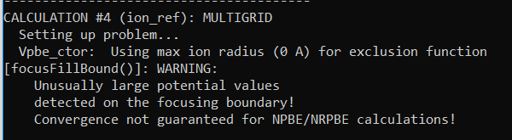

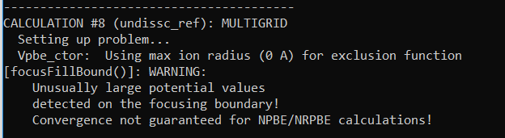

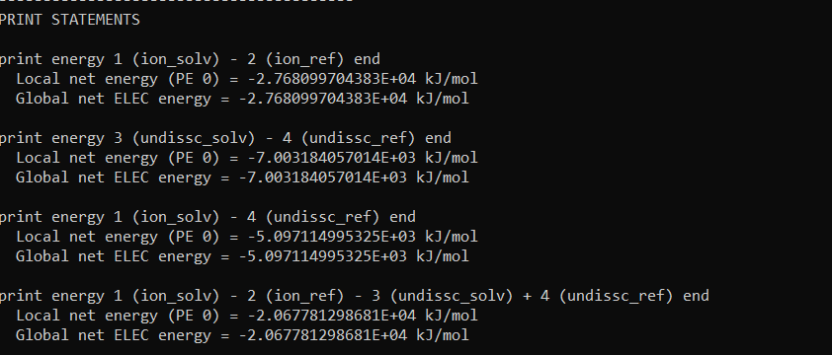

2)

cglen 300 300 300

fglen 200 200 200

Even now got the error but only for Calculation #4

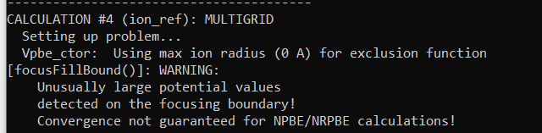

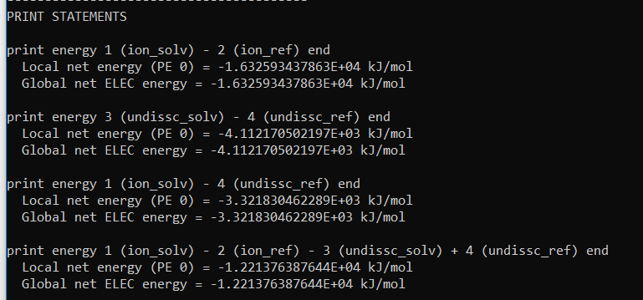3)

cglen 300 300 300

fglen 250 250 250

Got same error as in (2)

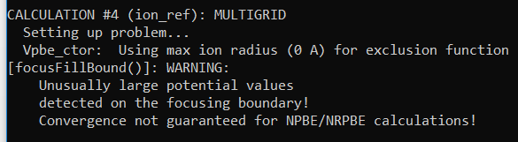

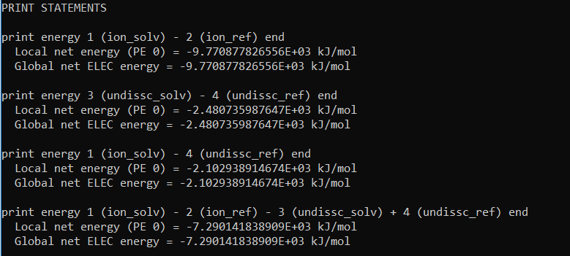

4)

cglen 300 300 300

fglen 75 75 75

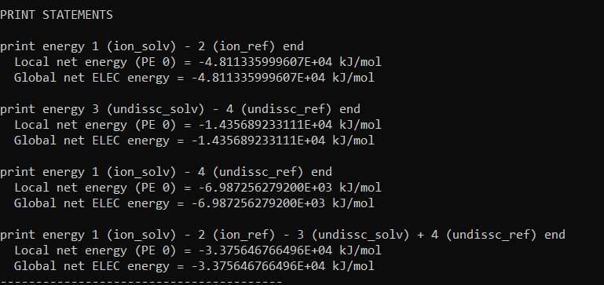

5)

Recommended by pysize.py

For charged:

cglen 446.371 26.884 10.888

fglen 282.571 26.884 10.888

For uncharged:

cglen 494.233 28.341 12.449

fglen 310.725 28.341 12.449

