# Forgot to Add Na+ here

## Condition-1:

dime 161 161 161

cglen 150 150 150

fglen 75 75 75

**Errors/ Warnings:**

Some atoms were outside the mesh!

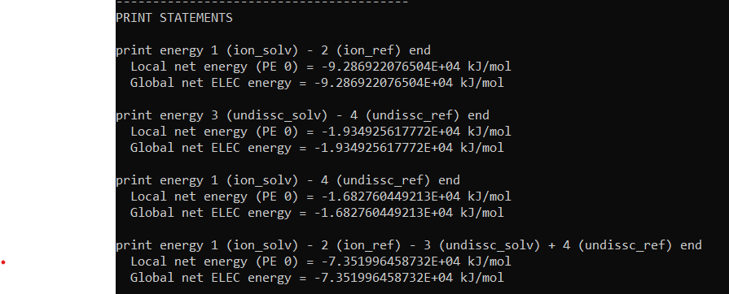

## Condition-2:

cglen 180 180 180

fglen 90 90 90

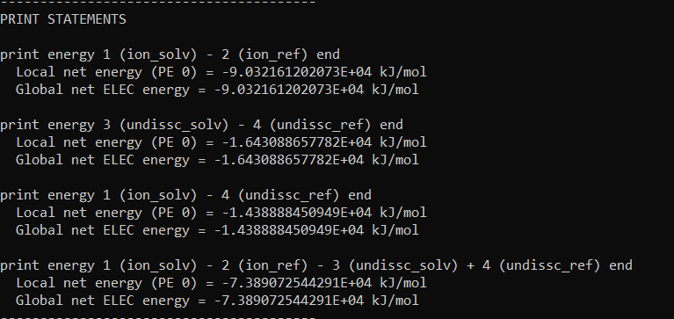

**Errors/ Warnings:**

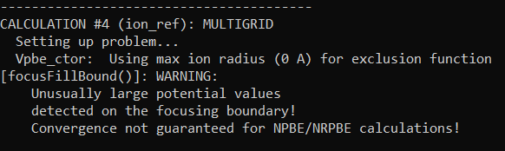

# After Adding Na+

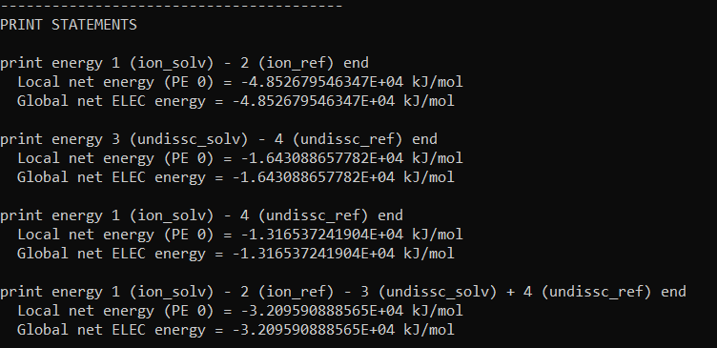

-3.209*10^4 kJ/mol. Slightly more negative than 30 unit PAA.