Using the old convention

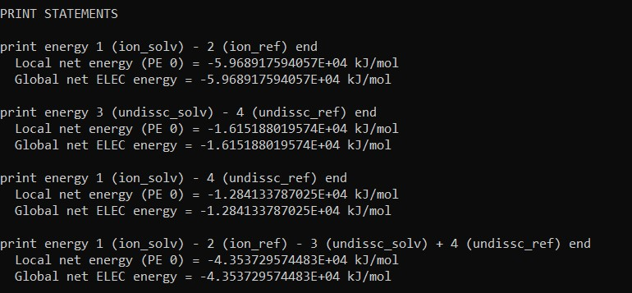

With Na in middle of two O atoms

1. cglen 180 180 180

fglen 90 90 90

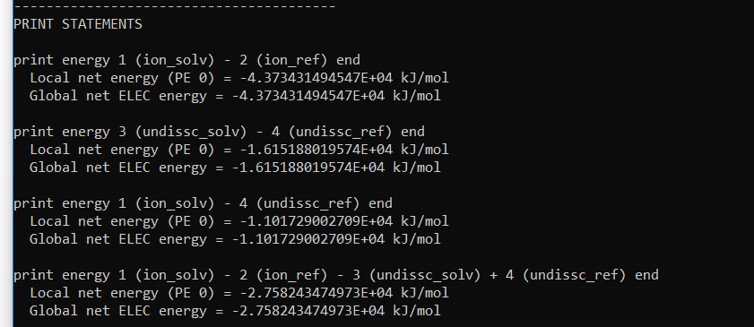

1. cglen 180 180 180

fglen 75 75 75

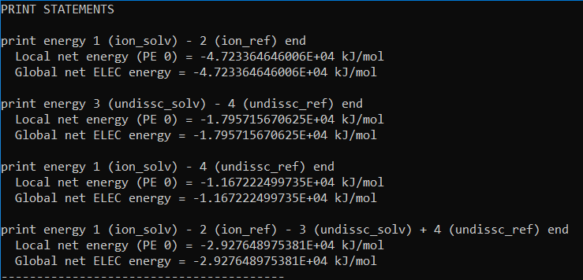

3)

cglen 150 150 150

fglen 75 75 75

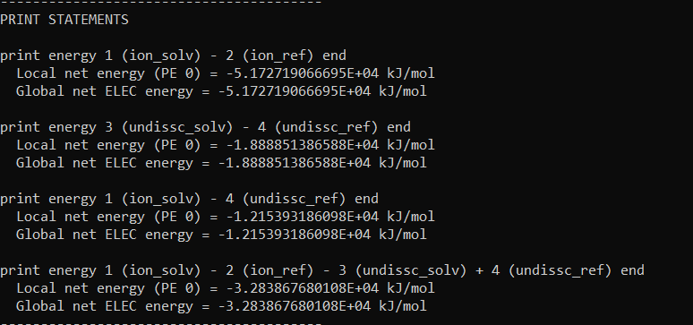

4)

Psize params

Ion

cglen 237.723 25.223 13.931

fglen 159.837 25.223 13.931

uncharged

cglen 195.480 25.707 17.044

fglen 134.988 25.707 17.044

