300 itself not good enough to cover the molecule, so going for 400 (didn’t check 350 etc)

1)

cglen 400 400 400

fglen 200 200 200

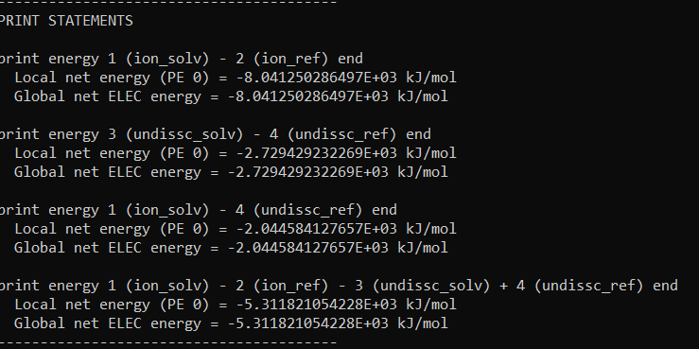

2)

cglen 400 400 400

fglen 100 100 100

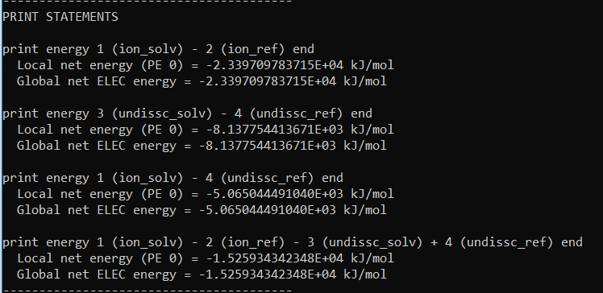

3)

