1)

cglen 500 500 500

fglen 250 250 250

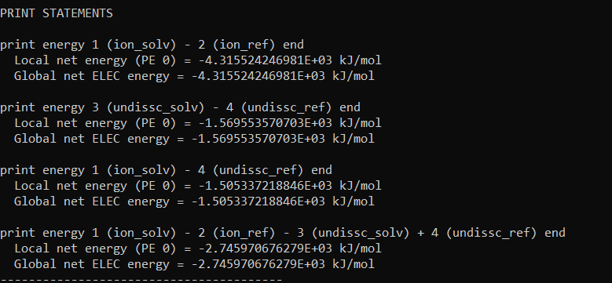

2)

cglen 500 500 500

fglen 200 200 200

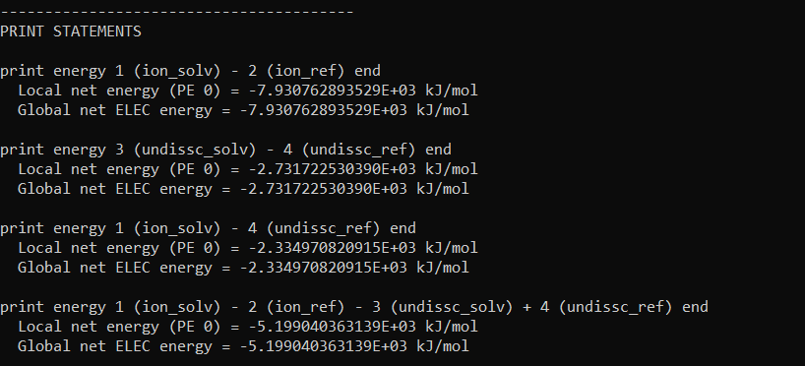

3)

cglen 450 450 450

fglen 200 200 200

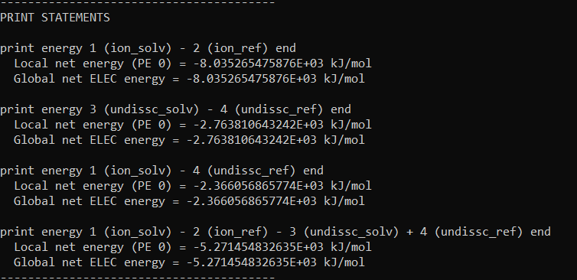

4)

cglen 450 450 450

fglen 75 75 75

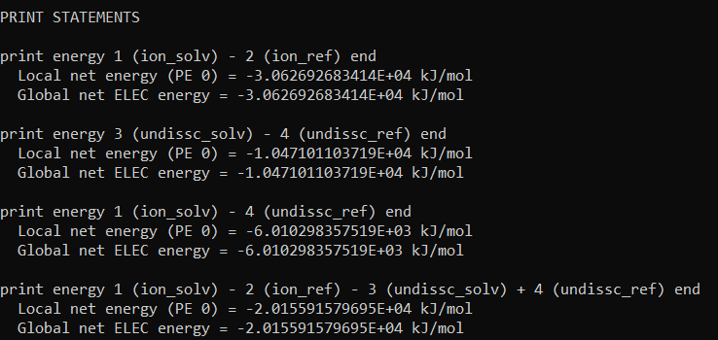

5) Psize params

cglen 705.808 25.248 4.393

fglen 435.181 25.248 4.393

cglen 707.555 26.923 4.272

fglen 436.209 26.923 4.272

