## Simulation results for neutral PAA

Unit molecular weight = 72 g/mol

|  |  |  |
| --- | --- | --- |
| units | ΔGsolvation (kJ/mol) | Per unit (kJ/unit) |
| 20 | -7837.97 | -391.899 |
| 25 | -12713.55 | -508.542 |
| 30 | -14990.15 | -499.672 |
| 35 | -17961.86 | -513.196 |
| 40 | -21427.39 | -535.685 |
| 45 | -20758.41 | -461.298 |
| 50 | -25150.20 | -503.004 |

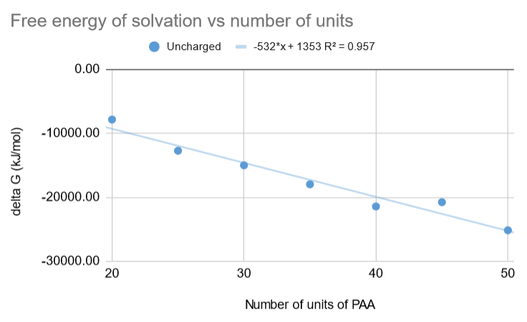

Figure-1: Line fit for free energy of solvation vs number of units of neutral PAA. Slope = -532 kJ/unit

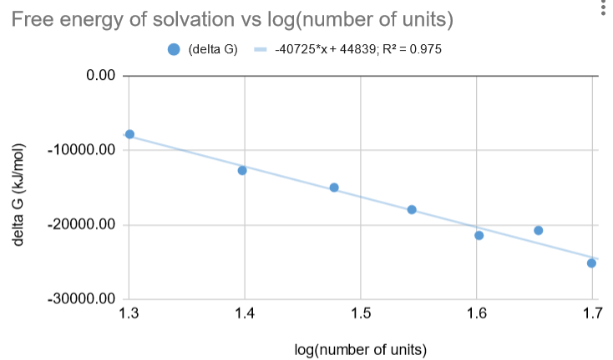

Figure-2: Line fit for free energy of solvation vs log(number of units) of neutral PAA.

## Simulation results for charged PAA

Unit molecular weight = 71 g/mol

|  |  |  |
| --- | --- | --- |
| units | ΔGsolvation (kJ/mol) | Per unit (kJ/unit) |
| 20 | -61377.37 | -3068.87 |
| 25 | -71810.06 | -2872.4 |
| 30 | -100054.15 | -3335.14 |
| 35 | -104250.60 | -2978.59 |
| 40 | -112519.08 | -2812.98 |
| 45 | -127771.11 | -2839.36 |
| 50 | -141572.00 | -2831.44 |

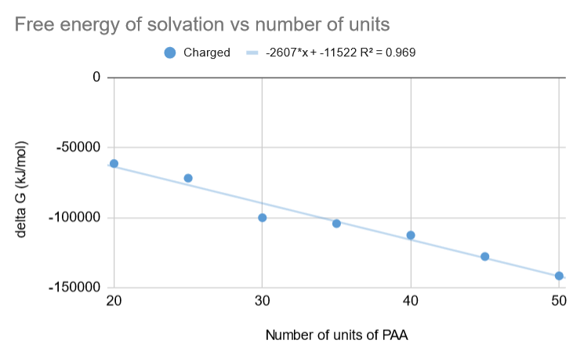

Figure-3: Line fit for free energy of solvation vs number of units of charged PAA. Slope = -2607 kJ/unit

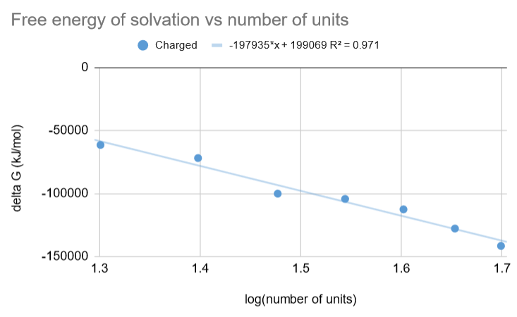

Figure-4: Line fit for free energy of solvation vs log(number of units) of charged PAA.

## Difference in solvation free energies: charged – neutral

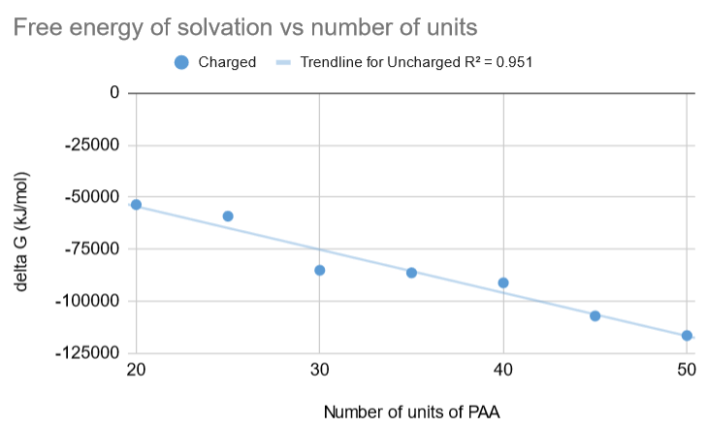

Figure-5: ΔGsolvation vs number of units

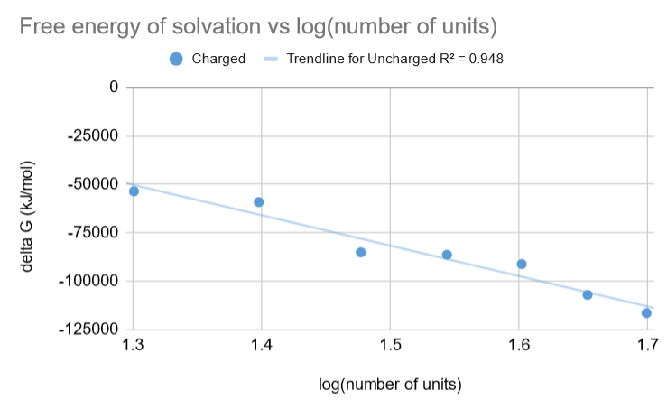

Figure-6: ΔGsolvation vs log(number of units)

## Comparison-1: Glycine

Paper - Solvation Free Energy of the Peptide Group: Its Model Dependence and Implications for the Additive-Transfer Free-Energy Model of Protein Stability

Dheeraj S. Tomar, D. Asthagiri, Valéry Weber, Biophysical Journal, Volume 105, Issue 6, 2013, Pages 1482-1490, <https://doi.org/10.1016/j.bpj.2013.08.011>

Polymer used: chain of Glycines – (Gly)n

Glycine molecular weight = 75 g/mol

|  |  |
| --- | --- |
| Unit | delta G / unit (kJ/mol) |
|  |  |
| PAA - uncharged | -487.6135595 |
| PAA - charged | -2962.681829 |
| **Glycine** | -26.89714286 |

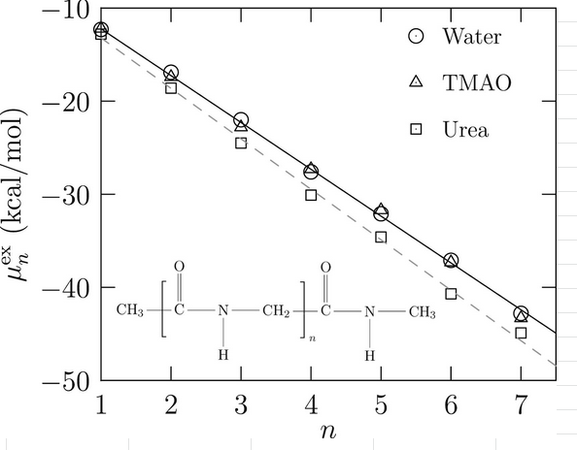

The [solvation](https://www.sciencedirect.com/topics/biochemistry-genetics-and-molecular-biology/solvation) free energy (Eq. 3) versus n for blocked (Gly)n in the extended conformation – Figure-3 in the paper

## Comparison-2: Alkanes

Paper- Extended scaled particle theory for dilute solutions of arbitrary shaped solutes. An application to solvation free energies of hydrocarbons, Masayuki Irisa, Kuniaki Nagayama, Fumio Hirata, Chemical Physics Letters, Volume 207, Issues 4–6, 1993, Pages 430-435, ISSN 0009-2614, <https://doi.org/10.1016/0009-2614(93)89025-D>.

Polymer used: n-alkane

Unit molecular weight (CH2 unit) = 14 g/mol

|  |  |
| --- | --- |
| Unit | delta G / unit (kJ/mol) |
|  |  |
| PAA - uncharged | -487.6135595 |
| PAA - charged | -2962.681829 |
| **CH2 unit** | 2.092 |

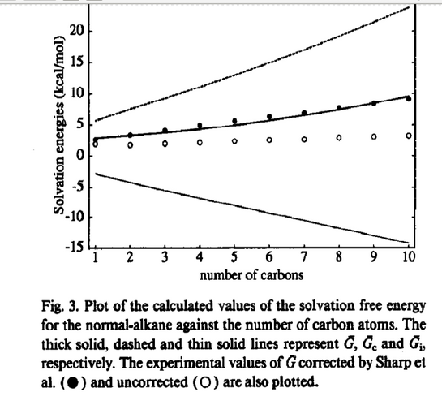

## Comparison-3: Peptides

Paper - Solvation Free Energies of Peptides:  Comparison of Approximate Continuum Solvation Models with Accurate Solution of the Poisson−Boltzmann Equation. Shlomit R. Edinger, Christian Cortis, Peter S. Shenkin, and Richard A. Friesner, J. Phys. Chem. B 1997, 101, 7, 1190–1197, <https://doi.org/10.1021/jp962156k>

(They didn’t show linear variation but they computed solvation energies of peptides of various lengths and multiple conformations using Poisson Boltzmann and other methods like Generalized Born and compared the resulting values.)

I am comparing the solvation energy they had got for the largest peptide (9 units) with the sequence of amino acids “ala-asn-tyr-val-trp-ile-gly-val-leu”.

Molecular weight of the compound = 1045 g/mol

Average per unit weight = 116.1 g/mol

|  |  |
| --- | --- |
| Unit | delta G / unit (kJ/mol) |
|  |  |
| PAA - uncharged | -487.6135595 |
| PAA - charged | -2962.681829 |
| **nonapeptide (avg/unit)** | -117.7777778 |

(value obtained from figure-6 in their paper)

## Comparison-4: Alkanes

Paper - Extracting Hydrophobic Free Energies from Experimental Data: Relationship to Protein Folding and Theoretical Model

Kim A. Sharp, Anthony Nicholls, Richard Friedman, and Barry Honig, Biochemistry 1991 30 (40), 9686-9697, <https://doi.org/10.1021/bi00104a017>

They have shown linear relationship of solvation energy vs solvent accessible surface area.

Polymer used – alkane

Unit molecular weight (CH2 unit) = 14 g/mol

|  |  |
| --- | --- |
| Unit | delta G / unit (kJ/mol) |
|  |  |
| PAA - uncharged | -487.6135595 |
| PAA - charged | -2962.681829 |
| **CH2 unit (for 10 units)** | -1.35 |

Values extracted from this table:

