Plots

# Question-4 plots

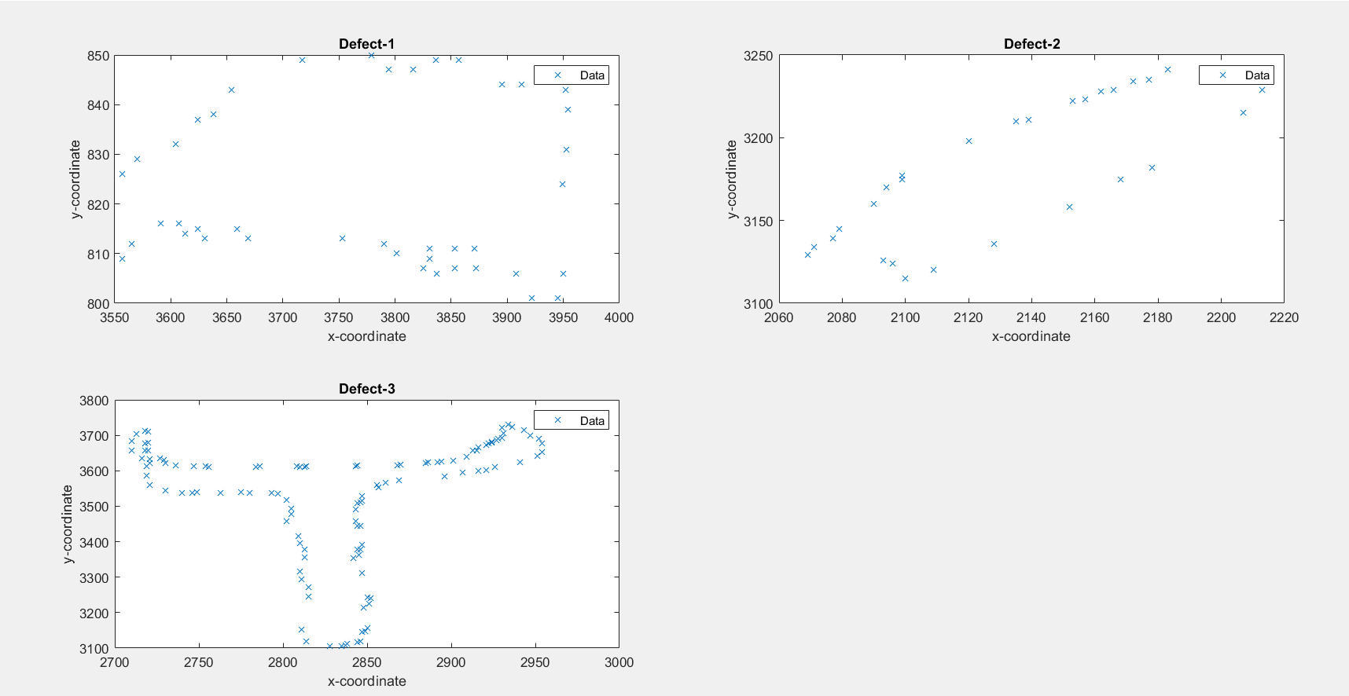

The above plots agree with the inferences concluded using OLS/TLS.

Defect-1: along horizontal axis

Defect-2: along y = x

Defect-3: along vertical axis

Code

# OLS.m (function to perform OLS)

function [alpha, beta, uhat, yhat, s] = OLS(u,y)

N = length(u);

ybar = mean(y);

ubar = mean(u);

syy = var(y,1);

suu = var(u,1);

syu = 1/N*sum((y-ybar).*(u-ubar));

uhat = u;

alpha = syu/suu;

beta = ybar - alpha*ubar;

yhat = alpha*uhat + beta;

s = struct('alpha',alpha,'beta',beta,'ybar',ybar,'ubar',ubar,'syy',syy,'syu',syu,'suu',suu);

end

# IOLS.m (function to perform IOLS)

function [alpha, beta, uhat, yhat, s] = IOLS(u,y)

N = length(u);

ybar = mean(y);

ubar = mean(u);

syy = var(y,1);

suu = var(u,1);

syu = 1/N*sum((y-ybar).*(u-ubar));

yhat = y;

alpha = syy/syu;

beta = ybar - alpha*ubar;

uhat = (yhat - beta)/alpha;

s = struct('alpha',alpha,'beta',beta,'ybar',ybar,'ubar',ubar,'syy',syy,'syu',syu,'suu',suu);

end

# TLS.m (function to perform TLS)

function [alpha, beta, uhat, yhat, s] = TLS(u,y)

N = length(u);

ybar = mean(y);

ubar = mean(u);

syy = var(y,1);

suu = var(u,1);

syu = 1/N*sum((y-ybar).*(u-ubar));

alpha = (syy - suu + sqrt((syy-suu)^2 + 4*syu^2))/2/syu;

beta = ybar - alpha*ubar;

uhat = (alpha*(y-beta)+u)/(alpha^2+1);

yhat = alpha*uhat + beta;

s = struct('alpha',alpha,'beta',beta,'ybar',ybar,'ubar',ubar,'syy',syy,'syu',syu,'suu',suu);

end

# Question-2

clear; close all;

%% Open data

A = readmatrix('CO2.csv');

time = A(:,1);

CO2 = A(:,2);

temp = A(:,3);

temp_cut = 3.6;

%% Predict maximum permissible level of CO2 - OLS

% y -> temperature deviation

% u -> CO2

u = CO2;

y = temp;

[alpha, beta, uhat, yhat, s] = OLS(u,y);

disp(s);

CO2_cut_OLS = (temp_cut-beta)/alpha;

%% Predict maximum permissible level of CO2 - TLS

[alpha_TLS, beta_TLS, uhat_TLS, yhat_TLS,s_TLS] = TLS(u,y);

CO2_cut_TLS = (temp_cut-beta_TLS)/alpha_TLS;

%% Predict year

ut = time;

yt = CO2;

[alpha_t, beta_t, uhat_t, yhat_t, s_t] = OLS(ut,yt);

t_OLS = (CO2_cut_OLS-beta_t)/alpha_t;

tpred_OLS = ceil(t_OLS);

t_TLS = (CO2_cut_TLS-beta_t)/alpha_t;

tpred_TLS = ceil(t_TLS);

# Question-3

close all; clear;

%% Data

EP = [1.98,2.31,3.29,3.56,1.23,1.57,2.05,0.66,0.31,2.82,0.13,3.15,2.72,2.31,1.92,1.56,0.94,2.27,3.17,2.36]';

CF = [1.87,2.2,3.15,3.42,1.1,1.41,1.84,0.68,0.27,2.8,0.14,3.2,2.7,2.43,1.78,1.53,0.84,2.21,3.10,2.34]';

% u - EP, y - CF

u = EP;

y = CF;

N = length(u);

%% Part a)

% OLS

[alpha_OLS, beta_OLS, uhat_OLS, yhat_OLS,s_OLS] = OLS(u,y);

sigma_e_OLS = 1/(N-2)*sum((y-alpha_OLS*u-beta_OLS).^2);

CI_OLS = [alpha_OLS-2.16*sigma_e_OLS,alpha_OLS+2.16*sigma_e_OLS];

% IOLS

[alpha_IOLS, beta_IOLS, uhat_IOLS, yhat_IOLS,s_IOLS] = IOLS(u,y);

sigma_e_IOLS = 1/(N-2)*sum((y-alpha_IOLS*u-beta_IOLS).^2);

CI_IOLS = [alpha_IOLS-2.16*sigma_e_IOLS,alpha_OLS+2.16*sigma_e_IOLS];

% TLS

[alpha_TLS, beta_TLS, uhat_TLS, yhat_TLS,s_TLS] = TLS(u,y);

sigma_e_TLS = 1/(N-2)*sum((y-alpha_TLS*u-beta_TLS).^2);

CI_TLS = [alpha_TLS-2.16*sigma_e_TLS,alpha_TLS+2.16*sigma_e_TLS];

%% Part b)

ui = 2.31;

yi = 2.20;

% OLS: u is perfect

OLS_pred = ui;

% IOLS: y is perfect

IOLS_pred = yi;

% TLS: both imperfect. doing a perpendicular projection will give us an

% estimate for EP and CF. Since we need a single estimate we will assume

% alpha = 1 and beta = 0. So yhat = uhat = (u+y)/2

TLS_pred = (ui+yi)/2;

# Question-4

clear; close all;

%% Open data

A = readmatrix('defects_annotation_data.csv');

x1 = rem_NaN(A(:,1)); y1 = rem_NaN(A(:,2));

x2 = rem_NaN(A(:,4)); y2 = rem_NaN(A(:,5));

x3 = rem_NaN(A(:,7)); y3 = rem_NaN(A(:,8));

%% Defect-1

N = length(x1);

% TLS

[alpha_TLS, beta_TLS, uhat_TLS, yhat_TLS,s_TLS] = TLS(x1,y1);

sigma_e_TLS = 1/(N-2)*sum((y1-alpha_TLS*x1-beta_TLS).^2);

CI_TLS = [alpha_TLS-2.16*sigma_e_TLS,alpha_TLS+2.16*sigma_e_TLS];

% TLS - inverted

[alpha_TLS2, beta_TLS2, uhat_TLS2, yhat_TLS2,s_TLS2] = TLS(y1,x1);

sigma_e_TLS2 = 1/(N-2)*sum((y1-alpha_TLS2*x1-beta_TLS2).^2);

CI_TLS2 = [alpha_TLS2-2.16*sigma_e_TLS2,alpha_TLS2+2.16*sigma_e_TLS2];

% OLS

[alpha_OLS, beta_OLS, uhat_OLS, yhat_OLS,s_OLS] = OLS(x1,y1);

sigma_e_OLS = 1/(N-2)*sum((y1-alpha_OLS*x1-beta_OLS).^2);

CI_OLS = [alpha_OLS-2.16*sigma_e_OLS,alpha_OLS+2.16*sigma_e_OLS];

% OLS - inverted

[alpha_OLS2, beta_OLS2, uhat_OLS2, yhat_OLS2,s_OLS2] = OLS(y1,x1);

sigma_e_OLS2 = 1/(N-2)*sum((y1-alpha_OLS2*x1-beta_OLS2).^2);

CI_OLS2 = [alpha_OLS2-2.16*sigma_e_OLS2,alpha_OLS2+2.16*sigma_e_OLS2];

% Plot

subplot(2,2,1);

plot(x1,y1,'x');

title('Defect-1'); xlabel('x-coordinate'); ylabel('y-coordinate');

legend('Data');

%% Defect-2

% TLS

[alpha_TLS_def2, beta_TLS_def2, uhat_TLS_def2, yhat_TLS_def2,s_TLS_def2] = TLS(x2,y2);

sigma_e_TLS_def2 = 1/(N-2)*sum((y2-alpha_TLS_def2*x2-beta_TLS_def2).^2);

CI_TLS_def2 = [alpha_TLS_def2-2.16*sigma_e_TLS_def2,alpha_TLS_def2+2.16*sigma_e_TLS_def2];

% TLS - inverted

[alpha_TLS2_def2, beta_TLS2_def2, uhat_TLS2_def2, yhat_TLS2_def2,s_TLS2_def2] = TLS(y2,x2);

sigma_e_TLS2_def2 = 1/(N-2)*sum((y2-alpha_TLS2_def2*x2-beta_TLS2_def2).^2);

CI_TLS2_def2 = [alpha_TLS2_def2-2.16*sigma_e_TLS2_def2,alpha_TLS2_def2+2.16*sigma_e_TLS2_def2];

% OLS

[alpha_OLS_def2, beta_OLS_def2, uhat_OLS_def2, yhat_OLS_def2,s_OLS_def2] = OLS(x2,y2);

sigma_e_OLS_def2 = 1/(N-2)*sum((y2-alpha_OLS_def2*x2-beta_OLS_def2).^2);

CI_OLS_def2 = [alpha_OLS_def2-2.16*sigma_e_OLS_def2,alpha_OLS_def2+2.16*sigma_e_OLS_def2];

% OLS - inverted

[alpha_OLS2_def2, beta_OLS2_def2, uhat_OLS2_def2, yhat_OLS2_def2,s_OLS2_def2] = OLS(y2,x2);

sigma_e_OLS2_def2 = 1/(N-2)*sum((y2-alpha_OLS2_def2*x2-beta_OLS2_def2).^2);

CI_OLS2_def2 = [alpha_OLS2_def2-2.16*sigma_e_OLS2_def2,alpha_OLS2_def2+2.16*sigma_e_OLS2_def2];

% Plot

subplot(2,2,2);

plot(x2,y2,'x');

title('Defect-2'); xlabel('x-coordinate'); ylabel('y-coordinate');

legend('Data');

%% Defect-3

% TLS

[alpha_TLS_def3, beta_TLS_def3, uhat_TLS_def3, yhat_TLS_def3,s_TLS_def3] = TLS(x3,y3);

sigma_e_TLS_def3 = 1/(N-2)*sum((y3-alpha_TLS_def3*x3-beta_TLS_def3).^2);

CI_TLS_def3 = [alpha_TLS_def3-2.16*sigma_e_TLS_def3,alpha_TLS_def3+2.16*sigma_e_TLS_def3];

% TLS - inverted

[alpha_TLS2_def3, beta_TLS2_def3, uhat_TLS2_def3, yhat_TLS2_def3,s_TLS2_def3] = TLS(y3,x3);

sigma_e_TLS2_def3 = 1/(N-2)*sum((y3-alpha_TLS2_def3*x3-beta_TLS2_def3).^2);

CI_TLS2_def3 = [alpha_TLS2_def3-2.16*sigma_e_TLS2_def3,alpha_TLS2_def3+2.16*sigma_e_TLS2_def3];

% OLS

[alpha_OLS_def3, beta_OLS_def3, uhat_OLS_def3, yhat_OLS_def3,s_OLS_def3] = OLS(x3,y3);

sigma_e_OLS_def3 = 1/(N-2)*sum((y3-alpha_OLS_def3*x3-beta_OLS_def3).^2);

CI_OLS_def3 = [alpha_OLS_def3-2.16*sigma_e_OLS_def3,alpha_OLS_def3+2.16*sigma_e_OLS_def3];

% OLS - inverted

[alpha_OLS2_def3, beta_OLS2_def3, uhat_OLS2_def3, yhat_OLS2_def3,s_OLS2_def3] = OLS(y3,x3);

sigma_e_OLS2_def3 = 1/(N-2)*sum((y2-alpha_OLS2_def3*x2-beta_OLS2_def3).^2);

CI_OLS2_def3 = [alpha_OLS2_def3-2.16*sigma_e_OLS2_def3,alpha_OLS2_def3+2.16*sigma_e_OLS2_def3];

% Plot

subplot(2,2,3);

plot(x3,y3,'x');

title('Defect-3'); xlabel('x-coordinate'); ylabel('y-coordinate');

legend('Data');

%% function to remove NaN values

function vnew = rem_NaN(v)

vnew = v(~isnan(v));

end