MVDA Assignment-2

# Question-1

## Part-a)

Bijol toof

## Part-b)

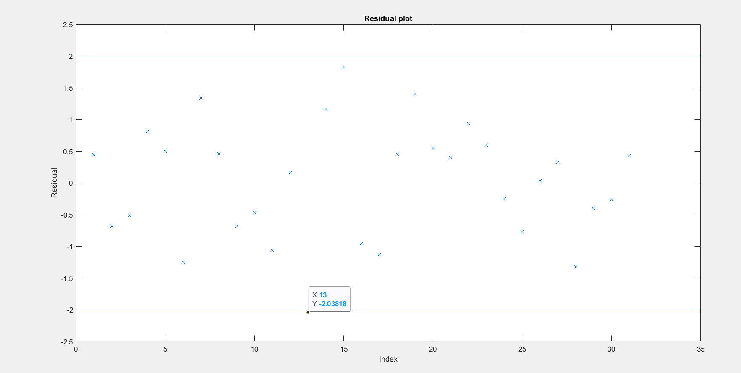

13th data point dropped

