# ASSIGNMENT-1 Process Engineering

P = 1 + 0.20 = 1.2 atm

**Flowsheet**

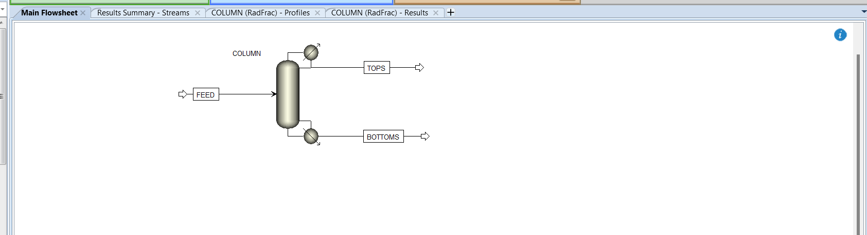

**Mass balance**

$$mass of species j in feed=mass of species j in distillate+mass of species j in bottoms$$

Results

|  |  |  |  |  |
| --- | --- | --- | --- | --- |
| **Species** | **units** | **Feed** | **Bottoms** | **Distillate** |
| acetone | kg/hr | 14.5200 | 0.02021 | 14.4998 |
| ethanol | kg/hr | 11.5173 | 0.01734 | 11.4999 |
| n-butanol | kg/hr | 18.5307 | 18.4770 | 0.05369 |
| phenol | kg/hr | 23.5283 | 23.5283 | 1.88E-09 |
| Total | kg/hr | 68.0962 | 42.0428 | 26.0534 |

**The concentrations (mole fraction) of the distillate and bottoms streams**

|  |  |  |  |  |
| --- | --- | --- | --- | --- |
|  | xAcetone | xEthanol | xButanol | xPhenol |
| Distillate | 0.4993 | 0.4992 | 0.0014 | 4.00E-11 |
| Bottoms | 0.00070 | 0.00075 | 0.49855 | 0.50000 |

**Vapor and liquid composition profile along the column**

|  |  |  |  |  |  |  |  |  |
| --- | --- | --- | --- | --- | --- | --- | --- | --- |
|  | Vapor | | | | Liquid | | | |
|  | yAcetone | yEthanol | yButanol | yPhenol | xAcetone | xEthanol | xButanol | xPhenol |
| Distillate | 0.6934 | 0.3065 | 0.0002 | 6.50E-14 | 0.4993 | 0.4992 | 0.0014 | 4.00E-11 |
| Tray 1 | 0.4993 | 0.4992 | 0.0014 | 4.0E-11 | 0.2633 | 0.7264 | 0.0103 | 1.19E-08 |
| Tray 2 | 0.3051 | 0.6861 | 0.0088 | 9.81E-09 | 0.1244 | 0.8258 | 0.0498 | 1.62E-06 |
| Tray 3 | 0.1937 | 0.7654 | 0.0409 | 1.32E-06 | 0.0678 | 0.7487 | 0.1834 | 1.35E-04 |
| Tray 4 | 0.1507 | 0.7008 | 0.1484 | 1.09E-04 | 0.0459 | 0.4888 | 0.4597 | 0.0056 |
| Tray 5 | 0.1374 | 0.4909 | 0.3673 | 0.0045 | 0.0441 | 0.2214 | 0.6415 | 0.0930 |
| Tray 6 | 0.0530 | 0.2670 | 0.6710 | 0.0089 | 0.0157 | 0.0859 | 0.8021 | 0.0963 |
| Tray 7 | 0.0188 | 0.1036 | 0.8652 | 0.0125 | 0.0052 | 0.0282 | 0.8678 | 0.0988 |
| Tray 8 | 0.0061 | 0.0339 | 0.9443 | 0.0157 | 0.0017 | 0.0087 | 0.8796 | 0.1100 |
| Tray 9 | 0.0020 | 0.0103 | 0.9588 | 0.0289 | 0.0008 | 0.0026 | 0.8131 | 0.1835 |
| Bottoms | 0.0008 | 0.003028 | 0.88112 | 0.115053 | 0.0007 | 0.00075 | 0.49855 | 0.50000 |