# ASSIGNMENT-2 PROCESS ENGINEERING

## Flowsheet

## 1. Concentration of butanol in the Distillate stream

The concentration of butanol (in terms of mole fraction) is **0.024814**

Distillate concentrations:

|  |  |
| --- | --- |
| Component | distillate |
| Butanol | **0.024814** |
| Isobutanol | 0.975186 |

## 2. Butanol Concentration < 0.2 lbmol/hr in distillate

Parameters to change: Operating pressure, Distillate to feed ratio, Reflux ratio, Trays, Feed tray location. Changing pressure and reflux ratio did not have much effect on the flow rate.

**Conditions-1:** Reducing distillate to feed ratio (obviously) reduced butanol flow in distillate. Flow rate of <0.2 was achieved for **Distillate to Flow rate ratio** of **0.18** (other parameters as given in question). The flow rates were found to be:

|  |  |  |  |  |
| --- | --- | --- | --- | --- |
| Component | units | feed | bottoms | distillate |
| Butanol | lbmol/hr | 50 | 49.8052 | 0.194801 |
| Isobutanol | lbmol/hr | 50 | 32.1948 | 17.8052 |

**Conditions-2:** At **number of stages to 40** with **feed entering at the top of the 25th tray** helped reduce butanol flow to less than 0.2 lbmol/hr (other parameters as given in question). Note that I have changed the feed tray also because it has considerable effect on flow rates.

Flow rates

|  |  |  |  |  |
| --- | --- | --- | --- | --- |
| Component | units | feed | bottoms | distillate |
| Butanol | lbmol/hr | 50 | 49.80355 | 0.196451 |
| Isobutanol | lbmol/hr | 50 | 0.196451 | 49.80355 |

Mole fractions

|  |  |  |  |
| --- | --- | --- | --- |
| Component | feed | bottoms | distillate |
| Butanol | 0.5 | 0.996071 | 0.003929 |
| Isobutanol | 0.5 | 0.003929 | 0.996071 |

## 3. Number of trays vs Reboiler Duty tradeoff

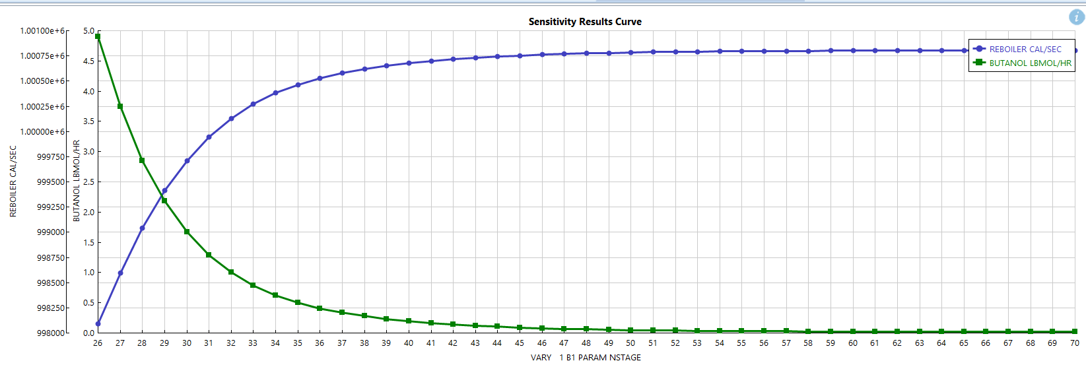

Trays varied from 26-70. Feed enters on top of 25th tray.

x-axis: number of stages. y-axis: reboiler duty (in cal/s)

## 4. Recovery of 90.2% of Isobutanol

Total flow rate of isobutanol in feed = 0.5*100 = 50 lbmol/hr

=> Required Isobutanol flow rate in distillate = 0.902*50 = 45.1 lbmol/hr

From the graph obtained using sensitivity analysis, we find the resulting reflux ratio (corresponding to 45.087 lbmol/hr isobutanol flow) = 4.45

Reflux ratio = Reflux rate/Distillate rate => Reflux rate = 4.45*50 = **222.5 lbmol/hr**

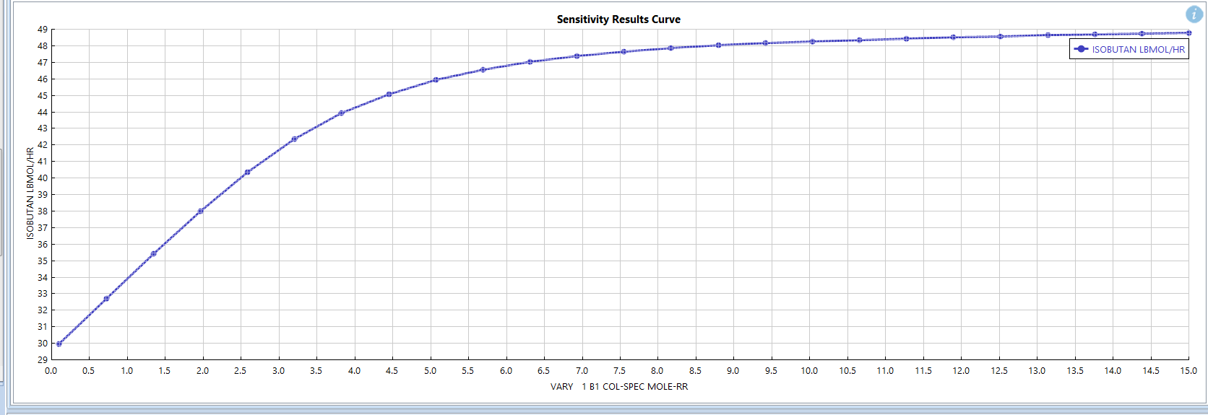

## 5. Using “Design Specification” and “Vary” feature in the Radfrac block

Design specification

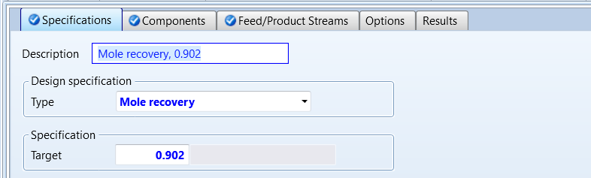

Vary

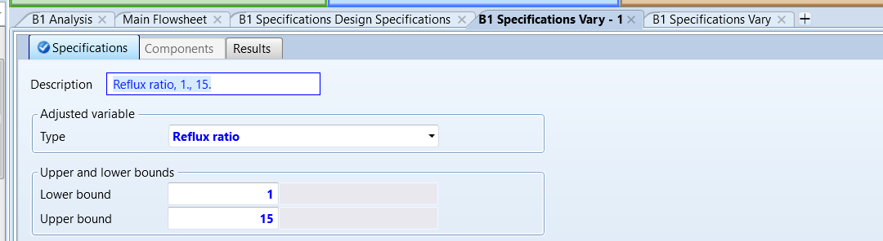

Results

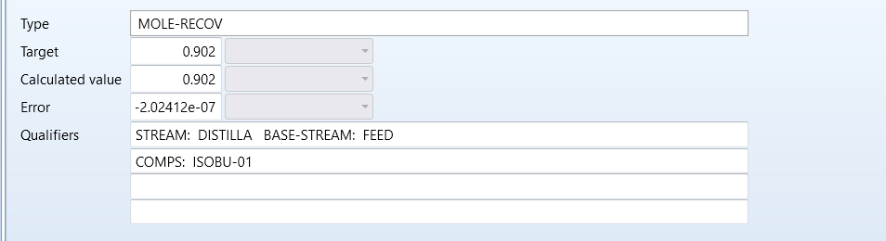

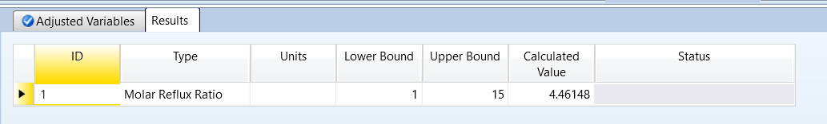

Reflux Ratio = 4.4615

Reflux ratio = Reflux rate/Distillate rate => Reflux rate = 4.4615*50 = **223.075 lbmol/hr**

(matches closely with previous answer)