# ASSIGNMENT-2 PROCESS ENGINEERING

## Concentration of butanol in the Distillate stream

The concentration (in terms of mole fraction) is 0.024814

|  |  |  |  |  |
| --- | --- | --- | --- | --- |
| Component | units | feed | bottoms | tops |
| Butanol | lbmol/hr | 50 | 48.75931 | 1.240687 |
| Isobutanol | lbmol/hr | 50 | 1.240687 | 48.75931 |

|  |  |  |  |  |
| --- | --- | --- | --- | --- |
| Component | units | feed | bottoms | tops |
| Butanol |  | 0.5 | 0.975186 | 0.024814 |
| Isobutanol |  | 0.5 | 0.024814 | 0.975186 |

## Butanol Concentration < 0.2 in distillate

Parameters to change:

1. Pressure
2. Distillate to feed ratio
3. Trays
4. Feed tray

Required butanol conc < 0.2lbmol/h

10 atm => butanol in tops increases to 7

Pressure not much effect.

Reducing distillate to feed ratio (obviously) reduces butanol flow in distillate.

D2F ratio: 0.18

Mole Flows lbmol/hr 100 82.0000000000001 18

1-BUT-01 lbmol/hr 50 49.8051991778538 0.1948008208763

ISOBU-01 lbmol/hr 50 32.1948008221463 17.8051991791237

Mole Fractions

1-BUT-01 0.5 0.607392610678943 0.0107669950741048

ISOBU-01 0.5 0.392607389321057 0.989233004925895

Changing reflux ratio not helping much

Feed higher => Butanol increases (obviously)

Feed lower also butanol increases. (but why)

40 stages; Feed on 25th tray. (Feed location makes considerable difference.)

1-BUT-01 lbmol/hr 50 49.8035491593092 0.196450840704728

ISOBU-01 lbmol/hr 50 0.196450840690891 49.8035491592953

1-BUT-01 0.5 0.996070983186182 0.00392901681409455

ISOBU-01 0.5 0.00392901681381782 0.996070983185905

Following the same for next part also.

3.

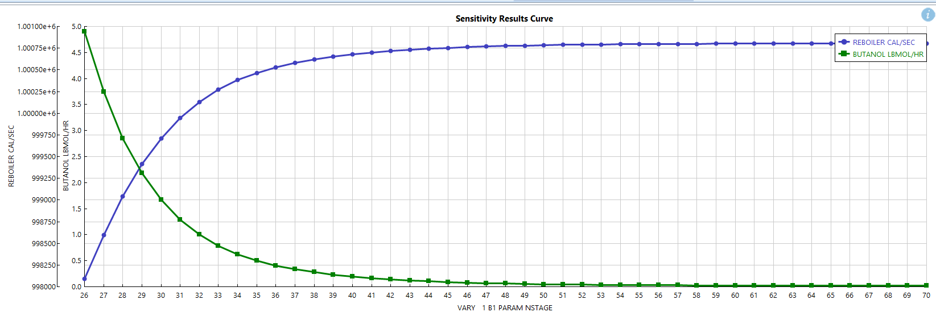

Vary trays from 26-70. Feed tray kept constant at 25.

4. Isobutanol recovery required: 90.2%

Flow = 0.902*50 = 45.1

Reflux ratio = 4.45 (45.087)

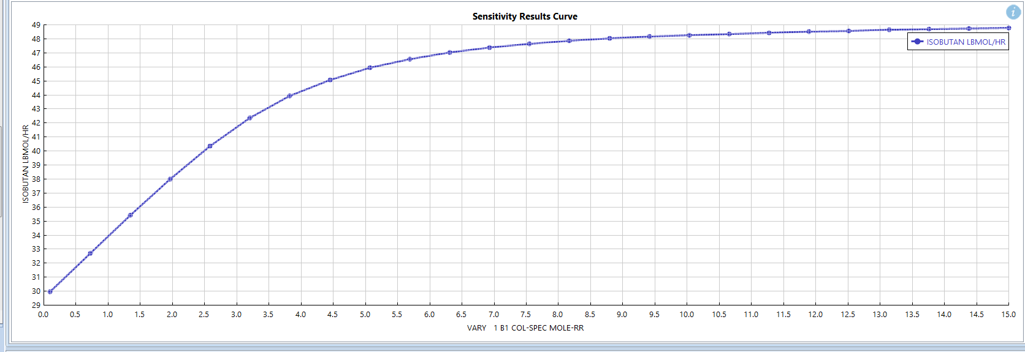

5.

Reflux Ratio = 4.46148094

