# ASSIGNMENT-5 PROCESS ENGINEERING

T = (a+b+10*c) = 0 + 2 + 10*0 = 2

X = 2 mod 9 = 2

Y = 2 mod 19 = 2

## Achieving given specifications

Design specifications that can’t be directly achieved: maintaining less than 37 lbmol/hr waste gas, 99% conversion, 99.2% purity cumene in output. To achieve these specifications we vary parameters that haven’t been directly given in the problem. Those are as follows:

|  |  |  |
| --- | --- | --- |
| Specification | Parameter varied | Value of parameter for which specs achieved |
| 37 lbmol/hr waste gas | Vapor fraction in distillate | 0.02 |
| 99% conversion | Length of the reactor | 3.54731947 m (DS-1) |
| 99.2% purity cumene | Propylene inlet flow rate | 50.5205273 kmol/hr (DS-2) |

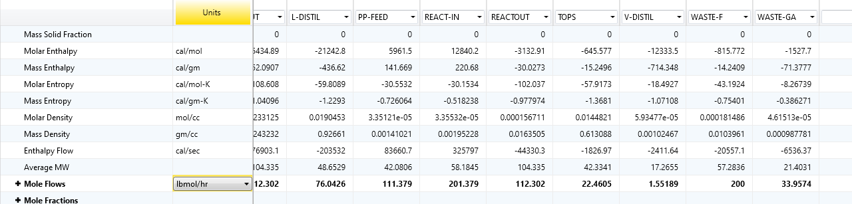

Figure-1: Waste gas flow < 37 lbmol/hr

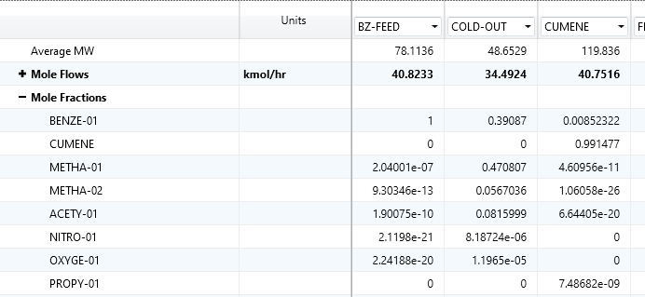

Figure-2: Achieving 99.2% purity

All these were achieved using Flowsheeting options -> Design Specs in ASPEN. It is also found that 206.247 oF is the temperature for 30 degrees of superheating.

## Cumene product flowrate vs Preheater Temperature

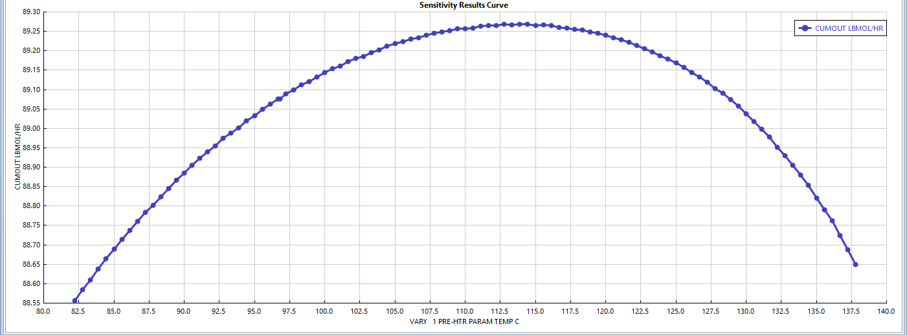

Figure-3: Cumene product flowrate with the preheater temperature

## PFD for process and stream table.

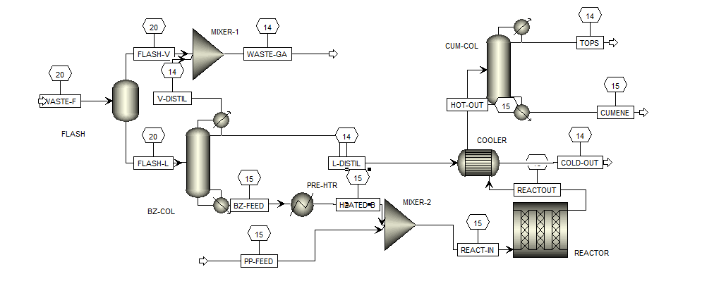

Figure-4: PFD

We see a significant pressure drop at the two distillation columns: BZ-COL and CUM-COL, so pumps are present in those two units (say, 1 pump for each).

Due to space constraints, I am sharing the stream table in this [drive link](https://docs.google.com/spreadsheets/d/1kv-MtGO7I3ZPBUI-_KnPXIp3NyiLZ1CV7upqC4S5t4g/edit?usp=sharing).