CH4010 Assignment-2

**[Excerpts from HW1 for using some of the values found out there]**

**Given stream data:**

|  |  |  |  |  |
| --- | --- | --- | --- | --- |
| Stream No. | Type | Heat Capacity* Flow Rate | Supply Temperature | Target Temperature |
|  |  |  |
| kW / K | oC | oC |
| 1 | Hot | 2.1 | 180 | 40 |
| 2 | Hot | 4 | 150 | 40 |
| 3 | Cold | 3 | 60 | 180 |
| 4 | Cold | 2.6 | 30 | 130 |

Since (ΔT)min = 9 degrees C (even roll number), we can shift the hot stream below by 9/2 = 4.5 degrees and the cold stream above by 4.5 degrees. This results in:

**Modified stream data:**

|  |  |  |  |  |
| --- | --- | --- | --- | --- |
| Stream No. | Type | Heat Capacity* Flow Rate | Supply Temperature | Target Temperature |
|  |  |  |
| kW / K | oC | oC |
| 1 | Hot | 2.1 | 175.5 | 35.5 |
| 2 | Hot | 4 | 145.5 | 35.5 |
| 3 | Cold | 3 | 64.5 | 184.5 |
| 4 | Cold | 2.6 | 34.5 | 134.5 |

# Part-1: Pinch-point, Qc, QH and composite curves

Using the problem table algorithm, one can arrive at the following table:

|  |  |  |  |  |  |  |  |  |  |
| --- | --- | --- | --- | --- | --- | --- | --- | --- | --- |
|  | 2.1 | 4 | 3 | 2.6 | Σ (FCp, hot)  (in kW/C) | Σ(FCp, cold)  (in kW/C) | ΔT (in C) | ΔH  (in kW) | qtransfer  (in kW) |
| 184.5 | 0 | 0 | 1 | 0 | 0 | 3 | 9 | 27 | 0 |
| 175.5 | 1 | 0 | 1 | 0 | 2.1 | 3 | 30 | 27 | -27 |
| 145.5 | 1 | 1 | 1 | 0 | 6.1 | 3 | 11 | -34.1 | -54 |
| 134.5 | 1 | 1 | 1 | 1 | 6.1 | 5.6 | 70 | -35 | -19.9 |
| 64.5 | 1 | 1 | 0 | 1 | 6.1 | 2.6 | 29 | -101.5 | 15.1 |
| 35.5 | 0 | 0 | 0 | 1 | 0 | 2.6 | 1 | 2.6 | 116.6 |
| 34.5 | 0 | 0 | 0 | 0 | 0 | 0 |  |  | 114 |

We can see the lowest qtransfer is -54 kW. So if we provide a heating of 54 kW, all heat transfers will be non-negative (and hence heat won’t flow from lower temperature to higher temperature).

|  |  |  |  |  |  |  |  |  |  |
| --- | --- | --- | --- | --- | --- | --- | --- | --- | --- |
|  | 2.1 | 4 | 3 | 2.6 | Σ (FCp, hot)  (in kW/C) | Σ(FCp, cold)  (in kW/C) | ΔT  (in C) | ΔH  (in kW) | qtransfer (in kW) |
| 184.5 | 0 | 0 | 1 | 0 | 0 | 3 | 9 | 27 | 54 |
| 175.5 | 1 | 0 | 1 | 0 | 2.1 | 3 | 30 | 27 | 27 |
| 145.5 | 1 | 1 | 1 | 0 | 6.1 | 3 | 11 | -34.1 | 0 |
| 134.5 | 1 | 1 | 1 | 1 | 6.1 | 5.6 | 70 | -35 | 34.1 |
| 64.5 | 1 | 1 | 0 | 1 | 6.1 | 2.6 | 29 | -101.5 | 69.1 |
| 35.5 | 0 | 0 | 0 | 1 | 0 | 2.6 | 1 | 2.6 | 170.6 |
| 34.5 | 0 | 0 | 0 | 0 | 0 | 0 |  |  | 168 |

Hence from the above Problem Table we obtain the following:

**Pinch point:** i) cold stream pinch = 145.5 ̊C – 4.5 ̊C = **141 ̊C**

ii) hot stream pinch = 145.5 ̊C + 4.5 ̊C = **150 ̊C**

Heating utility required, **Qh** = **54 kW**

Cooling utility required, **Qc** = **168 kW**

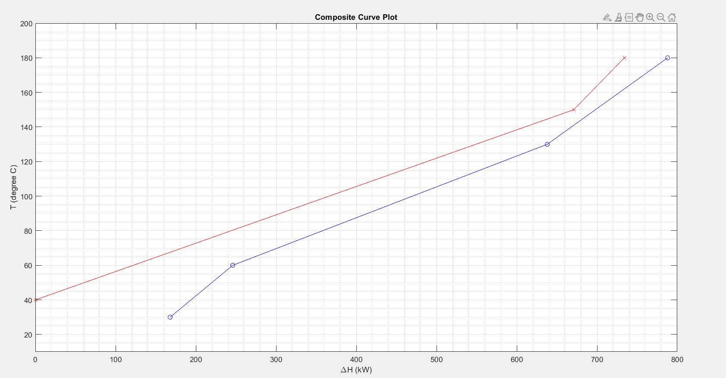

**Plot 1: Composite curves.** Red: hot curve; blue: cold curve

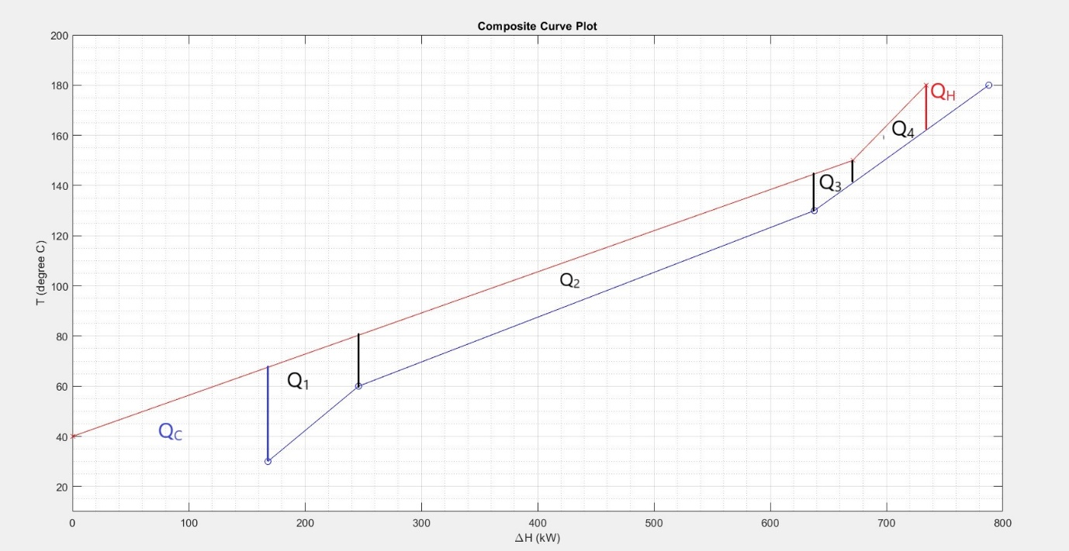

**Plot 2:** Showing different segments of the heat exchanger network used for Spaghetti Design

**[Excerpts over]**