# Q3 Part d)

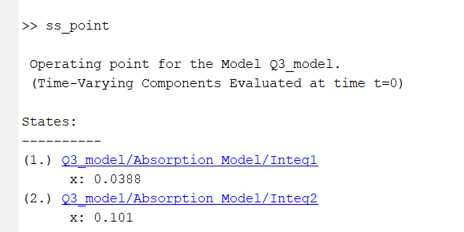

linsys =

A =

Integ1 Integ2

Integ1 -6.5 2.5

Integ2 4 -6.5

B =

FR FR1

Integ1 -0.001938 0.00155

Integ2 -0.003101 0.002481

C =

Integ1 Integ2

Out1 1 0

Out2 0 1

D =

FR FR1

Out1 0 0

Out2 0 0

Continuous-time state-space model.

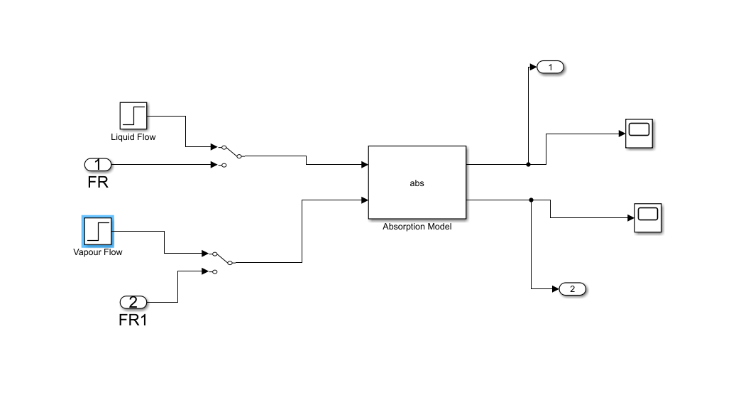

# Part e)

Since if we change both the flow rates, steady state values are same as original, I am changing only L in both cases.

ALL GRAPHS ARE FROM NON LINEAR MODEL. I DID NOT PLOT FOR LINEAR MODEL.

1. L = 1.05Lss

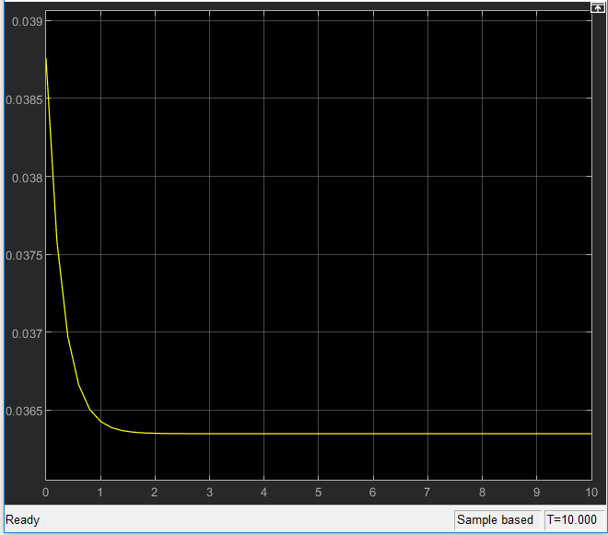

W graph

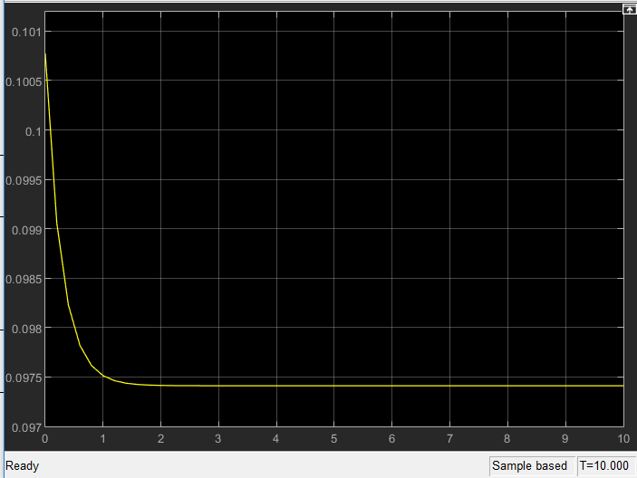

Z graph

Linear model

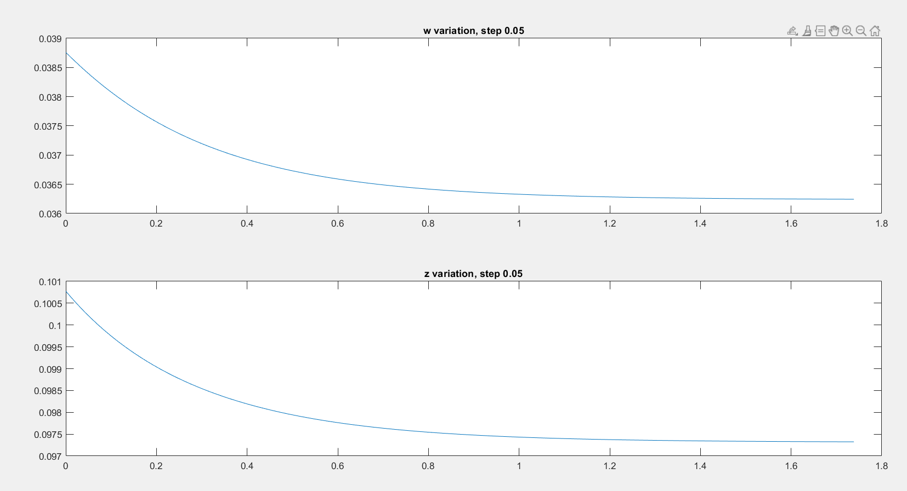

1. L= 1.15Lss

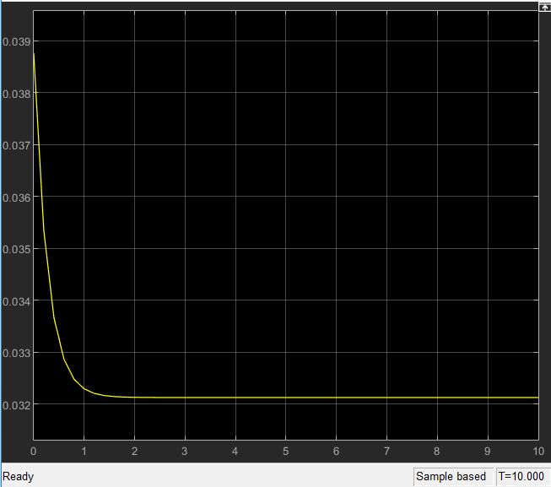

W graph

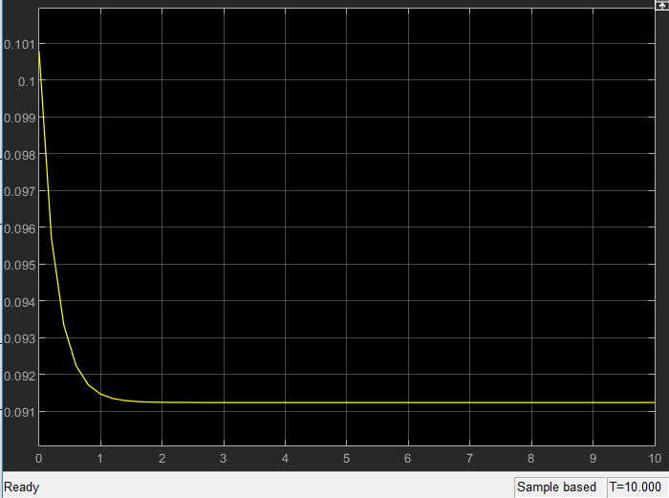

Z graph

Linear model:

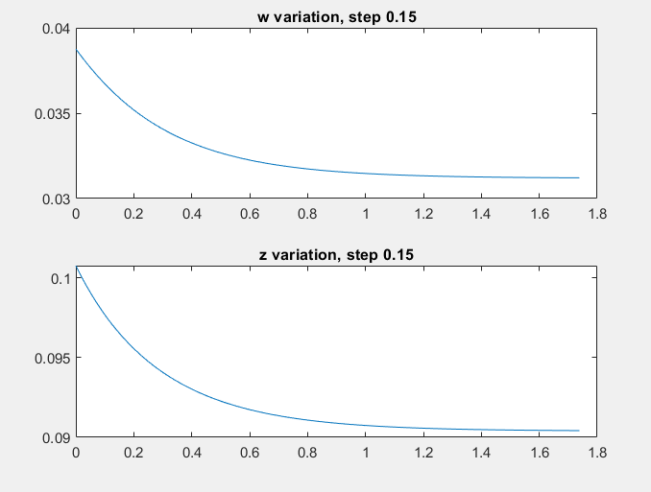

Code:

clear;close all;

%% System charecterstics

Lss = 80; Vss = 100;

M = 20; a=0.5; zf = 0.1;

%% Part a) Finding steady state (by hand)

% Equate derivatives to zero, solve the linear eqn

Ass = [-(a*Vss+Lss)/M Vss*a/M;Lss/M -(a*Vss+Lss)/M];

bss = [0;-Vss*zf/M];

x_ss = inv(Ass)*bss;

%% Part b) Linearisation (by Taylor Expansion)

w_ss = x_ss(1);z_ss=x_ss(2);

A = [-(Vss*a+Lss)/M Vss*a/M;Lss/M -(Lss+Vss*a)/M];

B = [-w_ss/M (-a*w_ss+a*z_ss)/M;(w_ss-z_ss)/M -a*z_ss/M+zf/M];

%% Part c) Finding the eigenvalues-eignvectors of the system

[V,D] = eig(A);

% Second eigen value is faster (more negative)

%% Part d) Find steady-state and linearise

open_system('Q3_model')

% Read the operating conditions into an object

opc = operspec('Q3_model');

% Operating conditions

opc.Inputs(1).u = 80;

opc.Inputs(2).u = 100;

opc.Inputs(1).Known = 1;

opc.Inputs(2).Known = 1;

% Constraints

opc.States(1).Min = 0;opc.States(2).Min = 0;

% Find the steady state point

ss_point = findop('Q3_model',opc);

% Linearize

linsys = linearize('Q3_model',ss_point)

%% Part e) Give step changes and plot

% Done in SIMULINK. Use the manual switch to step input(s)

[Y,T,X]=step(linsys);

% Y(:,:,1) contains responses for change in L

% Since linear system, changes in input and output are proportional

figure();

subplot(2,1,1);plot(T,Y(:,1,1)*.05*Lss+w_ss); title('w variation, step 0.05');

subplot(2,1,2);plot(T,Y(:,2,1)*.05*Lss+z_ss); title('z variation, step 0.05');

figure();

subplot(2,1,1);plot(T,Y(:,1,1)*.15*Lss+w_ss); title('w variation, step 0.15');

subplot(2,1,2);plot(T,Y(:,2,1)*.15*Lss+z_ss); title('z variation, step 0.15');