# Q1 d)

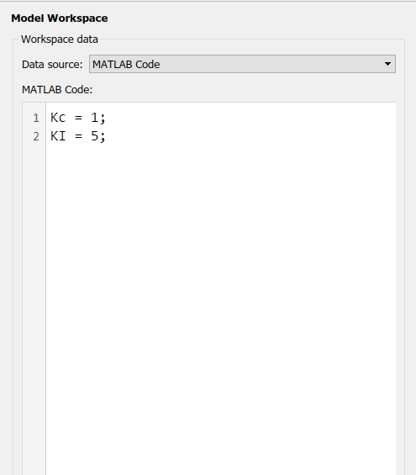

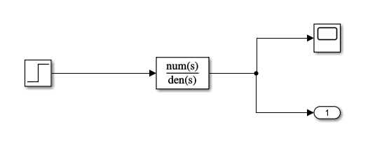

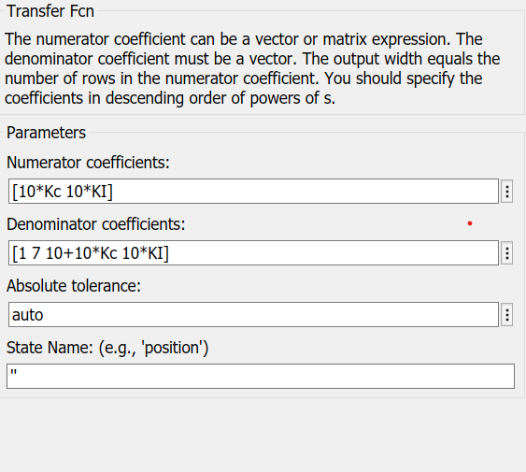

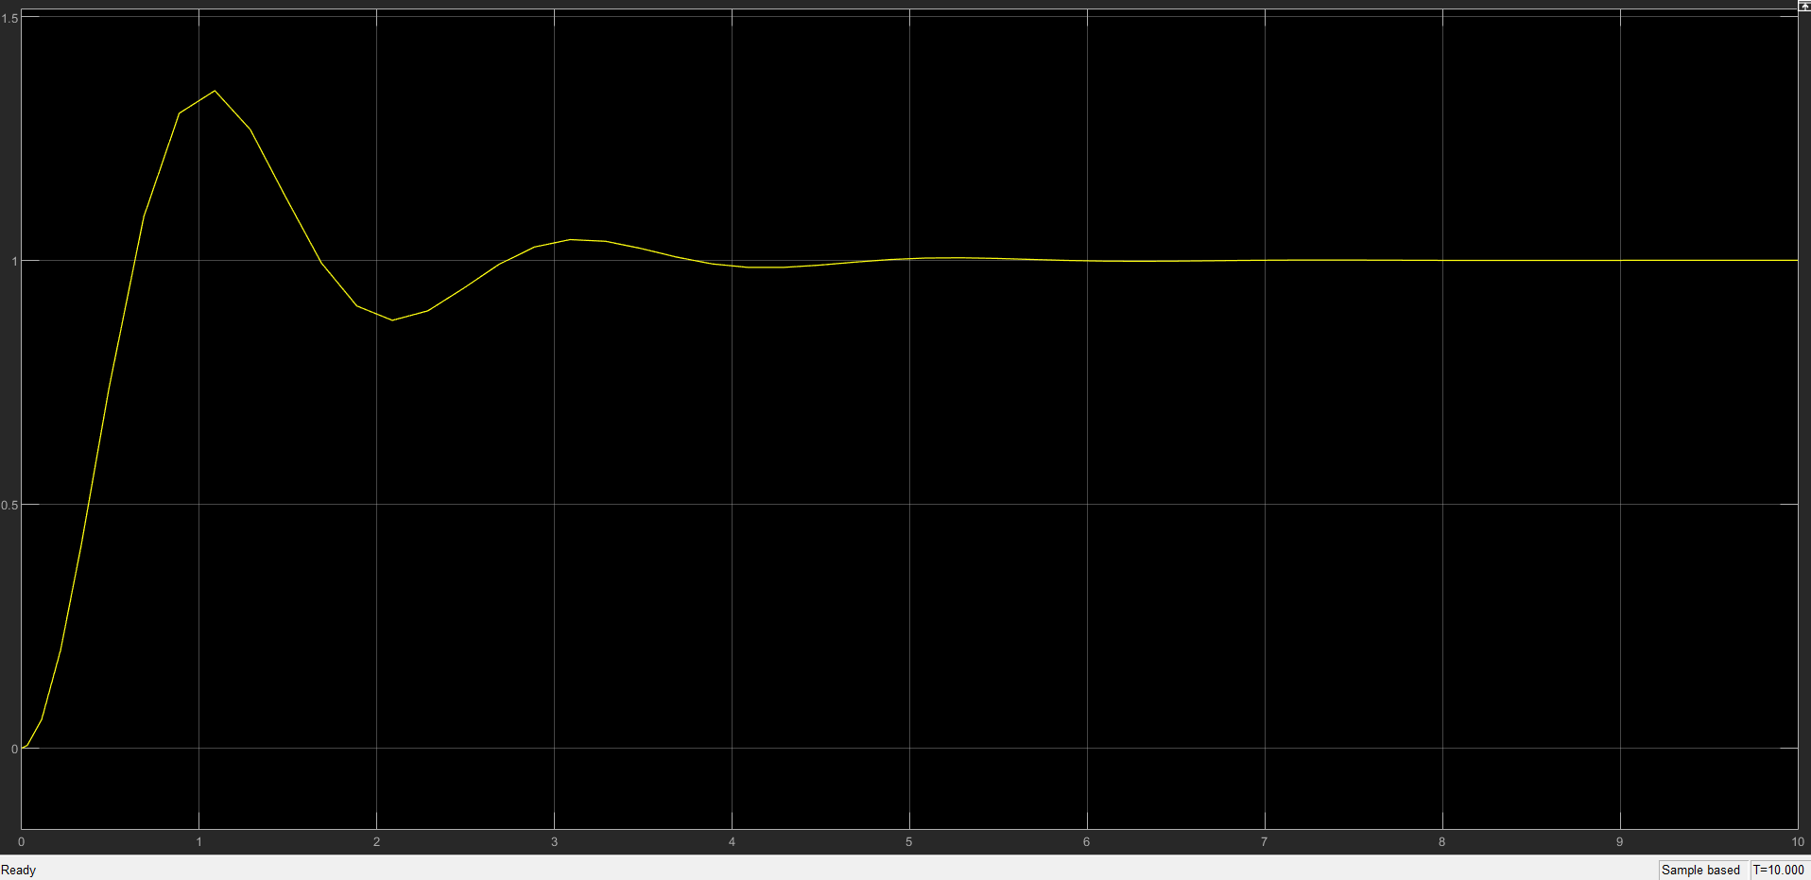

*Figure 1.1: Kc = 1, KI = 5; Acceptable region*

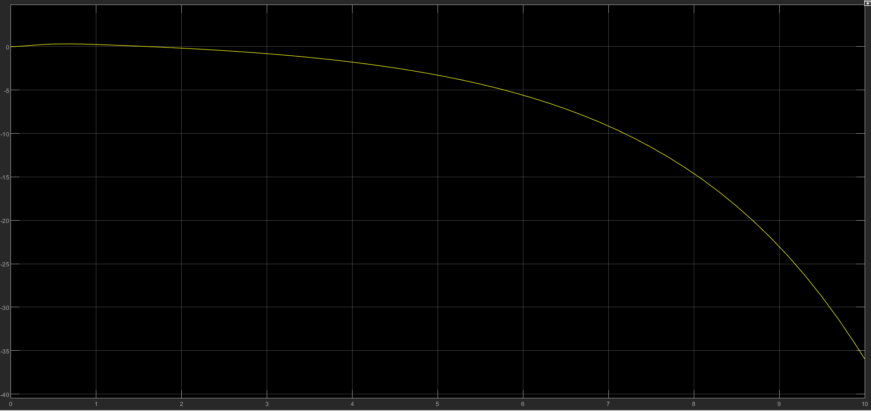

*Figure 1.2: Kc = 1, Ki = -1; Kc acceptable, Ki not in acceptable region. Result: Setpoint not reached; unstable*

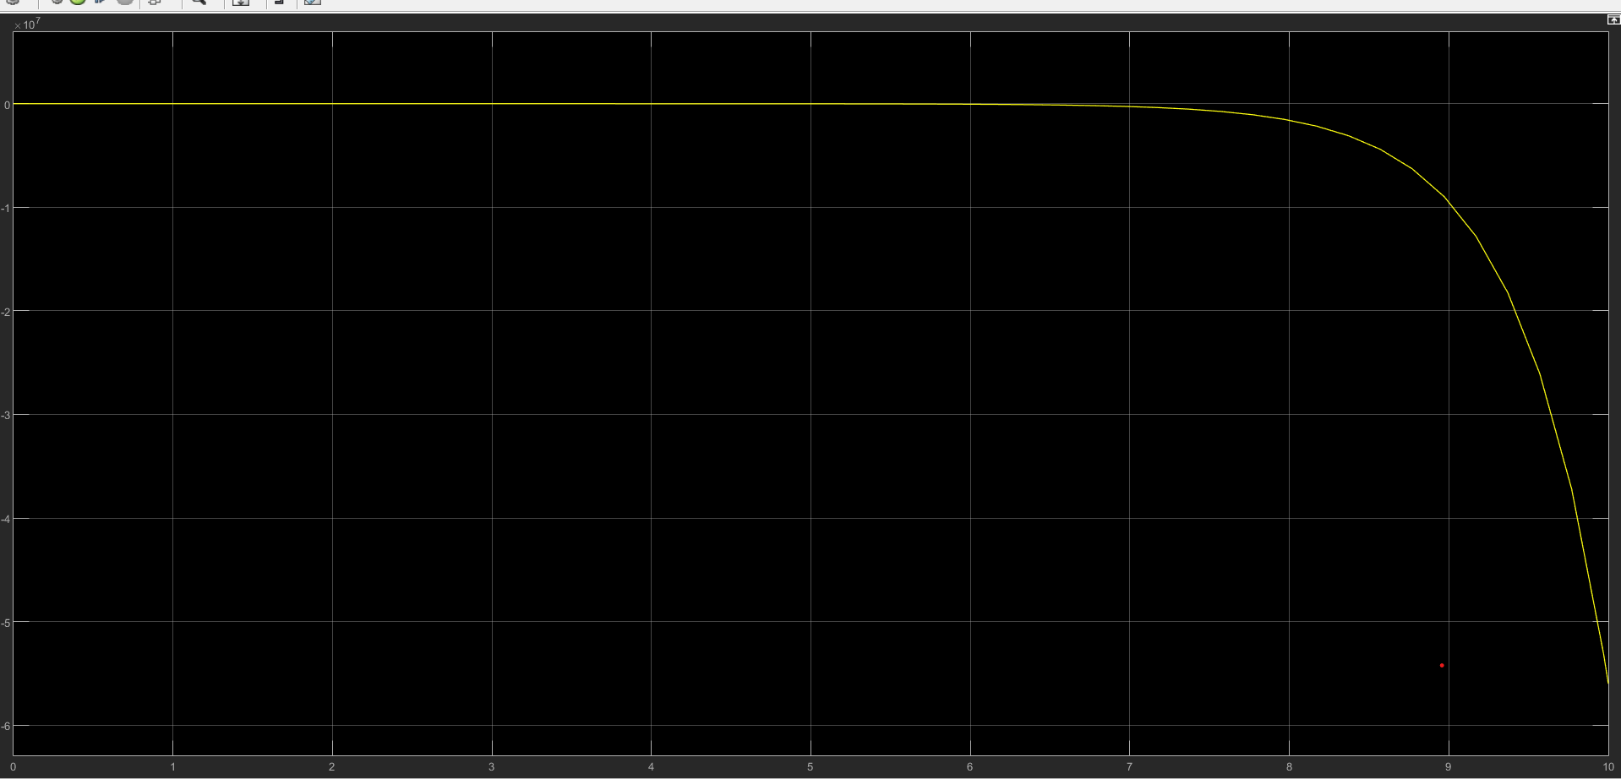

*Figure 1.3: Kc = -2; KI = -1; Both in unacceptable region. Setpoint not achieved, Gcl unstable*